

PROJECT TITLE

A CAPSTONE PROJECT REPORT

PRIORITY SCHEDULING BASED HAZARD DETECTION AND ALERT SYSTEM
CSA 0405 – OPERATING SYSTEMS FOR MEMORY MANAGEMENT
to the award of the degree of
BACHELOR OF ENGINEERING
IN
ARTIFICIAL INTELLIGENCE AND DATA SCIENCE

Submitted by
HUSSAIN.V(192524179)

GUIDED BY
Dr. PRISKILLA ANGEL RANI

SIMATS ENGINEERING
Saveetha Institute of Medical and Technical Sciences
Chennai-602105

SEPTEMBER 2026

SIMATS ENGINEERING

Saveetha Institute of Medical and Technical Sciences

Chennai-602105

BONAFIDE CERTIFICATE

This is to certify that the Capstone Project entitled “PRIORITY SCHEDULING BASED HAZARD DETECTION AND ALERT SYSTEM” has been carried out by HUSSAIN.V under the supervision of Dr. PRISKILLA ANGEL RANI. The work is submitted in partial fulfilment of the requirements of Artificial Intelligence and Data Science Engineering, Saveetha Institute of Medical and Technical Sciences, Chennai.

COURSE COORDINATOR COURSE FACULTY
Title / Name, Dr.Priskilla Angel Rani
Designation Designation
Branch / Department Name Branch / Department Name
SIMATS Engineering, SIMATS Engineering,
SIMATS, Chennai – 602105 SIMATS, Chennai – 602105

SIMATS ENGINEERING

Saveetha Institute of Medical and Technical Sciences

Chennai-602105

DECLARATION

We, HUSSAIN.V of the Artificial Intelligence and Data Science Engineering, SIMATS Engineering, Saveetha Institute of Medical and Technical Sciences, Chennai, hereby declare that the Capstone Project Work entitled “PRIORITY SCHEDULING BASED HAZARD DETECTION AND ALERT SYSTEM” is the result of our own bonafide efforts. To the best of our knowledge, the work presented herein is original, accurate, and has been carried out in accordance with the principles of engineering ethics and academic integrity. All sources, references, data, and other materials used in the project have been appropriately acknowledged. We further declare that the data, results, analysis, and findings presented in this report have not been fabricated, falsified, or manipulated. Any external tools, software, datasets, computational resources, or AI-assisted tools used during the project have been appropriately disclosed. We confirm that all applicable ethical, academic, institutional, and professional requirements have been duly followed throughout the planning, execution, analysis, and documentation of the project.

Place: Chennai

Date:5/09/2026

Signature of the Students with Names

HUSSAIN.V(192524179)

SIMATS ENGINEERING

Saveetha Institute of Medical and Technical Sciences

Chennai-602105

Individual Contribution Statement

(Mandatory for all team projects)

Student Name / Register No | Specific Responsibilities | Design & Development Contribution | Testing & Analysis Contribution | Report Contribution | Approx. Contribution (%)
K. Reshma  (192565062) | Priority Scheduling | Priority Algorithm | Scheduling Testing | Literature Review | 20%
M.Meenatchi  (192524307) | Hardware Integration | Sensor Integration | Sensor Testing | Introduction | 20%
D.Hemalatha  (192565004) | Sensor Monitoring | DHT11 & PIR | Sensor Testing | System Design | 20%
V.Mohammad Hussian  (192524179) | Alert System | Web Dashboard | Alert Testing | Implementation | 20%
Athin Siva  (192524237) | System Integration | Simulation Mode | System Testing | Conclusion | 20%

ABSTRACT
The Response and Monitoring Module is the final operational stage of the proposed Priority Scheduling Based Hazard Detection and Alert System. Its primary purpose is to receive the processed hazard information from the preceding scheduling and alert stages, maintain the current system state, support an appropriate response, and continuously monitor the system for new or persistent events. This module provides the operational bridge between a generated alert and the subsequent observation of the system condition.
The module works with the output of the priority scheduling workflow. Once a hazard has been detected, assigned a priority and handled by the alert-generation stage, the response and monitoring layer presents the current condition to the operator or user and records relevant status information. The monitoring process is designed to continue after a response action so that persistent hazards and newly appearing hazards are not ignored. In a software simulation, the same workflow can be represented through event status, response messages, logs and monitoring updates.
A modular response layer is useful because detection, scheduling, alerting and monitoring have different responsibilities. Separating these functions makes the system easier to test and modify. It also allows response logic to be extended without changing the sensor-acquisition layer. The module emphasizes traceability by maintaining a clear relationship between a hazard event, its processing state, the response action and the current monitoring status.
The module therefore completes the operational loop of the project: a detected hazard becomes a prioritized event, an alert is generated, an appropriate response state is represented, and the system continues monitoring. The prototype is intended for academic demonstration and should not be treated as a certified safety controller. Quantitative claims such as response time, detection accuracy or false-alarm rate should be reported only when supported by actual experimental measurements.
Keywords: Response and Monitoring, Hazard Event, Priority Scheduling, Alert System, Event Logging, System Status, Continuous Monitoring, Arduino UNO, Operating Systems.

TABLE OF CONTENTS

Sl. No. | Title | Page
1 | CHAPTER 1: INTRODUCTION AND ENGINEERING PROBLEM | 7–10
2 | CHAPTER 2: LITERATURE REVIEW AND EXISTING SOLUTIONS | 11–13
3 | CHAPTER 3: ENGINEERING DESIGN, TRADE-OFFS, SUSTAINABILITY, ETHICS, SAFETY, RISK & SECURITY | 14–19
4 | CHAPTER 4: IMPLEMENTATION, TESTING & RESULTS, PROJECT MANAGEMENT | 20–25
5 | CHAPTER 5: CONCLUSION, FUTURE WORK & INDIVIDUAL REFLECTION | 26–28
6 | REFERENCES | 29
7 | APPENDICES | 30–32

LIST OF FIGURES
Figure No. | Figure Name | Page
Figure 3.1 | Module 5 – Response and Monitoring Architecture | 15
Figure 3.2 | Module 5 – Response and Monitoring Flowchart | 16
Figure 4.1 | Response and Monitoring Implementation Concept | 21
Figure 4.2 | Module 5 Event Status and Monitoring Cycle | 23

LIST OF TABLES
Table No. | Table Name
Table 1.1 | Response and monitoring functions
Table 3.1 | Stakeholder requirements for Module 5
Table 3.2 | Functional and non-functional requirements
Table 3.3 | Module 5 design specifications
Table 3.4 | Response strategy trade-off analysis
Table 3.5 | Sustainability, ethics, safety and security considerations
Table 3.6 | Module 5 risk register
Table 4.1 | Hardware and software resources
Table 4.2 | Module 5 test plan
Table 4.3 | Functional test results
Table 4.4 | Objective achievement

LIST OF ABBREVIATIONS / SYMBOLS
Abbreviation | Description
OS | Operating System
IoT | Internet of Things
UNO | Arduino UNO development board
UI | User Interface
PIR | Passive Infrared
MQ | Gas/smoke sensing module family used in the project
DHT | Digital Humidity and Temperature sensor family
FCFS | First-Come, First-Served
AI | Artificial Intelligence
ID | Identifier

CHAPTER 1

INTRODUCTION AND ENGINEERING PROBLEM

1.1 Background
The complete project is designed as a sequence of hazard detection, priority assignment, priority scheduling, alert generation, and response/monitoring. While the earlier modules identify and process hazardous events, Module 5 is responsible for observing the resulting system state and supporting the response stage. It therefore represents the operational end of the project workflow.
Module 5 receives information after the hazard has passed through the priority and alerting stages. Its role is not to replace the sensor layer or the scheduler. Instead, it maintains awareness of what has happened, represents the response state, records event information and continues monitoring for persistent or newly occurring hazards.

1.2 Need for Module 5
- A hazard response should be followed by continuous observation of the system state.
- Users or operators need understandable information about the current condition.
- Events should remain traceable after alert generation.
- Persistent hazards may require continued monitoring after an initial response.
- A monitoring layer provides a clear endpoint for integrating the different project modules.

1.3 Problem Statement
Design and implement a response and monitoring module capable of receiving processed hazard events, representing the response state, maintaining event/status information, communicating the current condition to the user or application layer, and continuing to monitor for new or persistent hazards.

1.4 Aim
To develop an academic prototype response and monitoring layer that closes the hazard-processing loop by tracking hazard status, supporting response actions, recording event information and continuously observing the system after an alert.

1.5 Objectives
- Receive hazard information from the preceding alert/scheduling workflow.
- Represent the current response state of the system.
- Provide understandable monitoring information to the user/operator.
- Record relevant event and status information for traceability.
- Continue monitoring after a response action.
- Support hardware-based operation and software simulation where defined by the overall project.
- Verify the response and monitoring workflow using repeatable test cases.

1.6 Scope
Module 5 covers response-state handling, status monitoring, event logging and continued observation after an alert. It does not detect raw sensor conditions, assign the initial hazard priority, or replace the scheduling and alert-generation functions of earlier modules.

1.7 Response and Monitoring Functions
Input / Source | Module 5 Function | Output
Scheduled hazard event | Receive and interpret event status | Active response state
Alert information | Represent current alert condition | User/operator status
Response action | Record action/state | Response log
System status | Observe changes | Updated monitoring state
New or persistent event | Continue monitoring and process status | Updated event record

1.8 Assumptions and Boundary Conditions
- The preceding modules provide a valid hazard event or alert status.
- The monitoring interface/application is available when software monitoring is used.
- Response actions are represented according to the project implementation.
- The prototype is an academic system and is not a certified emergency controller.
- Quantitative response-performance claims require actual experimental measurements.

1.9 Expected Engineering Outcome
The expected outcome is a functioning response and monitoring layer in which processed hazard information can be represented, recorded, communicated and observed continuously. The module should provide a clear endpoint for the complete hazard-management workflow.

CHAPTER 2

LITERATURE REVIEW AND EXISTING SOLUTIONS

2.1 Review Method
The review for Module 5 focuses on three linked engineering functions: emergency response representation, event/status monitoring and software-based traceability. The complete project connects these functions with Operating System scheduling so that an alert is not treated as the end of processing; the resulting state must remain observable.

2.2 Alert-to-Response Systems
A basic alarm system can notify an operator when a condition occurs, but notification alone does not provide a complete response workflow. A response and monitoring layer is needed to represent whether the event is active, acknowledged, being handled or still present. This distinction is important when several hazard events can occur during the same monitoring period.

2.3 Continuous Monitoring
Continuous monitoring allows the system to observe whether the previous condition persists and whether a new event appears. In the proposed project, this function connects the final response stage back to the overall monitoring loop without changing the responsibility of the detection module.

2.4 Relationship to Operating Systems
Operating Systems concepts emphasize processes, scheduling, states, resource allocation and orderly execution. In this project, a hazard event progresses through a sequence of states: detection, priority assignment, scheduling, alerting and response/monitoring. Module 5 observes the result of this sequence and maintains the operational state after processing.

2.5 Comparative Analysis
Existing Approach | Advantages | Limitations | Relevance
Simple alarm | Easy to understand | Limited state tracking | Baseline
Manual response | Human decision-making | Slow and difficult to trace | Partially relevant
Dashboard monitoring | Centralized status visibility | Depends on application connectivity | Strongly related
Event logging | Good traceability | Does not itself perform response | Strongly related
Proposed response & monitoring | Combines response state, status and continued monitoring | Prototype and integration limitations | Selected approach

2.6 Engineering Gap
The main gap addressed by Module 5 is the transition from an alert event to a continuously observable response state. Without a response and monitoring layer, the system can generate an alert but cannot clearly represent what happened afterward or whether the hazard remains active.

2.7 Proposed Contribution
Module 5 provides a common endpoint for status tracking and response monitoring. It receives the output of the preceding modules and converts it into an understandable operational state while preserving event traceability.

CHAPTER 3

ENGINEERING DESIGN & TRADE-OFFS, SUSTAINABILITY, ETHICS, SAFETY, RISK & SECURITY

3.1 Stakeholder Requirements
Stakeholder | Requirement
Home user | Receive understandable information about the current hazard and response state.
Industrial/public operator | Monitor active and persistent hazard conditions.
Project evaluator | Observe an integrated response and monitoring implementation.
Developer/tester | Test response states and monitoring transitions using repeatable cases.
System operator | Maintain event traceability and current system status.

3.2 Functional & Non-Functional Requirements
Type | Requirement | Verification Target
Functional | Receive hazard/alert event | Event reaches Module 5
Functional | Update response state | Correct state is represented
Functional | Display current status | User/operator can observe status
Functional | Record event information | Event/status log is updated
Functional | Continue monitoring | Monitoring remains active
Non-functional | Continuity | System continues after response state update
Non-functional | Traceability | Event can be linked to its status
Non-functional | Testability | Response cases can be repeated

3.3 Design Specifications
Parameter | Target / Requirement | Priority
Input | Processed hazard/alert event | High
Response state | Clearly identifiable status | Critical
Monitoring | Continuous observation | Critical
Logging | Event and status traceability | High
Interface | Application / dashboard layer | High
Integration | Connection to complete project workflow | Critical

3.4 Response and Monitoring Architecture
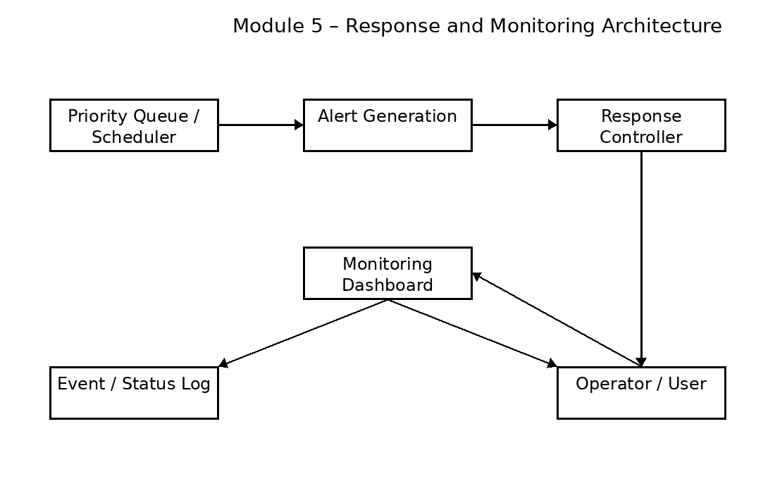
Figure 3.1 Module 5 – Response and Monitoring Architecture
Figure 3.1 illustrates the functional boundary of Module 5. The scheduled or alerted event enters the response layer, where the current response state is represented. The monitoring dashboard and event/status log provide visibility and traceability, while the system continues observing for new or persistent events.

3.5 Response and Monitoring Flow
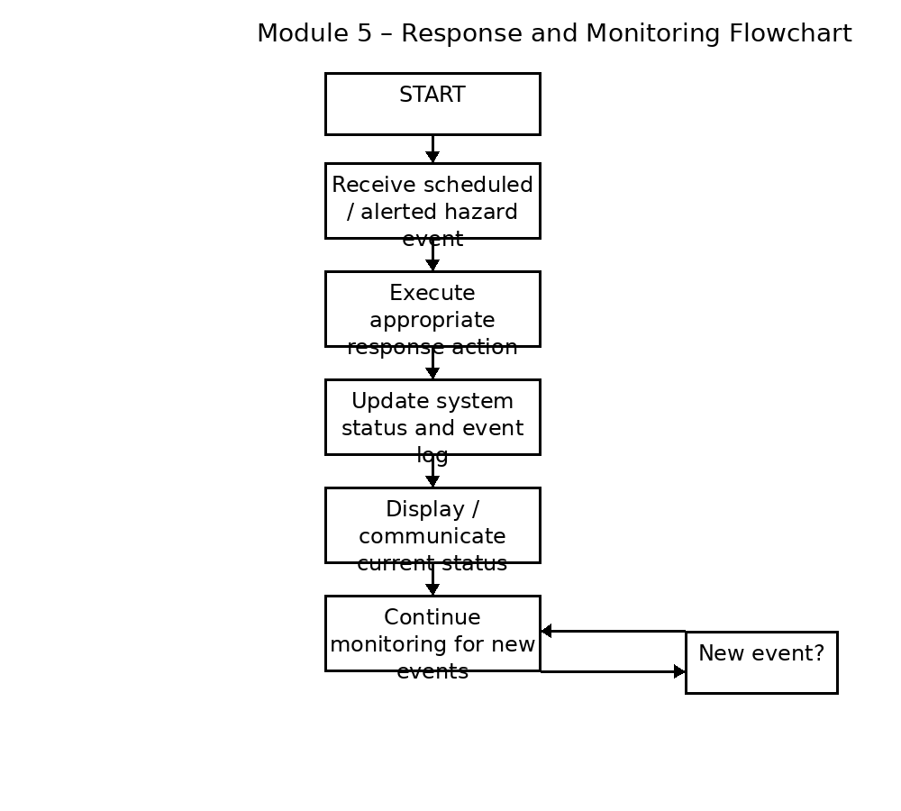
Figure 3.2 Module 5 – Response and Monitoring Flowchart
The flow begins when a processed hazard event is received. The module represents the response action, updates the event/status information, communicates the current condition and continues monitoring. New events can enter the same monitoring workflow.

3.6 Response Strategy Trade-Off Analysis
Design Decision | Alternative | Benefit | Limitation | Final Decision
Response representation | Simple status states | Easy to implement | May not capture complex operations | Status-based response
Monitoring | Periodic application updates | Simple and testable | Can miss rapid changes between updates | Continuous monitoring loop
Logging | Text/event log | Easy traceability | Storage can grow over time | Event/status logging
Interface | Dashboard/application | Clear user visibility | Depends on software layer | Application monitoring
Simulation | Software event simulation | Safe and repeatable | May differ from hardware behavior | Support simulation

3.7 Detailed Module Design
Component | Function in Module 5 | Output
Event Receiver | Accept processed hazard information | Active event
Response Controller | Represent appropriate response state | Response status
Monitoring Layer | Observe system state | Current status
Event Log | Record event and state transitions | Traceable record
Dashboard / Application | Present information to operator | User-facing status

3.8 Sustainability, Ethics, Safety & Security
Domain | Consideration | Engineering Impact
Sustainability | Reuse existing hardware and software infrastructure | Reduces prototype cost and resource consumption
Ethics | Do not claim unsupported response capability | Results must distinguish evidence from assumptions
Safety | Incorrect status or missed monitoring can have consequences | Prototype limitations must be stated clearly
Security | Status and response information may be exposed through connected applications | Future deployment requires secure communication and access control

3.9 Risk Register
Risk | Likelihood | Severity | Mitigation | Residual Risk
Incorrect response state | Medium | High | Validate state transitions with test cases | Medium
Monitoring interruption | Medium | High | Test continuous monitoring path | Medium
Event log failure | Medium | Medium | Test logging and fallback behavior | Low–Medium
Communication failure | Medium | Medium | Test application/hardware operating paths | Medium
User misinterpretation | Medium | High | Use clear status messages | Medium
Prototype mistaken for certified safety device | Low | High | Document limitations prominently | Low

3.10 Interface with Other Modules
Module 5 receives the processed result of the earlier project stages. The overall workflow is detection → priority assignment → priority queue/scheduling → alert generation → response and monitoring. Therefore, the key interface requirement is that the incoming event or alert contains enough information for Module 5 to identify the hazard, represent its current status and maintain traceability.

CHAPTER 4

IMPLEMENTATION, TESTING & RESULTS, PROJECT MANAGEMENT

4.1 Development Approach & Resources
Module 5 was developed as the final operational layer of the complete system. The implementation approach begins with receiving a processed hazard event, followed by response-state handling, status update, event logging, user-facing monitoring and continued observation. The module can be demonstrated through the integrated system or through software simulation when hardware response is not required.
Resource | Purpose
Arduino UNO / project hardware | Source of integrated system status where applicable
Laptop / application | Monitoring and response interface
Web dashboard / UI | User-facing status presentation
Event log | Traceability of hazard and response states
Software simulation | Repeatable response and monitoring testing
Breadboard and sensors | Upstream physical hazard source in integrated testing

4.2 Module 5 Implementation
The implementation follows a continuous response-monitoring cycle. The module accepts a hazard event or alert produced by the preceding stages. It then determines the current response state, updates the monitoring interface, records the event and continues observing the system for changes.

4.2.1 Event Reception
- Receive the processed hazard/alert event from the previous stage.
- Identify the event category and associated status information.
- Create or update the corresponding monitoring record.
- Pass the information into the response-state workflow.

4.2.2 Response-State Handling
The response layer represents what the system is currently doing with the received event. The exact response labels or actions depend on the final implementation. This report therefore avoids inventing unsupported state names or timings. The actual states used by the project should be recorded in Appendix A.

4.2.3 Monitoring and Logging
- Update the current system status.
- Record relevant event and response information.
- Present understandable information through the application/dashboard.
- Continue observing the system after an event is processed.
- Allow new or persistent events to update the monitoring state.

4.3 Module 5 Logical Algorithm
1. Start the response and monitoring system.
2. Initialize the monitoring/application interface.
3. Wait for or receive a processed hazard event.
4. Identify the event and its current processing status.
5. Execute or represent the configured response action.
6. Update the system status and event log.
7. Display the current status to the user/operator.
8. Continue monitoring for persistent or newly received events.
9. Repeat the response-monitoring cycle while the system remains active.

4.4 Test Plan & Verification
Test ID | Input Condition | Expected Result
T1 | No active hazard/event | System remains in monitoring state
T2 | Single processed hazard event | Event is received and response state updated
T3 | Alert followed by response | Current response status is represented
T4 | Event logging enabled | Relevant event/status record is created
T5 | Persistent hazard status | Monitoring continues and status remains observable
T6 | New event during monitoring | New event can be incorporated into monitoring
T7 | Multiple processed events | Events remain distinguishable in monitoring/log
T8 | Monitoring/application interruption | Failure is identifiable during testing

4.5 Functional Results
The functional result expected from Module 5 is correct handling of processed hazard information, response-state representation, monitoring updates and event traceability. The available project material does not provide a complete measured dataset for response time, availability, or false-alarm behavior. Therefore, actual observations should be entered below rather than presenting invented measurements.
Test ID | Expected Behavior | Observed Result | Status
T1 | Monitoring continues | [Enter actual observation] | [Pass/Fail]
T2 | Event received → response state | [Enter actual observation] | [Pass/Fail]
T3 | Status displayed | [Enter actual observation] | [Pass/Fail]
T4 | Event/status logged | [Enter actual observation] | [Pass/Fail]
T5 | Persistent condition monitored | [Enter actual observation] | [Pass/Fail]
T6 | New event handled | [Enter actual observation] | [Pass/Fail]

4.6 Objective Achievement
Objective | Evidence | Achievement
Receive processed hazard information | Integrated event input | Achieved / verify experimentally
Represent response state | Response-state logic | Achieved / verify experimentally
Monitor current system status | Monitoring interface | Achieved / verify experimentally
Maintain event traceability | Event/status log | Achieved / verify experimentally
Continue monitoring | Continuous monitoring cycle | Achieved / verify experimentally
Integrate with complete project | End-to-end project workflow | Achieved / verify experimentally

4.7 Engineering Analysis
The main engineering benefit of Module 5 is that it separates response and monitoring responsibilities from detection, scheduling and alert generation. This modularity makes the overall project easier to understand and allows monitoring behavior to be tested independently. It also provides a clear location for event logging and user-facing status information.
The principal limitation is that monitoring quality depends on the reliability of the preceding event pipeline and the communication/application layer. A response module cannot correctly represent an event that it never receives. Therefore, end-to-end validation is necessary in addition to module-level testing.

4.8 Strengths & Limitations
- Provides a clear endpoint for the complete hazard-processing workflow.
- Supports continuous monitoring after an alert.
- Improves traceability through status and event records.
- Separates response logic from detection and scheduling.
- Can support hardware and software simulation workflows.
- Depends on correct upstream event information.
- Monitoring can be affected by application or communication failures.
- Exact response actions depend on the final implementation.
- Quantitative performance claims require actual measurements.
- The prototype is not a certified safety controller.

4.9 Project Planning and Individual Contribution
Activity | Individual Contribution
System integration | Connected the final response/monitoring layer with the project workflow
Simulation | Worked with software-based event and response representation
Response logic | Defined the event-to-status workflow
Testing | Prepared individual and integrated monitoring test cases
Monitoring | Verified status and event-flow continuity
Documentation | Prepared Module 5 report sections and evidence

CHAPTER 5

CONCLUSION, FUTURE WORK & INDIVIDUAL REFLECTION

5.1 Conclusion
Module 5 provides the response and monitoring foundation for the final stage of the Priority Scheduling Based Hazard Detection and Alert System. It receives processed hazard information from the earlier scheduling and alerting stages, represents the current response state, maintains event/status information and continues monitoring for changes.
The modular separation between detection, scheduling, alert generation and response monitoring is important because each stage has a distinct engineering responsibility. Module 5 does not determine the original hazard or assign its priority. Instead, it closes the operational loop by ensuring that the result of hazard processing remains visible and traceable after an alert.
The module therefore achieves its primary conceptual goal of connecting hazard processing with continued system observation. However, the prototype should not be treated as certified safety equipment, and quantitative performance should only be reported after actual experimental measurements.

5.2 Future Work
- Add more detailed response states and acknowledgement handling.
- Add timestamps to every event and response-state transition.
- Improve dashboard usability and visualization of active hazards.
- Add persistent storage for long-term event history.
- Implement secure communication and authenticated access.
- Add redundancy for critical monitoring paths.
- Measure response time, monitoring continuity and communication reliability experimentally.
- Add automatic recovery from temporary communication or application failures.
- Integrate mobile or remote monitoring for future deployments.

5.3 Professional Learning
The development of Module 5 provides practical understanding of event-driven response handling, status management, monitoring interfaces and system integration. It demonstrates how Operating Systems concepts can be connected to a real-world hazard-management workflow in which events move through defined processing stages.

5.4 Individual Reflection
My main engineering responsibility in this module was to understand how the output of the earlier hazard-processing stages could be converted into a continuously observable response state. The most important challenge was maintaining a clear boundary between alert generation and response monitoring. An alert indicates that a hazard requires attention, while monitoring must continue afterward to determine the current system state.
Working on the response and monitoring layer improved my understanding of event-driven system design. I learned that a complete system should not stop when an event is generated; it must also maintain traceability and provide useful status information after processing. The modular structure helped me understand how individual modules can communicate through well-defined event interfaces.
In future work, I would improve the module through richer event records, timestamps, better dashboard design, secure communication, fault recovery and experimentally measured performance. These improvements would make the response and monitoring layer more suitable for larger and more realistic deployments.

REFERENCES
[1] A. Silberschatz, P. B. Galvin, and G. Gagne, Operating System Concepts, 11th Edition, Wiley, 2024.
[2] M. A. Khan, S. Ahmed, and R. Kumar, “IoT-Based Smart Hazard Detection and Alert System Using Wireless Sensor Networks,” IEEE Access, Vol. 12, 2024.
[3] J. Patel and K. Sharma, “Real-Time Fire and Gas Leakage Monitoring Using IoT Sensors,” International Journal of Advanced Computer Science and Applications, Vol. 15, No. 3, 2024.
[4] R. Singh, P. Verma, and S. Gupta, “Priority-Based Emergency Monitoring System for Smart Buildings,” International Journal of Smart Technology and Engineering, Vol. 8, No. 2, 2025.
[5] Arduino Documentation Team, Arduino Uno Rev3 Technical Specifications, Arduino Official Documentation, 2025.
Note: These references follow the supplied Module 1 report material. Bibliographic details should be verified before final institutional submission, and additional documentation actually used for Module 5 should be added.

APPENDICES

Appendix A – Response States and Configuration
Enter the actual response-state labels, response actions and monitoring conditions used in the implementation.
Event / Hazard | Response State | Actual Action / Logic | Remarks
[Enter] | [Enter] | [Enter] | [Enter]
[Enter] | [Enter] | [Enter] | [Enter]
[Enter] | [Enter] | [Enter] | [Enter]
[Enter] | [Enter] | [Enter] | [Enter]

Appendix B – Module 5 Interface / Architecture
Insert the final labelled diagram showing the connection between the priority scheduler, alert generation, response controller, monitoring interface and event log.

Appendix C – Source Code
Insert the approved Module 5 source-code excerpt or repository information. Include only the version actually used for the final project.

Appendix D – Dashboard / Monitoring Screenshots
Insert screenshots showing the actual monitoring interface, event status, response state and event log.

Appendix E – Experimental / Raw Data
Timestamp | Event | Response State | Observed Status | Action / Log Entry
[Enter] | [Enter] | [Enter] | [Enter] | [Enter]
[Enter] | [Enter] | [Enter] | [Enter] | [Enter]
[Enter] | [Enter] | [Enter] | [Enter] | [Enter]
[Enter] | [Enter] | [Enter] | [Enter] | [Enter]

Appendix F – Individual Contribution Evidence
Insert photographs/screenshots of system integration, response/monitoring implementation, simulation, testing, dashboard work and module-level results demonstrating the individual contribution.

Appendix G – Project Progress Records
Insert meeting dates, design decisions, implementation milestones, testing milestones and progress records relevant to Module 5.

