
CUSTOMER ENABLEMENT PACK
EzeeFin Customer
Platform Manual
A page-by-page guide to the public experience, customer account and staff operations platform.
PURPOSE Use this manual to present what has been designed, demonstrate the intended flow, and align the production roadmap.

Prepared for: EzeeFin stakeholders and customer-facing teams
Platform: Premium automotive concierge experience
Status: Synthetic-data demonstration; production integrations remain staged
Demo URL: https://ezeefin.valosystems.co.za/

How to use this manual
Each page has the same five-part structure: who it is for, why it exists, what to demonstrate, the value it creates, and the exact route. Screens are captured from the current working application.

Recommended demonstration flow
- Begin with the public site to establish the premium concierge proposition.
- Complete one guided request to show structured enquiry capture and consent.
- Open the customer portal to show continuity, readiness and next actions.
- Move to staff operations to demonstrate queues, reviews and case coordination.
- Publish a validated journey update and return to the customer portal to show the shared state.

Platform map
- Public experience: 12 screens
- Customer portal: 11 screens
- Staff operations: 14 screens
- Case workspace: 9 screens
IMPORTANT The current build uses synthetic demonstration data. OTP delivery, live provider integrations, production persistence and legal wording require final production readiness work.

Route index

Public experience
- Homepage — /
- How it works — /how-it-works
- Finance assistance — /services/finance-assistance
- Insurance and tracker — /services/insurance-and-tracker
- Find me a vehicle — /find-me-a-vehicle
- I found a vehicle — /found-a-vehicle
- Fleet enquiry — /fleet
- About EzeeFin — /about
- Frequently asked questions — /faqs
- Contact — /contact
- Privacy notice — /privacy
- Terms of use — /terms

Customer portal
- Customer sign-in — /portal
- Customer home — /portal/home
- Journey — /portal/journey
- Document vault — /portal/documents
- Customer messages — /portal/messages
- Account and Finance Passport — /portal/account
- Finance Passport section — /portal/account/passport/identity
- Notification preferences — /portal/account/notifications
- Privacy centre — /portal/account/privacy
- Journey history — /portal/account/history
- Start another journey — /portal/new-journey

Staff operations
- Staff sign-in — /admin
- Operations work queue — /admin/work
- Lead management — /admin/leads
- Customer directory — /admin/customers
- Customer 360° — /admin/customer/customer-1
- Profile-change reviews — /admin/profile-reviews
- Case list — /admin/cases

Case workspace
- Case overview — /admin/case/c1/overview
- Internal journey view — /admin/case/c1/journey
- Profile snapshot — /admin/case/c1/profile
- Case documents — /admin/case/c1/documents
- Vehicle options — /admin/case/c1/vehicles
- Finance coordination — /admin/case/c1/finance
- Cover and tracker coordination — /admin/case/c1/cover
- Case messages — /admin/case/c1/messages
- Case activity — /admin/case/c1/activity

Staff operations
- Document review queue — /admin/documents
- Unified staff inbox — /admin/messages
- Operations calendar — /admin/calendar
- Operational reports — /admin/reports
- Staff and roles — /admin/staff
- Audit history — /admin/audit
- System settings — /admin/settings

PUBLIC EXPERIENCE / 01

Homepage
Route: /
Audience: Prospective customers
Introduces EzeeFin as a premium vehicle concierge and directs visitors into a guided request.
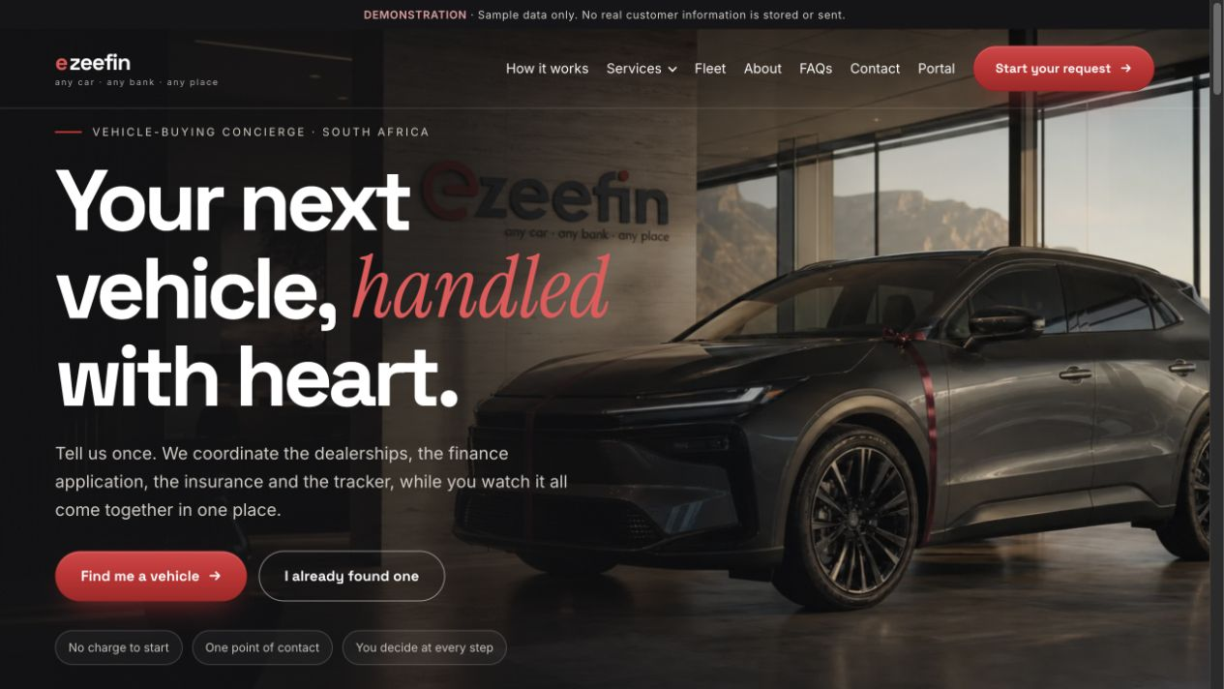
WHAT TO DEMONSTRATE
- Editorial showroom hero and primary request action
- Concierge promise, service narrative and journey preview
- Authentic delivery proof and closing conversion
CUSTOMER VALUE Builds confidence before asking for personal details.

PUBLIC EXPERIENCE / 02

How it works
Route: /how-it-works
Audience: Prospective customers
Explains the complete journey from first request to delivery.
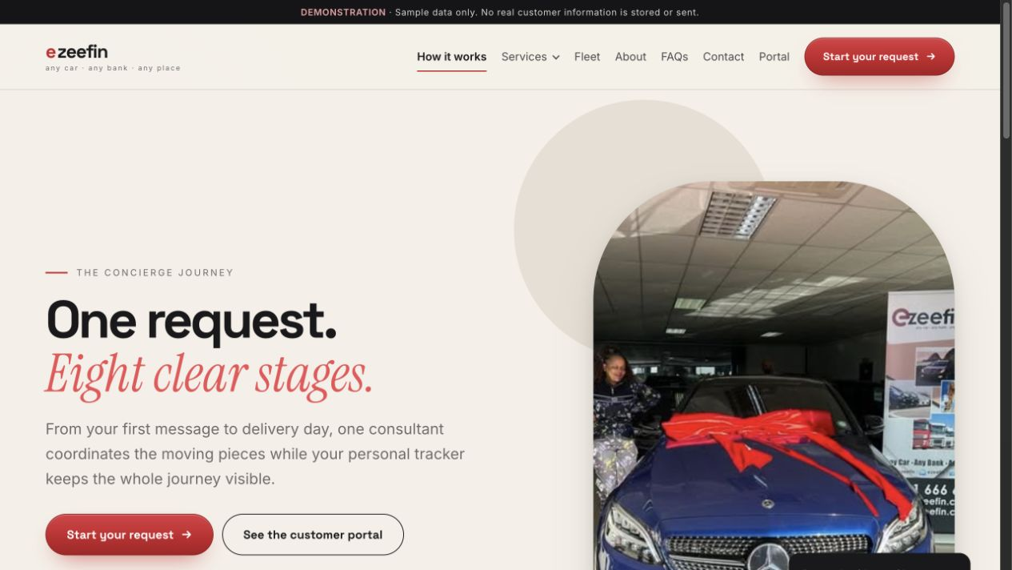
WHAT TO DEMONSTRATE
- Eight customer-visible stages
- What EzeeFin handles and what the customer provides
- Contextual action to start a request
CUSTOMER VALUE Makes a complex process feel transparent and manageable.

PUBLIC EXPERIENCE / 03

Finance assistance
Route: /services/finance-assistance
Audience: Customers considering vehicle finance
Explains EzeeFin’s coordination role with registered credit providers.
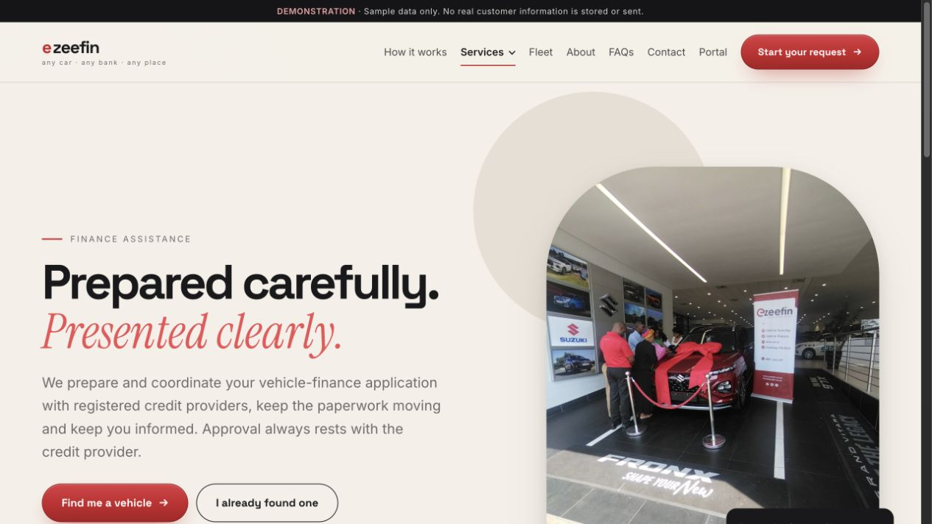
WHAT TO DEMONSTRATE
- Finance-focused editorial hero
- Benefits, preparation steps and required information
- Transparent legal wording and FAQs
CUSTOMER VALUE Sets accurate expectations without implying credit approval.

PUBLIC EXPERIENCE / 04

Insurance and tracker
Route: /services/insurance-and-tracker
Audience: Customers preparing for vehicle delivery
Shows how insurance and tracker quotations are coordinated.
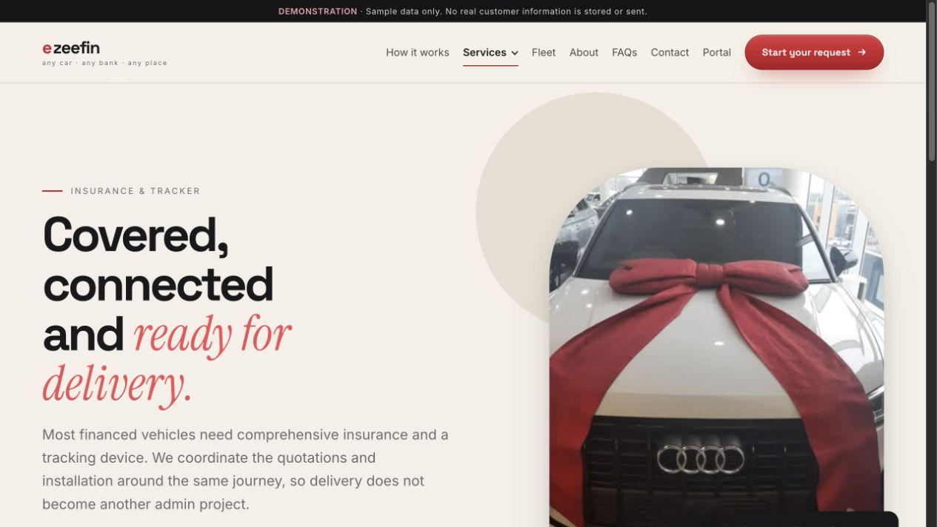
WHAT TO DEMONSTRATE
- Cover and tracker service overview
- Quotation process and customer choices
- Provider-role clarification and guided request action
CUSTOMER VALUE Connects vehicle sourcing to a ready-for-the-road handover.

PUBLIC EXPERIENCE / 05

Find me a vehicle
Route: /find-me-a-vehicle
Audience: Customers who need EzeeFin to source a vehicle
Captures vehicle preferences through a guided, resumable consultation.
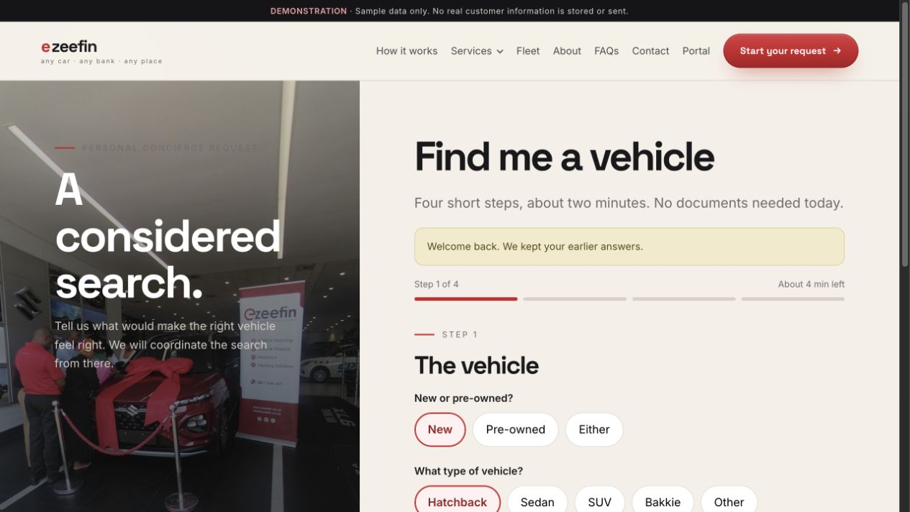
WHAT TO DEMONSTRATE
- Named stages and expected completion time
- Vehicle, budget and contact field groups
- Validation, consent and reference confirmation
CUSTOMER VALUE Turns a broad vehicle need into a structured sourcing brief.

PUBLIC EXPERIENCE / 06

I found a vehicle
Route: /found-a-vehicle
Audience: Customers who already have a vehicle or dealership in mind
Captures the identified vehicle and the assistance still required.
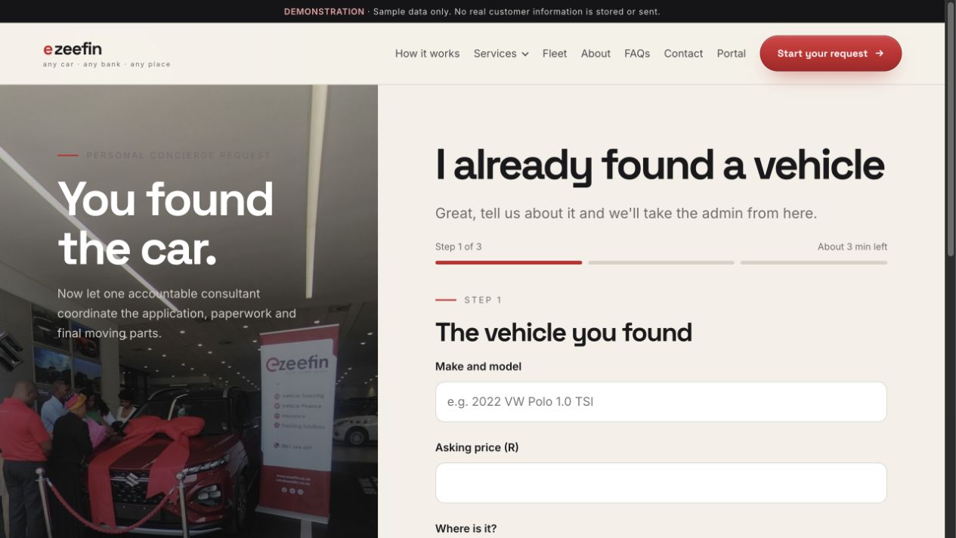
WHAT TO DEMONSTRATE
- Vehicle and dealership details
- Finance, cover and tracker support choices
- Consent, draft restoration and handoff reference
CUSTOMER VALUE Creates a faster route for customers who have already done the search.

PUBLIC EXPERIENCE / 07

Fleet enquiry
Route: /fleet
Audience: Businesses sourcing multiple vehicles
Collects company, fleet and operational requirements.
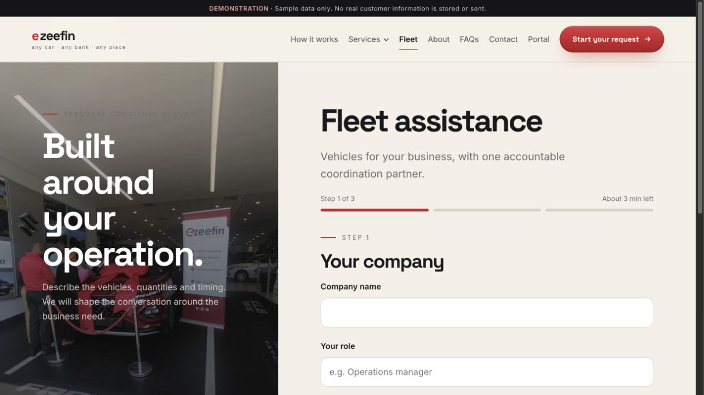
WHAT TO DEMONSTRATE
- Business and contact context
- Vehicle quantity, use and timing
- Consultation handoff and reference confirmation
CUSTOMER VALUE Provides a dedicated path for more complex commercial needs.

PUBLIC EXPERIENCE / 08

About EzeeFin
Route: /about
Audience: Customers validating the brand
Presents the company story, operating principles and authentic proof.
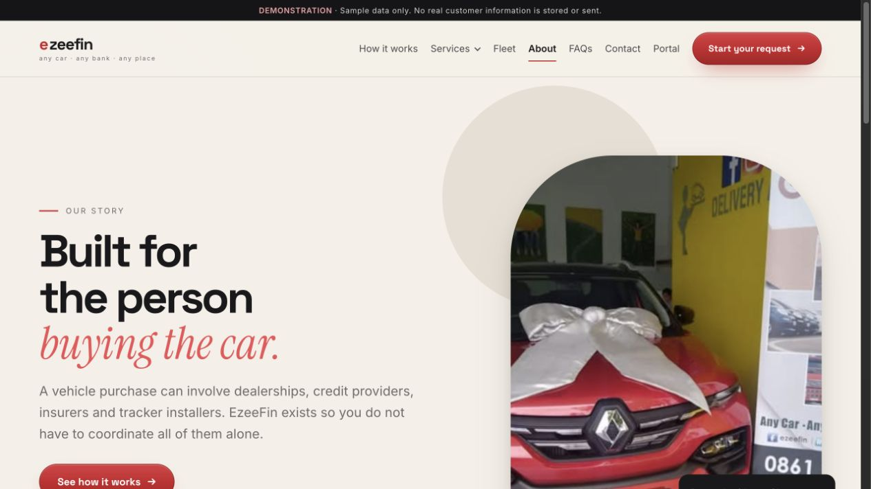
WHAT TO DEMONSTRATE
- Brand and service narrative
- Real delivery photography
- Principles, credibility and contact action
CUSTOMER VALUE Reinforces that the service is human, established and accountable.

PUBLIC EXPERIENCE / 09

Frequently asked questions
Route: /faqs
Audience: Visitors with practical questions
Answers common questions in categorized, accessible accordions.
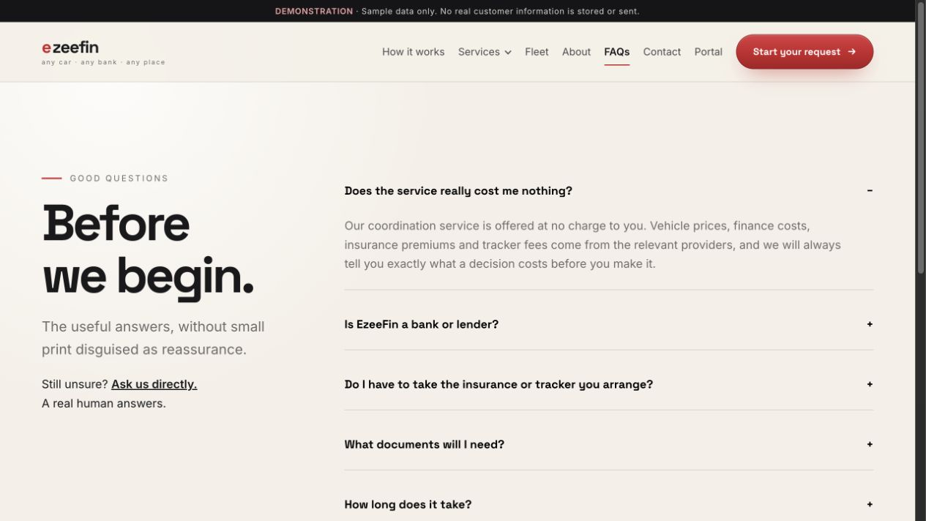
WHAT TO DEMONSTRATE
- Categories for sourcing, finance, delivery and support
- Large accordion touch targets
- Clear next step when an answer needs personal guidance
CUSTOMER VALUE Reduces uncertainty without forcing a customer to contact support.

PUBLIC EXPERIENCE / 10

Contact
Route: /contact
Audience: Prospective and existing customers
Provides direct concierge contact and a clearly separated complaints path.
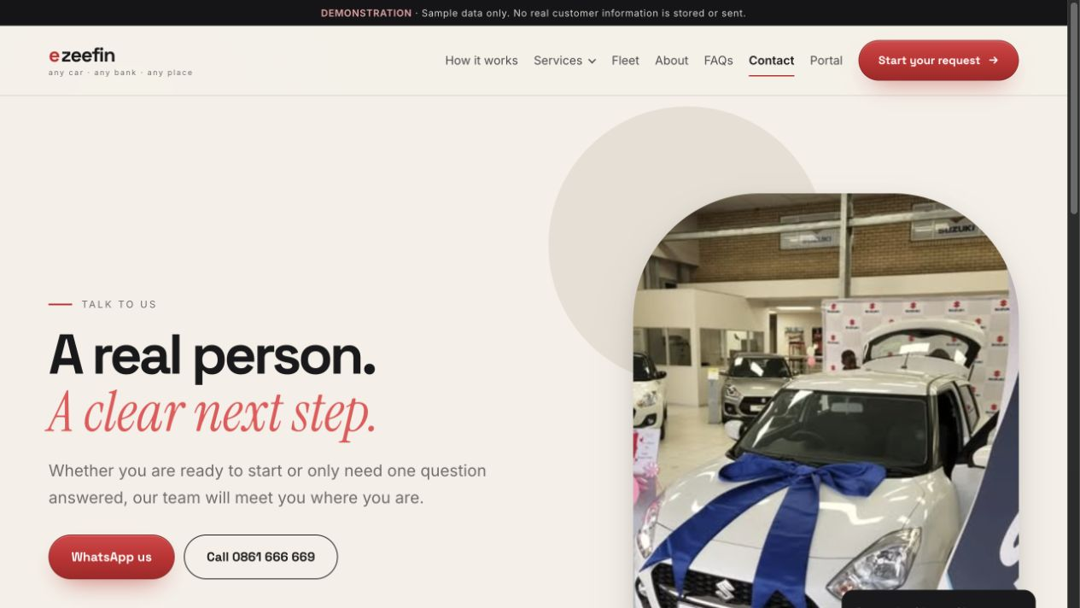
WHAT TO DEMONSTRATE
- Phone, email and WhatsApp options
- Office details and availability expectations
- Complaints and escalation information
CUSTOMER VALUE Makes human help easy to find and sets response expectations.

PUBLIC EXPERIENCE / 11

Privacy notice
Route: /privacy
Audience: All visitors and customers
Explains how personal information is handled in a calm reading layout.
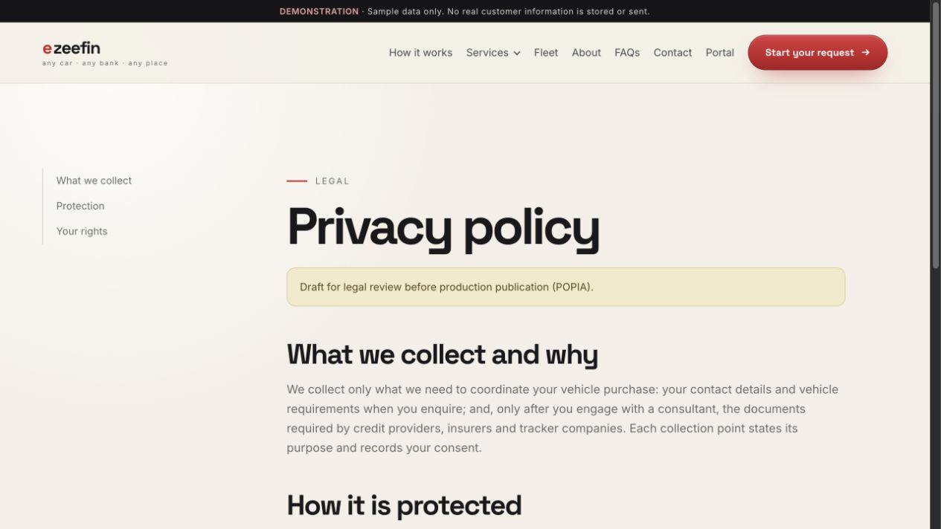
WHAT TO DEMONSTRATE
- Desktop contents rail
- Readable legal sections and retention context
- Visible legal-review notice
CUSTOMER VALUE Supports informed consent and POPIA review.

PUBLIC EXPERIENCE / 12

Terms of use
Route: /terms
Audience: All visitors and customers
Sets service boundaries, responsibilities and legal conditions.
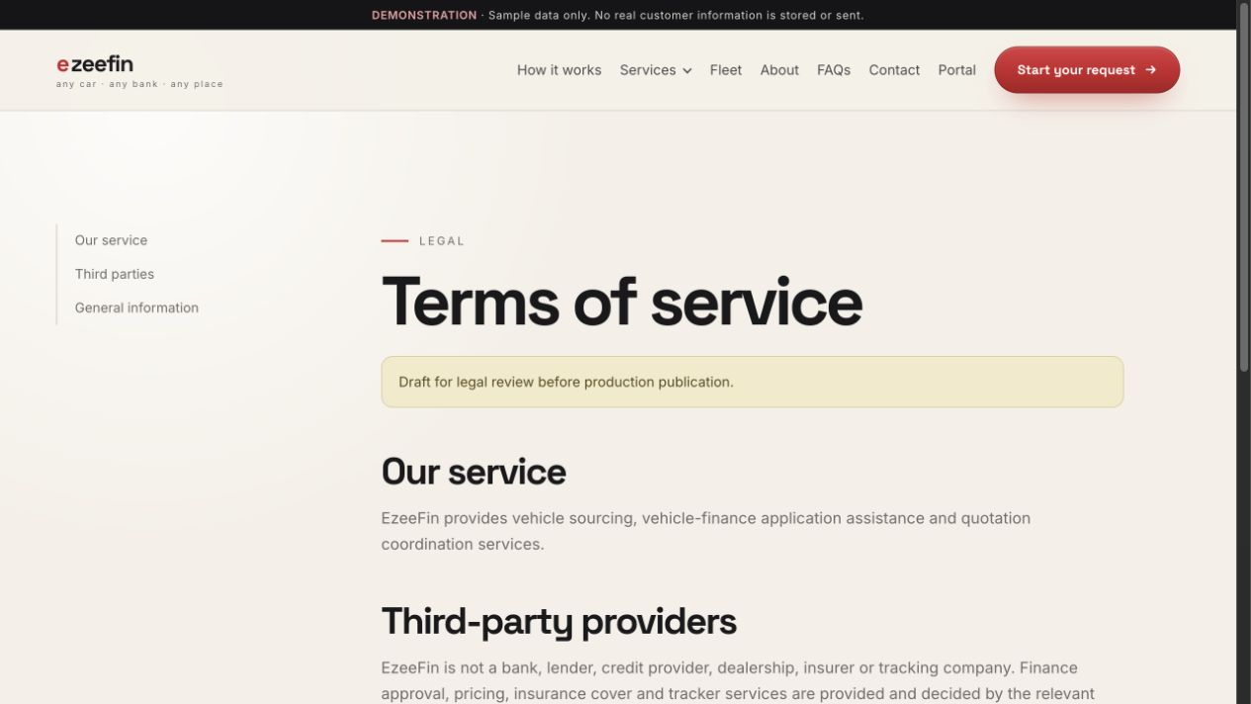
WHAT TO DEMONSTRATE
- Structured contents navigation
- Readable service and responsibility sections
- Preserved legal-review notice
CUSTOMER VALUE Clarifies the operating relationship before a customer proceeds.

CUSTOMER PORTAL / 13

Customer sign-in
Route: /portal
Audience: Returning customers
Provides passwordless access through a verified mobile and one-time PIN.
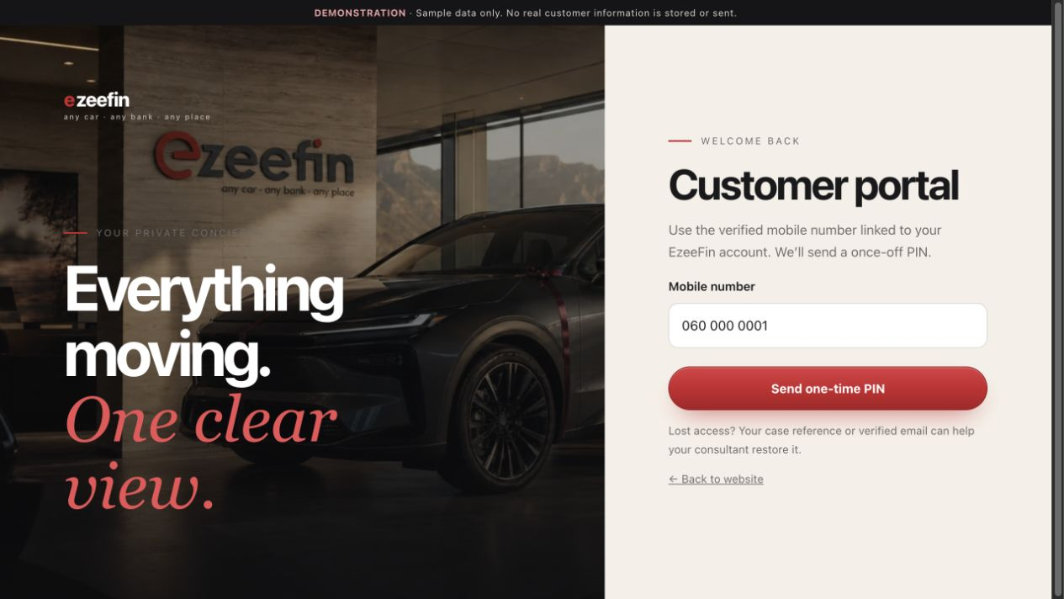
WHAT TO DEMONSTRATE
- Mobile-number entry
- Demo OTP step and privacy reassurance
- Clear path into the private account
CUSTOMER VALUE Keeps sign-in simple while reserving step-up verification for sensitive actions.

CUSTOMER PORTAL / 14

Customer home
Route: /portal/home
Audience: Signed-in customers
Presents the active journey, next action and account readiness in one view.
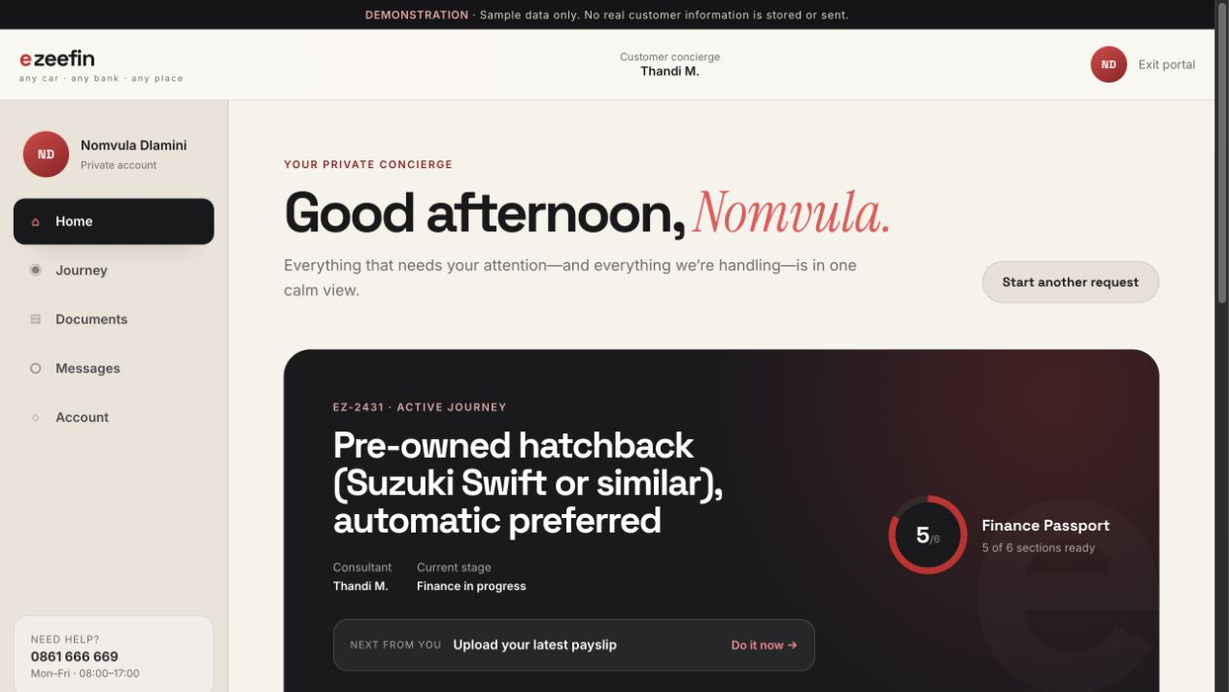
WHAT TO DEMONSTRATE
- Journey reference, consultant and current stage
- Finance Passport readiness and next customer action
- Messages, document alerts, appointments and history
CUSTOMER VALUE Answers the customer’s main question: what needs my attention now?

CUSTOMER PORTAL / 15

Journey
Route: /portal/journey
Audience: Signed-in customers
Combines progress, tasks, vehicle options and provider coordination.
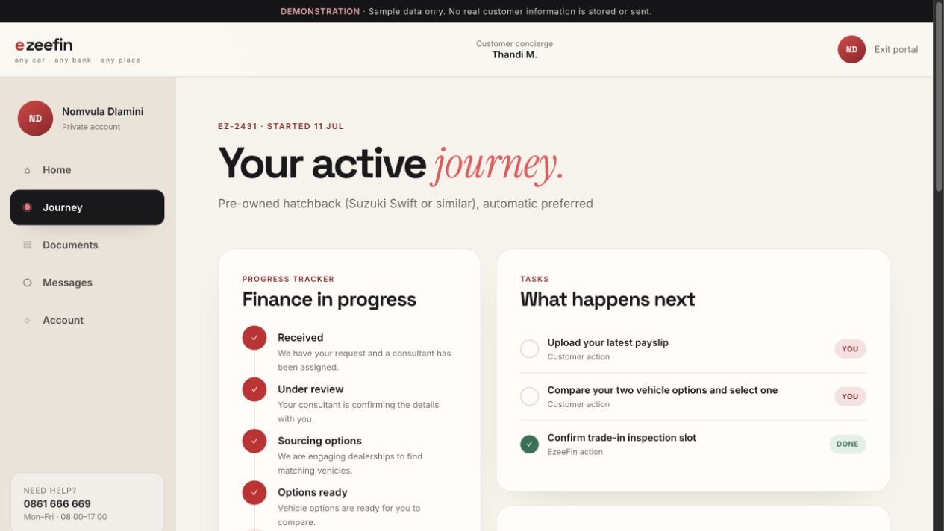
WHAT TO DEMONSTRATE
- Customer-visible stage timeline
- Customer and EzeeFin tasks
- Vehicle choices, finance and cover coordination
CUSTOMER VALUE Keeps the whole purchase journey understandable without exposing sensitive internal outcomes.

CUSTOMER PORTAL / 16

Document vault
Route: /portal/documents
Audience: Signed-in customers
Shows requested and reusable documents with freshness and verification status.
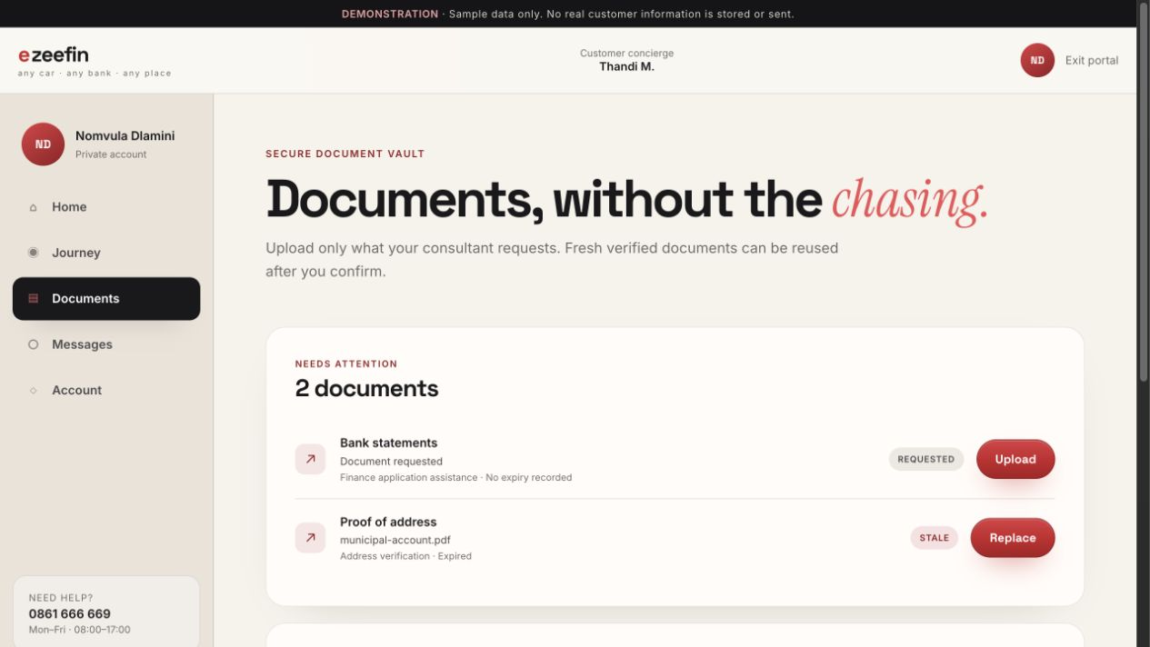
WHAT TO DEMONSTRATE
- ID, licence, address, payslip and statement records
- Upload date, purpose, expiry and journey usage
- Requested, uploaded, verified and stale states
CUSTOMER VALUE Reduces repeated document requests and explains why each document is needed.

CUSTOMER PORTAL / 17

Customer messages
Route: /portal/messages
Audience: Signed-in customers
Provides a bounded conversation with the assigned consultant.
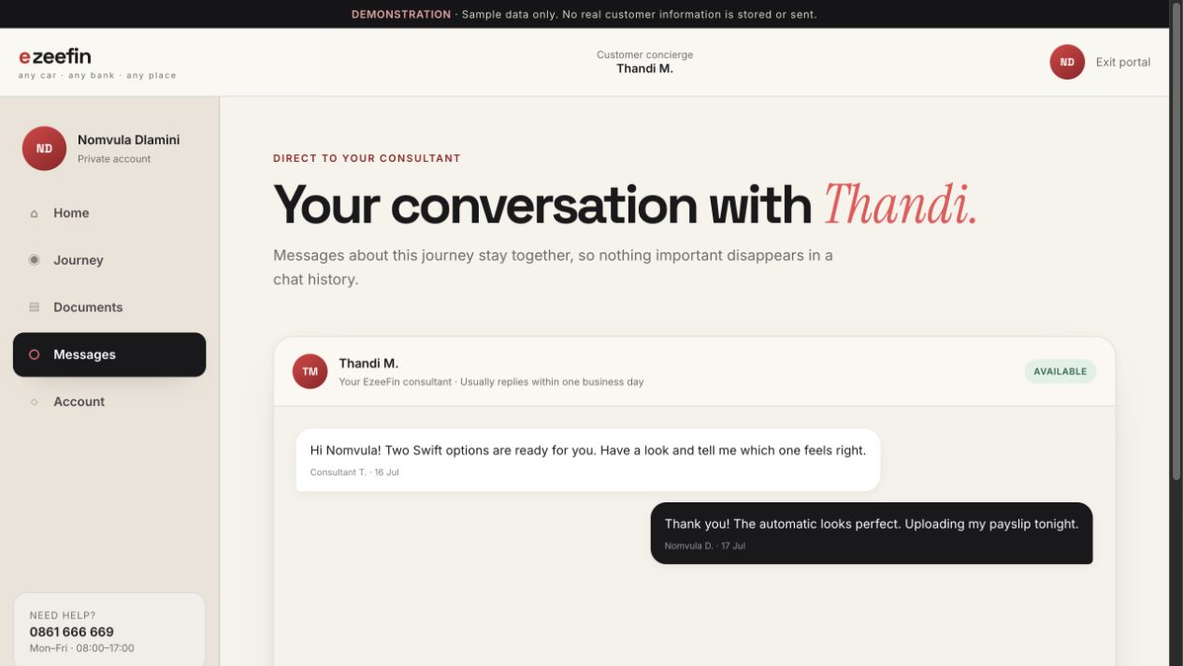
WHAT TO DEMONSTRATE
- Conversation history with staff identity
- Persistent message composer
- Support fallback when the portal is not enough
CUSTOMER VALUE Keeps journey communication attached to the customer’s case.

CUSTOMER PORTAL / 18

Account and Finance Passport
Route: /portal/account
Audience: Signed-in customers
Summarizes reusable profile readiness, preferences, privacy and history.
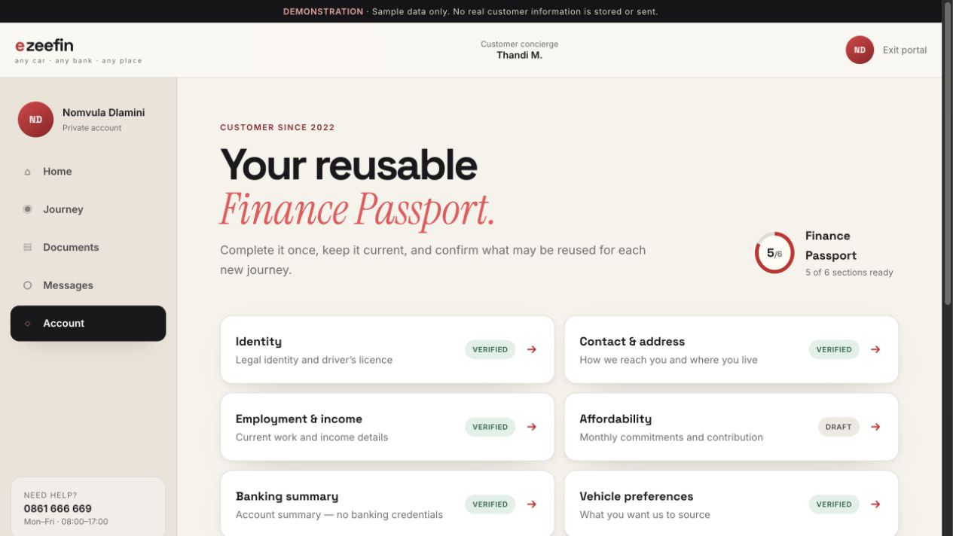
WHAT TO DEMONSTRATE
- Readiness shown as sections, never a credit score
- Seven profile states from Not started to Stale
- Links to preferences, privacy and journey history
CUSTOMER VALUE Turns one enquiry profile into a reusable long-term customer account.

CUSTOMER PORTAL / 19

Finance Passport section
Route: /portal/account/passport/identity
Audience: Signed-in customers
Lets customers review or correct one profile section at a time.
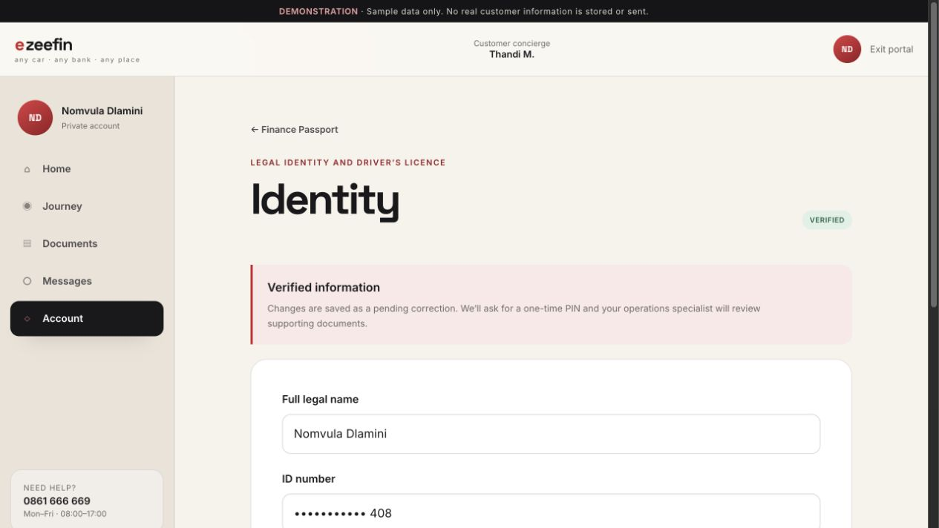
WHAT TO DEMONSTRATE
- Short labeled fields and masked sensitive values
- Save, confirmation and review states
- Pending corrections preserve the prior verified value
CUSTOMER VALUE Makes profile maintenance understandable and auditable.

CUSTOMER PORTAL / 20

Notification preferences
Route: /portal/account/notifications
Audience: Signed-in customers
Controls WhatsApp, SMS and email by alert type.
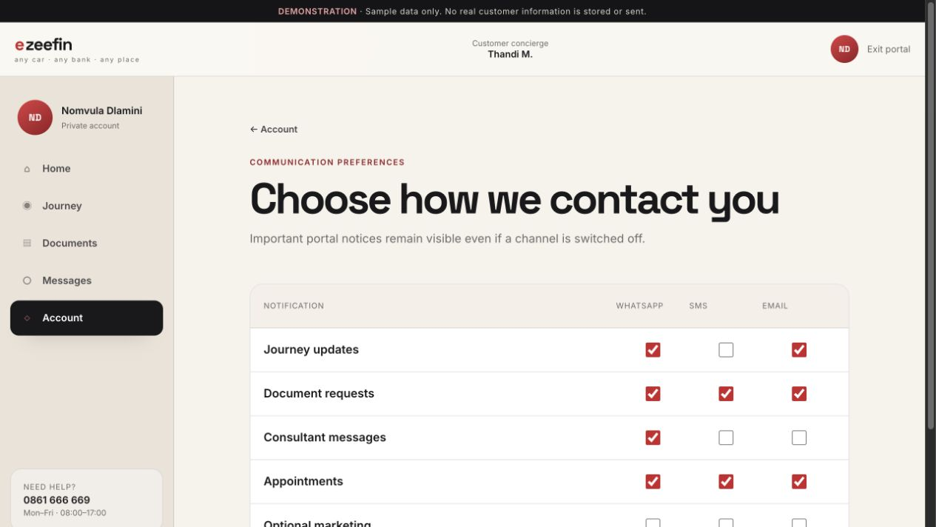
WHAT TO DEMONSTRATE
- Journey, document, message and appointment alerts
- Separate optional marketing controls
- Mobile-friendly 44px channel controls
CUSTOMER VALUE Respects customer channel choice without hiding essential portal notices.

CUSTOMER PORTAL / 21

Privacy centre
Route: /portal/account/privacy
Audience: Signed-in customers
Makes consent and personal-data rights visible inside the account.
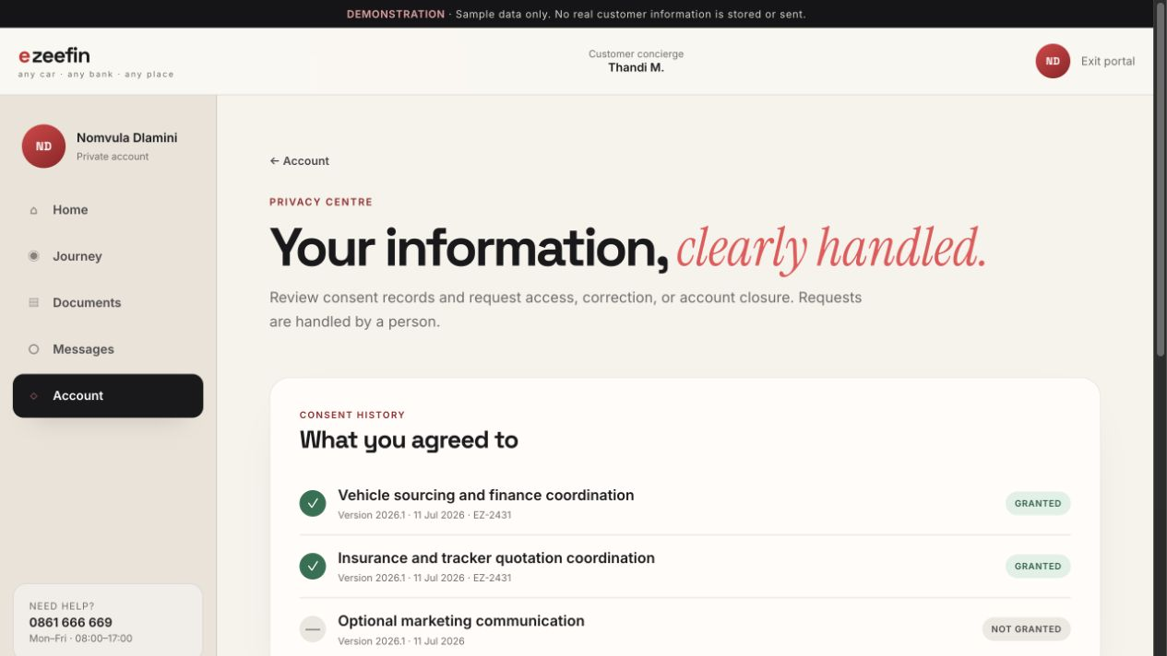
WHAT TO DEMONSTRATE
- Journey-specific consent history
- Data access, correction and closure requests
- Plain-language retention explanation
CUSTOMER VALUE Gives customers practical control over their information.

CUSTOMER PORTAL / 22

Journey history
Route: /portal/account/history
Audience: Signed-in customers
Shows active and completed vehicle journeys linked to the account.
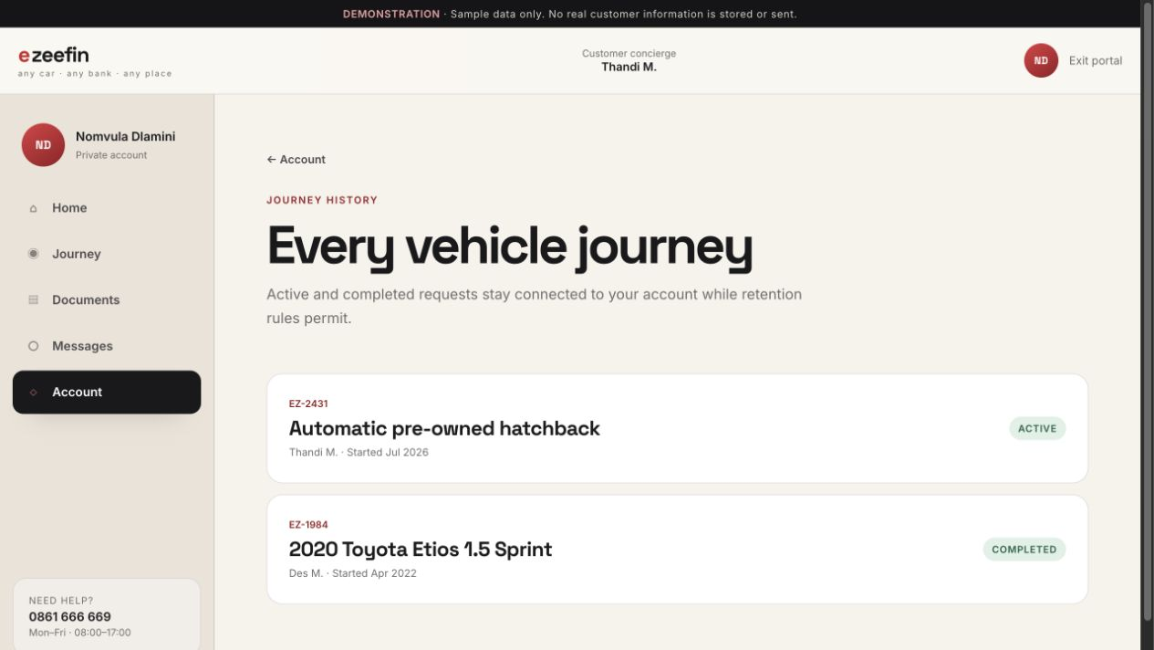
WHAT TO DEMONSTRATE
- Reference, consultant and important dates
- Final delivered vehicle for completed journeys
- Archived journey context where retention permits
CUSTOMER VALUE Creates continuity for returning customers.

CUSTOMER PORTAL / 23

Start another journey
Route: /portal/new-journey
Audience: Returning customers
Starts a new request using confirmed profile data after reconfirmation.
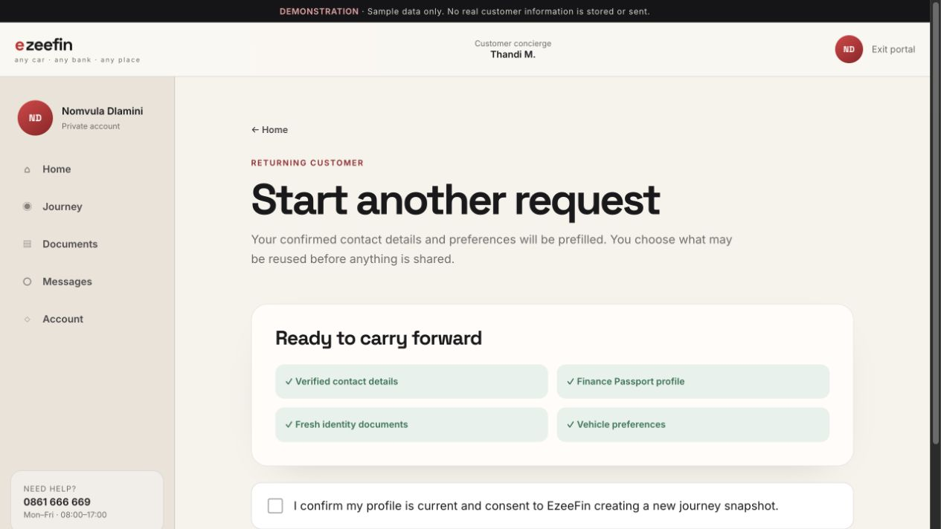
WHAT TO DEMONSTRATE
- Prefilled contact and vehicle preferences
- Explicit choice of reusable profile and documents
- Fresh journey consent before sharing
CUSTOMER VALUE Makes repeat business quicker without silently reusing personal information.

STAFF OPERATIONS / 24

Staff sign-in
Route: /admin
Audience: Authorized EzeeFin staff
Introduces secure staff access and the manager demonstration workspace.
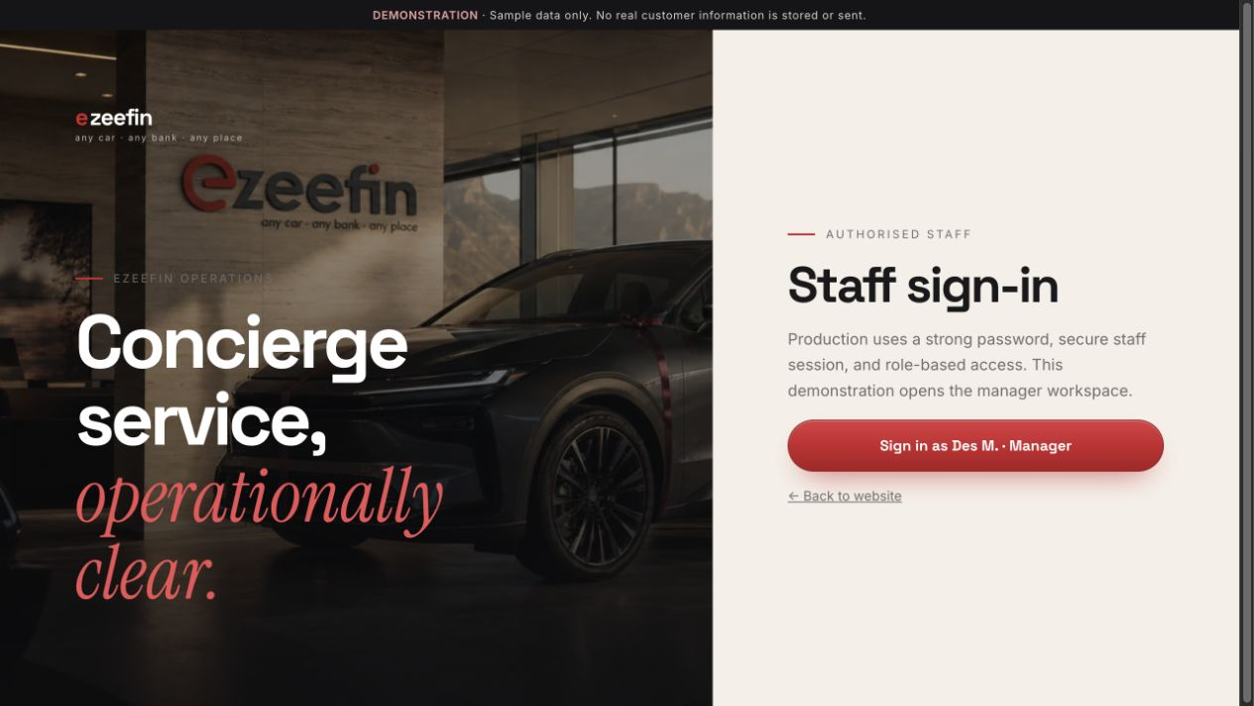
WHAT TO DEMONSTRATE
- Staff identity and password entry
- Role-based access explanation
- Direct handoff into operations
CUSTOMER VALUE Separates customer access from operational permissions.

STAFF OPERATIONS / 25

Operations work queue
Route: /admin/work
Audience: Consultants, operations and managers
Prioritizes daily work by customer impact and due time.
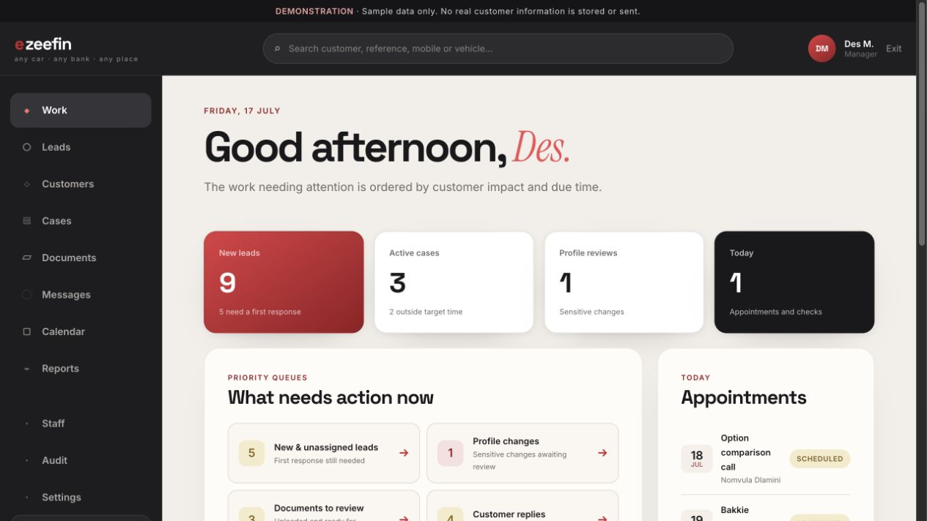
WHAT TO DEMONSTRATE
- New leads, reviews, documents and customer replies
- Stalled cases, provider follow-ups and failed notifications
- Appointments and recent operational activity
CUSTOMER VALUE Staff begin with actionable queues instead of browsing disconnected tables.

STAFF OPERATIONS / 26

Lead management
Route: /admin/leads
Audience: Consultants and managers
Qualifies, assigns and progresses incoming enquiries.
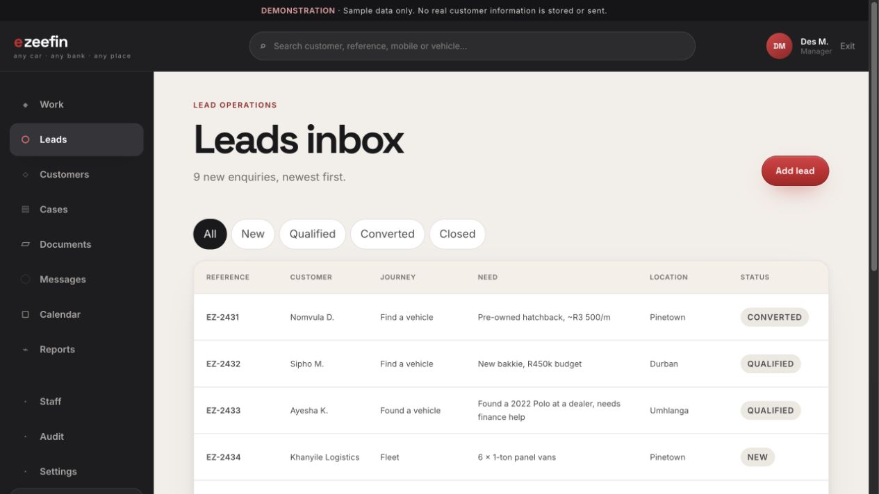
WHAT TO DEMONSTRATE
- Journey type, customer need and current status
- Filters and saved-view pattern
- Conversion, follow-up and closure context
CUSTOMER VALUE Protects the original enquiry and consent while creating an accountable response process.

STAFF OPERATIONS / 27

Customer directory
Route: /admin/customers
Audience: Authorized staff
Provides searchable access to long-term customer accounts.
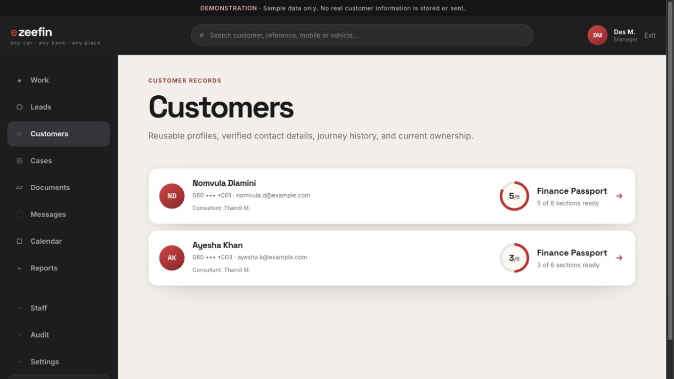
WHAT TO DEMONSTRATE
- Verified contact summary
- Finance Passport readiness
- Assigned consultant and active journey context
CUSTOMER VALUE Shifts the operating model from isolated cases to ongoing customer relationships.

STAFF OPERATIONS / 28

Customer 360°
Route: /admin/customer/customer-1
Audience: Authorized staff
Combines profile, journeys, document freshness, consent and interaction history.
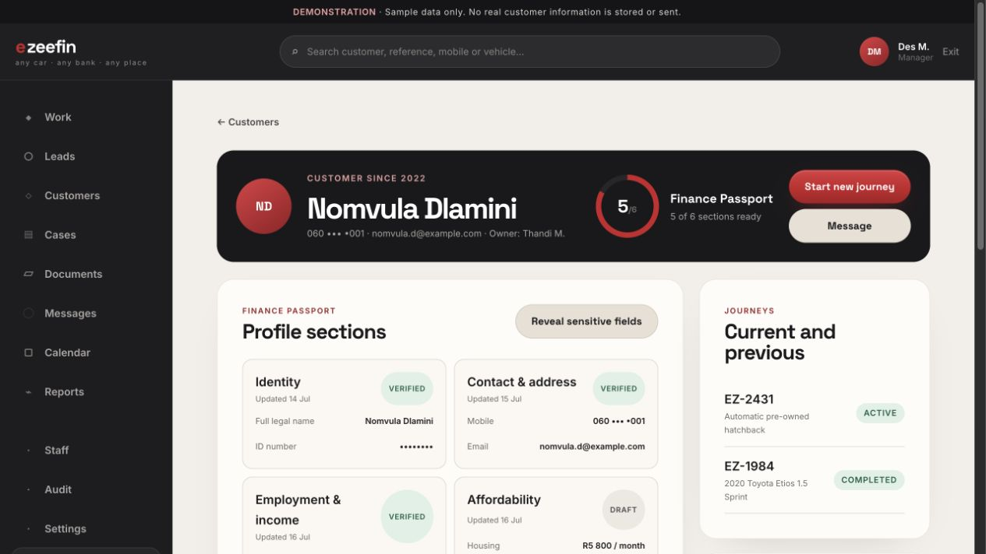
WHAT TO DEMONSTRATE
- Masked sensitive information with reasoned reveal
- Active and completed journeys
- Pending profile changes and audit-backed activity
CUSTOMER VALUE Gives staff context without exposing more personal data than necessary.

STAFF OPERATIONS / 29

Profile-change reviews
Route: /admin/profile-reviews
Audience: Operations and managers
Reviews corrections to previously verified sensitive fields.
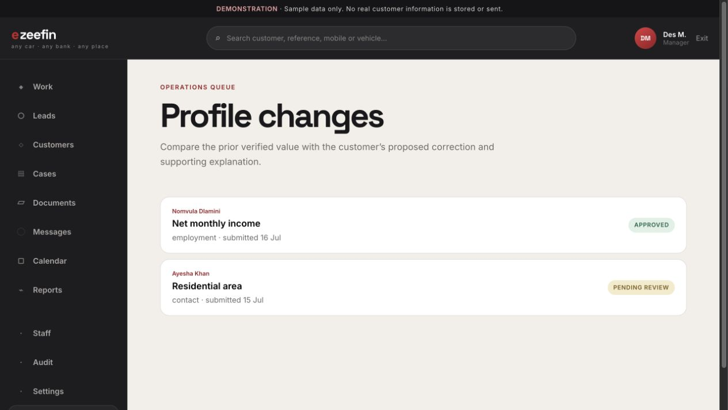
WHAT TO DEMONSTRATE
- Previous verified value and proposed correction
- Customer explanation and supporting context
- Approve, reject or request clarification
CUSTOMER VALUE Prevents unreviewed changes from replacing trusted identity, income or banking data.

STAFF OPERATIONS / 30

Case list
Route: /admin/cases
Audience: Consultants, operations and managers
Provides a fast scan of active journeys and ownership.
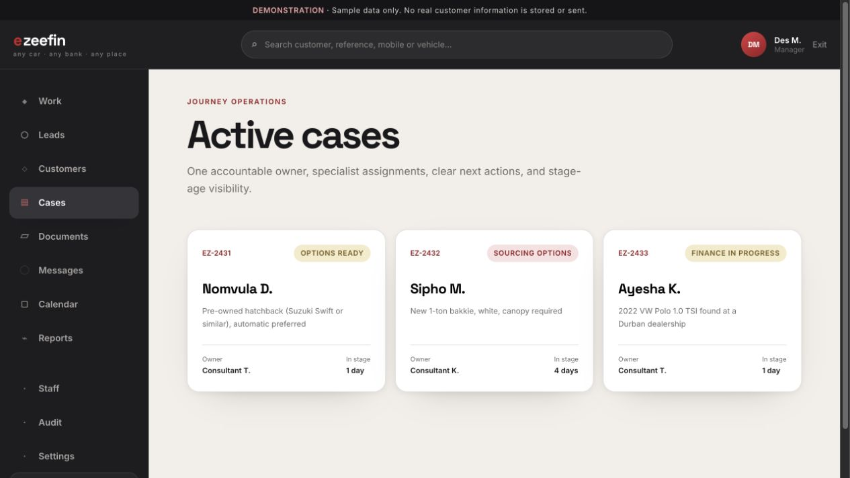
WHAT TO DEMONSTRATE
- Reference, customer, stage and priority
- Age in stage and next action
- Responsive labeled cards on mobile
CUSTOMER VALUE Supports rapid case triage while retaining a dense desktop view.

CASE WORKSPACE / 31

Case overview
Route: /admin/case/c1/overview
Audience: Assigned case team
Shows the immediate operational state and accountability.
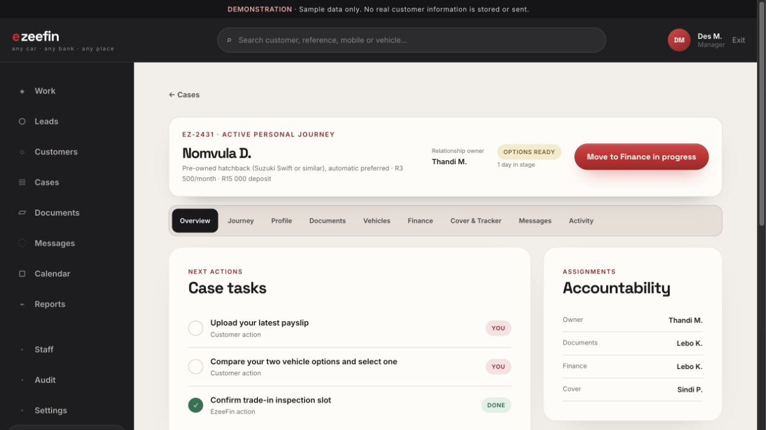
WHAT TO DEMONSTRATE
- Persistent case header and validated transition action
- Tasks, documents and specialist assignments
- Customer-visible next step and internal note area
CUSTOMER VALUE Keeps relationship ownership and operational ownership clear.

CASE WORKSPACE / 32

Internal journey view
Route: /admin/case/c1/journey
Audience: Assigned case team
Relates internal progress to the curated customer-visible tracker.
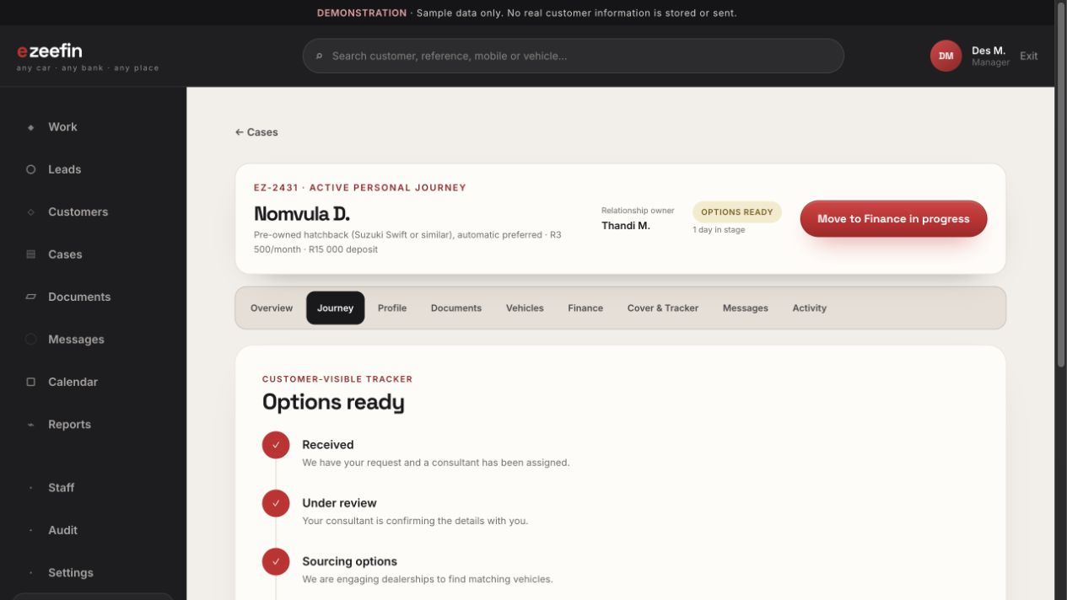
WHAT TO DEMONSTRATE
- Current operational stage
- Customer-safe journey stages
- Validated transition with notification preview
CUSTOMER VALUE Prevents raw operational outcomes from leaking into the customer experience.

CASE WORKSPACE / 33

Profile snapshot
Route: /admin/case/c1/profile
Audience: Authorized case staff
Shows the immutable Finance Passport snapshot used when the journey was submitted.
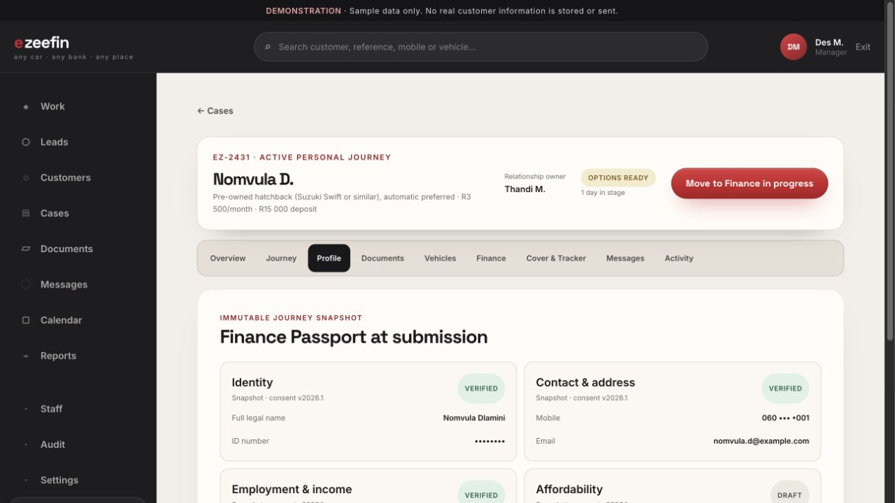
WHAT TO DEMONSTRATE
- Snapshot date and consent version
- Masked sensitive fields
- Profile state independent of later account edits
CUSTOMER VALUE Preserves exactly what was relied on for each journey.

CASE WORKSPACE / 34

Case documents
Route: /admin/case/c1/documents
Audience: Document and finance operations
Requests, reviews and verifies journey-specific documents.
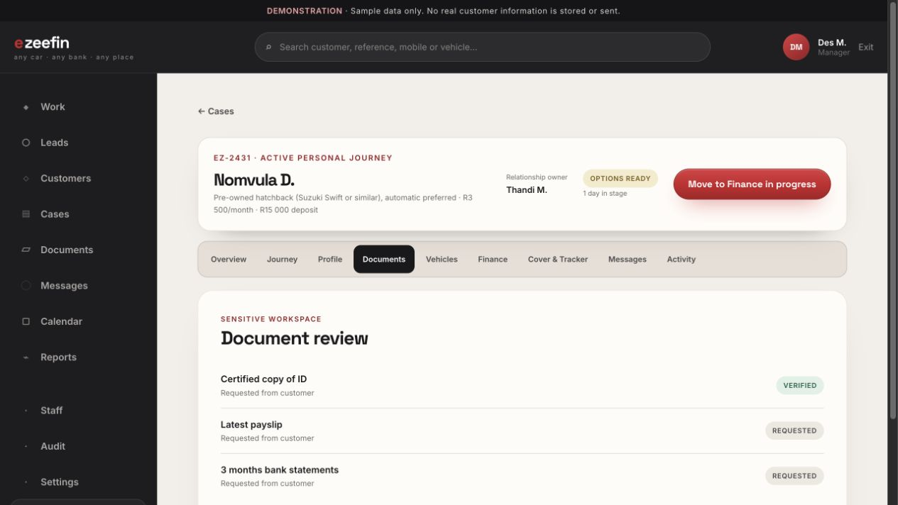
WHAT TO DEMONSTRATE
- Approved document types and freshness rules
- Review, rejection and clarification actions
- Internal review notes separated from customer reasons
CUSTOMER VALUE Creates a consistent, auditable document-review process.

CASE WORKSPACE / 35

Vehicle options
Route: /admin/case/c1/vehicles
Audience: Consultants and sourcing staff
Creates, compares and publishes suitable vehicle options.
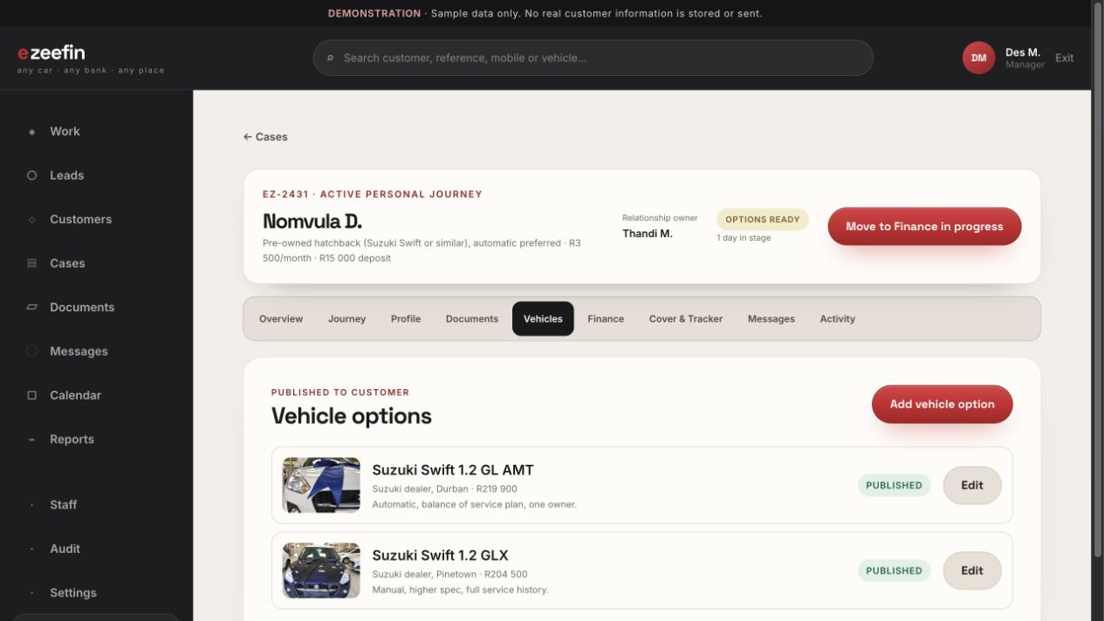
WHAT TO DEMONSTRATE
- Vehicle, dealership, mileage, price and estimate
- Published versus internal information
- Customer selection state
CUSTOMER VALUE Ensures only reviewed options and customer-safe notes are visible externally.

CASE WORKSPACE / 36

Finance coordination
Route: /admin/case/c1/finance
Audience: Finance operations and assigned consultants
Tracks separate submissions to registered credit providers.
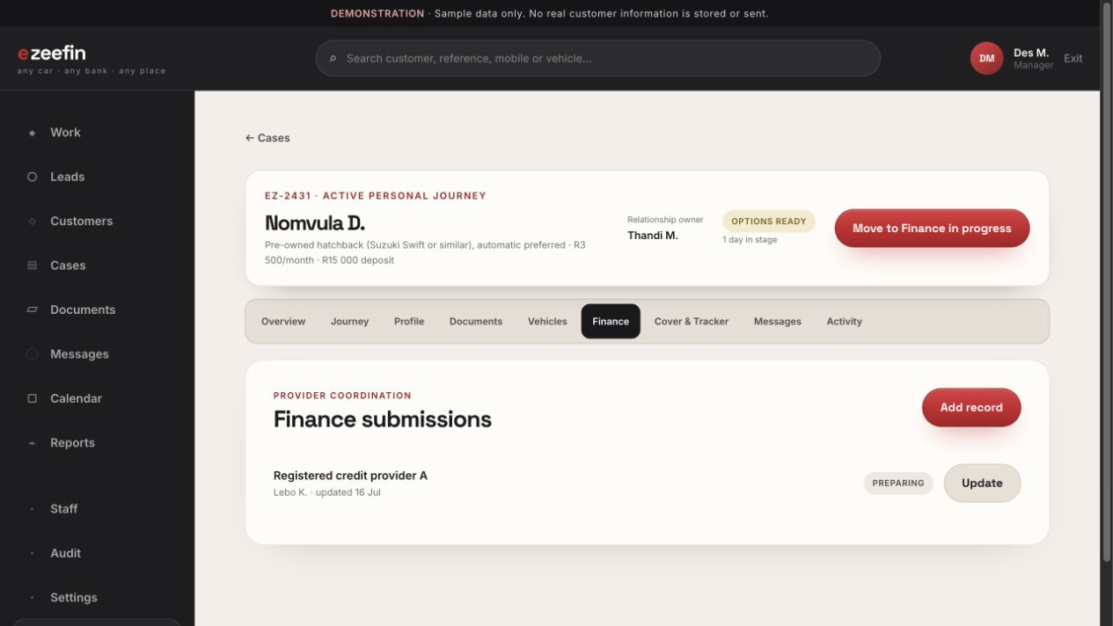
WHAT TO DEMONSTRATE
- Provider, owner, status and follow-up date
- Internal information-required state
- Safe customer-visible wording
CUSTOMER VALUE Keeps EzeeFin positioned as coordinator rather than credit approver.

CASE WORKSPACE / 37

Cover and tracker coordination
Route: /admin/case/c1/cover
Audience: Insurance and tracker operations
Tracks quotation requests, terms, expiry and selection.
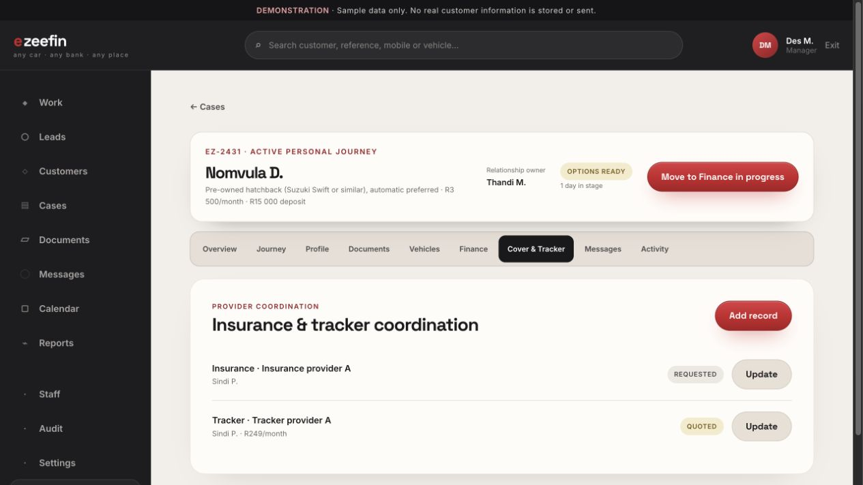
WHAT TO DEMONSTRATE
- Separate insurance and tracker records
- Provider ownership and quotation status
- Monthly amount and expiry where applicable
CUSTOMER VALUE Keeps delivery-readiness work visible without implying underwriting.

CASE WORKSPACE / 38

Case messages
Route: /admin/case/c1/messages
Audience: Assigned case team
Manages the customer conversation inside the case context.
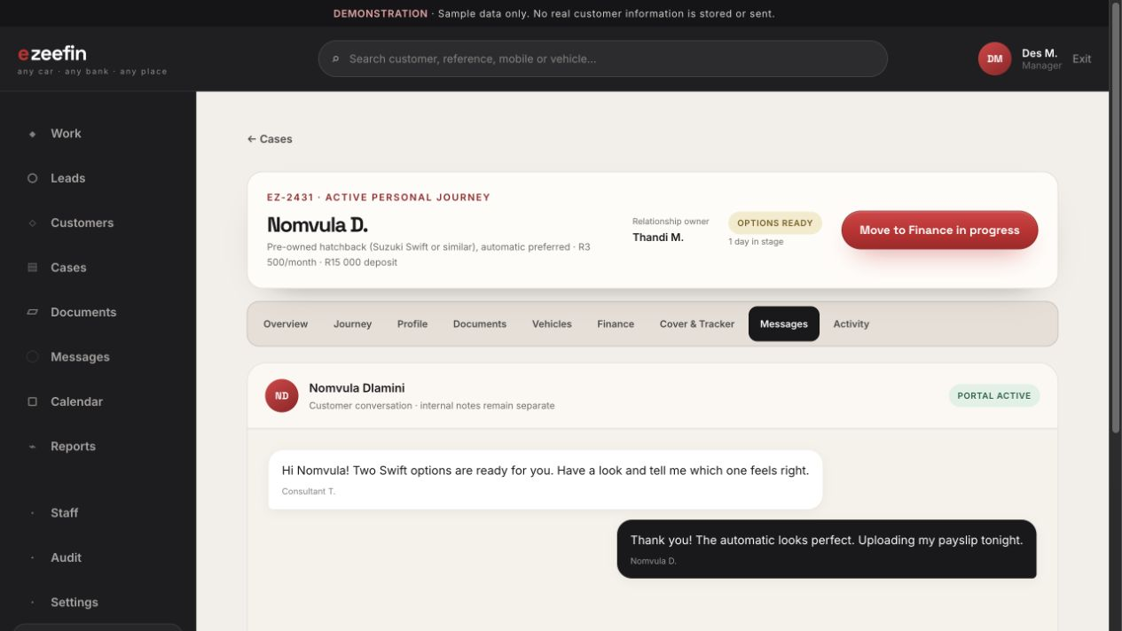
WHAT TO DEMONSTRATE
- Staff identity, unread and delivery state
- Persistent composer and templates
- Clear separation from internal notes
CUSTOMER VALUE Prevents operational notes from appearing in customer communication.

CASE WORKSPACE / 39

Case activity
Route: /admin/case/c1/activity
Audience: Managers and authorized staff
Shows a chronological, append-only record of important actions.
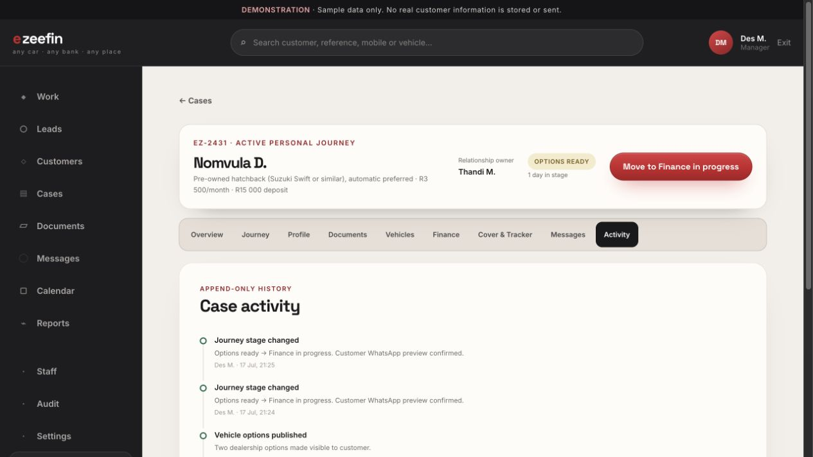
WHAT TO DEMONSTRATE
- Actor, action, subject and timestamp
- Sensitive reveals and verification decisions
- Journey transitions and notification events
CUSTOMER VALUE Supports accountability, investigation and compliance review.

STAFF OPERATIONS / 40

Document review queue
Route: /admin/documents
Audience: Document and finance operations
Collects uploads awaiting review across customers and cases.
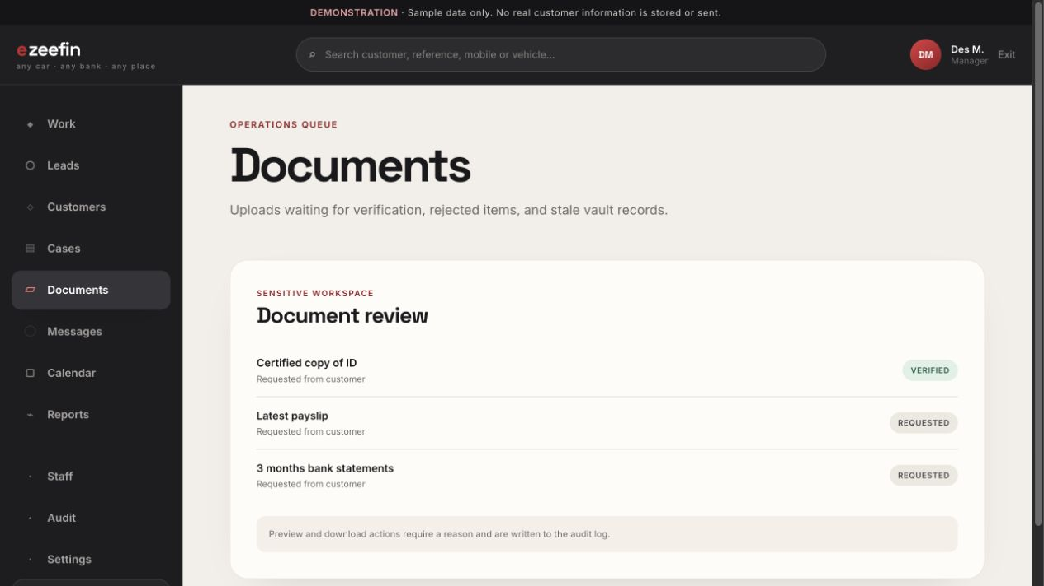
WHAT TO DEMONSTRATE
- Customer, reference, document type and waiting time
- Priority and assignment context
- Direct route into the relevant case
CUSTOMER VALUE Turns document review into a managed service queue.

STAFF OPERATIONS / 41

Unified staff inbox
Route: /admin/messages
Audience: Consultants and assigned operations staff
Prioritizes customer replies by response time and journey impact.
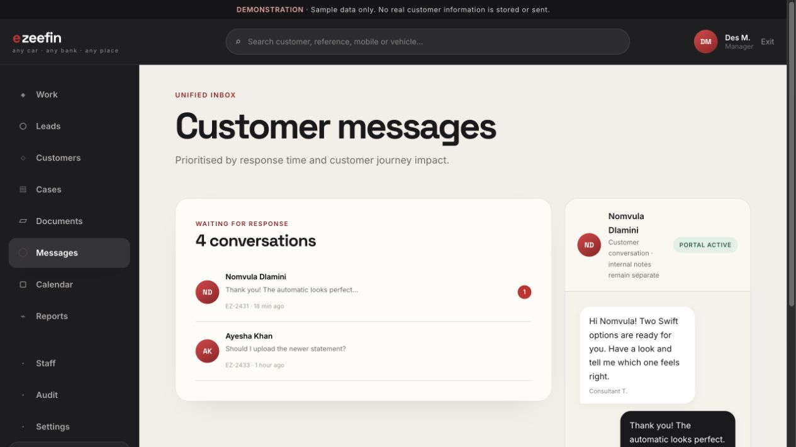
WHAT TO DEMONSTRATE
- Conversation queue and unread state
- Case reference and recent preview
- Bounded thread with persistent reply composer
CUSTOMER VALUE Helps staff respond promptly without losing case context.

STAFF OPERATIONS / 42

Operations calendar
Route: /admin/calendar
Audience: Consultants, specialists and managers
Coordinates calls, checks, visits, inspections and deliveries.
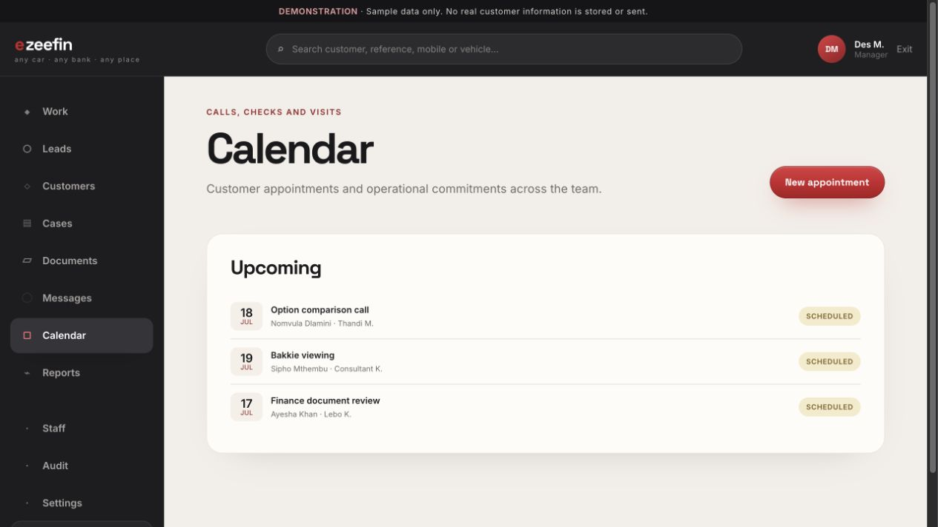
WHAT TO DEMONSTRATE
- Appointment type, owner, customer and case
- Upcoming schedule and status
- Direct relationship to work queues
CUSTOMER VALUE Keeps time-based commitments visible alongside case work.

STAFF OPERATIONS / 43

Operational reports
Route: /admin/reports
Audience: Managers
Summarizes service performance, journey flow and portal adoption.
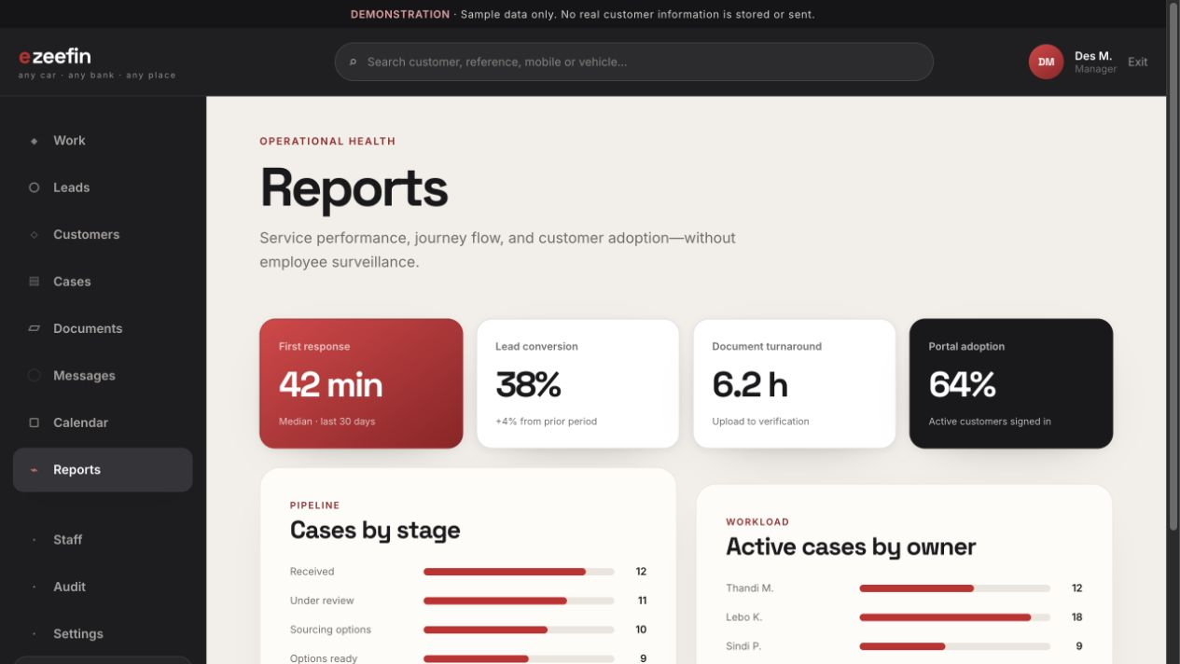
WHAT TO DEMONSTRATE
- Lead response and conversion
- Stage ageing and review turnaround
- Workload, selection and notification delivery
CUSTOMER VALUE Supports service improvement without employee-surveillance framing.

STAFF OPERATIONS / 44

Staff and roles
Route: /admin/staff
Audience: Managers and system administrators
Shows fixed roles, account status and active workload.
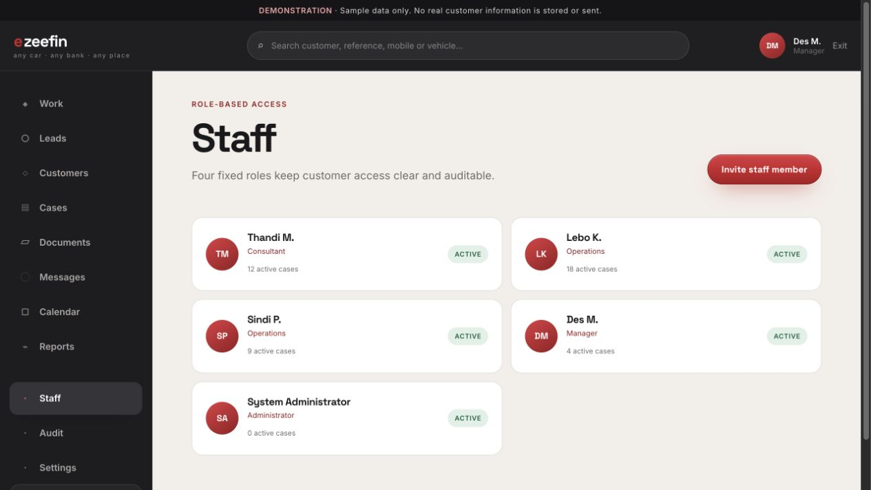
WHAT TO DEMONSTRATE
- Consultant, operations, manager and administrator roles
- Active, invited and suspended access states
- Role-gated administration
CUSTOMER VALUE Provides a clear first-version permission model.

STAFF OPERATIONS / 45

Audit history
Route: /admin/audit
Audience: Managers and system administrators
Provides a searchable record of sensitive reveals and mutations.
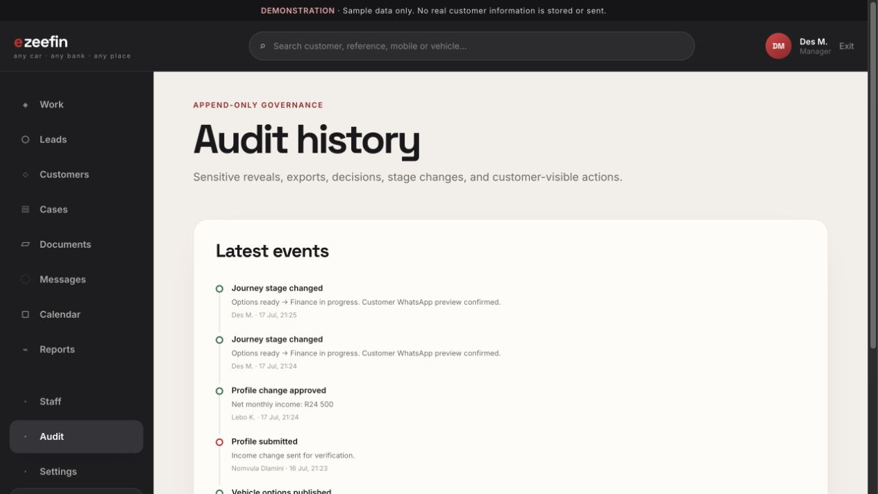
WHAT TO DEMONSTRATE
- Actor, time, reason and affected object
- Before-and-after context where applicable
- Profile, document, export and journey events
CUSTOMER VALUE Makes privileged access and operational changes accountable.

STAFF OPERATIONS / 46

System settings
Route: /admin/settings
Audience: System administrators
Centralizes notification templates, consent versions, journey rules and integrations.
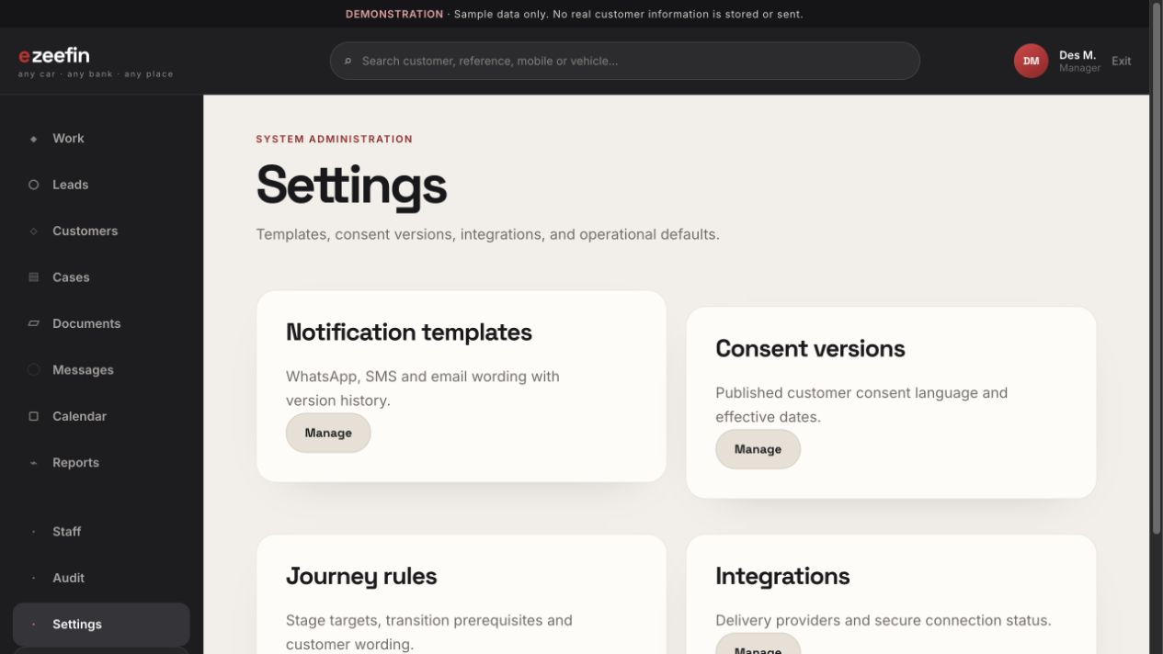
WHAT TO DEMONSTRATE
- Versioned customer wording
- Operational defaults and transition rules
- Integration status and administrative ownership
CUSTOMER VALUE Keeps high-impact configuration separate from day-to-day case work.

