
USER MANUAL

Phatsema Back-Office Portal
Practical guidance for inventory, transfers, counts, assets, reports, and administration
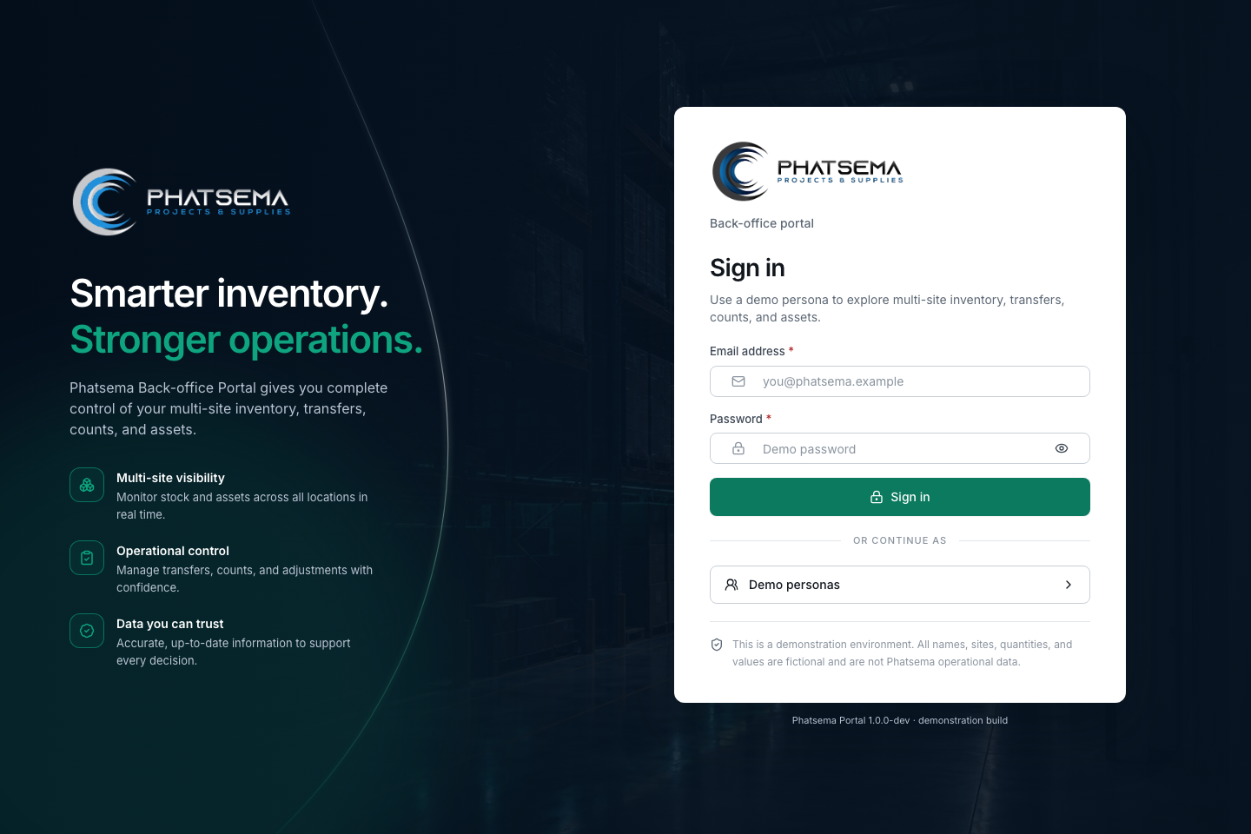
Prepared by Valo Systems
Version 1.0 demonstration guide | July 2026

START HERE

About this guide
This manual explains the demonstration portal from the user’s point of view. It focuses on completing work safely, understanding workflow states, and knowing what evidence the system records.
Demonstration notice. All names, sites, quantities, values, and transactions are fictional. Data is stored in the browser session and can be reset. It is not Phatsema operational data.

Who should use it
- System administrators who configure users and access.
- Operations and site managers who review work, approve workflows, and monitor exceptions.
- Storekeepers who receive, issue, transfer, and count stock.
- Executives and reviewers who use dashboards, reports, and audit evidence.

Core operating principle
Posted inventory is explained by ledger movements. Balances are outcomes, not manually edited totals. Transfers, counts, and assets have their own controlled workflows.

Quick map
Area | Purpose
Dashboard | Network health, stock value, site comparison, pending work, recent activity
Inventory | Items, balances, movement history, receive, issue, adjust, counts
Operations | Transfers, assets, sites
Insight | Reports and audit log
Administration | Users, roles, site access, work profiles
My profile | Personal details, access visibility, password change, last sign-in

ACCESS

Sign in and choose a demo persona
- Open the portal. Go to phatsema.valosystems.co.za.
- Enter credentials. Use your assigned email and password.
- Use a demo persona when exploring. Expand Demo personas, select a role, then sign in.
- Confirm your scope. Check the site selector and user menu before posting work.

Demo personas
System Administrator  Full configuration, users, reset, audit | Operations Manager  All sites, approvals, dashboards, reports
Site Manager  Assigned site, approvals, counts, transfers | Storekeeper  Receiving, issues, transfers, counting
Executive Viewer
Read-only dashboards, reports, activity
Shared demo password. PhatsemaDemo1. Selecting a persona fills the form automatically in the demonstration.

The premium login page keeps demo access optional and collapsed.

ORIENTATION

Navigate the portal and set site scope

Use the left navigation
The sidebar groups work into Overview, Inventory, Operations, Insight, and Administration. Only actions permitted for the signed-in user are available.

Use the site selector deliberately
- All sites shows the network view when your role permits it.
- A selected site limits applicable pages and actions to that location.
- Always verify the selected site before receiving, issuing, adjusting, counting, or transferring stock.
- The global search helps locate items, references, and pages quickly.
Control point. Site context is part of the transaction evidence. Do not rely on memory or browser history before posting.
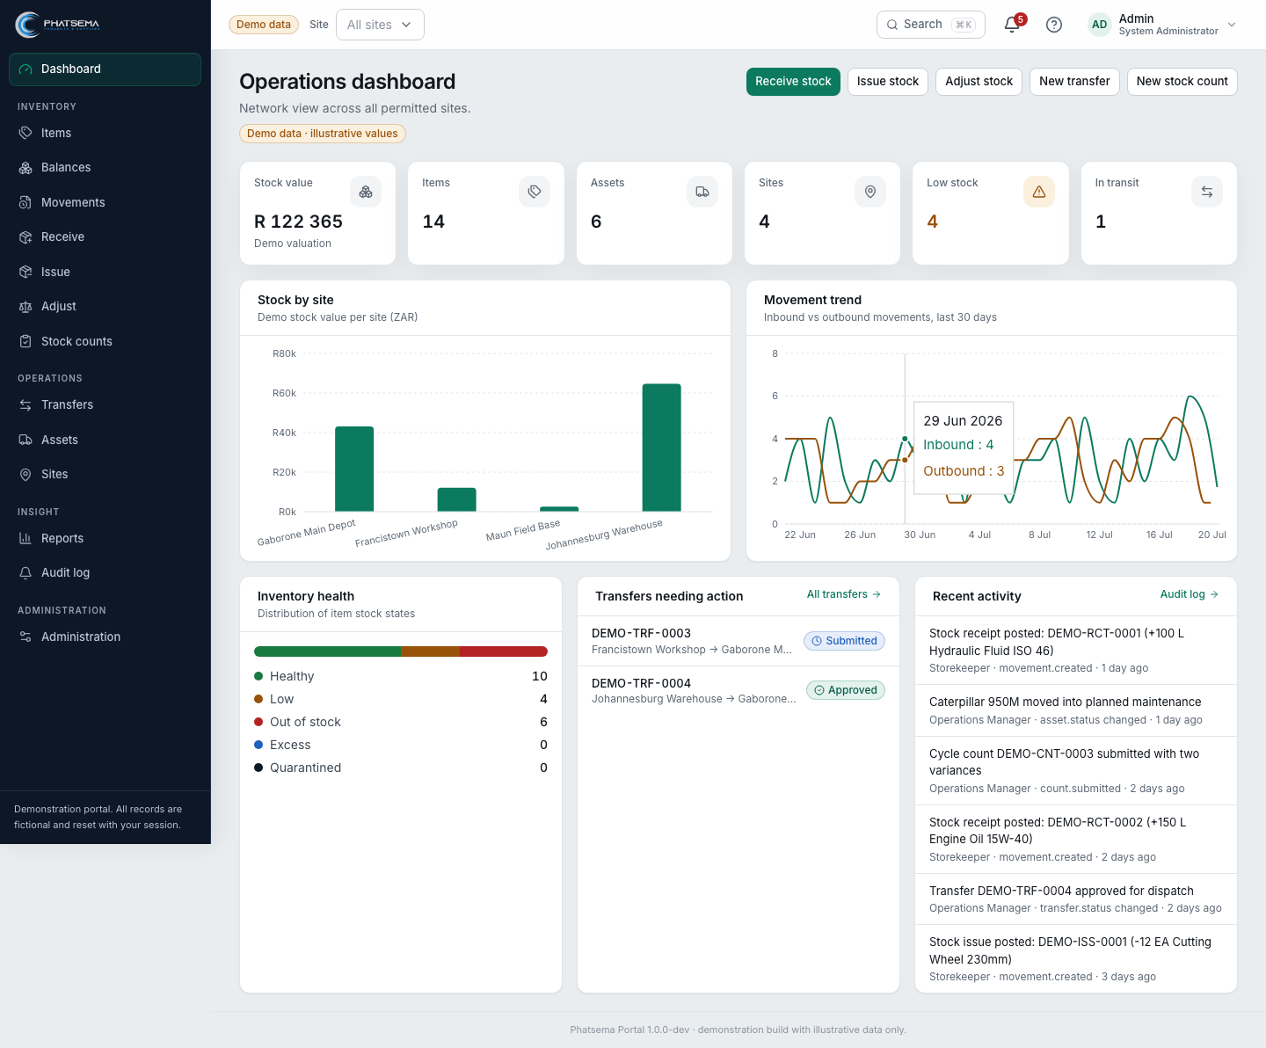
The dashboard shows the active site context in the top bar.

OVERVIEW

Read the operations dashboard
Use the dashboard to understand the network before opening detailed records.
- Stock value is an illustrative demo valuation and must not be treated as a production finance figure.
- Items, assets, and sites show the current scoped master-data totals.
- Low stock and in-transit indicators point to operational attention.
- Stock by site compares value distribution across permitted locations.
- Movement trend compares inbound and outbound activity over the recent period.
- Transfers needing action and recent activity provide direct paths to follow-up work.

Recommended daily review
- Confirm scope. Choose All sites or the required operating site.
- Review risks. Check low stock, out-of-stock, in-transit, and transfer exceptions.
- Open action lists. Resolve submitted, approved, or discrepant workflows.
- Check recent activity. Confirm unusual movements or asset changes.

INVENTORY MASTER DATA

Items, balances, and movement history

Item catalogue
The catalogue defines the identity and operating rules for materials, consumables, spare parts, and fabricated goods.
- Search by SKU or name and filter by category, type, health, or status.
- Use stock-health summaries to find healthy, low, or out-of-stock items.
- Reference codes are generated by the portal where users should not invent identifiers.
- Keep stock for sale, consumables, spares, fabricated-to-order goods, and assets distinct.

Balances
Balances show available quantities by item, site, and location. They are derived from posted movements.

Movements
Movement history is the primary explanation for why a balance changed. Filter it by date, site, item, type, or reference.
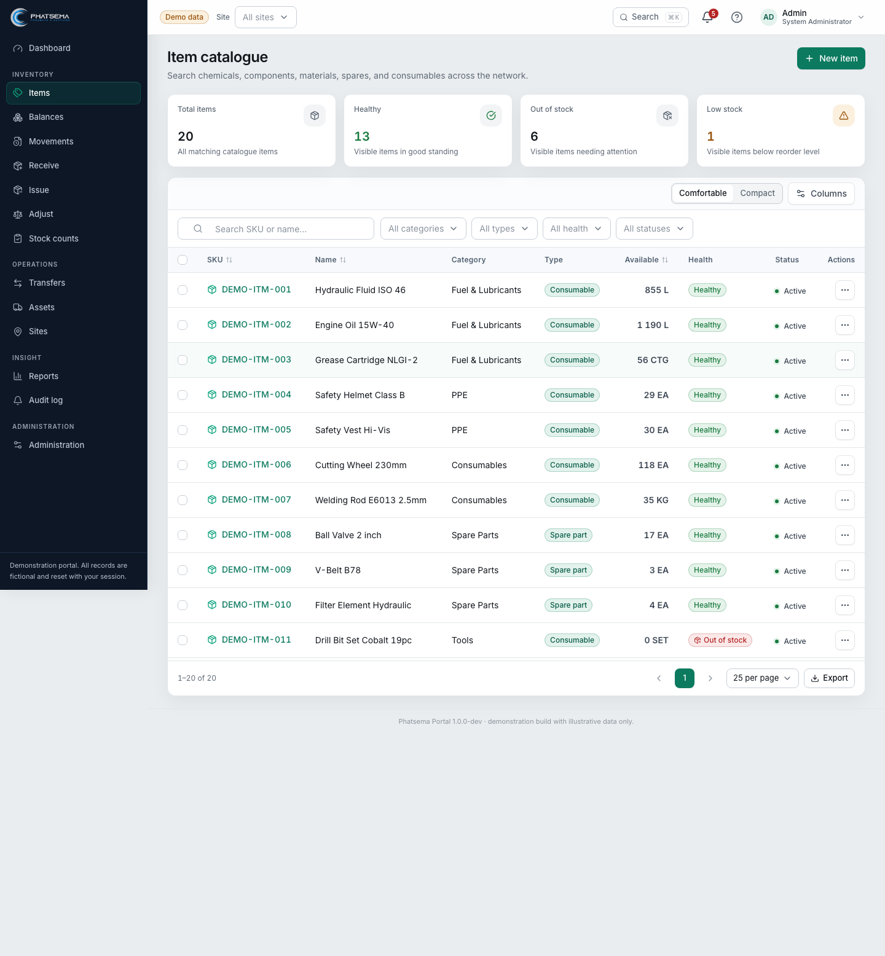
Catalogue summary widgets make exceptions visible before users scan rows.

DIRECT STOCK OPERATIONS

Receive, issue, and adjust stock

Receive stock
- Choose site and location. Confirm where the stock physically arrived.
- Enter source evidence. Capture supplier, delivery, purchase, or other approved reference information.
- Add items and quantities. Use the controlled item picker and correct unit.
- Review and post. Check every line before creating the inbound ledger movements.

Issue stock
- Choose site and location. Select the point from which stock will leave.
- State purpose and recipient. Use meaningful operational references and reasons.
- Add quantities. The portal checks availability at the selected location.
- Review and post. Confirm the outbound movement and resulting balance.

Adjust stock
Use adjustment only for an approved correction that is not better represented by a receipt, issue, transfer, count, or reversal.
Control point. Adjustments require a clear reason and supporting reference. They should be reviewed for frequency, value, and user pattern.

INTER-SITE WORKFLOW

Create and complete a stock transfer
A transfer preserves custody between the source and destination. It is not a pair of unrelated issue and receipt transactions.

Lifecycle
Draft > Submitted > Approved > Dispatched > Received
- Create. Choose source, destination, expected date, purpose, and requested lines.
- Submit. Lock the request for review and expose it to approvers.
- Approve or reject. Apply role and site authority before physical dispatch.
- Dispatch. Record quantities that leave the source and move them into in-transit custody.
- Receive. Confirm destination quantities and record any discrepancy.
Discrepancies stay visible. Short, excess, or damaged quantities must be investigated and resolved through an authorised follow-up process.
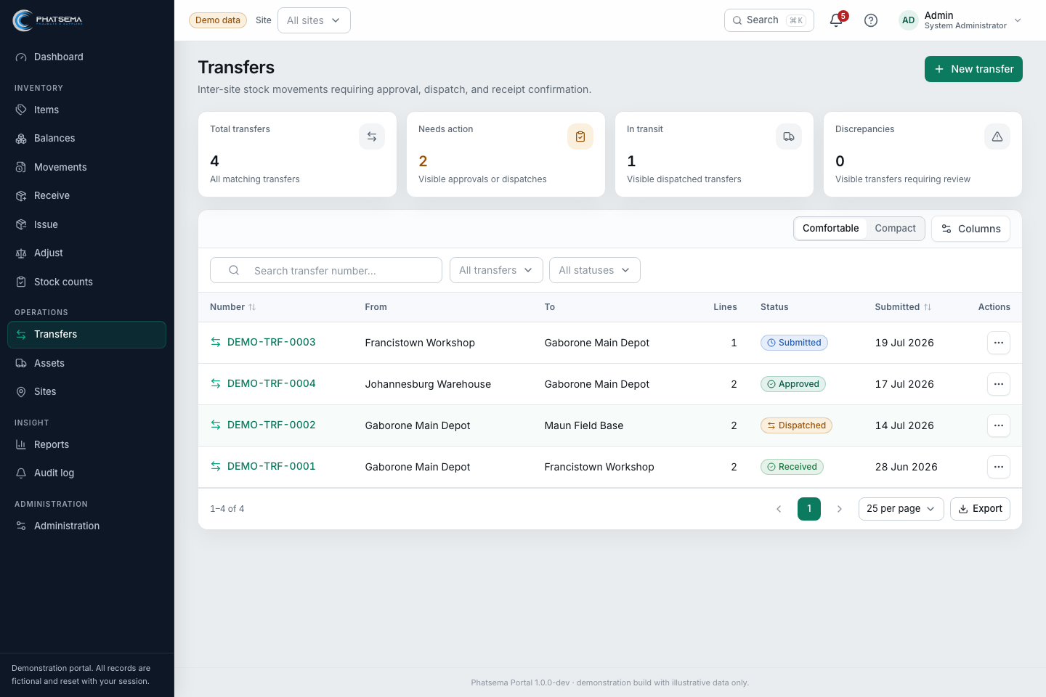
Transfer summaries separate pending approvals, in-transit stock, and discrepancies.

INVENTORY ASSURANCE

Run and post a stock count

Lifecycle
Draft > In progress > Submitted > Recount required or approved > Posted
- Define scope. Select the site, location, count type, and included items or categories.
- Start the count. Freeze the count snapshot and assign responsibility.
- Capture physical quantities. Enter observed stock without changing balances directly.
- Submit. Calculate and expose variances for independent review.
- Recount or approve. Resolve material or suspicious differences.
- Post. Create authorised adjustment movements and complete the count evidence.
Do not overwrite balances. The count workflow preserves expected quantity, counted quantity, variance, review decisions, and the resulting ledger entries.
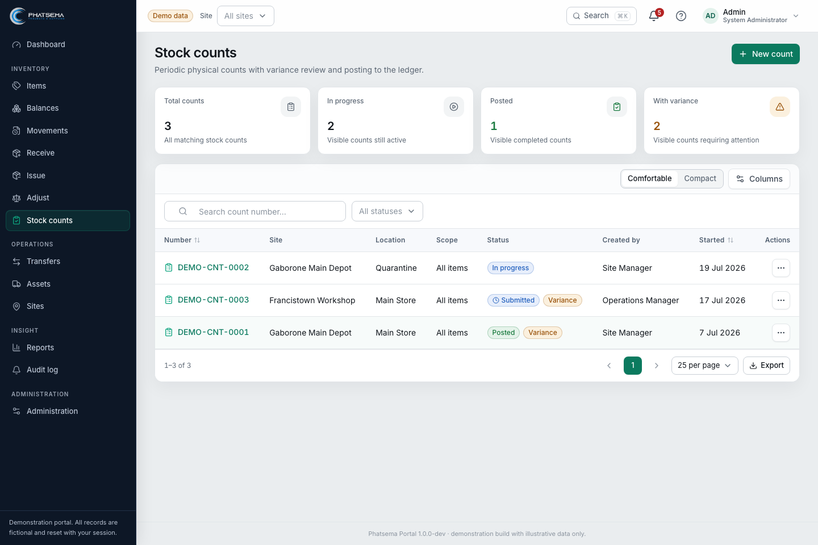
The stock-count list highlights active work, submitted reviews, and variance value.

ACCOUNTABLE EQUIPMENT

Manage assets separately from stock
Assets represent identifiable equipment that needs status, assignment, location, and lifecycle history. They should not be mixed with quantity-based inventory.
- Create or review the asset code, name, category, ownership type, serial or identifying details, and status.
- Track company-owned, hired, and client-owned equipment distinctly.
- Record site or location assignment and responsible custodian where applicable.
- Use asset status changes for operational states such as active, maintenance, unavailable, or retired.
- Review asset history before accepting handover or making a lifecycle decision.
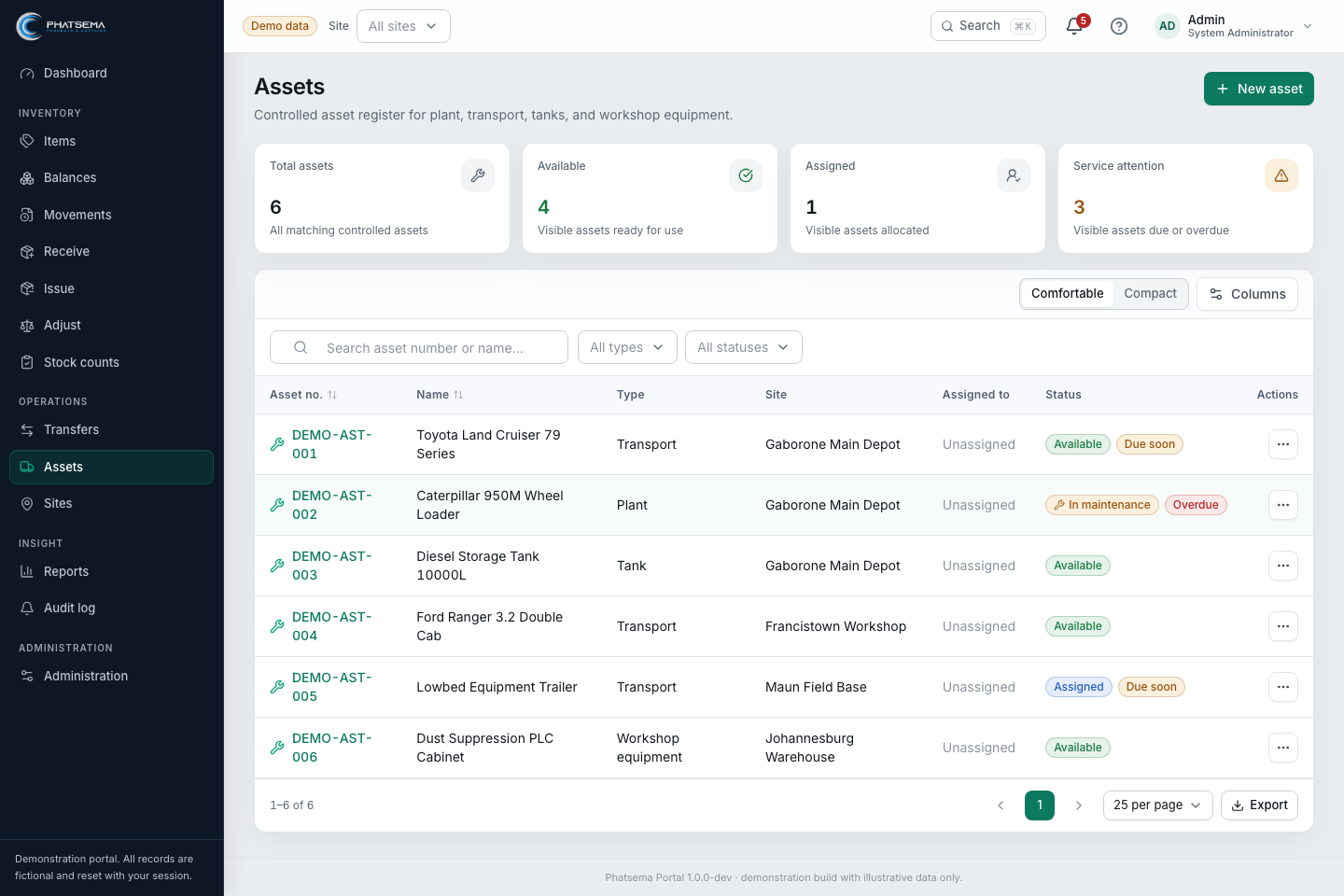
The asset register combines identity, ownership, location, status, and lifecycle visibility.

INSIGHT AND EVIDENCE

Use reports and the audit log

Reports
Reports provide filtered operational views for balances, movements, transfers, counts, and assets. Select the report type, scope, dates, and filters, then review before exporting.

Audit log
The audit log records important business and access events. It is designed to show who did what and when, while keeping passwords, hashes, biography contents, and phone values out of audit payloads.
- Search by event, entity, user, or time period.
- Use the related reference to trace back to the operational record.
- Investigate reversals, adjustments, rejected workflows, access changes, and unusual timing.
- Export only the evidence required for the review and protect personal information.
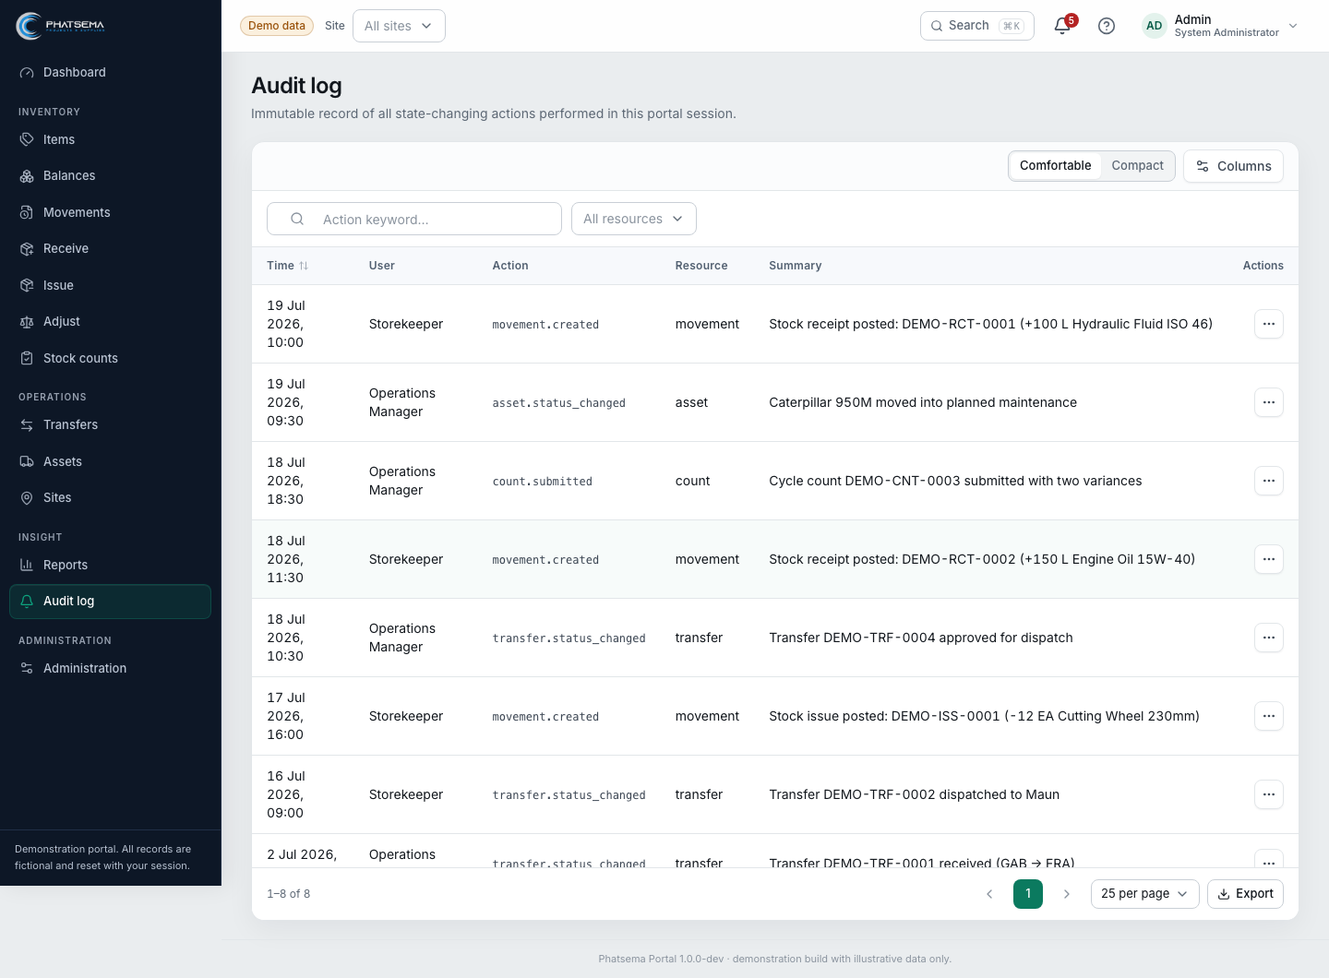
The audit log supports focused review without exposing sensitive values.

PEOPLE AND ACCESS

Administration and user profiles

Administrator responsibilities
- Create accounts with an immutable login email.
- Assign role, status, sites, and all-site access according to approved authority.
- Maintain controlled employment fields such as job title and department.
- Use temporary-password and activation workflows carefully.
- Review effective permissions and remove access promptly when responsibilities change.

My profile
Every authenticated user can maintain their full name, preferred name, work phone, and biography. Employment and access details remain read-only, and users can change their password after confirming the current one.
Password rule. Use 12 to 100 characters. The new password must match confirmation and differ from the current password. The active session remains signed in after a successful change.
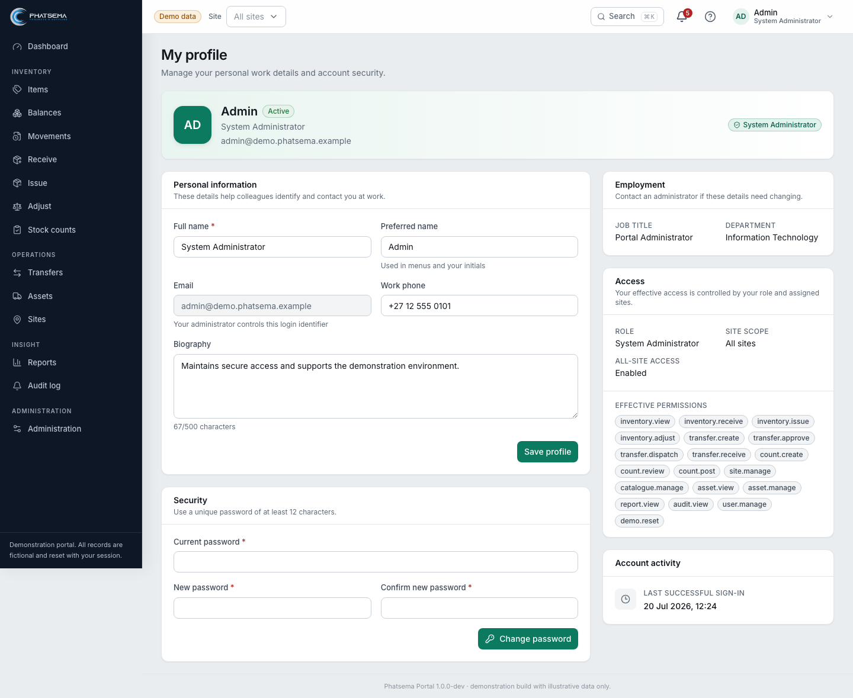
My profile separates personal details, employment, access, security, and account activity.

CONTROL GUIDE

Good operating practice
Situation | Expected practice
Before posting | Confirm user, site, location, item, unit, quantity, reason, and source reference.
After posting | Read the success message, open the new record, and verify the resulting balance or status.
When data conflicts | Refresh and re-open the record. Optimistic version checks prevent silent overwrites.
When stock differs | Use the count and review workflow; do not force the balance through an unexplained adjustment.
When a transfer differs | Record the received reality and investigate the visible discrepancy.
When access is wrong | Stop the transaction and ask an administrator to correct role or site scope.
For audit review | Start with the source record, then trace the movement, workflow history, actor, time, and audit event.

Production controls to confirm
- Legal entities, physical sites, warehouse and location hierarchy, and stock ownership.
- Approval thresholds, segregation of duties, delegated authority, and emergency access.
- Units, valuation, cutoff, opening balances, finance reconciliation, and retention.
- Evidence attachments, audit export formats, backups, recovery, and access reviews.

HELP

Troubleshooting and quick reference
What you see | What to do
The page says you lack permission | Confirm the signed-in persona, site scope, role, and account status.
The record changed while you were editing | Reload the latest version, compare changes, and reapply only valid updates.
Available stock is lower than expected | Review site, location, open transfers, recent issues, and movement history.
A workflow action is missing | Check its current state and your permission. Actions appear only when valid.
Demo changes disappeared | The demonstration is session-backed. Sign-in resets and new sessions may start from fixtures.
A code field is not editable | The portal generates controlled identifiers for supported records.
You need production evidence | Agree the source, retention, attachment, export, and sign-off requirements before go-live.
Remember. Use the process that best represents what physically happened. Clear reasons and references make the system trustworthy.
Prepared by Valo Systems for Phatsema
Open the demonstration portal

