
SYSTEM BROCHURE

Phatsema Back-Office Portal
Smarter inventory. Stronger operations.
A focused, modern portal for controlling inventory, transfers, stock counts, assets, reporting, and audit evidence across multiple operating sites.

Prepared by Valo Systems
Demonstration edition | July 2026

ONE NETWORK. ONE OPERATIONAL VIEW.

See what is on hand, where it is, and who changed it
Phatsema’s operations span locations, materials, machinery, projects, and people. The portal brings these activities into one simple operating view so teams can act quickly without losing accountability.
Multi-site visibility  View stock, assets, risks, and activity across permitted sites. | Operational control  Run receipts, issues, adjustments, transfers, and counts through clear workflows.
Reliable history  Build each balance from an immutable movement ledger with actor and time context. | Simple by design  Use clear pages, guided forms, generated reference codes, and role-aware actions.
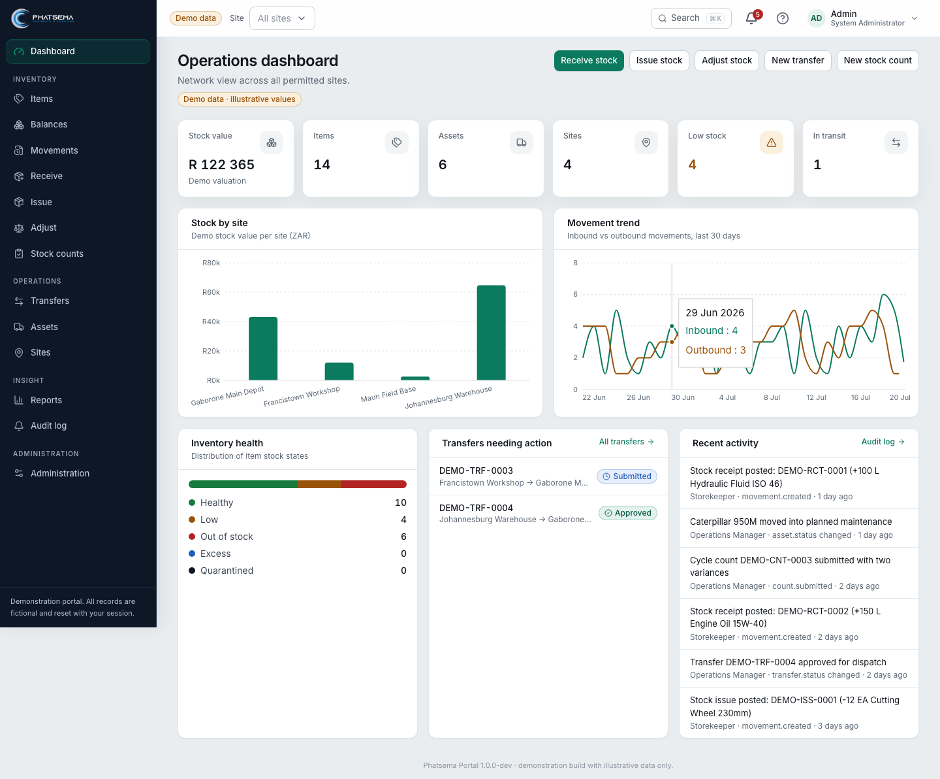
The operations dashboard brings stock value, health, sites, transfers, and recent activity together.
Designed for confidence. Every action should be easy to perform, easy to explain, and easy to review.

A COMPLETE FIRST-VERSION PLATFORM

The daily tools operations teams need
Item catalogue  Maintain clear item identities, categories, units, stock health, and status. | Balances and movements  See current quantities and trace the ledger entries that created them.
Receive, issue, adjust  Post direct stock operations with references, reasons, and validation. | Transfers  Move stock between sites through submit, approve, dispatch, and receive states.
Stock counts  Capture variances, review exceptions, request recounts, approve, and post. | Assets  Control serialised and accountable equipment separately from quantity stock.
Reports  Filter and export operational views for management and reconciliation. | Administration  Manage users, roles, site access, work profiles, and effective permissions.
One consistent experience. Summary widgets, filters, health states, tables, generated codes, and guided forms behave consistently across modules.

CONTROLLED INVENTORY WORKFLOWS

Fast work without hidden shortcuts
The portal separates different operational responsibilities while preserving a common ledger and audit trail.
Action | Validation | Approval | Ledger | Evidence

Transfers retain responsibility between sites
Draft > Submitted > Approved > Dispatched > Received
The source site records dispatch, the destination confirms receipt, and discrepancies remain visible for review.

Counts correct through review
Draft > In progress > Submitted > Recount or approval > Posted
A count does not silently overwrite stock. Variances are calculated, reviewed, and converted into controlled ledger entries.
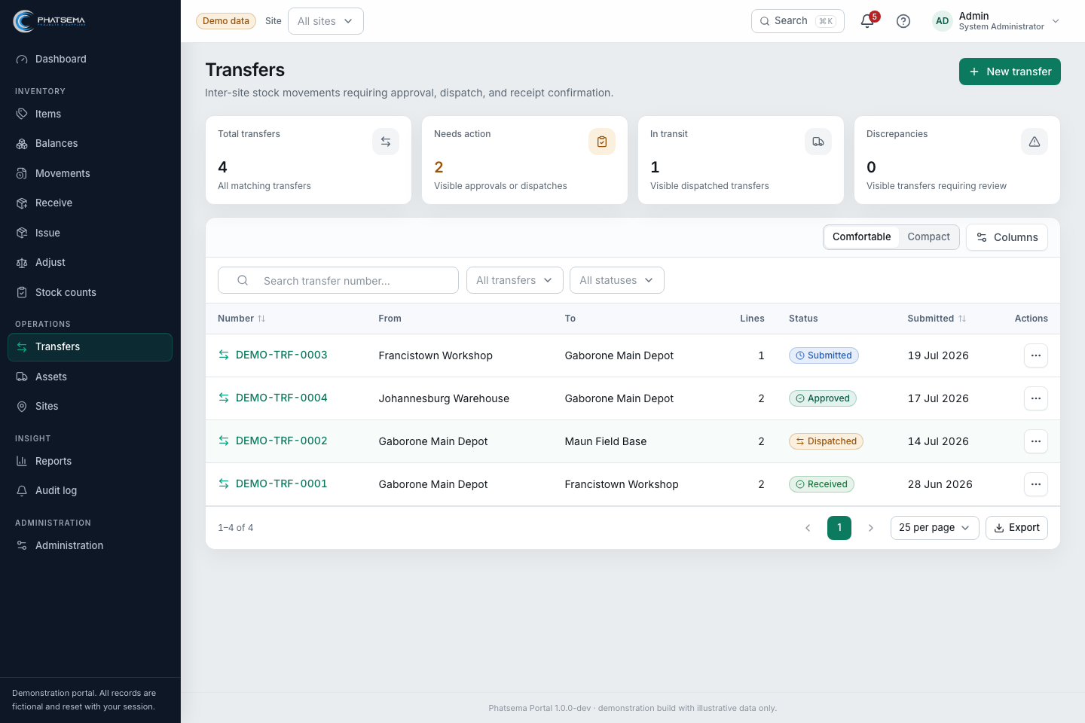
Transfer summary widgets highlight work in progress, in-transit stock, and discrepancies.

AUDIT-READY BY DESIGN

Evidence is created as work happens
Auditability is strongest when it is part of the operating workflow, not reconstructed at month-end. The portal records the evidence needed to explain inventory and access decisions.
- Immutable inventory movements with item, site, quantity, unit, time, reference, and actor context.
- Transfer status history, dispatch and receipt responsibility, and discrepancy visibility.
- Count scopes, captured quantities, variances, recount decisions, approvals, and posting history.
- Role and site-based permissions with administration and profile events recorded safely.
- Searchable reports and audit activity that support operational review and external-audit preparation.
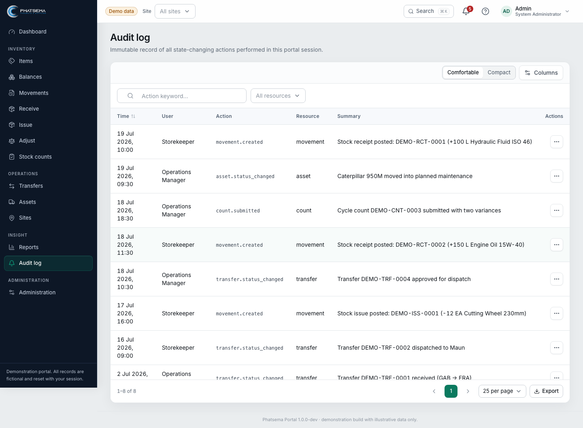
The audit log provides a searchable record of important actions without exposing sensitive values.
Production governance remains a client decision. Approval thresholds, segregation of duties, valuation, retention, backups, evidence attachments, and auditor export formats must be confirmed before go-live.

DEMONSTRATION TODAY. PRODUCTION-READY PATH TOMORROW.

Validate the operating model before committing to infrastructure
The current demonstration is a realistic, session-backed application. It lets Phatsema’s team test language, roles, workflows, data fields, and reports before production persistence and integrations are introduced.
Current demonstration  Rich fictional data, resettable sessions, full workflows, and responsive screens. | Production persistence  Repository contracts allow a MariaDB adapter to replace the demo store.
Controls workshop  Confirm sites, stock ownership, approvals, segregation, units, and evidence needs. | Launch preparation  Migrate opening balances, configure access, rehearse processes, and sign off controls.

Recommended next workshop
- Walk through one real receipt, issue, transfer, count, and asset scenario.
- Confirm users, roles, site scope, approvals, and exceptions.
- Agree master-data ownership, naming, units, and opening-balance evidence.
- Prioritise production reports, exports, integrations, and audit packs.
Demo access Explore the portal at phatsema.valosystems.co.za. Demonstration records are fictional and reset with the session.
Prepared with care by Valo Systems
phatsema.valosystems.co.za

