First time TabsetComponent has 2 tabs and isDestroyed: false
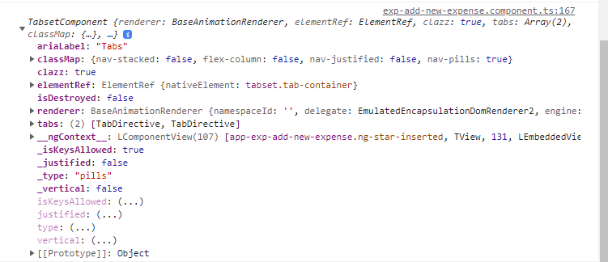

After saving data in the Tabset tabs, I route the user to different component.
When they come to add new data, tabset is loading, however the tabs array is empty and isDestroyed : true
