DATA FOR ADAPTATION

- The effects of climate change vary considerably across regions according to distinct physical, environmental, social, cultural, and economic characteristics, resulting in different sensitivities to climate change.
- Regional and local authorities produce and collect socioeconomic, demographic, and land-use data and information. These datasets and information can provide meaningful input to characterise climate risk and vulnerability at local scales.
- Hence, municipal/regional data and information have a “potential climate value”. But this climate value is not always evident, and it has to be revealed and realised.

Overall, this methodological package aims to support local authorities to tap on the climate value of data and information they produce and collect.
It presents a collection of methodologies that function as a guideline to improve data management practices for the sake of understanding, monitoring and addressing climate risks at local levels.

In particular, the aim of this methodological package is:
a. to facilitate prioritise data needs required to support adaptation.
b. to reveal the climate value of local data and information.

How to use this material
Step 1: Explore the Components
The package consists of four complementary methodologies:

Although each methodology can be applied independently, the four are designed to work together to emphasize a key message: local data management practices should better integrate climate adaptation considerations. This integration requires:
- A clear purpose – understanding climate risks and vulnerabilities through the Climate Impact Chains.
- A structured approach to prioritizing, collecting, and sharing data – through the Local Climate Adaptation Catalogue.
- A method to identify essential data for monitoring risks and evaluating progress – using Data Valuation Metrics.
- Effective communication tools – to present information clearly and concisely to decision-makers and the wider public.

Step 2: Start with Climate Impact Chains to understand your local risk context:
- Observe the climate impact chains and the cause-effect diagrams and how climate hazards, exposure, and vulnerability.
- Use them to identify key areas of interest that you want to focus on.

Step 3: Check the Adaptation Catalogue to see which indicators and datasets are relevant for your region.
- A structured list of indicators and datasets linked to specific climate risks is provided.
- The catalogue helps you connect data insights to specific indicators.
- From the Dashboard, select a Climate Impact Chain. Then select the component you want to explore (Exposure, sensitivity, adaptive capacity). Explore the indicators and the datasets and identify whether some of the proposed indicators are worth considering for your monitoring purposes.
- Integrate the catalogue into Local Processes:
- You can download the template catalogue and save it on your computer.
- Identify the indicators that are most relevant to the hazards, exposure, sensitivities or adaptive capacity that you want to monitor. You can also use the indicators to inform funding proposals, stakeholder engagement, and monitoring systems.
- Based on the examples provided in the template catalogue, you can start collecting the metadata available in your local government and that will help you populate the indictors. In doing this, you are already generating your locally tailored adaptation catalogue.
- There are a series of assignments you can lead -together with colleagues-, to support improving data practices that you can follow.
- You can contribute to improving the VALORADA catalogue in GitHub by sending us examples of metadata in this feedback-form. Once we check your entries, we will integrate them in the catalogue and enlarge the number of examples of data and information that helps understand and explain climate risks.

Step 5: Evaluate your data using the valuation metrics to identify gaps and opportunities.
- A framework to assess the “climate value” of your datasets can be found here.
- The framework provides a series of value domains and criteria to identify high-value datasets for adaptation.
- Once you have collected your data of interest, apply the framework to selected datasets, and prioritize which data emerges as high-value datasets. High value datasets are the essential pieces of data that you want to improve, share, or integrate for adaptation planning.

Step 6: Visualization Tools
- We have provided examples of demo decision-support tools developed in VALORADA and tailored to specific VALORADA demonstration regions. These dashboards are designed to communicate climate risks clearly to decision-makers and stakeholders. While only available as demos, they are examples of how climate and local data can describe local climate risks in a visually accessible format and informed decision-making.

Step 7: Iterate and Update
- Climate risks and data availability evolve over time.
- Regularly revisit the methodologies and the catalogue to keep your adaptation strategies up to date.

------ here below come the respective links mentioned in the previous section--------

Climate Impact Chains
Risks associated with climate change are often analysed in isolation, focusing only on specific economic sectors or ecosystems. However, this narrow approach can miss indirect impacts, risks of maladaptation and feedback loops.
A climate-impact chain describes the relationship between a particular climate hazard and its impact on a specific area of influence, thereby helping identify cause-effect relationships between different components within a system.

Five climate impact chains are displayed:

Climate Impact Chain | Hazard
Degradation of urban ecosystems due to urban heat and droughts | High T and Drought
Extreme high temperatures on people’s health in the context of urban transport | High T
Drought affecting agricultural production and rural livelihoods | Drought
Wildfire affecting infrastructure | High T and Drought
Floods affecting rural livelihoods | Extreme PP

Climate Impact Chains (CICs) in VALORADA
The Climate Impact Chains (CICs) were co-developed with stakeholders from VALORADA’s demonstrator regions, ensuring validation against real-world contexts. While CICs serve as a generic framework for exploring climate risks, they are also illustrated with concrete examples from the demonstrator regions, reinforcing their practical relevance and applicability.

Exploring Climate Impact Chains
Each Climate Impact Chain includes a detailed explanation of its sequences, allowing readers to examine the potential implications of the identified risk factors. To support practical understanding, illustrative examples of policy challenges associated with each chain are provided. While not exhaustive, these examples highlight key issues and serve as a starting point for further exploration.
I. Climate Impact Chain 1. Main Risk: Degradation of urban ecosystems due to urban heat and droughts.
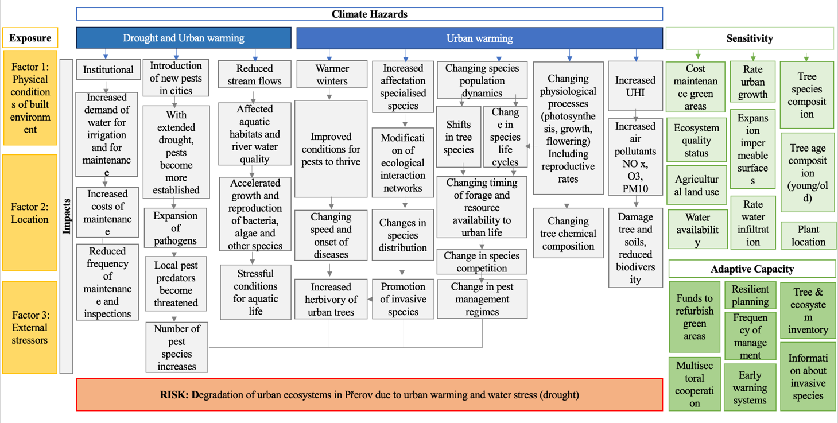

Key Policy Issues:
- Urban heat island effect and drought degrading urban green spaces.
- Loss of ecosystem services (temperature control, green areas for social activities).
- Introduction of foreign pests and changes in plant-disease patterns.
- Stress on aquatic life and changes in species distribution.
- Need for resilient urban planning, increased green infrastructure, and improved ecosystem monitoring.
- Addressing social vulnerability, especially for elderly and health-compromised populations.

Sequence 1. Institutional impacts
In the first sequence of impacts proposed, the focus is on the reduced capacity to keep appropriate and frequent maintenance and inspection to degrading urban ecosystems provoked by urban heat, warming and droughts. The proposed impact factors in this first sequence emerge as propositions provided by the participants during the workshop. The cause-effect relationships are presented below.

Sequence 2: Expansion of pests and pathogens
In the second sequence of impacts proposed, the focus is on the expansion of pests and pathogens provoked by urban heat, warming and droughts. Literature supporting the statements as well as suggestions connecting the cause-effect relationship are presented below.

Sequence 3: Drought and urban heat on river ecosystems
In the third sequence of impacts proposed, the focus is on the degradation of aquatic habitats provoked by urban heat, warming and droughts. Literature supporting the statements as well as suggestions connecting the cause-effect relationship are presented below.

Sequence 4: Urban heat on pests and tree degradation
In the fourth sequence of impacts proposed, the focus is on expansion of new pests and tree degradation provoked by urban heat and warming. Literature supporting the statements as well as suggestions connecting the cause-effect relationship are presented below.

Sequence 5: Urban heat on the promotion of invasive species
In the fifth sequence of impacts proposed, the focus is on the affectation of specialised species and the promotion of invasive species degradation provoked by urban heat and warming. Literature supporting the statements as well as suggestions connecting the cause-effect relationship are presented below.

Sequence 6: Urban heat on population dynamics and forage availability
In the sixth sequence of impacts proposed, the focus is on the changing population dynamics and forage availability provoked by extreme heat. Literature supporting the statements as well as suggestions connecting the cause-effect relationship are presented below.

Sequence 7: Urban heat on physiology
In the seventh sequence of impacts proposed, the focus is on plant physiological impacts provoked by urban heat and warming. Literature supporting the statements as well as suggestions connecting the cause-effect relationship are presented below.

Sequence 8: Heat on air pollution
In the eighth sequence of impacts proposed, the focus is on the degradation of urban ecosystems due to increasing levels of air pollution as provoked by urban heat and warming. Literature supporting the statements as well as suggestions connecting the cause-effect relationship are presented below.

Climate Impact Change 2. Main risk: Heat affecting people’s health: transport and deterioration of social and environmental determinants of health
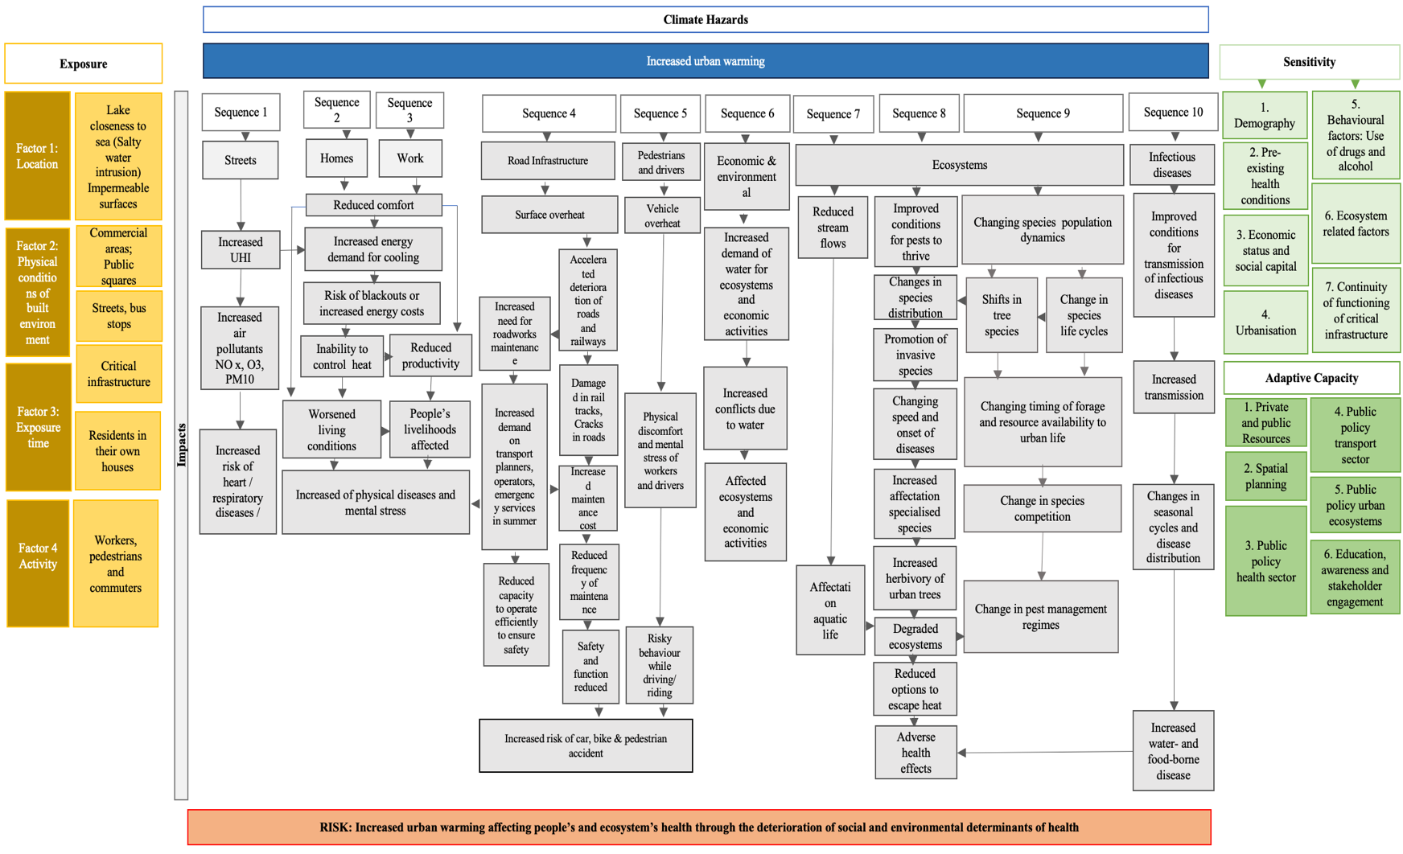
Key Policy Issues:
- Heat stress and accidents in urban mobility (public transport, cycling, walking).
- Infrastructure overheating (roads, vehicles).
- Vulnerability of elderly, children, and those with pre-existing health conditions.
- Need for early warning systems, public health interventions, and resilient transport infrastructure.

Sequence 1.
In the first sequence of impacts proposed, the focus is on the increase of air pollution as provoked by urban warming and related health effects. Literature supporting the statements as well as suggestions connecting the cause-effect relationship are presented below.

Sequence 2. People’s health being affected by the increased temperatures in their private households.

Sequence 3.
In the third sequence of impacts proposed, the focus is on the affectation on people’s health and on the reduction of people’s productivity while working due to increase temperature.

Sequence 4
In the fourth sequence, the focus is on people’s health as being affected by the increased risk of car, bike, and pedestrian accident due to mental stress and reduced performance of infrastructure. This sequence of impacts includes also the pressure exerted on the capacity of operators to keep pace with worsening infrastructure.

Sequence 5.
In the fifth sequence of impacts proposed, the focus is on the risk of accidents as people are affected by physical discomfort and mental stress while driving and commuting due to high temperatures, resulting in more risky behaviour. Literature supporting the statements as well as suggestions connecting the cause-effect relationship are presented in figure 5, below.

Sequence 6: Reduced water availability affecting urban ecosystems and economic activities.

Sequence 7: Drought and urban heat on river ecosystems
In the seventh sequence of impacts proposed, the focus is on the degradation of aquatic habitats provoked by urban heat, warming and droughts.

Sequence 8: Ecosystem degradation
In the eighth sequence of impacts proposed, the focus is on the degradation of urban ecosystems due to extreme temperatures and the loss of cooling spaces for people during extreme heat.

Sequence 9: Urban heat on ecosystem population dynamics and forage availability
In the nineth sequence of impacts proposed, the focus is on the changing population dynamics and forage availability provoked by extreme heat.

Sequence 10: Increased water- and food-borne disease
In the tenth sequence of impacts proposed, the focus is on the shifting the environmental suitability for the transmission of various infectious diseases due to extreme temperatures.

Climate Impact chain 3: Main Risk: Drought affecting agricultural production and rural livelihoods
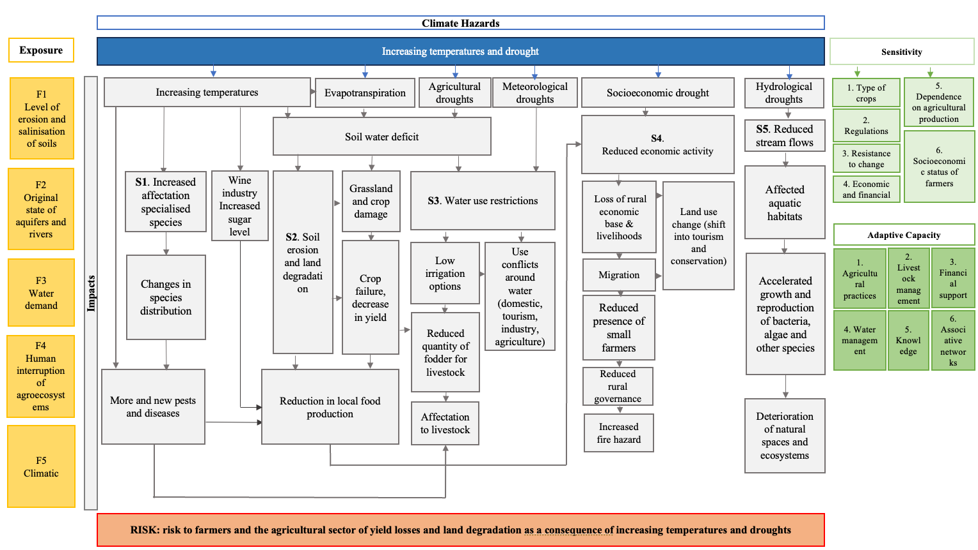
Key Policy Issues:
- Water scarcity and conflicts over water use (irrigation, domestic, industrial).
- Soil erosion, salinisation, and land degradation.
- Declining agricultural productivity and risk to rural livelihoods.
- Need for sustainable water management, support for farmers, and ecosystem restoration.

Sequence 1.
In the first sequence, the focus is on increased affectation of plant specialised species due to increasing temperatures and the resulting increased risks of new pests and diseases affecting livestock and agricultural production.

Sequence 2. In the second sequence, the focus is on the combined effects of high T and evapotranspiration in connection with agricultural droughts impacting soil erosion and reducing food production.

Sequence 3. In the third sequence, the focus is on the effects provoked by both, agricultural and meteorological droughts on water restrictions on reduced quantity of fodder for livestock.

Sequence 4. In the fourth sequence, the focus is on the impact of droughts on rural livelihoods.

Sequence 5. In the fifth sequence, the focus is on the effects of hydrological droughts on the accelerated growth and reproduction of bacteria, algae and other species which affects aquatic ecosystems.

Climate Impact chain 4: Main risk: Drought and heat increasing the risk of wildfire
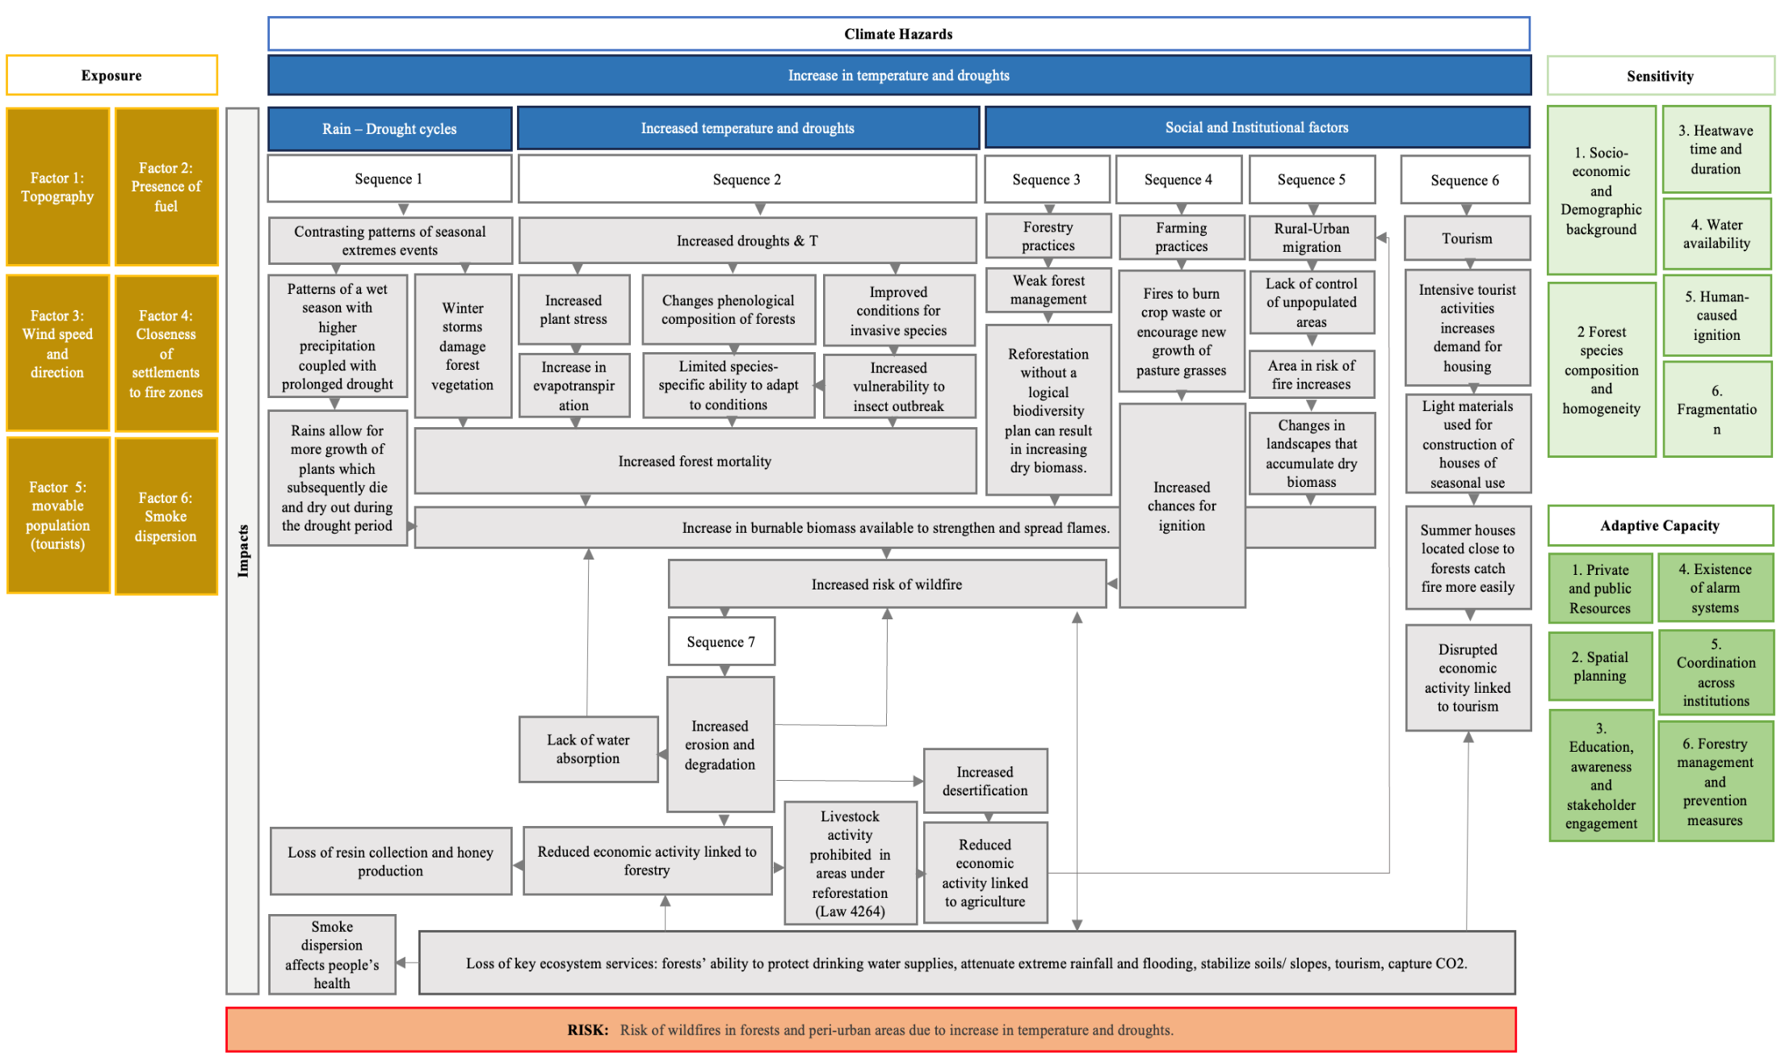

Key Policy Issues:
- Wildfire risk due to high temperatures, drought, and poor forest management.
- Increased fuel load from storms and lack of forest maintenance.
- Intensive tourism increasing fire risk.
- Need for integrated forest management, wildfire prevention, and flood resilience.

Sequence 1. Contrasting patterns of seasonal extremes events
In the first sequence of impacts proposed, the focus is on the effects provoked by seasonal extreme events (extreme precipitation followed by drought and extreme temperatures) on the generation of fuels.

Sequence 2. Increased drought and temperature

Sequence 3. Forestry practices
In the third sequence of impacts proposed, the focus is on the negative effect that poor forestry practices provoke by increasing the accumulation of burnable biomass.

Sequence 4. Farming practices
In the fourth sequence of impacts proposed, the focus is on the higher chance of fire ignition due to human negligence linked to poor farming practices.

Sequence 5. Rural-Urban migration
In the fifth sequence of impacts proposed, the focus is on the higher risk of fire ignition linked to abandoned rural lands due to urban migration. This sequence is connected to sequence 7, as far as migration and reduced economic activity are closely linked together, enhancing the likelihood of wildfires through increased amounts of burnable biomass, and further affecting local economy and need to migrate.

Sequence 6. Tourism
In the sixth sequence of impacts proposed, the focus is on the higher risk of fire propagation linked to the increased demand for holidays housing and the use of light material for their construction, as well as due to closeness to wildfire-risk-prone areas.
This sequence is connected to sequence 7, as far as tourism is disrupted in the short term due to wildfires and smokes, as well as in the long term due to loss of ecosystem services that make a touristic destination to be attractive.

Sequence 7. Socio-economic and ecological impacts

Climate Impact chain 5: Main Risk: Floods affecting rural livelihoods.
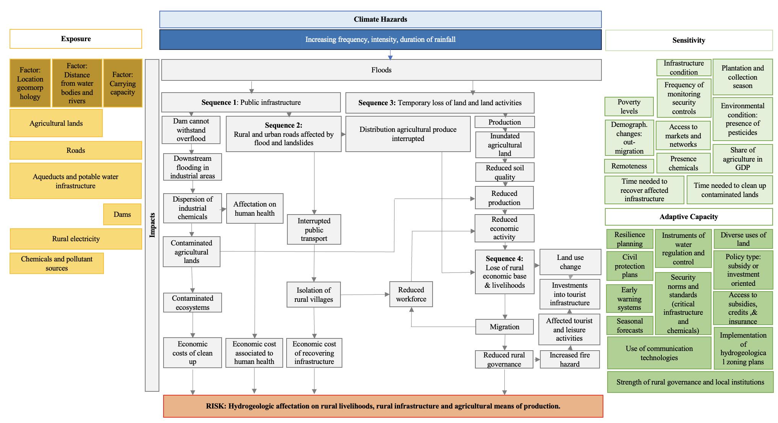

Key Policy Issues:
- Flooding of agricultural land and rural infrastructure.
- Risk of dam failure and chemical contamination from industrial sites.
- Outmigration and reduced rural governance, increasing fire and hydrogeological risks.
- Need for robust flood management, infrastructure resilience, and rural development policies.

Sequence 1. Hydrogeological events impact public infrastructure
In the first sequence of impacts proposed, the focus is on how hydrogeological events affect the dissemination of chemical pollutants., as extreme rainfall provokes water running off and inundating industrial areas, spreading chemical pollutants to nearby agricultural lands.

Sequence 2. Interruption of public services
In the second sequence of impacts proposed, the focus is on the affectation provoked by hydrogeological events on roads. The proposed impact factors in this first sequence emerge as propositions provided by the participants during the workshop.

Sequence 3. Soil degradation and reduced productivity
In the third sequence of impacts proposed, the focus is on the affectation provoked by hydrogeological events on soil degradation and associated reduced productivity.

Sequence 4. Affectation of hydrogeological events on demographic trends and land uses
In the third sequence of impacts proposed, the focus is on the affectation provoked by hydrogeological events on demographic trends and land uses.

Risk Factors across climate impact chains

I. Exposure

Definition exposure: ‘The presence of people, livelihoods, species or ecosystems, environmental functions, services, and resources, infrastructure, or economic, social, or cultural assets in places and settings that could be adversely affected.’ (GIZ & EURAC, 2017, p.17).
When exploring exposure, the aim is to identify the factors that generate or exacerbate exposure and determine certain groups of people or assets experiencing higher levels of exposure under a similar hazard. Across the demonstrators, 13 exposure factors were defined.

I. Exposure in the context of urban heat:
Factor 1: Location: refers to the physical space where people stand during a climate hazard.
Factor 2: Physical conditions of built environment: aspects contributing to unfavourable bioclimatic conditions in urban areas (building materials, housing density, etc.).
Factor 3: Timing and length of exposure: Exposure to heat-related hazards can be influenced by the duration and timing of exposure. Vulnerable groups, such as the elderly, children, and pregnant women, may face increased risks, especially at night when cooling amenities may be lacking. Workers in outdoor settings, like road builders, may experience fatigue due to prolonged exposure to high temperatures. Furthermore, individuals waiting at unsheltered transit stations during peak hours may also be at risk of severe heat stress.
Factor 4: Nature of activity (indoor – outdoor activity): For outdoor workers, high metabolic heat production associated with occupational tasks combined with high ambient and radiant heat, low air flow, and sometimes high humidity, add to human heat strain (Ebi et al 2021). Furthermore, cyclists and pedestrians can be exposed to dehydration and heat strokes and might also suffer from heat stress and health problems (Jaroszweski et al. 2014).

II. Exposure in the context of heat and drought in rural areas
Factor 1: Level of erosion and salinisation leading to negative impacts on soil properties and plant physiology, therefore significantly reducing agricultural production.
Factor 2: Water demand and availability: A region whose water level in aquifers and rivers is currently relatively low will be more exposed to the effects of climate change and some areas are more exposed to risk if they have high water demands (linked to economic activities).
Factor 3: Human intervention in agroecosystem: It refers to human intervention impacting agroecosystem and provoking erosion of natural habitats, or through processes of urbanization, pollution, and use of chemicals in agroecosystem.

III. Exposure factors in the context of wildfires
Factor 1: Topography: It refers to terrain shape and morphology which greatly influence fire ignition and behaviour (Chuvieco et al 2023).
Factor 2: Presence of fuel: All factors increasing the amount of burnable biomass, including fuel composition and weather conditions (windstorms that increase dead tree which becomes burnable biomass) (Chuvieco et al. 2023).
Factor 3: Location: It refers to distance, which makes areas be exposed directly through contact with the fire front or via flaming embers; or indirectly through the dispersion of smoke (Chuvieco et al. 2023).

IV. Exposure in the context of extreme precipitation
Factor 1: Location: It refers to instances where geomorphology amplifies exposure (physical extent of floodplains and catchment hydrology) (Thomson and Clayton, 2022).
Factor 2: Distance from water bodies and rivers: It refers to the proximity of streams, lakes, rivers that can overflow and affect populated areas.
Factor 3: Carrying capacity of specific infrastructure: Floods are also generated from catastrophic failure of artificial (reservoirs) (such as documented in Molise)

2. Vulnerability
Definition of vulnerability: ‘The propensity or predisposition to be adversely affected. Vulnerability encompasses a variety of concepts and elements including sensitivity or susceptibility to harm and lack of capacity to cope and adapt.’ (GIZ & EURAC, 2017, p.17).

2.1. Vulnerability component 1: Sensitivity
Sensitivity is determined by factors that directly affect the consequences of a climate hazard. Sensitivity may include physical attributes of a system (e.g., building material of houses, type of soil on agriculture fields), social, economic, and cultural attributes (e.g. age structure, income structure), etc. (Dasgupta et al. 2014).

I. Factors mediating human health:
Factor 1: Demography: As urban population steadily increase; larger numbers of people are at risk of heat stress in the built-up environment of cities (Richter 2015).
Factor 2: Human physical attributes: The impact of extreme high temperatures primarily revolves around two key factors: aging and pre-existing health conditions (Feyen et al., 2020; Ebi et al. 2021; Hajat et al., 2010).
Factor 3: Economic status and social capital: Under a similar climate hazard, people’s susceptibility to harm differs according to factors such as poverty, unemployment, social isolation and little mobility, social cohesion, household structure, gender, education attainment, language proficiency, race, house-ownership and more (Puntub et al 2022; Ebi et al 2021; Hajat et al, 2010; Barata et al 2018).
Factor 5: Behavioural factors: The use of alcohol, medications, and illegal narcotics is associated with increased mortality during heat extremes (Ebi et al 2021).

II. Factors mediating sensitivity of livelihoods:
Factor 1: Production and distribution means: In the rural settings of Molise and Sicoval, factors such as crop choices, reliance on agricultural production, access to markets and networks were identified as significant contributors.
Factor 2: Remoteness: Rural areas often lack alternatives in the event of road blockages, as evidenced in Molise and as previously documented by Dasgupta et al. (2014).
Factor 3: Outmigration: Outmigration has been observed to diminish territorial governance, thereby increasing the risk of fires and hydrogeological instability.
Factor 4: Institutional inertia: This factor accounts for concerns about the neglect by policymakers and underinvestment in infrastructure and services in rural areas.

III. Factors mediating the sensitivity of ecosystems:
In urban areas, demonstrators highlighted concerns about changes in tree species composition, degradation due to overuse and population pressures, and the urban heat island phenomenon.
In rural areas, different crops present different degrees of sensitivity to high temperatures and drought.
In the context of forests, the risk of wildfires can be influenced by the composition and homogeneity of forest species, as well as forest management practices that lead to lead to ecosystem fragmentation (Greenpeace, 2023; Chuvieco et al. 2023).

III. Factors mediating sensitivity of urban areas:
Factor 1: Rate of urban growth: Increasing urbanisation could amplify the urban heat island effect and further exacerbate human stress in densely populated areas (Feyen et al 2020).
Factor 2: Expansion of impermeable surfaces: It modifies the hydrological dynamics and channels pollutants that accumulate from buildings, roadways, and parking lots into natural streams (Grimm, et al. 2008).
Factor 3: Interruption of infrastructure: Blackouts amplify heat exposure (Barata et al., 2018). Aging infrastructure, maintenance expenses, and rise in demand for infrastructure utilization influence the uninterrupted operation of critical infrastructure.

2.2. Vulnerability component 2: adaptive capacity
Adaptive capacity is normally determined in terms of knowledge, financial resources, social and institutional factors, technologies, legislations, and infrastructures that enable people to adjust to the effects of climate change (Dasgupta et al. 2014).

I. Factors determining adaptive capacity in the context of urban heat and drought.
Factor 1. Availability, access, and distribution of financial resources (Puntub 2022).
Factor 2. Spatial planning: Spatial planning influences the spatial configuration, type, and degree of development of buildings and land use, as well as landscapes and green spaces (Richter 2015; Feyen et al 2020). Also, the Implementation of thermal regulations and building codes are relevant in this sense.
Factor 3. Public policy in the health sector: Implementation of effective and cost-efficient public health interventions including monitoring, involving young people and marginalized groups in solution identification, heat health warning systems are and community alerts, etc. (Ebi et al 2021).
Factor 4: Public policy in transport sector: It underscores the importance of adaptive organizations in operating transport systems, which entails embedding adaptation across all functions, ensuring that transport planners and operators adhere to design standards that consider specific climate parameters.
Factor 5: Public policy in urban ecosystem: It emphasizes the critical need for conserving, restoring, and expanding urban ecosystems to bolster climate resilience and address the growing pressures of urbanization and development.
Factor 6. Education, awareness, and stakeholder engagement: Education, awareness, and engagement were proposed as central factors increasing adaptation, which underscore the significance of training public officials and increasing collaboration across sectors to address health issues.

3. Factors determining adaptative capacity in the rural world in the context of heat and drought:
Factor 1: Capacity to adapt agricultural and livestock-management practices: Including adjusting sowing and harvesting dates, utilizing longer cycle crop varieties, implementing adaptive land use and water management (Kovats et al (2014) etc; and improve livestock, management (Gowda et al 2018).
Factor 2. Integration of best practices in forestry management and prevention measures: Enhancing ecosystem resistance and resilience while addressing burnable biomass accumulation (Chuvieco et al. 2023).
Factor 3: Knowledge: It encompasses the ability to conduct knowledge generation activities, including ecosystem, forest, and soil monitoring, as well as epidemiological surveillance of vector-borne animal diseases. It also involves building capacities based on this information.
Factor 4. Coordination across institutions: Coordination is needed for reducing the risk of wildfires (firefighting involves citizens/people safety and management); and actors involved in public policy in urban areas, transport, ecosystem management and the rural world.

III. Factors affecting adaptive capacity against floods in the rural world: access to land, access to technologies, markets, and infrastructure, etc. But also, policies emphasizing collaboration among stakeholders and investment-based approaches over subsidies. Institutions and networks, access to information and the behavioural factors that lead to utilization.

VALORADA’s Valorisation Framework

The value of data is context-dependent, shaped by professional norms (Gherardi, 2012). Metrics help assess data's worth objectively and make value transferable across contexts. These metrics can be qualitative or quantitative, and either subjective or objective.

No metric can fully objectify data value. The VALORADA metric aims to build consensus on the value of data for reducing climate risks.

The framework consists of:
  - Four value dimensions
  - Three criteria per dimension
  - Definitions, indicators, and a scoring system (low–medium–high)

Table below presents the dimensions, criteria, and definitions.

Value dimensions | Criterion | Definitions |  | Indicators | Scoring
Relevance  (Contribution to knowledge generation) | Relevance to climate risk understanding | This criterion evaluates how well the dataset contributes to improving the understanding of climate risks, including vulnerabilities, exposure, impacts, and adaptive capacity. It assesses whether the data provides insights necessary for assessing and managing climate-related risks within a given context (e.g., local, regional, or sectoral). |  | Risk Identification: Does the dataset provide information that is directly relevant to identifying climate risks?  - The dataset clearly identifies and quantifies specific background information (e.g., socio-economic vulnerability) to characterise climate risks.  - The dataset offers measurable variables (e.g., historical weather data, disaster occurrence) that allow for risk quantification.  - The dataset contains detailed information on socio-economic, demographic, or geospatial factors that influence exposure/vulnerability.  - The dataset provides data at appropriate temporal (e.g., historical, real-time) and spatial scales (e.g., local, regional) relevant to climate risk assessment.  - The dataset provides ongoing monitoring capacity, allowing for continuous evaluation of climate risks and trends. | • High Value (5-4): The dataset strongly contributes to improving the understanding of climate risks  • Moderate Value (3-2): The dataset contributes to some aspects of climate risk understanding.  • Low Value (1-0): The dataset provides minimal or no contribution to understanding climate risks.
Relevance  (Contribution to knowledge generation) | Irreplaceability of the Dataset | This criterion evaluates the uniqueness and irreplaceability of the dataset by assessing whether the data can be easily substituted by other sources or datasets, or whether it offers unique, critical insights that cannot be replicated through other means. A highly irreplaceable dataset provides essential information that is either unavailable elsewhere or not reproducible through other existing datasets. Knoweldge generation is highly dependent on this dataset. This attribute is unique to this dataset and cannot be replaced by other sources of information. | Irreplaceability of data: Does the dataset contain unique data that is not available from other sources or datasets?  - The dataset provides data that cannot be found or replicated from any other source, making it critical for the specific context.  - The dataset offers highly granular or specific information (e.g., high-resolution spatial data, frequent temporal updates) that is not available from any other source.  - The dataset is uniquely relevant to a specific region, community, or climate condition, and no other datasets are available with comparable relevance or detail.  - The dataset contains long-term or historical data that is essential for trend analysis and cannot be found elsewhere.  - The dataset is central to key analyses or decisions and cannot be substituted without a significant loss in quality or insight. | • High Irreplaceability (5-4): The dataset is unique and critical, offering insights or details that cannot be replicated or substituted, making it indispensable for specific analyses, contexts, or decisions.  • Moderate Irreplaceability (3-2): The dataset provides useful but not entirely unique data. It could be replaced by other sources with some effort or loss of quality.  • Low Irreplaceability (1-0): The dataset is easily replaceable by other sources, and its absence would not significantly impact analysis or decision-making.
Relevance  (Contribution to knowledge generation) | Performance value | This criterion assesses how well the dataset can contribute to a broad range of climate risk indicators, evaluating its versatility in providing data for multiple aspects of climate risk assessment (e.g., hazards, vulnerabilities or exposure, etc.). A dataset with high versatility value is one that can be applied across various climate risk indicators. |  | Performance Value: Does the dataset support multiple risk indicators and analytical contexts?  -The dataset is highly adaptable and can be used across multiple frameworks, serving both short-term and long-term risk analysis needs.  - The dataset is capable of supporting analyses that assess compound or multi-hazard risks, providing essential data for complex climate risk scenarios.  - The dataset provide data that can support both immediate and long-term climate risk indicators (e.g., immediate flood risk vs. long-term sea-level rise).  - The dataset offer spatial detail that can be applied across different geographic scales (e.g., local, regional, national) for climate risk indicators.  - The dataset integrates well with others, enhancing its value by contributing to a wide range of combined risk indicators. | • High Performance Value (5-4): The dataset supports a wide range of climate risk indicators across different risk domains, time scales, and geographic scales, and can be integrated with other datasets for compound risk assessments.  • Moderate Performance Value (3-2): The dataset supports some climate risk indicators but is either limited in scope or adaptability to multiple risk types or scales.  • Low Performance Value (1-0): The dataset is narrowly focused and does not support climate risk indicators, offering low performance value.
Strategic value | Contribution to Risk Management and Decision-Making Capacity | This criterion evaluates the dataset’s ability to support local governments in guiding risk management activities, including mitigation, adaptation, and resilience-building. It assesses whether the dataset enhances decision-making capacity by providing actionable insights and improving the implementation of climate risk responses. |  | Contribution to Risk Management and Decision-Making Capacity: Does the dataset support decision making?  - The dataset directly informs specific risk management actions (e.g., identifies priority areas for intervention, supports planning for climate-resilient infrastructure).  - The dataset is useful for informing political leaders and decision-makers in prioritizing climate-related actions and investments  - The dataset is highly localized and provides data that addresses specific climate risks relevant to the municipality’s geographic and socio-economic context.  - The dataset is essential for monitoring progress toward climate goals and provides clear metrics for evaluation. | • High Value (5-4): The dataset significantly enhances the capacity of local governments to support effective risk management activities.  • Moderate Value (3-2): The dataset contributes to risk management and capacity-building in certain areas but is less impactful on other areas.  • Low Value (1-0): The dataset provides minimal or no support for risk management activities and does little to enhance local government capacity.
Strategic value | Data support linking climate risk with municipal political or strategic agendas and goals | This criterion evaluates how effectively the dataset supports the integration of climate risk data into political decision-making processes and strategic municipal agendas. A high-value dataset should enable local governments to align climate risk assessments with their policy objectives, development plans, and long-term sustainability goals. The dataset must help municipalities in making data-driven decisions that directly influence climate adaptation strategies within the broader political and administrative context. | Relevance to Policy Objectives: Does the dataset provide data that is directly relevant to the political goals or policy objectives of the municipality (e.g., climate action plans, resilience strategies, sustainability goals)?  - The dataset offers critical data that directly informs and supports key municipal policy objectives and climate action strategies.  - The dataset can help address the current operational priorities of local governments (e.g., urban planning, infrastructure management, public health, etc.)  - The dataset is designed or structured to be easily communicated, enhancing understanding among various stakeholders and encouraging action.  - The dataset is a key input for strategic planning, enabling data-driven decision-making in areas such as urban development, infrastructure, and resource allocation.  - The dataset provides essential data that aids compliance with climate-related regulations and policy commitments.  - The dataset facilitates cross-sectoral policy coordination, enabling integration of climate risk management into various municipal departments.  - The dataset promotes collaboration across sectors (e.g., health, infrastructure, environment) and helps to break down silos in climate risk management. | • High Alignment (5-4): The dataset is deeply integrated into municipal political goals and strategic agendas, contributing directly to policy decisions, regulatory compliance, and cross-sectoral coordination. It supports comprehensive planning and offers localized insights for targeted climate risk management.  • Moderate Alignment (3-2): The dataset aligns with certain political and strategic objectives but is not fully integrated into all relevant municipal processes or goals. It provides some support for decision-making but is not essential across the board.  • Low Alignment (1-0): The dataset has little to no relevance to political goals or strategic agendas. It is not used in policy decisions and does not contribute meaningfully to municipal climate planning or risk management.
Strategic value | Contribution to Connecting Regional and National Climate Policy | This criterion evaluates how effectively a dataset supports the alignment and integration of local climate actions with broader regional and national climate policies. High-value datasets should facilitate local governments in contributing to and complying with climate policies, targets, and strategies set at the regional or national level. The dataset should help bridge the local climate risk management activities with higher-level policy frameworks, promoting coherence and consistency across governance scales. | Alignment with Regional/National Policy Goals: Does the dataset provide data that aligns with the goals, targets, and mandates set by regional or national climate policies (e.g., adaptation frameworks, emission reduction targets)?  - The dataset directly supports the achievement of key regional or national climate goals and targets.  - The dataset enable coordination between local, regional, and national authorities, facilitating multi-level governance for climate risk management  - The dataset is useful for fulfilling reporting requirements or complying with national climate-related regulations (e.g., Nationally Determined Contributions, climate adaptation reporting)  - The dataset reflect the priorities and strategies outlined in regional climate plans (e.g., regional adaptation strategies, climate resilience frameworks)  - The dataset is aligned with and supports the implementation of regional climate strategies.  - The dataset is essential for contributing to regional or national climate risk assessments.  - The dataset actively promotes cross-jurisdictional collaboration and helps address climate risks that span multiple regions.  - The dataset can be used to evaluate the effectiveness of regional or national climate policies and initiatives at the local level | • High Contribution (5-4): The dataset is closely aligned with regional/national climate policies, enabling local governments to contribute directly to broader goals and strategies. It promotes strong coordination between governance levels, aids compliance, and supports multi-level governance and policy evaluation.  • Moderate Contribution (3-2): The dataset supports some aspects of regional/national climate policy but is not fully integrated. It aids coordination in specific areas but lacks comprehensive alignment with broader policy frameworks.  • Low Contribution (1-0): The dataset has little to no relevance to regional or national climate policies and does not promote alignment or coordination between local and higher levels of governance.
Usability | Resource efficient | This criterion assesses how easily local stakeholders (e.g., municipal officials, planners, decision-makers) can utilize the available datasets to effectively characterize climatic risks without needing additional resources such as advanced technology, financial investment, political buy-in, or specialized skills. High-value datasets should be accessible, user-friendly, and manageable within existing capacities. |  | Resource efficiency: Can the data be used without demanding additional resources?  - The data can be easily accessed, interpreted and used without additional tools or infrastructure (specialized software or hardware)  - The dataset is well-suited to the skills and competencies of local administrators and requires minimal additional training or capacity building.  - The dataset is easy to use, well-documented, and readily accessible, requiring minimal technical expertise.  - The dataset is user-friendly, with clear, actionable formats (e.g., visualizations, maps, indicators) that align with the needs and capacities of local governments.  - The dataset does not require significant modifications to integrate with current systems  - The use of the dataset is aligned with existing political and institutional priorities, requiring no additional political buy-in. | • Low cost of Use (5-4): The dataset is highly accessible and easy to use without requiring significant resources, training, or changes to workflows. Local stakeholders can quickly adopt it for climate risk assessments.  • Moderate cost of Use (3-2): The dataset requires some additional resources, training, or adjustments, but these are feasible within the current capacities of local governments.  • High cost of Use (1-0): The dataset is difficult to access, use, or integrate, requiring significant resources, technological upgrades, or political changes, making it challenging for local stakeholders to adopt.
Usability | Fit within Existing Administrative Competencies, Political Mandates, Operations and Workflows | This criterion evaluates how well a dataset can be integrated into the existing administrative, political, and operational structures of local governments. High-value datasets should align with the competencies, mandates, and workflows already in place, minimizing disruption and ensuring smooth adoption by public sector institutions. This includes compatibility with current legal frameworks, ease of integration into ongoing processes, and utility in supporting political mandates and responsibilities. | Alignment with Existing Political Mandates: Does the dataset support local governments in implementing their administrative competencies, or fulfilling their current political mandates, goals, or legal responsibilities (e.g., climate adaptation planning, disaster management, public service provision)?  - The dataset is directly aligned with policy and planning processes, providing essential data for developing and implementing local climate action plans.  - The dataset fits seamlessly into existing workflows and risk assessment processes, requiring little to no adjustment.  - The dataset can be easily incorporated into the ongoing workflows, processes, and operations of local governments  - The dataset comply with local regulations, policies, and data governance rules (e.g., data privacy, security, and open data policies) | • High Fit (5-4): The dataset aligns closely with existing political mandates, administrative competencies, and operational workflows. It requires minimal adjustments and can be easily integrated, while also complying with local regulations and being cost-efficient.  • Moderate Fit (3-2): The dataset aligns with some aspects of current mandates and workflows but requires moderate adjustments or capacity building. It offers value but may involve additional costs or resources.  • Low Fit (1-0): The dataset does not align well with existing competencies, mandates, or workflows. It is difficult to integrate and may not comply with local policies or regulations, making its adoption challenging.
Usability | Ongoing Maintenance Requirements for Data | This criterion assesses the level of effort, cost, and frequency required to maintain and update a dataset over time. High-value datasets should require minimal ongoing maintenance or the necessary updates should be affordable and feasible for local governments. The datasets should be regularly updated to allow for continuous monitoring and decision-making related to climate risks, without placing an excessive burden on resources. |  | Update Frequency: How regularly is the dataset updated to ensure it reflects current conditions?  - The dataset is updated at regular, reliable intervals (e.g., annually, biannually), supporting timely climate risk monitoring.  - The dataset is updated intermittently, with some gaps or irregular intervals, but still useful for monitoring trends.  - The data sources are stable and reliable, ensuring that updates will be available consistently over time.  - Maintenance costs are low or covered by external sources, making it affordable for local governments to maintain.  - Local governments can perform updates with their existing personnel and systems.  - Some manual intervention is required to update the dataset, but it is manageable with existing staff. | • Low Maintenance (5-4): The dataset requires minimal maintenance effort and costs, is updated regularly and automatically, and fits within local government systems without major adjustments. It allows for continuous, low-cost monitoring of climate risks.  • Moderate Maintenance (3-2): The dataset requires moderate maintenance efforts or costs, with updates needing some manual intervention or technical support. It can be managed with some adjustments to local government systems and resources.  • High Maintenance (1-0): The dataset requires significant effort, cost, or external support to maintain and update. It is difficult to integrate into local systems and does not easily support ongoing climate risk monitoring.
Quality | Provenance of Data | This criterion assesses the ability to trace the origins, creation, collection, and curation process of the dataset. High-value datasets should have clear, well-documented provenance, providing transparency about where the data comes from, how it was collected, and the processes used to curate and maintain it. This ensures data reliability, accountability, and trustworthiness for decision-making related to climate risk. |  | Data Documentation and Support: Is the dataset well-documented with clear guidelines and support for use by local stakeholders?  - The origin of the dataset is fully documented, with detailed information about the source, collection process, and any relevant metadata.  - The dataset has a well-defined, transparent collection and creation process, with clear methodologies and procedures.  - The dataset is accompanied by detailed, high-quality metadata that fully describes its content, format, origin, and other relevant attributes.  - The dataset has been subjected to official standards accepted by the local government.  - The dataset complies with international standards for geospatial data (for example OGC Standards to ensure interoperability and maximize the value of their geospatial data)  - The dataset comes with detailed documentation / tutorials / technical support that allow local governments to use it independently. | • High Provenance (5-4): The dataset’s origin, creation, collection, and curation are fully documented and transparent, with clear adherence to standards. It inspires confidence in its reliability and is traceable across all processes, making it highly valuable for climate risk management.  • Moderate Provenance (3-2): The dataset’s provenance is generally clear, but some details may be incomplete or lack transparency. It is still useful but may require additional verification or clarification.  • Low Provenance (1-0): The dataset’s provenance is unclear or poorly documented, leading to concerns about its reliability, accuracy, and appropriateness for decision-making.
Quality | Precision and Accuracy of Data | This criterion assesses the extent to which the dataset is precise (provides exact, detailed, and consistent information) and accurate (correctly reflects the real-world conditions it aims to represent). High-value datasets should demonstrate high levels of both precision and accuracy, ensuring that the data is reliable and useful for informing climate risk assessments and decision-making processes. |  | Level of Precision and accuracy: Does the dataset provide highly detailed and specific data and accurately represent the real-world conditions it aims to measure?  - The dataset’s precision and accuracy fully meet the needs of climate risk analysis, supporting effective decision-making with reliable data.  - The dataset comprehensively covers all the key variables necessary for a full and accurate understanding of climate risks.  - The dataset contains highly granular, detailed data, offering fine distinctions and specific measurements that are necessary for climate risk assessments.  - The dataset consistently reflects real-world conditions with a high degree of correctness, based on well-established, reliable methods.  - The dataset is free from bias, providing a fair and accurate reflection of the climate risk factors it aims to measure.  - The dataset has been thoroughly validated and cross-checked, confirming its high precision and accuracy. | • High Precision and Accuracy (5-4): The dataset consistently provides highly detailed, accurate, and reliable information with clear validation and adherence to robust data collection methods. It is well-suited for precise climate risk analysis and decision-making.  • Moderate Precision and Accuracy (3-2): The dataset is generally precise and accurate but may have minor errors, inconsistencies, or lack of validation that reduce confidence in its reliability for certain uses.  • Low Precision and Accuracy (1-0): The dataset contains significant errors, lacks detail, or has not been validated, making it unsuitable for reliable climate risk assessments.
Quality | Completeness of Data | This criterion assesses the extent to which the dataset contains all the necessary information without omissions (completeness). High-value datasets should exhibit both high completeness, meaning no significant data is missing that would hinder effective analysis. |  | Data Completeness: Does the dataset contain all necessary information for comprehensive climate risk assessment?  - The dataset is complete, with all relevant variables and data points included, allowing for a full understanding of climate risks  - The dataset is internally consistent, with no contradictory or conflicting data points, ensuring reliable analysis.  - The dataset provides a comprehensive and continuous timeline that is sufficient for tracking changes in climate risk over time.  - The dataset provides comprehensive spatial coverage, ensuring all relevant regions and locations are included in the analysis. | • High Completeness (5-4): The dataset contains all necessary information for a thorough analysis. No significant data points are missing, and the dataset is free from biases or errors.  • Moderate Completeness (3-2): The dataset is mostly complete, but there may be some minor gaps or inconsistencies that limit its usefulness for certain aspects of climate risk analysis.  • Low Completeness (1-0): The dataset is incomplete, with significant missing data that render it unreliable for climate risk assessment.

