Seedset by Era

Valerie Martin

1/24/2020

## Analysis of skypilot seedset/plant and seedset/fruit using era as a predictor variable

*It looks like the only roughly normally distributed response variable is total no. of flowers* 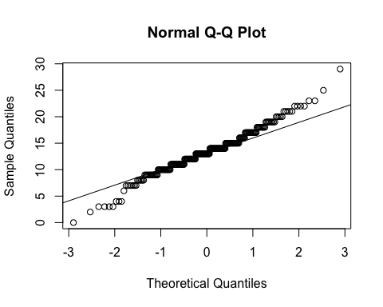

*The other response variables appear to have high 0 counts, and look to be roughly Poisson distributed.* *That said, Poisson is usually for integer count data - should I use it in the case of Seeds/Fruit and Seeds/Flower?* *Seeds/fruit looks like it may have a roughly normal distribution if the 0’s are taken out.* (No. fruits and seeds/plant shown below)

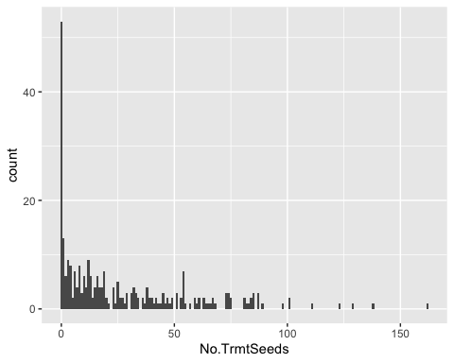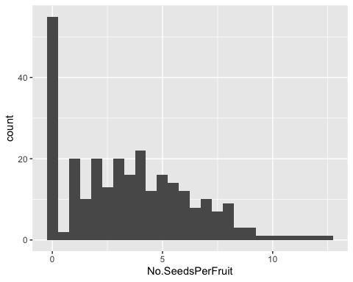

*Attempting an analysis similar to Niki’s stigma analysis by era, even though the distribution is not normal*

fit <- lme(No.TrmtSeeds ~ Era*Morph, random=~1|Site/Habitat, data= MergedData)  
anova.lme(fit)

## numDF denDF F-value p-value  
## (Intercept) 1 267 32.52108 <.0001  
## Era 1 267 7.07064 0.0083  
## Morph 1 267 0.04283 0.8362  
## Era:Morph 1 267 0.08456 0.7714

ggplot(MergedData, aes(x=Era, y=No.TrmtSeeds, group = Era, color = Morph)) +   
 geom_dotplot(binaxis='y', stackdir='center', binwidth = 2,  
 stackratio=1, dotsize=0.8)

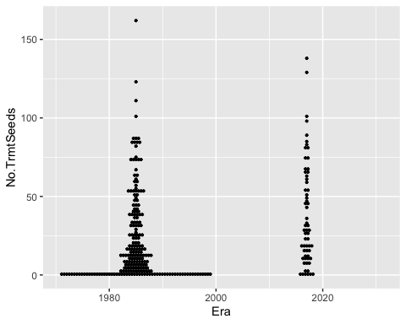

*GLM with poisson for No.TrmtSeeds (i.e. total seeds/plant)*

PoissonSeedsPerPlant <- glm(No.TrmtSeeds ~ Era*Morph, data = MergedData, family = poisson)  
summary(PoissonSeedsPerPlant)

##   
## Call:  
## glm(formula = No.TrmtSeeds ~ Era * Morph, family = poisson, data = MergedData)  
##   
## Deviance Residuals:   
## Min 1Q Median 3Q Max   
## -8.883 -5.901 -2.233 3.017 19.329   
##   
## Coefficients:  
## Estimate Std. Error z value Pr(>|z|)   
## (Intercept) -3.352e+01 2.385e+00 -14.054 <2e-16 ***  
## Era 1.843e-02 1.195e-03 15.426 <2e-16 ***  
## MorphSweet 1.241e+00 3.147e+00 0.394 0.693   
## Era:MorphSweet -6.063e-04 1.576e-03 -0.385 0.701   
## ---  
## Signif. codes: 0 '***' 0.001 '**' 0.01 '*' 0.05 '.' 0.1 ' ' 1  
##   
## (Dispersion parameter for poisson family taken to be 1)  
##   
## Null deviance: 8964.1 on 278 degrees of freedom  
## Residual deviance: 8462.3 on 275 degrees of freedom  
## AIC: 9542.5  
##   
## Number of Fisher Scoring iterations: 6

*Switching to a GLM with quasipoisson because the data is overdispersed (lambda = 33.5, not 1 in the above poisson)*

QuasipoissonSeedsPerPlant <- glm(No.TrmtSeeds ~ Era*Morph, data = MergedData, family = quasipoisson)  
summary(QuasipoissonSeedsPerPlant)

##   
## Call:  
## glm(formula = No.TrmtSeeds ~ Era * Morph, family = quasipoisson,   
## data = MergedData)  
##   
## Deviance Residuals:   
## Min 1Q Median 3Q Max   
## -8.883 -5.901 -2.233 3.017 19.329   
##   
## Coefficients:  
## Estimate Std. Error t value Pr(>|t|)   
## (Intercept) -3.352e+01 1.381e+01 -2.427 0.01587 *   
## Era 1.843e-02 6.920e-03 2.664 0.00818 **  
## MorphSweet 1.241e+00 1.822e+01 0.068 0.94574   
## Era:MorphSweet -6.063e-04 9.129e-03 -0.066 0.94710   
## ---  
## Signif. codes: 0 '***' 0.001 '**' 0.01 '*' 0.05 '.' 0.1 ' ' 1  
##   
## (Dispersion parameter for quasipoisson family taken to be 33.53531)  
##   
## Null deviance: 8964.1 on 278 degrees of freedom  
## Residual deviance: 8462.3 on 275 degrees of freedom  
## AIC: NA  
##   
## Number of Fisher Scoring iterations: 6

### I’m seeing similar results with the GLM and the LME (p-value for effect of era is ~0.0082)

*Running analyses for the rest…*

fit <- lme(No.SeedsPerFruit ~ Era*Morph, random=~1|Site/Habitat, data= MergedData)  
anova.lme(fit)

## numDF denDF F-value p-value  
## (Intercept) 1 267 63.68114 <.0001  
## Era 1 267 0.64896 0.4212  
## Morph 1 267 0.00305 0.9560  
## Era:Morph 1 267 0.00960 0.9220

QuasipoissonSeedsPerFruit <- glm(No.SeedsPerFruit ~ Era*Morph, data = MergedData, family = quasipoisson)  
summary(QuasipoissonSeedsPerFruit)

##   
## Call:  
## glm(formula = No.SeedsPerFruit ~ Era * Morph, family = quasipoisson,   
## data = MergedData)  
##   
## Deviance Residuals:   
## Min 1Q Median 3Q Max   
## -2.6965 -1.5701 -0.1383 0.9361 3.7590   
##   
## Coefficients:  
## Estimate Std. Error t value Pr(>|t|)  
## (Intercept) -1.472285 10.794343 -0.136 0.892  
## Era 0.001370 0.005417 0.253 0.801  
## MorphSweet 3.061045 14.449345 0.212 0.832  
## Era:MorphSweet -0.001542 0.007253 -0.213 0.832  
##   
## (Dispersion parameter for quasipoisson family taken to be 2.257584)  
##   
## Null deviance: 734.23 on 278 degrees of freedom  
## Residual deviance: 734.06 on 275 degrees of freedom  
## AIC: NA  
##   
## Number of Fisher Scoring iterations: 5

ggplot(MergedData, aes(x=Era, y=No.SeedsPerFruit, group = Era, color = Morph)) +   
 geom_dotplot(binaxis='y', stackdir='center', binwidth = 0.3,  
 stackratio=1, dotsize=0.8)

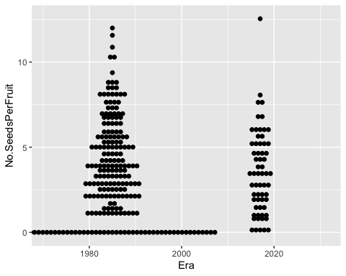

## Not running this particular LME because I'm missing some values, not sure how to fix this atm  
##fit <- lme(No.SeedsPerFlower ~ Era*Morph, random=~1|Site/Habitat, data= MergedData)  
##anova.lme(fit)  
  
QuasipoissonSeedsPerFlower <- glm(No.SeedsPerFlower ~ Era*Morph, data = MergedData, family = quasipoisson)  
summary(QuasipoissonSeedsPerFlower)

##   
## Call:  
## glm(formula = No.SeedsPerFlower ~ Era * Morph, family = quasipoisson,   
## data = MergedData)  
##   
## Deviance Residuals:   
## Min 1Q Median 3Q Max   
## -2.5054 -1.5019 -0.6114 0.6985 4.7203   
##   
## Coefficients:  
## Estimate Std. Error t value Pr(>|t|)   
## (Intercept) -39.381088 13.554038 -2.905 0.00398 **  
## Era 0.020092 0.006794 2.957 0.00339 **  
## MorphSweet 17.348537 19.586637 0.886 0.37658   
## Era:MorphSweet -0.008783 0.009824 -0.894 0.37217   
## ---  
## Signif. codes: 0 '***' 0.001 '**' 0.01 '*' 0.05 '.' 0.1 ' ' 1  
##   
## (Dispersion parameter for quasipoisson family taken to be 2.243153)  
##   
## Null deviance: 574.28 on 263 degrees of freedom  
## Residual deviance: 547.62 on 260 degrees of freedom  
## (15 observations deleted due to missingness)  
## AIC: NA  
##   
## Number of Fisher Scoring iterations: 5

ggplot(MergedData, aes(x=Era, y=No.SeedsPerFlower, group = Era, color = Morph)) +   
 geom_dotplot(binaxis='y', stackdir='center', binwidth = 0.3,  
 stackratio=1, dotsize=0.8)

## Warning: Removed 15 rows containing non-finite values (stat_bindot).

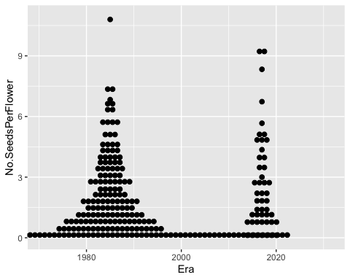

*The only test for which the quasipoisson glm is similar to the lme is for the first test - seeds per plant.*