Effects of Morph*Flower Measurements on Pollen Counts/Purity

Valerie Martin

10/12/2019

### Pooled PC (What I will run analyses with)

measures <- c("Corolla.Flare_1", "Corolla.Length","Lobe.Width_1")  
pv.size<-as.matrix(subset(stigma.new, select=measures))  
pv.size<-pv.size[complete.cases(pv.size),]  
pc<-princomp(pv.size)  
print(pc)

## Call:  
## princomp(x = pv.size)  
##   
## Standard deviations:  
## Comp.1 Comp.2 Comp.3   
## 0.36918272 0.20110447 0.08979564   
##   
## 3 variables and 89 observations.

plot(pc, type="l")

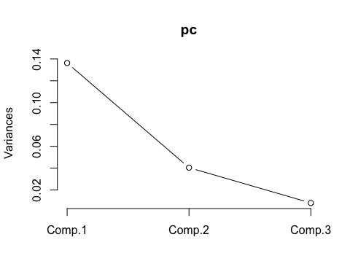

summary(pc)

## Importance of components:  
## Comp.1 Comp.2 Comp.3  
## Standard deviation 0.3691827 0.2011045 0.08979564  
## Proportion of Variance 0.7375233 0.2188449 0.04363184  
## Cumulative Proportion 0.7375233 0.9563682 1.00000000

loadings(pc) #Val: What is the loadings() function telling us?

##   
## Loadings:  
## Comp.1 Comp.2 Comp.3  
## Corolla.Flare_1 0.645 0.710 0.284  
## Corolla.Length 0.736 -0.677   
## Lobe.Width_1 0.207 0.195 -0.959  
##   
## Comp.1 Comp.2 Comp.3  
## SS loadings 1.000 1.000 1.000  
## Proportion Var 0.333 0.333 0.333  
## Cumulative Var 0.333 0.667 1.000

pc.extracted <- as.data.frame(predict(pc, newdata=stigma.new))  
stigma.new$PC1 <- -pc.extracted$Comp.1 # all floral measurements negatively correclated with pc1, so I reversed it to be more intuitive  
stigma.new$PC2 <- pc.extracted$Comp.2  
plot(stigma.new$PC1, stigma.new$PC2, ylim=c(-1,1), xlim=c(-1.5,1.5), ylab="PC2 (21.9%)", xlab="PC1 (73.8%)")

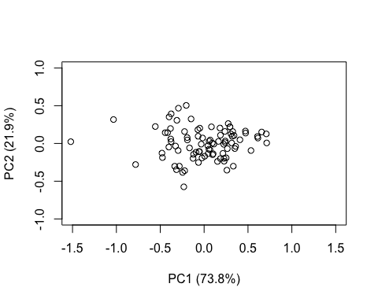

### All analyses are completed with both morphs

Effects on No. Total P.v. pollen grains (Sqrt-transformed) – No significant effects

## numDF denDF F-value p-value  
## (Intercept) 1 82 7.966881 0.0060  
## Corolla.Flare_1 1 82 0.000307 0.9861  
## Scent.Morph 1 82 0.078818 0.7796  
## Corolla.Flare_1:Scent.Morph 1 82 0.002259 0.9622

## numDF denDF F-value p-value  
## (Intercept) 1 82 2.8123030 0.0974  
## Tube.Length_1 1 82 0.0434534 0.8354  
## Scent.Morph 1 82 0.0043851 0.9474  
## Tube.Length_1:Scent.Morph 1 82 0.0418036 0.8385

## numDF denDF F-value p-value  
## (Intercept) 1 82 2.7417059 0.1016  
## Corolla.Length 1 82 0.1102788 0.7407  
## Scent.Morph 1 82 0.3282204 0.5683  
## Corolla.Length:Scent.Morph 1 82 0.4801291 0.4903

## numDF denDF F-value p-value  
## (Intercept) 1 82 156.13092 <.0001  
## PC1 1 82 0.04591 0.8309  
## Scent.Morph 1 82 1.23814 0.2691  
## PC1:Scent.Morph 1 82 0.11909 0.7309

**Effects on No. Other Pollen Grains (Log-transformed)**

Significant p-values for Morph ~ No. Other Pollen Grains (skunky picking up more foreign pollen)

## numDF denDF F-value p-value  
## (Intercept) 1 82 5.903959 0.0173  
## Corolla.Flare_1 1 82 2.449898 0.1214  
## Scent.Morph 1 82 0.947618 0.3332  
## Corolla.Flare_1:Scent.Morph 1 82 2.189969 0.1427

## numDF denDF F-value p-value  
## (Intercept) 1 82 0.4038463 0.5269  
## Tube.Length_1 1 82 2.0747185 0.1536  
## Scent.Morph 1 82 1.1538317 0.2859  
## Tube.Length_1:Scent.Morph 1 82 1.8911578 0.1728

## numDF denDF F-value p-value  
## (Intercept) 1 82 0.077570 0.7813  
## Corolla.Length 1 82 4.754901 0.0321  
## Scent.Morph 1 82 3.721010 0.0572  
## Corolla.Length:Scent.Morph 1 82 4.901818 0.0296

## numDF denDF F-value p-value  
## (Intercept) 1 82 333.9125 <.0001  
## PC1 1 82 4.7697 0.0318  
## Scent.Morph 1 82 6.2063 0.0147  
## PC1:Scent.Morph 1 82 4.6604 0.0338

## Warning: Removed 2 rows containing non-finite values (stat_ydensity).

## `stat_bindot()` using `bins = 30`. Pick better value with `binwidth`.

## Warning: Removed 2 rows containing non-finite values (stat_bindot).

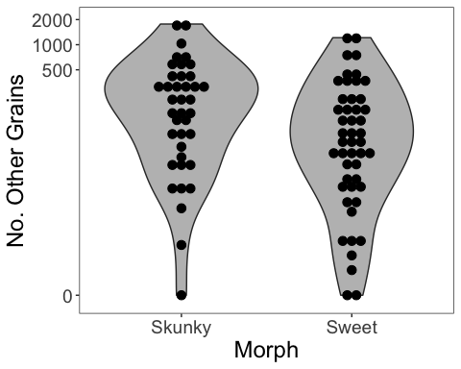

## Warning: Removed 2 rows containing non-finite values (stat_smooth).

## Warning: Removed 2 rows containing missing values (geom_point).

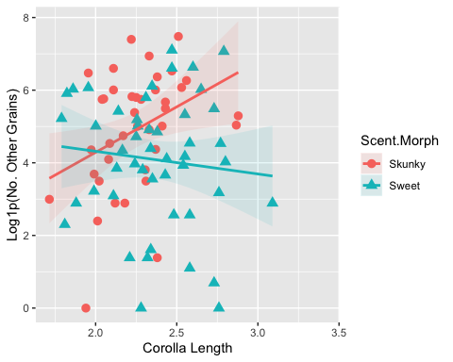

## Warning: Removed 2 rows containing non-finite values (stat_smooth).  
  
## Warning: Removed 2 rows containing missing values (geom_point).

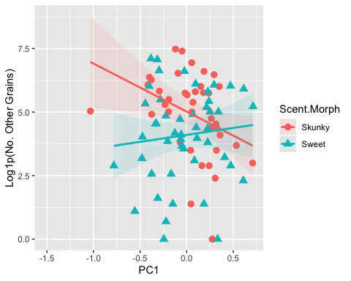

Total Purity Distribution

Decided to go with the “logit” transformation - recommended in my stats class for

proportional data.

## Warning in logit(x): proportions remapped to (0.025, 0.975)  
  
## Warning in logit(x): proportions remapped to (0.025, 0.975)

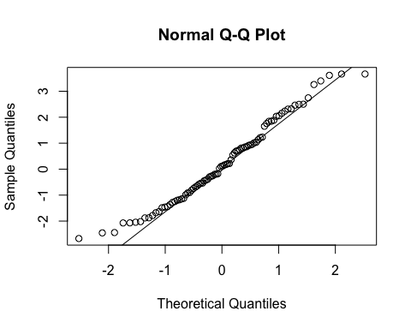

## Warning in logit(x): proportions remapped to (0.025, 0.975)

**Effects on Total Purity Log-transformed**

Significant effects of scent morph on pollen purity (skunky much lower than sweet)

I think the warning (this popped up 3 times in each analysis) is related to the 2 values of 1.0 and one value that is NaN (0/0 – undefined).

## Warning in logit(Purity.tot): proportions remapped to (0.025, 0.975)

## numDF denDF F-value p-value  
## (Intercept) 1 81 1.7083475 0.1949  
## Corolla.Flare_1 1 81 2.4565598 0.1209  
## Scent.Morph 1 81 0.8430624 0.3612  
## Corolla.Flare_1:Scent.Morph 1 81 2.2203976 0.1401

## numDF denDF F-value p-value  
## (Intercept) 1 81 2.419025 0.1238  
## Tube.Length_1 1 81 2.831731 0.0963  
## Scent.Morph 1 81 0.651163 0.4221  
## Tube.Length_1:Scent.Morph 1 81 1.343325 0.2499

## numDF denDF F-value p-value  
## (Intercept) 1 81 5.506448 0.0214  
## Corolla.Length 1 81 6.083234 0.0158  
## Scent.Morph 1 81 3.850024 0.0532  
## Corolla.Length:Scent.Morph 1 81 5.244453 0.0246

## numDF denDF F-value p-value  
## (Intercept) 1 81 1.912036 0.1705  
## PC1 1 81 5.521995 0.0212  
## Scent.Morph 1 81 8.024040 0.0058  
## PC1:Scent.Morph 1 81 4.604176 0.0349

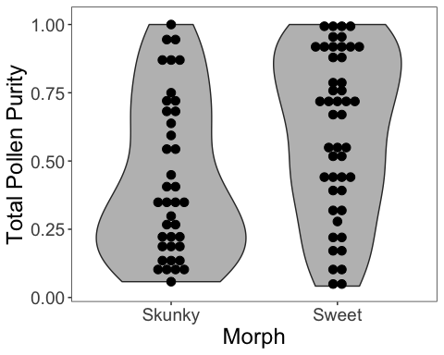

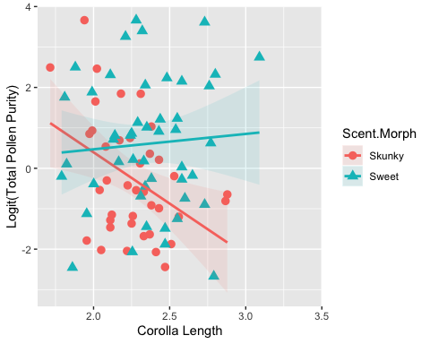

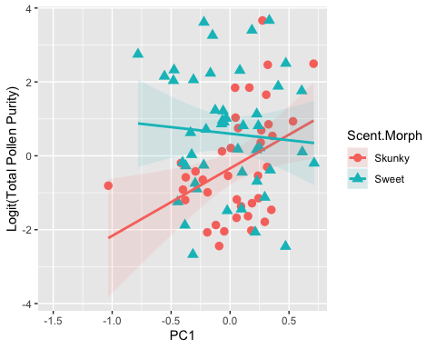

###Effects on No. Other Pollen Types - no significant effects Log-transformed

## numDF denDF F-value p-value  
## (Intercept) 1 82 12.582158 0.0006  
## Corolla.Flare_1 1 82 2.131731 0.1481  
## Scent.Morph 1 82 0.185516 0.6678  
## Corolla.Flare_1:Scent.Morph 1 82 0.512704 0.4760

## numDF denDF F-value p-value  
## (Intercept) 1 82 2.2445375 0.1379  
## Tube.Length_1 1 82 1.2025875 0.2760  
## Scent.Morph 1 82 0.3060133 0.5816  
## Tube.Length_1:Scent.Morph 1 82 0.5518759 0.4597

## numDF denDF F-value p-value  
## (Intercept) 1 82 0.3279978 0.5684  
## Corolla.Length 1 82 3.1394499 0.0801  
## Scent.Morph 1 82 1.6259056 0.2059  
## Corolla.Length:Scent.Morph 1 82 2.0923566 0.1518

## numDF denDF F-value p-value  
## (Intercept) 1 82 506.9271 <.0001  
## PC1 1 82 3.6029 0.0612  
## Scent.Morph 1 82 2.1699 0.1446  
## PC1:Scent.Morph 1 82 1.5710 0.2136