This diagram models a typically university staffing list. We have a department chair as the top level, then the professor, and then the student.

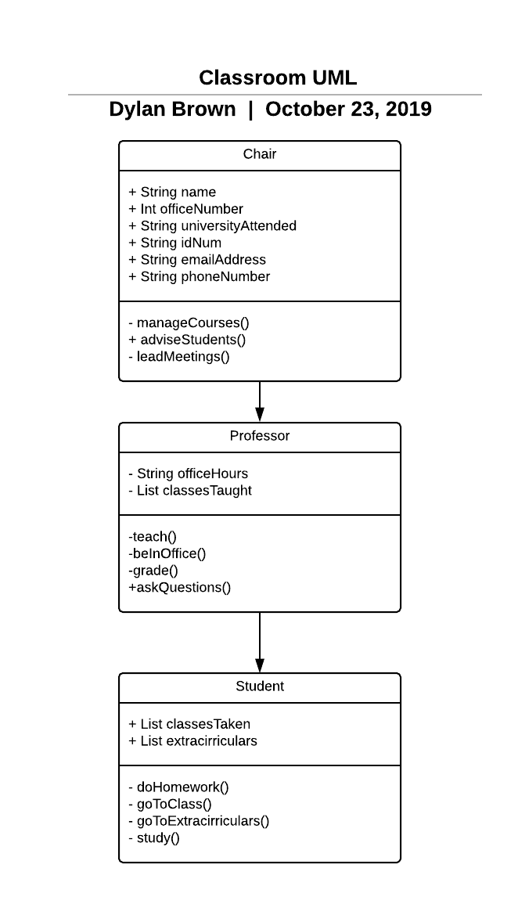

This diagram showcases you and the students in cs250 so far. 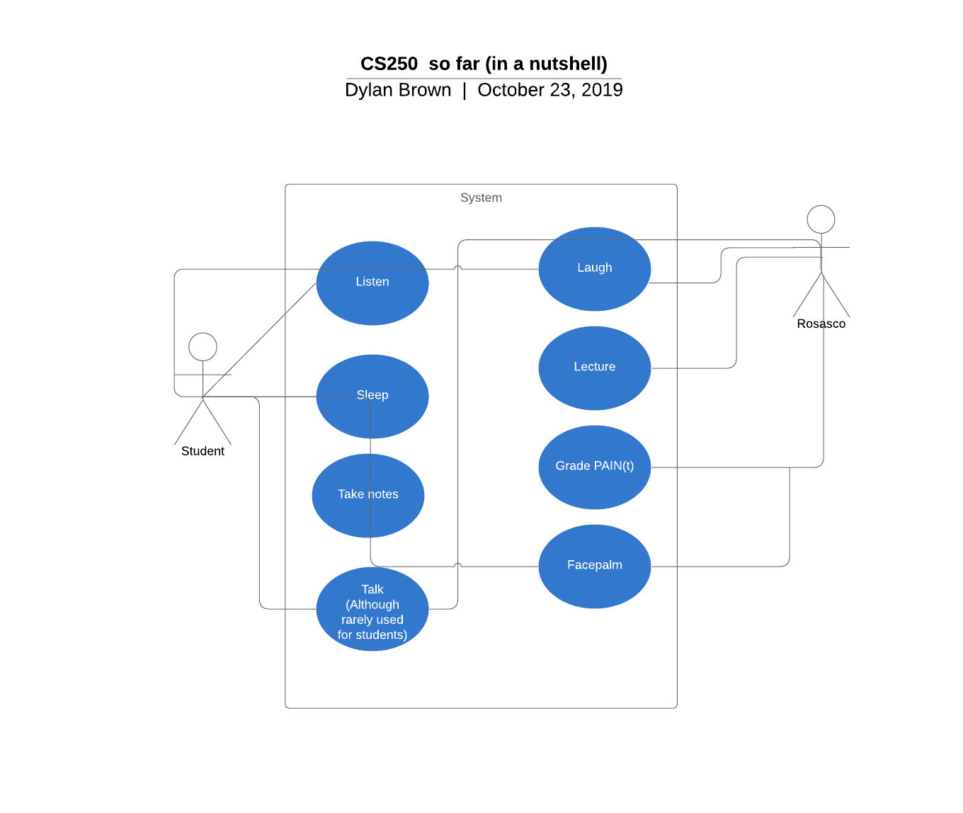

This diagram showcases students going on the Disney trip with professor Budnik.

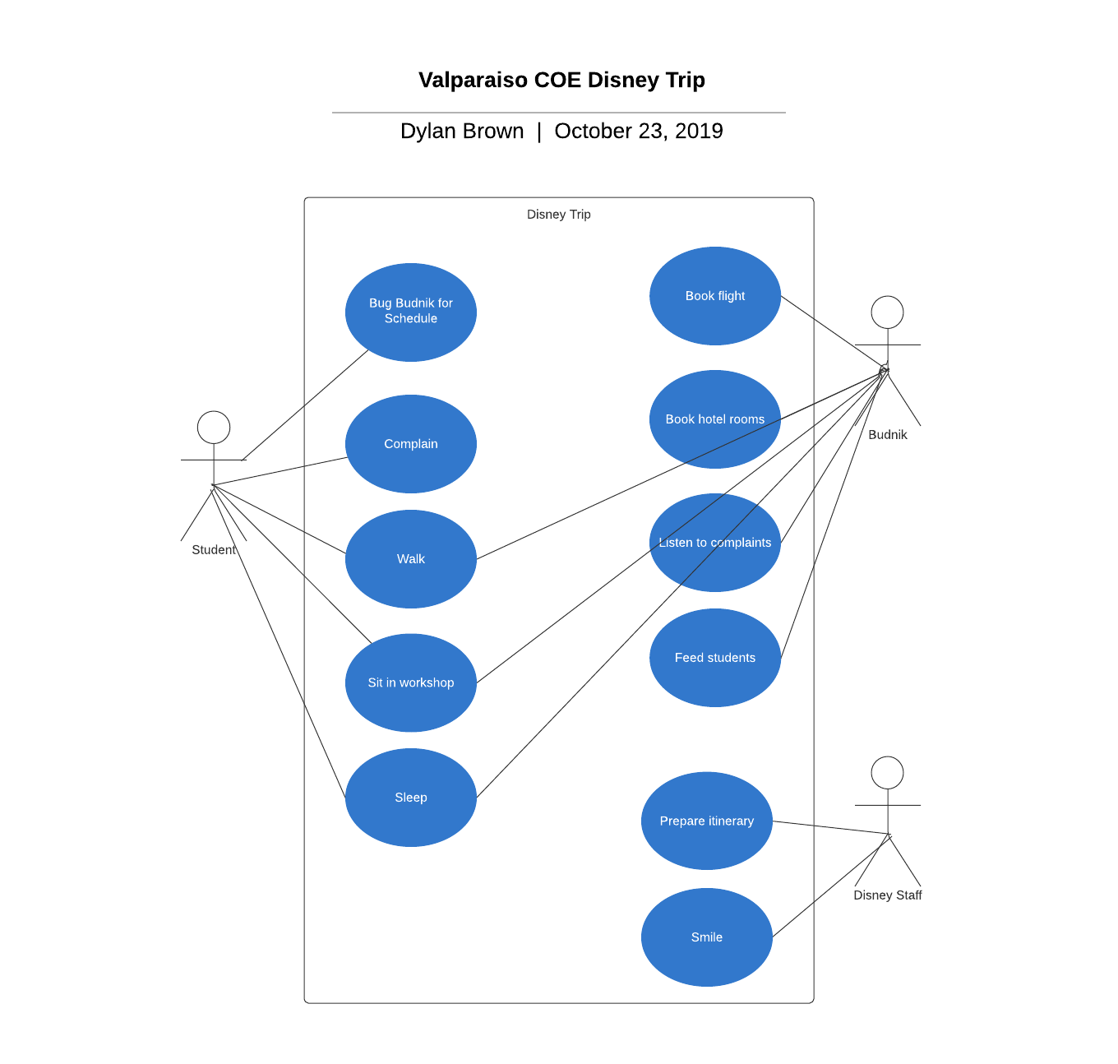

This class models animals. Animal is the top class. Cow chicken and pig are all sub-classes. 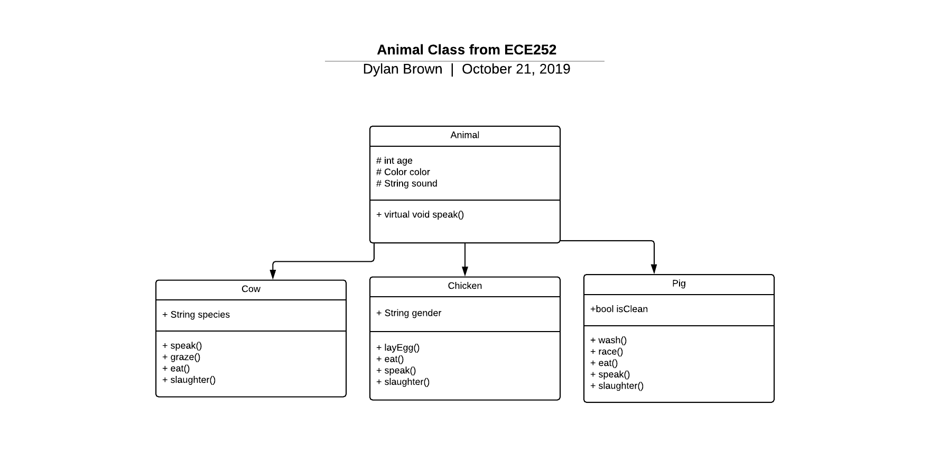

This diagram showcases a typically shift at the Hesse center. 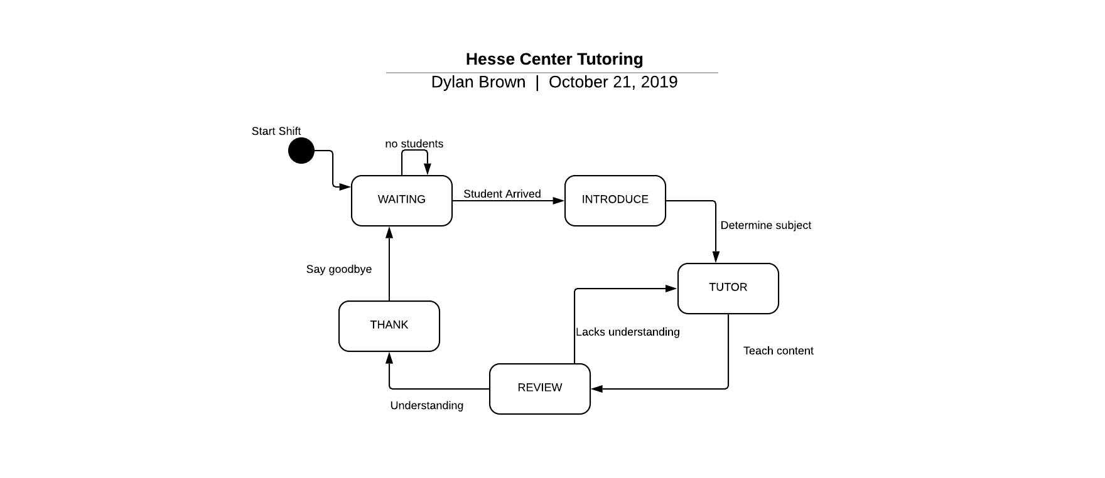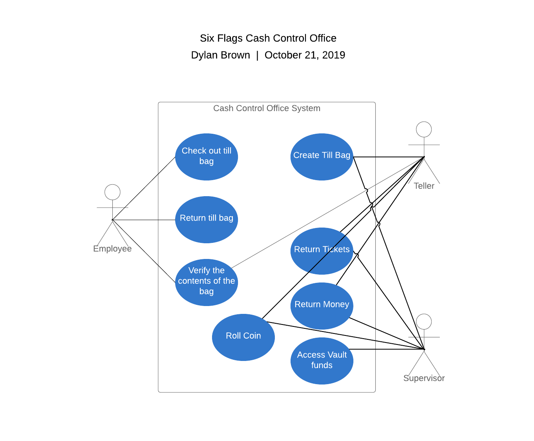

This diagram showcases my old job at six flags. We have different roles in the office.