NOTA:
Entre las comillas hay que escribir el nombre de la variable que debe ir a esa terminal

# Pin assignment for push buton switch.
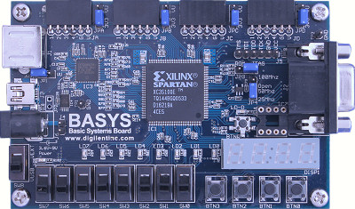
# Suelto =>0 oprimido => 1
# “botones”
NET "" LOC = "G12"; #bt0, el de la derecha
NET "" LOC = "C11"; #bt1
NET "" LOC = "M4"; #bt2
NET "" LOC = "A7"; #bt3, el de la izquierda
Bt0
L0
# Pin assignment for SWs
# Abajo = 0 Arriba =1
NET "" LOC ="P11"; # sw0, el de la derecha
NET "" LOC ="L3"; # sw1
NET "" LOC ="K3"; # sw2
NET "" LOC ="B4"; # sw3
NET "" LOC ="G3"; # sw4
NET "" LOC ="F3"; # sw5
NET "" LOC ="E2"; # sw6
NET "" LOC ="N3"; # sw7, el de la izquierda
SW0

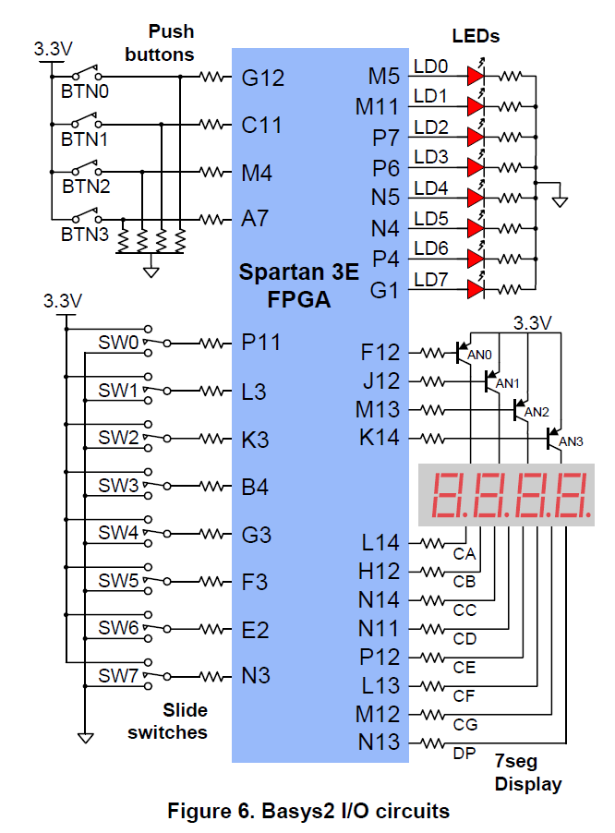
# Pin assignment for LEDs.
# Para encenderlo requiere un 1
NET "" LOC ="M5"; # L0, el de la derecha
NET "" LOC ="M11"; # L1
NET "" LOC ="P7"; # L2
NET "" LOC ="P6"; # L3
NET "" LOC ="N5"; # L4
NET "" LOC ="N4"; # L5
NET "" LOC ="P4"; # L6
NET "" LOC ="G1"; # L7, el de la izquierda

# Pin assignment for Transistors. Para encenderlo con un 0
NET "" LOC = "F12"; # Transistor 0, el de la derecha
NET "" LOC = "J12"; # Transistor 1
NET "" LOC = "M13"; # Transistor 2
NET "" LOC = "K14"; # Transistor 3, el de la izquierda
#Nota, el transistor de la derecha está en F12, no en k14

# Pin assignment for Segments. Para encenderlo con un 0
# NOTA: Como casi siempre el nombre de las variables
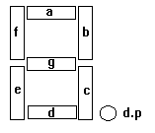
# Corresponde al de los segmentos
NET "a" LOC = "L14"; # segmento a
NET "b" LOC = "H12"; # segmento b
NET "c" LOC = "N14"; # segmento c
NET "d" LOC = "N11"; # segmento d
NET "e" LOC = "P12"; # segmento e
NET "f" LOC = "L13"; # segmento f
NET "g" LOC = "M12"; # segmento g
NET "dp" LOC = "N13"; # punto decimal “dp”

NET "clk" LOC = "B8"; # Bank = 0, Signal name = MCLK reloj interno
NET "rst" LOC = "A7"; #bt3, el de la izquierda.
Cuando la entrada de clk no sea la terminal B8 se requiere: NET "clk" CLOCK_DEDICATED_ROUTE = FALSE;
# En los 4 conectores (JA,JB, JC y JD), la terminal 5 es tierra y la 6 es Vcc
# Son bidireccionales, es decir, cada una de las 16 líneas se puede usar como entrada o salida.
# Si la terminal es usada como salida hay que quitar “ | PULLUP ” y dejar “ | DRIVE = 2 ”
# Si la terminal es usada como entrada hay que quitar “ | DRIVE = 2 ” y dejar “ | PULLUP ”
#
NET "" LOC = "B2" | DRIVE = 2 | PULLUP ; # JA terminal 1, está arriba de SW7Conector JA
NET "" LOC = "A3" | DRIVE = 2 | PULLUP ; # JA terminal 2
NET "" LOC = "J3" | DRIVE = 2 | PULLUP ; # JA terminal 3
NET "" LOC = "B5" | DRIVE = 2 | PULLUP ; # JA terminal 4, está junto a la terminal JA-5, la de tierra

NET "" LOC = "C6" | DRIVE = 2 | PULLUP ; # JB 1, está arriba de SW4
NET "" LOC = "B6" | DRIVE = 2 | PULLUP ; #·JB 2
NET "" LOC = "C5" | DRIVE = 2 | PULLUP ; # JB 3
NET "" LOC = "B7" | DRIVE = 2 | PULLUP ; # JB 4, está junto a la terminal JB-5, la de tierra#
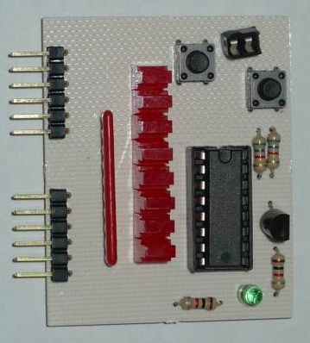
NET "" LOC = "A9" | DRIVE = 2 | PULLUP ; # JC 1
NET "" LOC = "B9" | DRIVE = 2 | PULLUP ; # JC 2
H
G
F
E
-
+

D
C
B
A
-
+
NET "" LOC = "A10" | DRIVE = 2 | PULLUP ; # JC 3
NET "" LOC = "C9" | DRIVE = 2 | PULLUP ; # JC 4
#
NET "" LOC = "C12" | DRIVE = 2 | PULLUP ; # JD 1
NET "" LOC = "A13" | DRIVE = 2 | PULLUP ; # JD 2
NET "" LOC = "C13" | DRIVE = 2 | PULLUP ; # JD 3
NET "" LOC = "D12" | DRIVE = 2 | PULLUP ; # JD 4

Nota: Cuando las terminales de los "headers" de la Basys 2 se usen como entradas hay que usar "PULLUP" y cuando se usen como salida hay que usar "DRIVE = 2".

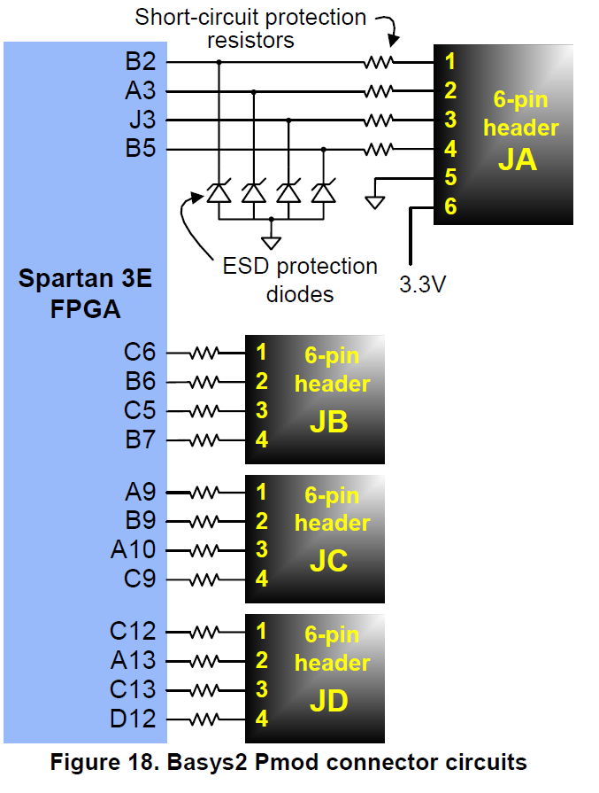
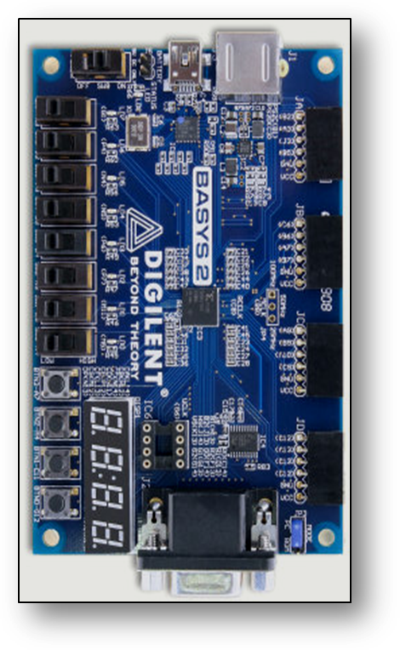
JA
JB
JD
JC
Generador de Tablas de Verdad

Como conectar el Generador de Tablas de Verdad (GTV)
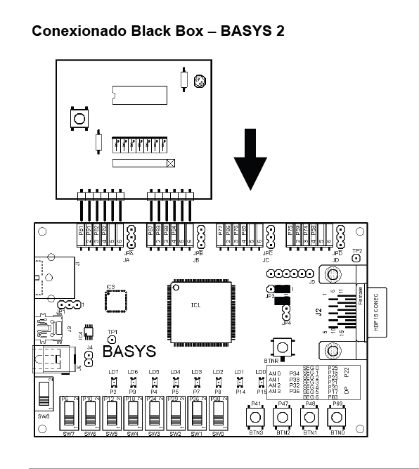
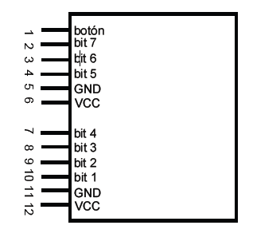
B2 Botón
A3 Bit 6
J3 Bit 5
B5 Bit 4
GND
3.3V

C6 Bit 3
B6 Bit 2
C5 Bit 1
B7 Bit 0
GND
3.3V
Generador de tablas de Verdad GTV
Btn 7 6 5
B2 A3 J3 B5
4 3 2 1
C6 B6 C5 B7

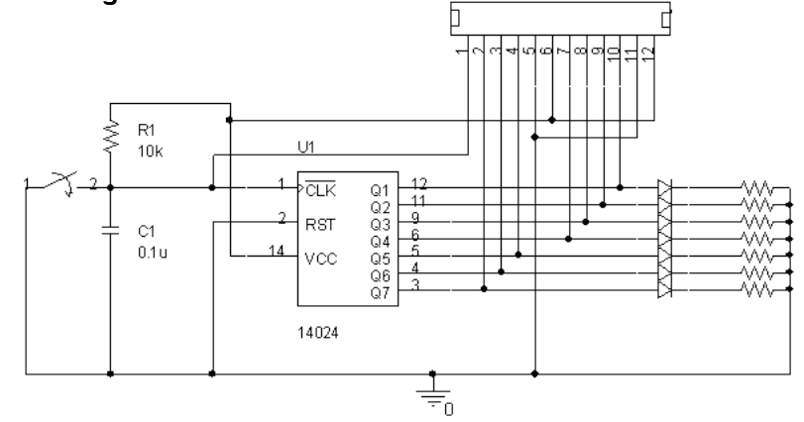

# clock pin for Basys2 Board
NET "mclk" LOC = "B8"; # Bank = 0, Signal name = MCLK reloj interno
NET "uclk" LOC = "M6"; # Bank = 2, Signal name = UCLK reloj externo
NET "mclk" CLOCK_DEDICATED_ROUTE = FALSE;
NET "uclk" CLOCK_DEDICATED_ROUTE = FALSE;

# Pin assignment for EppCtl
# Connected to Basys2 onBoard USB controller
NET "EppAstb" LOC = "F2";
NET "EppDstb" LOC = "F1";
NET "EppWR" LOC = "C2";

NET "EppWait" LOC = "D2";

NET "EppDB<0>" LOC = "N2";
NET "EppDB<1>" LOC = "M2";
NET "EppDB<2>" LOC = "M1";
NET "EppDB<3>" LOC = "L1";
NET "EppDB<4>" LOC = "L2";
NET "EppDB<5>" LOC = "H2";
NET "EppDB<6>" LOC = "H1";
NET "EppDB<7>" LOC = "H3";

# Loop back/demo signals
# Pin assignment for PS2
NET "PS2C" LOC = "B1" | DRIVE = 2 | PULLUP ;
NET "PS2D" LOC = "C3" | DRIVE = 2 | PULLUP ;

# Pin assignment for VGA
NET "HSYNC" LOC = "J14" | DRIVE = 2 | PULLUP ;
NET "VSYNC" LOC = "K13" | DRIVE = 2 | PULLUP ;

NET "OutRed<2>" LOC = "F13" | DRIVE = 2 | PULLUP ;
NET "OutRed<1>" LOC = "D13" | DRIVE = 2 | PULLUP ;
NET "OutRed<0>" LOC = "C14" | DRIVE = 2 | PULLUP ;
NET "OutGreen<2>" LOC = "G14" | DRIVE = 2 | PULLUP ;
NET "OutGreen<1>" LOC = "G13" | DRIVE = 2 | PULLUP ;
NET "OutGreen<0>" LOC = "F14" | DRIVE = 2 | PULLUP ;
NET "OutBlue<2>" LOC = "J13" | DRIVE = 2 | PULLUP ;
NET "OutBlue<1>" LOC = "H13" | DRIVE = 2 | PULLUP ;

Eb digilentinc se encuentra este archive:
Basys2_100_250General.ucf

# This file is a general .ucf for Basys2 rev C board
# To use it in a project:
# - remove or comment the lines corresponding to unused pins
# - rename the used signals according to the project

# clock pin for Basys2 Board
NET "mclk" LOC = "B8"; # Bank = 0, Signal name = MCLK
NET "uclk" LOC = "M6"; # Bank = 2, Signal name = UCLK
NET "mclk" CLOCK_DEDICATED_ROUTE = FALSE;
NET "uclk" CLOCK_DEDICATED_ROUTE = FALSE;

# Pin assignment for EppCtl
# Connected to Basys2 onBoard USB controller
NET "EppAstb" LOC = "F2"; # Bank = 3
NET "EppDstb" LOC = "F1"; # Bank = 3
NET "EppWR" LOC = "C2"; # Bank = 3

NET "EppWait" LOC = "D2"; # Bank = 3

NET "EppDB<0>" LOC = "N2"; # Bank = 2
NET "EppDB<1>" LOC = "M2"; # Bank = 2
NET "EppDB<2>" LOC = "M1"; # Bank = 3
NET "EppDB<3>" LOC = "L1"; # Bank = 3
NET "EppDB<4>" LOC = "L2"; # Bank = 3
NET "EppDB<5>" LOC = "H2"; # Bank = 3
NET "EppDB<6>" LOC = "H1"; # Bank = 3
NET "EppDB<7>" LOC = "H3"; # Bank = 3

# Pin assignment for DispCtl
# Connected to Basys2 onBoard 7seg display
NET "seg<0>" LOC = "L14"; # Bank = 1, Signal name = CA
NET "seg<1>" LOC = "H12"; # Bank = 1, Signal name = CB
NET "seg<2>" LOC = "N14"; # Bank = 1, Signal name = CC
NET "seg<3>" LOC = "N11"; # Bank = 2, Signal name = CD
NET "seg<4>" LOC = "P12"; # Bank = 2, Signal name = CE
NET "seg<5>" LOC = "L13"; # Bank = 1, Signal name = CF
NET "seg<6>" LOC = "M12"; # Bank = 1, Signal name = CG
NET "dp" LOC = "N13"; # Bank = 1, Signal name = DP

NET "an<3>" LOC = "K14"; # Bank = 1, Signal name = AN3
NET "an<2>" LOC = "M13"; # Bank = 1, Signal name = AN2
NET "an<1>" LOC = "J12"; # Bank = 1, Signal name = AN1
NET "an<0>" LOC = "F12"; # Bank = 1, Signal name = AN0

# Pin assignment for LEDs
NET "Led<7>" LOC = "G1" ; # Bank = 3, Signal name = LD7
NET "Led<6>" LOC = "P4" ; # Bank = 2, Signal name = LD6
NET "Led<5>" LOC = "N4" ; # Bank = 2, Signal name = LD5
NET "Led<4>" LOC = "N5" ; # Bank = 2, Signal name = LD4
NET "Led<3>" LOC = "P6" ; # Bank = 2, Signal name = LD3
NET "Led<2>" LOC = "P7" ; # Bank = 3, Signal name = LD2
NET "Led<1>" LOC = "M11" ; # Bank = 2, Signal name = LD1
NET "Led<0>" LOC = "M5" ; # Bank = 2, Signal name = LD0

# Pin assignment for SWs
NET "sw<7>" LOC = "N3"; # Bank = 2, Signal name = SW7
NET "sw<6>" LOC = "E2"; # Bank = 3, Signal name = SW6
NET "sw<5>" LOC = "F3"; # Bank = 3, Signal name = SW5
NET "sw<4>" LOC = "G3"; # Bank = 3, Signal name = SW4
NET "sw<3>" LOC = "B4"; # Bank = 3, Signal name = SW3
NET "sw<2>" LOC = "K3"; # Bank = 3, Signal name = SW2
NET "sw<1>" LOC = "L3"; # Bank = 3, Signal name = SW1
NET "sw<0>" LOC = "P11"; # Bank = 2, Signal name = SW0

NET "btn<3>" LOC = "A7"; # Bank = 1, Signal name = BTN3
NET "btn<2>" LOC = "M4"; # Bank = 0, Signal name = BTN2
NET "btn<1>" LOC = "C11"; # Bank = 2, Signal name = BTN1
NET "btn<0>" LOC = "G12"; # Bank = 0, Signal name = BTN0

# Loop back/demo signals
# Pin assignment for PS2
NET "PS2C" LOC = "B1" | DRIVE = 2 | PULLUP ; # Bank = 3, Signal name = PS2C
NET "PS2D" LOC = "C3" | DRIVE = 2 | PULLUP ; # Bank = 3, Signal name = PS2D

# Pin assignment for VGA
NET "HSYNC" LOC = "J14" | DRIVE = 2 | PULLUP ; # Bank = 1, Signal name = HSYNC
NET "VSYNC" LOC = "K13" | DRIVE = 2 | PULLUP ; # Bank = 1, Signal name = VSYNC

NET "OutRed<2>" LOC = "F13" | DRIVE = 2 | PULLUP ; # Bank = 1, Signal name = RED2
NET "OutRed<1>" LOC = "D13" | DRIVE = 2 | PULLUP ; # Bank = 1, Signal name = RED1
NET "OutRed<0>" LOC = "C14" | DRIVE = 2 | PULLUP ; # Bank = 1, Signal name = RED0
NET "OutGreen<2>" LOC = "G14" | DRIVE = 2 | PULLUP ; # Bank = 1, Signal name = GRN2
NET "OutGreen<1>" LOC = "G13" | DRIVE = 2 | PULLUP ; # Bank = 1, Signal name = GRN1
NET "OutGreen<0>" LOC = "F14" | DRIVE = 2 | PULLUP ; # Bank = 1, Signal name = GRN0
NET "OutBlue<2>" LOC = "J13" | DRIVE = 2 | PULLUP ; # Bank = 1, Signal name = BLU2
NET "OutBlue<1>" LOC = "H13" | DRIVE = 2 | PULLUP ; # Bank = 1, Signal name = BLU1

# Loop Back only tested signals
NET "PIO<72>" LOC = "B2" | DRIVE = 2 | PULLUP ; # Bank = 1, Signal name = JA1
NET "PIO<73>" LOC = "A3" | DRIVE = 2 | PULLUP ; # Bank = 1, Signal name = JA2
NET "PIO<74>" LOC = "J3" | DRIVE = 2 | PULLUP ; # Bank = 1, Signal name = JA3
NET "PIO<75>" LOC = "B5" | DRIVE = 2 | PULLUP ; # Bank = 1, Signal name = JA4

NET "PIO<76>" LOC = "C6" | DRIVE = 2 | PULLUP ; # Bank = 1, Signal name = JB1
NET "PIO<77>" LOC = "B6" | DRIVE = 2 | PULLUP ; # Bank = 1, Signal name = JB2
NET "PIO<78>" LOC = "C5" | DRIVE = 2 | PULLUP ; # Bank = 1, Signal name = JB3
NET "PIO<79>" LOC = "B7" | DRIVE = 2 | PULLUP ; # Bank = 1, Signal name = JB4

NET "PIO<80>" LOC = "A9" | DRIVE = 2 | PULLUP ; # Bank = 1, Signal name = JC1
NET "PIO<81>" LOC = "B9" | DRIVE = 2 | PULLUP ; # Bank = 1, Signal name = JC2
NET "PIO<82>" LOC = "A10" | DRIVE = 2 | PULLUP ; # Bank = 1, Signal name = JC3
NET "PIO<83>" LOC = "C9" | DRIVE = 2 | PULLUP ; # Bank = 1, Signal name = JC4

NET "PIO<84>" LOC = "C12" | DRIVE = 2 | PULLUP ; # Bank = 1, Signal name = JD1
NET "PIO<85>" LOC = "A13" | DRIVE = 2 | PULLUP ; # Bank = 2, Signal name = JD2
NET "PIO<86>" LOC = "C13" | DRIVE = 2 | PULLUP ; # Bank = 1, Signal name = JD3
NET "PIO<87>" LOC = "D12" | DRIVE = 2 | PULLUP ; # Bank = 2, Signal name = JD4

Asignación de terminales (constraints) de la BASYS2.
0000.doc

Nomenclatura que vamos a usar para entendernos.

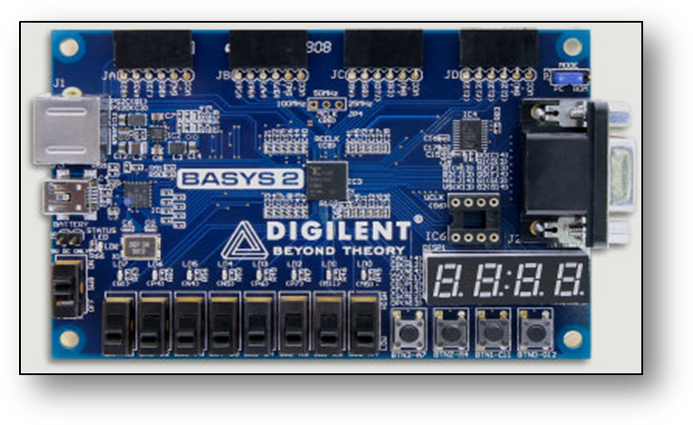
Arriba
Abajo
Izquierda
Derecha
Interruptores deslizables SW’s
Interruptores botones o push BTN
Displays de 7 segmentos
Led’s

