Results - “**A Review of Voltage Distribution on Metal Oxide Surge Arrester and Suggestions for Improvement in High Voltage Applications**”

Effect of Stray Capacitance (SC) on Voltage Distribution

There is a non-uniformity of voltage distribution when rating of MOSAs are increased. The major problem of non-uniform voltage distribution is presence of stray capacitance. This stray capacitance increases with height as well as rating of arrester. For this study, six MOSAs (66kV, 132 kV, 198 kV, 264 kV, 330 kV and 396kV) are considered. The voltage rating of single stack arrester is 66 kV. The dimension of 66 kV is presented in Fig. 1. Initially, a single stack arrester is drawn based on given dimension in finite element software package. The various materials are assigned using finite element method. After this, execution is performed in finite element method and stray capacitance result is computed.

The same procedure is repeated for two to six stack MOSAs and stray capacitance values are tabulated as in Table 2.

## Fig. 1 Arrester blocks and Dimensional details of single stack arrester (mm)

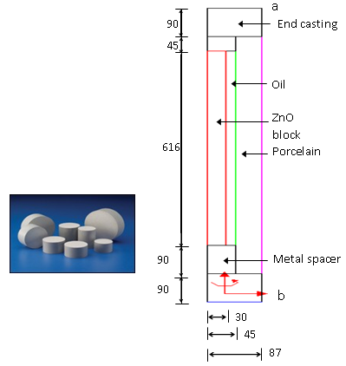

The same procedure is repeated for two to six stack MOSAs and stray capacitance values are tabulated as in Table 2.

Table 2 Stray Capacitance - different heights

|  |  |  |
| --- | --- | --- |
| kV | Ht  (mm) | SC  (pF) |
| 66 | 2116 | 2.1 |
| 132 | 2732 | 4.58 |
| 198 | 3348 | 6.78 |
| 264 | 3964 | 8.86 |
| 330 | 4580 | 10.78 |
| 396 | 5196 | 14.61 |

Fig. 2 Voltage Distribution -Various heights (S: no. of stacks)

Similarly, using above procedure using finite element method, voltage distribution values are plotted for single stack, three stacks and six stacks MOSAs. The graphs are drawn between percentage height of arrester and per unit voltage. This shows as the height of arrester is increased, there is more non-uniformity in voltage distribution (Fig. 2).

