Results - “**A Review of Voltage Distribution on Metal Oxide Surge Arrester and Suggestions for Improvement in High Voltage Applications**”

Voltage Distribution of MOSA under non-conduction mode – a Case Study

A voltage rating of 198 kV (three stack) arrester is taken as case study. Voltage Distribution analysis using finite element method under non-conduction mode without and with one & two grading rings are made. Initially, a three stack arrester (3×66kV=198kV) is drawn based on given dimension in finite element software package. The various materials are assigned using finite element method. After this, execution is performed in finite element method and voltage distribution result are computed.

Fig. 3 (a) 3-stack MOSA with two grading rings Fig. 3 (b) Location of Grading Ring-mm (GR)

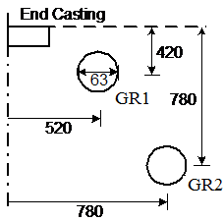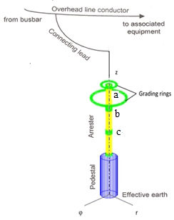

Fig. 3 (c) Voltage distribution for 3-stack arrester

