Results - “**A Review of Voltage Distribution on Metal Oxide Surge Arrester and Suggestions for Improvement in High Voltage Applications**”

Voltage Distribution of MOSA under conduction mode (lightning) – a Case Study

A voltage rating of 198 kV (three stack) arrester is taken as case study. The computed values of stray capacitance is incorporated for transient studies. The three stack MOSA is modelled for transient study and executed in transient program by injecting 10 kA,8/20 μs current surge.

Fig. 3 (a) 3-stack MOSA with two grading rings Fig. 3 (b) Location of Grading Ring-mm (GR)

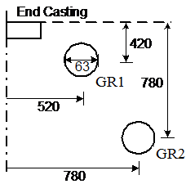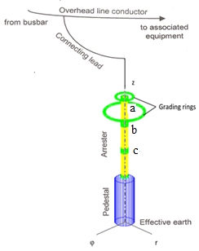

Software Coding

*

* . . . . . . . Case identification card

three sec198kV MOSA 0. 0.

*MOA model for fast transients 0. 0.

*

* . . . . . . . Time card

0.3e-9 12.e-6 1.e-1210 10 1

* 1.e-10 5.e-8 10 1

* 1.e-9 5.e-5 10 1

* 1.e-10 5.e-8 10 1

*

* . . . . . . . Lumped RLC branch

src bu11 .001 3

bu11 bu12 0.66 3

bu12 bu13 .12 3

bu21 bu22 0.66 3

bu22 bu23 .12 3

bu31 bu32 0.66 3

bu32 bu33 .12 3

bu12 bu22 41.e-6

bu22 bu32 41.e-6

bu32 41.e-6

bu13 20.e-6

bu23 20.e-6

bu33 20.e-6

bu11 bu22 10.e6

bu21 bu32 10.e6

bu31 10.e6

bu13 10.e9 3

$ = = End of level 1: Linear and nonlinear elements = = = = = = = = = = = =

*

92 bu12 bu22 19.8 190.e3 0.000002 3

92 bu12 bu22 3.046 211.8e3 0.000002

92 bu12 bu22 1.4667 227.6e3 0.000002

92 bu12 bu22 1.606 263.3e3 0.000002

92 bu22 bu32 19.8 190.e3 0.000002 3

92 bu22 bu32 3.046 211.8e3 0.000002

92 bu22 bu32 1.4667 227.6e3 0.000002

92 bu22 bu32 1.606 263.3e3 0.000002

92 bu32 19.8 190.e3 0.000002 3

92 bu32 3.046 211.8e3 0.000002

92 bu32 1.4667 227.6e3 0.000002

92 bu32 1.606 263.3e3 0.000002

92 bu13 bu22 4.62 155.4e3 0.000002 3

92 bu13 bu22 2.566 180.1e3 0.000002

92 bu13 bu22 1.7467 199.9e3 0.000002

92 bu13 bu22 1.3978 212.8e3 0.000002

92 bu23 bu32 4.62 160.4e3 0.000002 3

92 bu23 bu32 2.566 190.1e3 0.000002

92 bu23 bu32 1.7467 219.9e3 0.000002

92 bu23 bu32 1.3978 222.8e3 0.000002

92 bu33 4.62 155.4e3 0.000002 3

92 bu33 2.566 180.1e3 0.000002

92 bu33 1.7467 199.9e3 0.000002

92 bu33 1.3978 212.8e3 0.000002

*

* . . . . . . . Voltage or current sources

*15 src-2 5.0e3 1.e-6 5.e-6 -1.e-4 9999

*15 src-2 10.e3 1.e-6 10.e-6 0. 9999.

15 src-6 10.e3 8.e-6 20.e-6 -1.e-4 9999.

srd src

1 **** All voltages will be printed ****

Simulated Result

The voltage values are measured in three metal flanges (a, b, c) and shown in Fig. 4.a.

Fig. 4 (a) Voltage distribution during current surge of 10 kA,8/20 μs

a, b, c: metal flanges

