Results - “**A Review of Voltage Distribution on Metal Oxide Surge Arrester and Suggestions for Improvement in High Voltage Applications**”

Voltage Distribution of MOSA under conduction mode (lightning) – a Case Study

A voltage rating of 198 kV (three stack) arrester is taken as case study. The computed values of stray capacitance is incorporated for transient studies. The three stack MOSA is modelled for transient study and executed in transient program by injecting 10 kA,8/20 μs current surge.

Fig. 3 (a) 3-stack MOSA with two grading rings Fig. 3 (b) Location of Grading Ring-mm (GR)

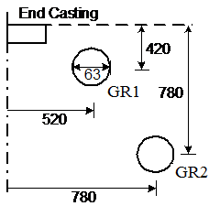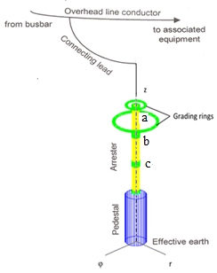

Software Coding

*

* . . . . . . . Case identification card

Simplified IEEE model with NLR

*

* . . . . . . . Time card

* 1.e-10 20e-9 10 1

1.e-9 30e-9 10 1

* 1.e-9 5.e-5 10 1

*

* . . . . . . . Lumped RLC branch

nod1 nod2 0. 388. 3.e5 1.0 1 3

nod2 nod3 0. 388. 3.0e5 1.0 1 3

nod3 src 0. 78. 3.e5 .007 1 3

src srd .001 3

sre nod4 0. 78. 3.e5 .007 1 3

nod4 bus1 0. 388. 3.0e5 .01 1 3

bus1 bus2 2.0e-3 3

bus2 bus3 5.9e-3 3

bus3 nod5 0. 388. 3.e5 .01 1 3

* bus3 nod2 .35 1.33 .0225 1.65

bus1 1.e7

bus2 1.e-4

nod5 1.e-6

bus3 nod5 1.

* nod1 1.e8

bus2 100e-6

*

* . . . . . . . Nonlinear resistance (card 1)

92bus2 .001 13

*

* . . . . . . . Nonlinear resistance (card 2)

-20.e3-670.4e3

-10.e3-627.4e3

-3.e3-581.7e3

-1.e3-552.3e3

-.1e3-511.3e3

-2.e-6-425.2e3

0. 0.

2.e-6 425.2e3

.1e3 511.3e3

1.e3 552.3e3

3.e3 581.7e3

10.e3 627.4e3

20.e3 670.4e3

9999999.

*

* . . . . . . . Nonlinear resistance (card 1)

92bus3 .001 23

*

* . . . . . . . Nonlinear resistance (card 2)

-20.e3-572.8e3

-10.e3-529.7e3

-3.e3-484.1e3

-1.e3-454.6e3

-.1e3 -413.7e3

-2.e-6-327.1e3

0. 0.

2.e-6 327.1e3

.1e3 413.7e3

1.e3 454.6e3

3.e3 484.1e3

10.e3 529.7e3

20.e3 572.8e3

9999999.

$ = = End of level 1: Linear and nonlinear elements = = = = = = = = = = = =

*

* . . . . . . . Time-controlled switch

srd sre -1.e-3 1.e9 3

$ = = = End of level 2: Switches and piecewise linear elements = = = = = = = =

*

* . . . . . . . Voltage or current sources

*15 src-2 10.e3 1.e-7 10.e-6 -1.e-4 9999

15 src-6 10.e3 8.e-6 20.e-6 -1.e-4 9999

*15 src-2 10.e3 5.e-9 10.e-6 -1.e-4 9999

*15 src-2 10.e3 1.e-8 10.e-6 -1.e-4 9999.

*15 src-2 10.e3 1.e-6 10.e-6 -1.e-4 9999

$ = = = End of level 3: Sources = = = = = = = = = = = = = = = = = = = = = = =

1 **** All voltages will be printed ****

$ = = = Level 5: End of data case = = = = = = = = = = = = = = = = = = = = = =

Fig. 5. (a) Conduction of 10 kA,8μs/20μs current surge

