Results - “**A Review of Voltage Distribution on Metal Oxide Surge Arrester and Suggestions for Improvement in High Voltage Applications**”

Fig. 2 VD -Various heights (S: no. of stacks)

Three graphs are drawn for arresters having single stack, three stacks and six stacks

The graphs are drawn between percentage height of arrester and per unit voltage.

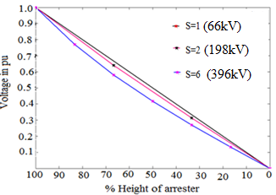

Fig. 3c Voltage distribution for 3-stack arrester

This graph is for non-conduction mode of metal oxide surge arrester. The dimension of single stack arrester (66 kV) is given in Fig. 1. Three stack (3×66kV=198kV) arrester is drawn based on dimension of single stack arrester. This three stack arrester is drawn in finite element method and materials are assigned. After drawing, executed in finite element method and results are plotted for without grading rings. The same procedure is repeated with one grading ring and two grading rings. The dimensions of grading rings are given in Fig. 3b. After simulating in finite element method, the Fig. 3c is obtained.

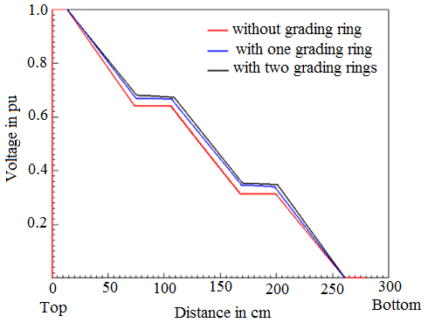

Fig. 4.a Voltage distribution during current surge of 10 kA,8/20 μs (a, b, c: metal flanges)

This graph is for conduction mode of metal oxide surge arrester with 198 kV (3×66kV) rating. Electrical transients based program is used for simulation. The surge arrester is modelled for lightning surge (10 kA,8/20 μs). In this model, distributed parameters are considered. The input current surge is taken as lightning surge (10 kA,8/20 μs). During simulation, much focus is given on maximum size and step size of time. The residual voltage of arrester is noted from the three metal flanges (a, b, c) of arrester. This shows the voltage distribution of three stack arrester when lightning surge (10 kA,8/20 μs) is injected.

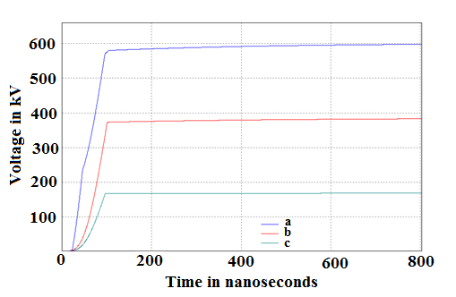

Fig. 4(b) Voltage distribution during current surge of 10 kA,5ns/10 μs (a, b, c: metal flanges)

This graph is for conduction mode of metal oxide surge arrester with 198 kV (3×66kV) rating. Electrical transients based program is used for simulation. The surge arrester is modelled for lightning surge (10 kA,5ns/10 μs). In this model, distributed parameters are considered. The input current surge is taken as lightning surge (10 kA, 5ns/10 μs). During simulation, much focus is given on maximum size and step size of time. The residual voltage of arrester is noted from the three metal flanges (a, b, c) of arrester. This shows the voltage distribution of three stack arrester when lightning surge (10 kA,5ns/10 μs) is injected.

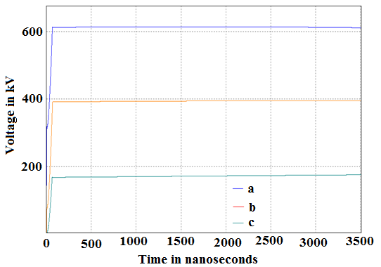

Fig. 5. (a) Conduction of 10 kA,8μs/20μs current surge

This graph is for conduction mode of metal oxide surge arrester with 198 kV (3×66kV) rating. Electrical transients based program is used for simulation. The surge arrester is modelled for lightning surge (10 kA,8/20 μs). In this model, distributed parameters are considered. The input current surge is taken as lightning surge (10 kA,8/20 μs). During simulation, much focus is given on maximum size and step size of time. The residual voltage of arrester is obtained from topmost stack of three stack arrester. The applied current is also plotted along with residual voltage of arrester, in order to observe the delay between residual voltage and current surge. Here the peak of residual voltage occurs before the peak of current surge, showing successful conduction of arrester.

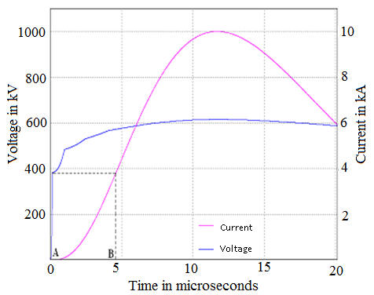

Fig. 5. (b) Conduction of 10 kA,5ns/10μs current surge (delay in response)

This graph is for conduction mode of metal oxide surge arrester with 198 kV (3×66kV) rating. Electrical transients based program is used for simulation. The surge arrester is modelled for lightning surge (10 kA,5ns/10 μs). In this model, distributed parameters are considered. The input current surge is taken as lightning surge (10 kA,5ns/10 μs). During simulation, much focus is given on maximum size and step size of time. The residual voltage of arrester is obtained from topmost stack of three stack arrester. The applied current is also plotted along with residual voltage of arrester, in order to observe the delay between residual voltage and current surge. Here the peak of residual voltage occurs after the peak of current surge, showing non-conduction of arrester. Hence the requirement of successful conduction of arrester is occurrence of peak of residual voltage before the peak of current surge.

