## Fig. 1 Arrester blocks and Dimensional details of single stack arrester (mm)

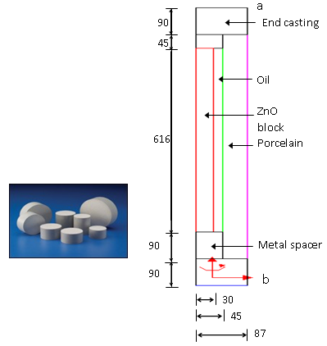

Fig. 3 (a) 3-stack MOSA with two grading rings

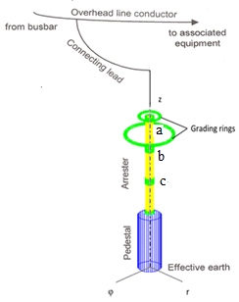

Fig. 3 (b) Location of Grading Ring-mm (GR)

