# History of Linux Mint Operating System

|  |  |
| --- | --- |
| **Date** | 2021-12-06 14:22:17 |

Linux Mint was developed and released by Clement Lefebrvre in France in 2006. His aim was to design the ubuntu distribution for elegance. Elegance of an operating system depends on user feedback, ease of use and pleasant colour layouts/schemes. Linux Mint OS is based on both Ubuntu and Debian operating systems. LDME is the Linux Mint Debian Edition based on Debian Operating System that is used in raspberry Pie products. Linux Mint supports full multimedia. There was a recent release of Linux Mint 20.2 edition known as Uma ((S, 2021).

[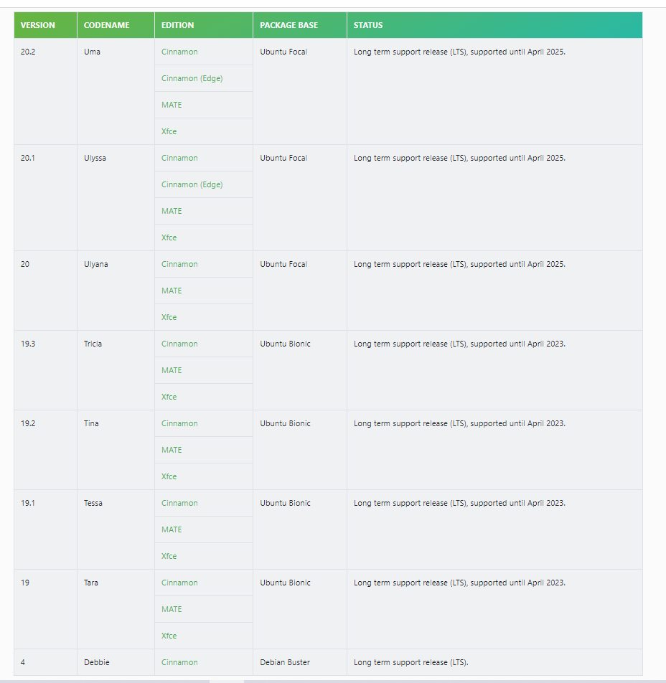](http://35.173.84.151/wp-content/uploads/2021/12/Linux-Mint-editions.png)

Linux Mint Editions (S, 2021).