# Market Statistics

|  |  |
| --- | --- |
| **Date** | 2021-12-06 14:46:03 |

Table: Ireland's percentage shares of operating systems that are used ((Desktop Operating System Market Share in Ireland - November 2021, 2021)

|  |  |
| --- | --- |
| iOS | 31.4% |
| Android | 29.33% |
| Windows | 26.38% |
| OS X | 9.17% |
| Linux | 1.26% |

[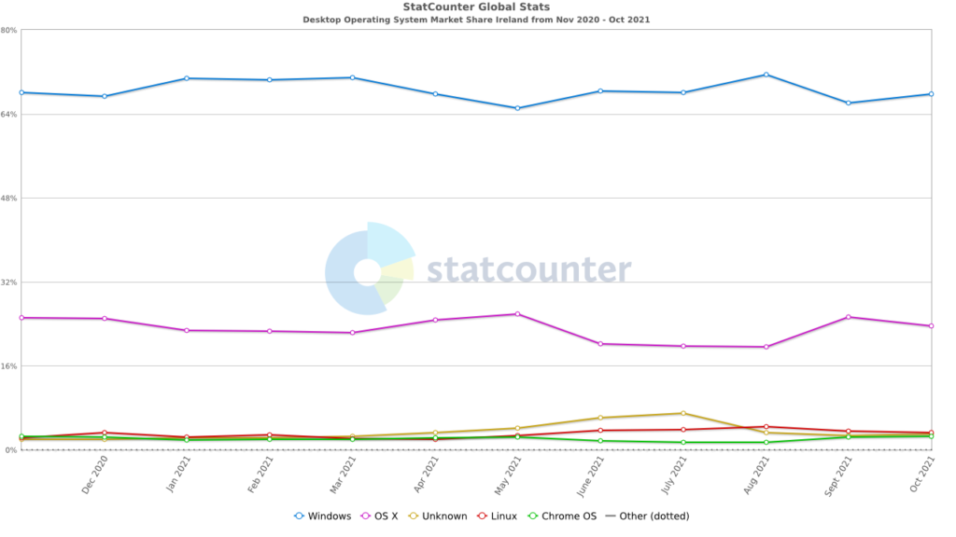](http://35.173.84.151/wp-content/uploads/2021/12/StatCounter-os_combined-IE-monthly-202011-202110.png)

Graph: Irish statistics graph of operating system usage by the Irish population (Desktop Operating System Market Share in Ireland - November 2021, 2021).

Windows currently have majority usage by users globally while Linux has 2% users. MAC-OS has 7% users because Mac is a Linux hybrid with the design and user-friendliness (Vardhman, 2021).