# Unique Features

|  |  |
| --- | --- |
| **Date** | 2021-12-06 14:37:50 |

Linux Mint has desktop environments to choose from like default desktops- Cinnamon, KDE, MATE, Xfce. Linux Mint has pre-installed software including Firefox, Transmission, LibreOffice, XChat, Pidgin, Thunderbird and GIMP. Hypnotix is one app installed on Linux Mint. I used Hypnotix to watch TV channels like those from NASA space station, RTE channel and 3e Irish TV channels. The quality and speed of transmission was adequate to watch the summer international football matches (Hypnotix, 2021).

[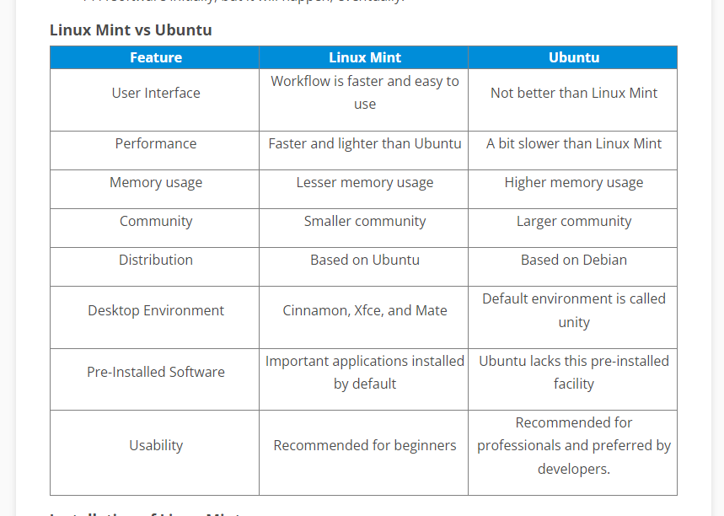](http://35.173.84.151/wp-content/uploads/2021/12/Linux-Mint-v-Ubuntu.png)

Table: Linux Mint versus Ubuntu comparison (What is Linux Mint and how is it better than Ubuntu?, 2019).