# Unix structure

|  |  |
| --- | --- |
| **Date** | 2021-12-07 11:47:52 |

UNIX -limited structuring, has 2 separable parts •Systems programs •Kernel •everything below system call interface and above physical hardware. •Filesystem, CPU scheduling, memory management

[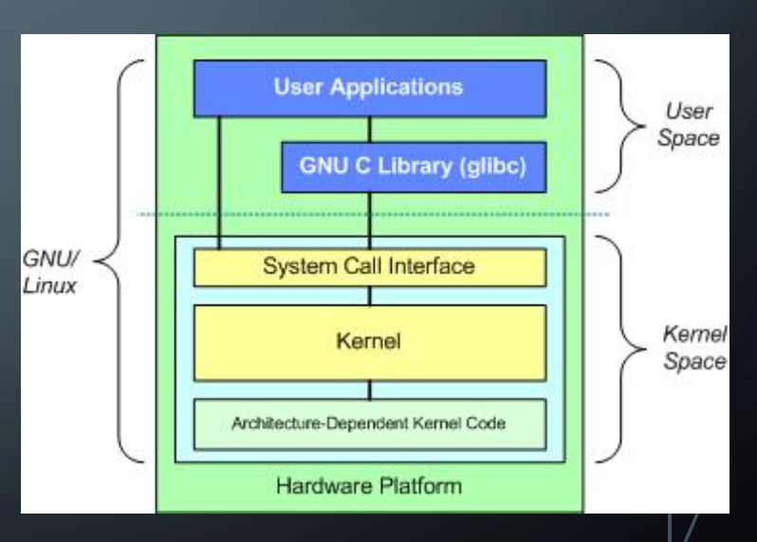](http://35.173.84.151/wp-content/uploads/2021/12/Linux-architecture-kernel-protected-from-user-space.png)

Linux-architecture-kernel-protected-from-user-space.png

1. Monolithic kernels are big in size, while microkernels are small in size - they usually fit into the processor's L1 cache (first generation microkernels).
2. In monolithic kernels, the device drivers reside in the kernel space while in the microkernels the device drivers are user-spaceSource: https://stackoverflow.com/questions/4537850/what-is-difference-between-monolithic-and-micro-kernel (Malallah et al., 2021).