**Benefits Highlight Reporting Guide**

Benefits reporting is to be completed quarterly in line with the Highlight Reporting WD 05 cycles. Please refer to the table below for required data input timelines and quarter reporting.



The benefits app is accessible via the highlight reporting tool.

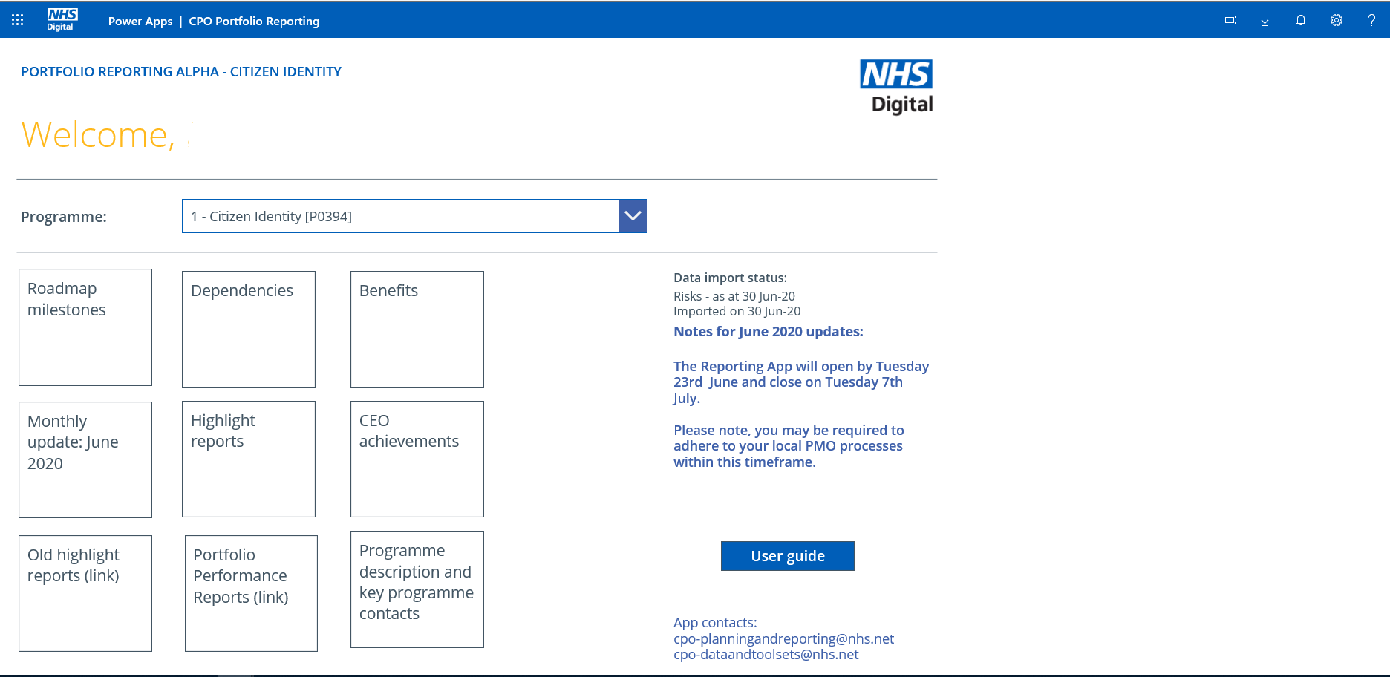

By selecting the benefits tile you will be taken to the CPMO SyS

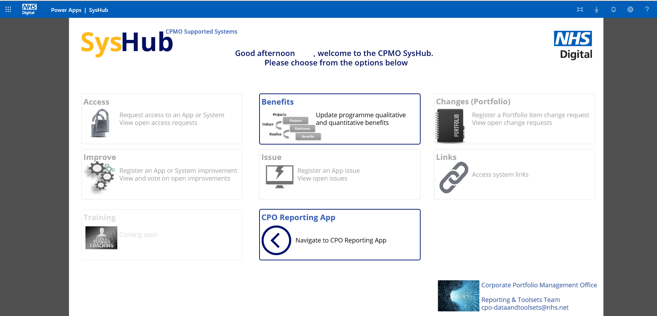

By selecting the benefits option you will be taken to the following benefits landing page where you will be presented with 4 benefits data tiles:

* Monetised benefits
* Quality benefits
* Dependencies and benefits challenges
* Benefits realisation details

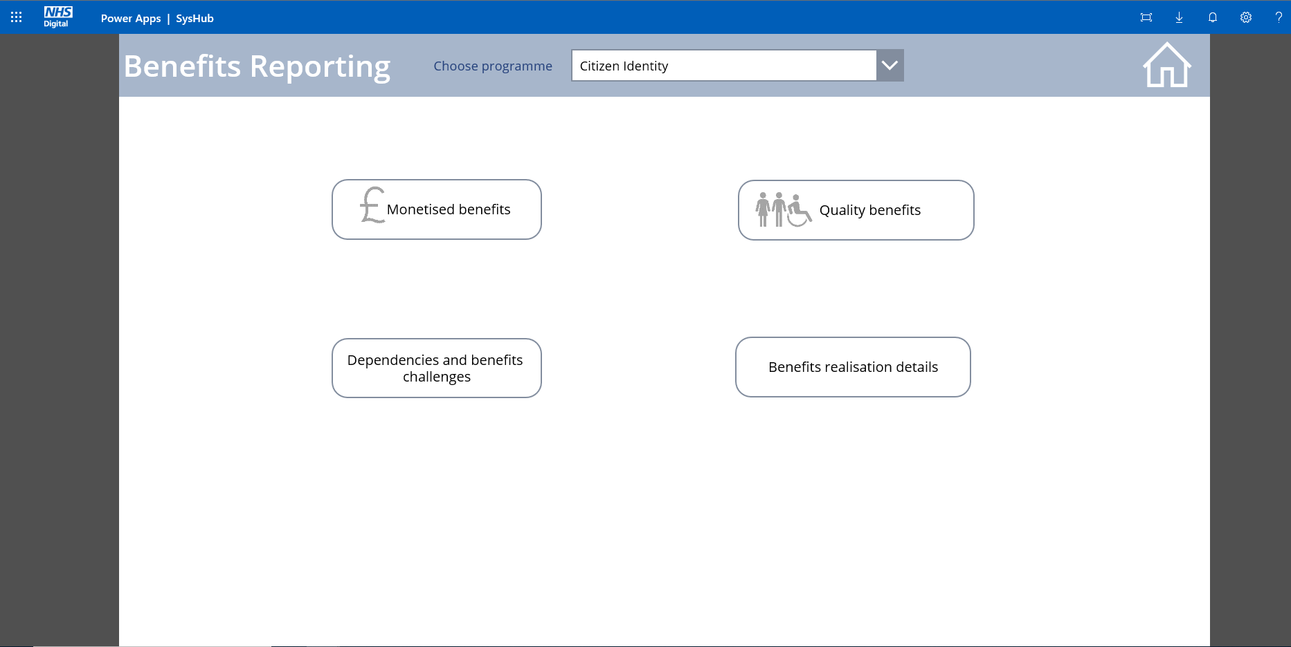

Start by selecting your programme from the drop-down list and then select the area that you wish to update.

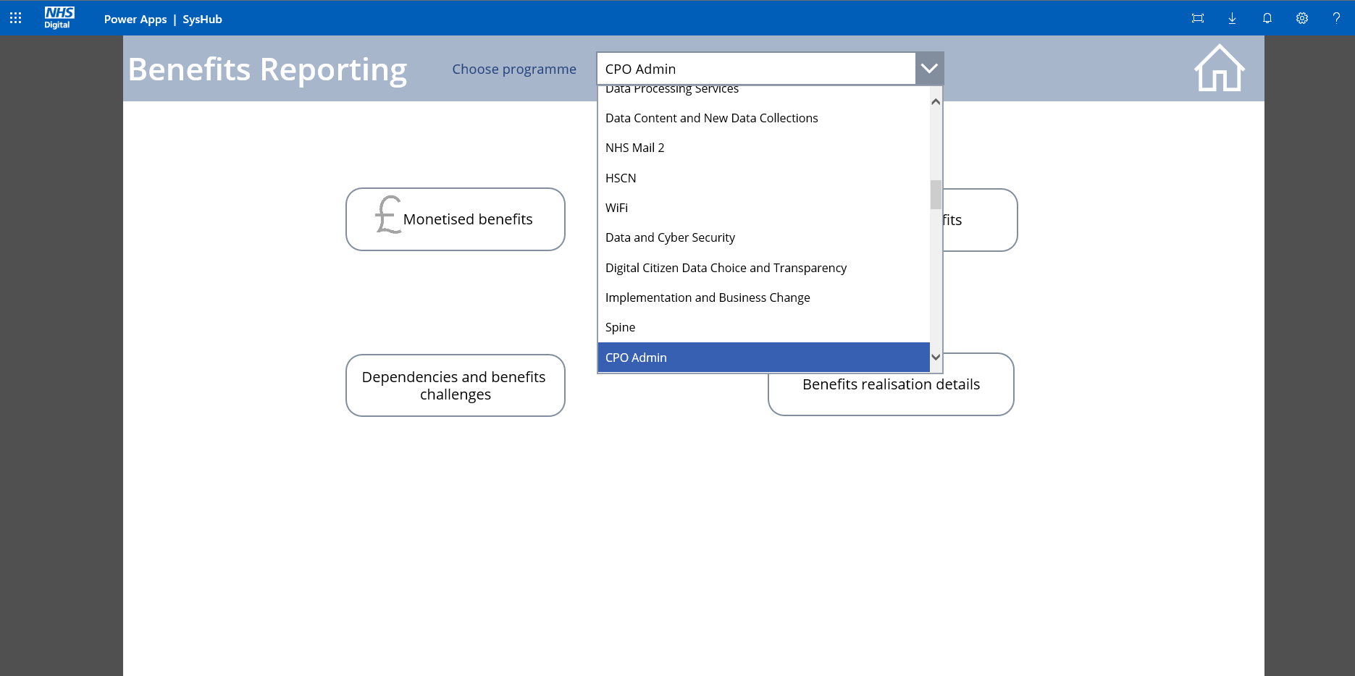

**Monetised benefits**

Monetised benefits data is collected by type (Cash releasing, Non-cash releasing, societal) against baseline (last approved business case), revised forecast (showing any revisions to the forecast that have not been through formal approval) and realised.

After selecting monetised benefits, you will be presented with a blank screen.

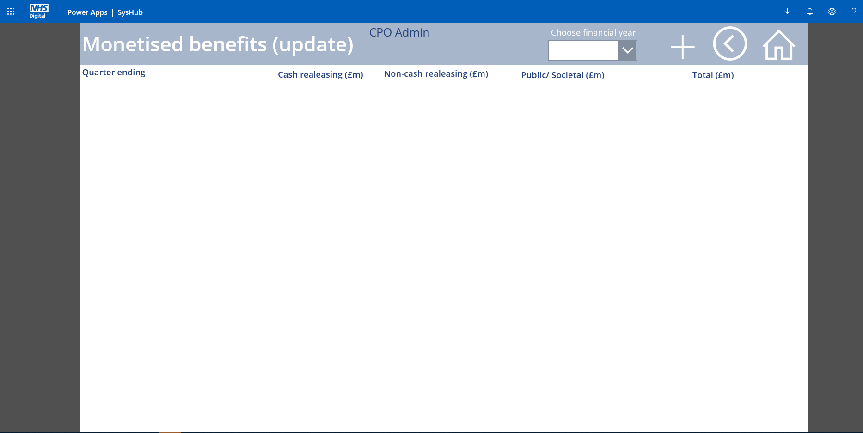

From here choose your required financial year from the drop-down list.

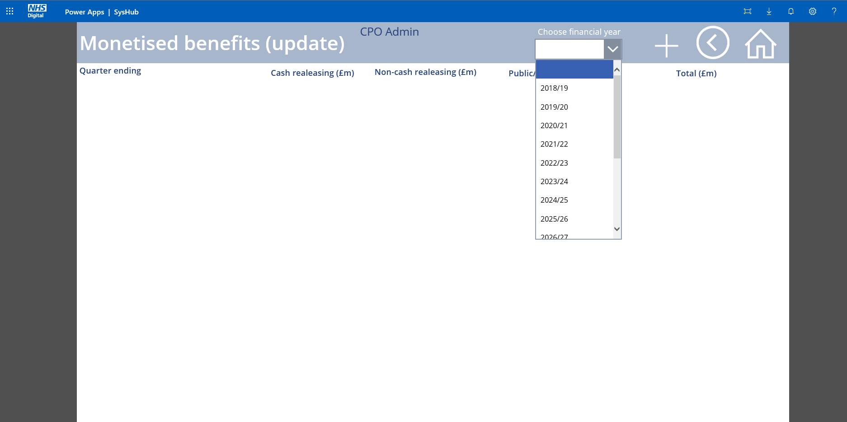

After selecting the appropriate financial year, the existing monetised benefits data for that year will be presented.

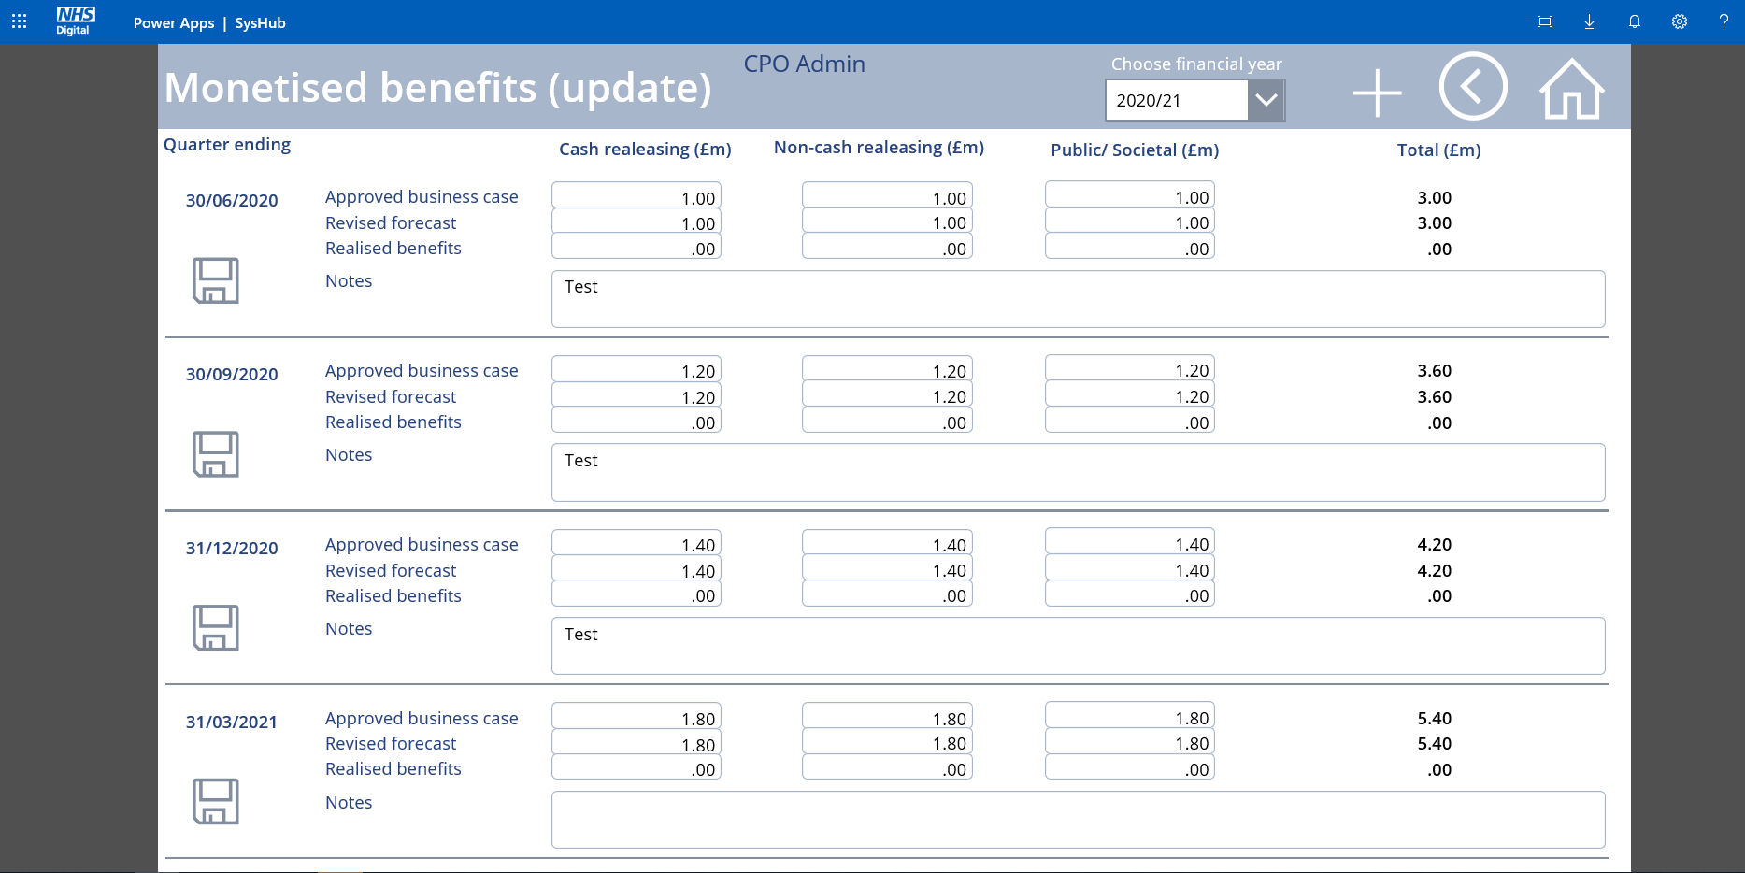

From here please enter the realised benefits value for the quarter due to be reported. A free text box is available to enable a narrative to be included with your submission. This enables an explanation to be given in the event that reported realisation is significantly different to the forecast. Once all updates have been made click on the disc icon on the left hand side to save your changes.

**Please note the following:**

* This screen enables you to change any previously reported monetised should this be required
* Only one quarter can be changed at a time

If you select a year and there is no data then the screen will be blank.

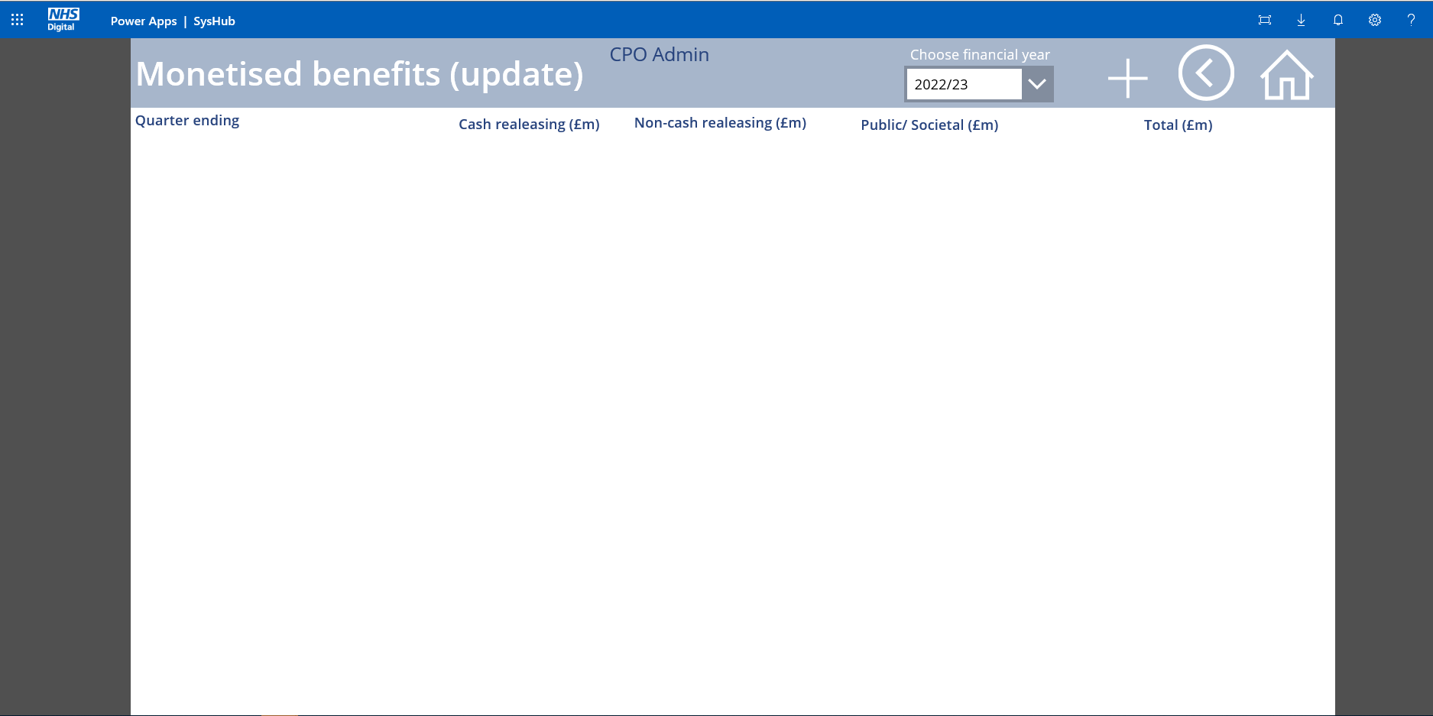

If you need to enter data then click on the +. Any new data for a given quarter can be added here.

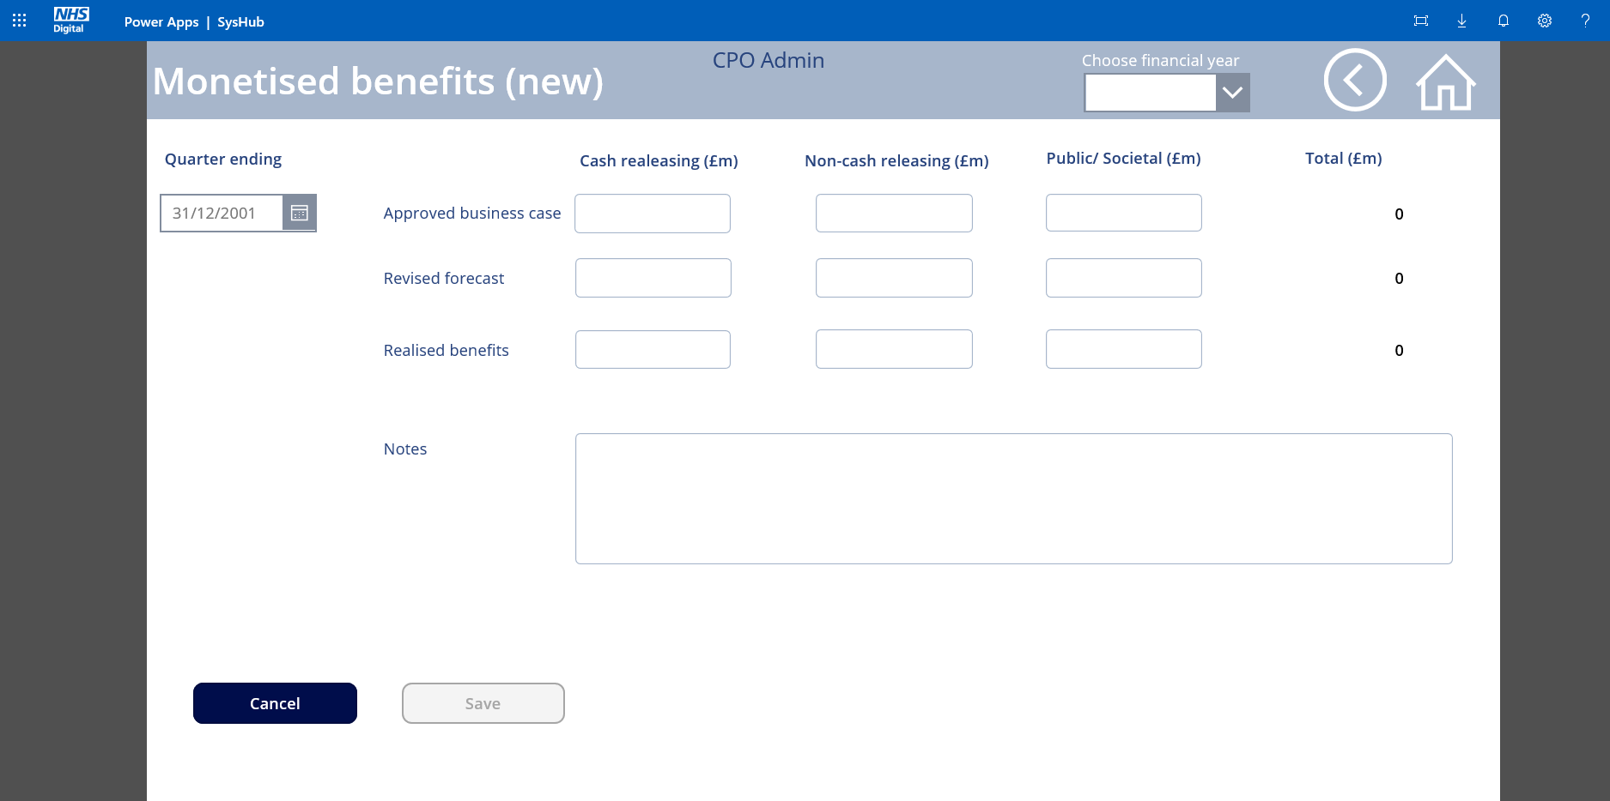

You must first select the quarter end date for the data that you wish to enter.

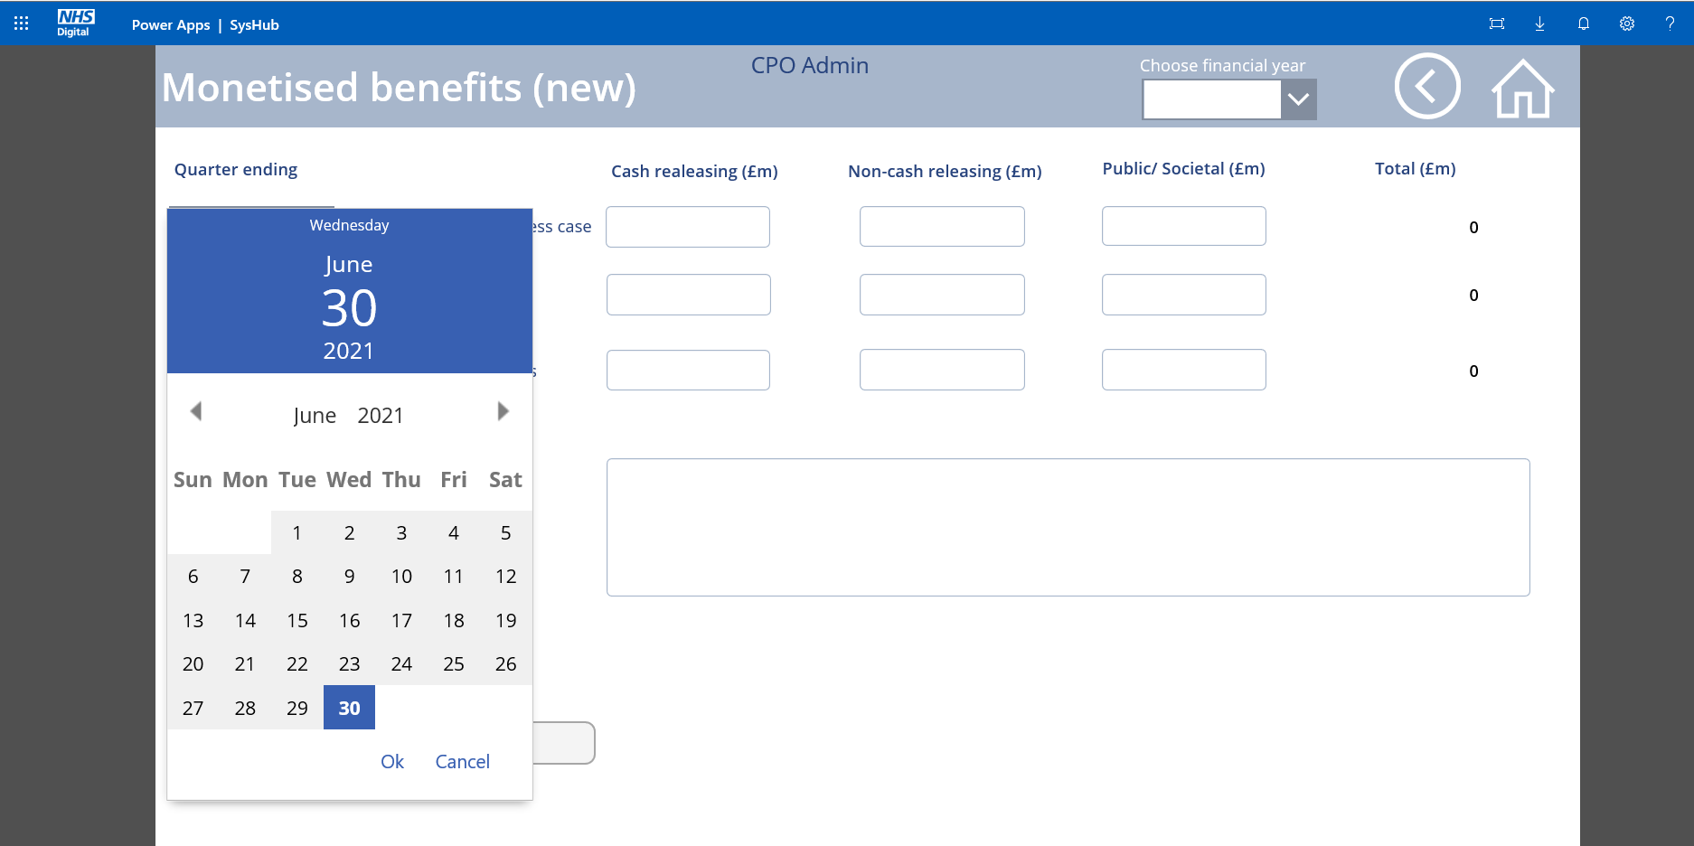

If you select a quarter end date for which data already exists, you will get a ‘Duplicate entry’ waning and will not be able to save any data entered.

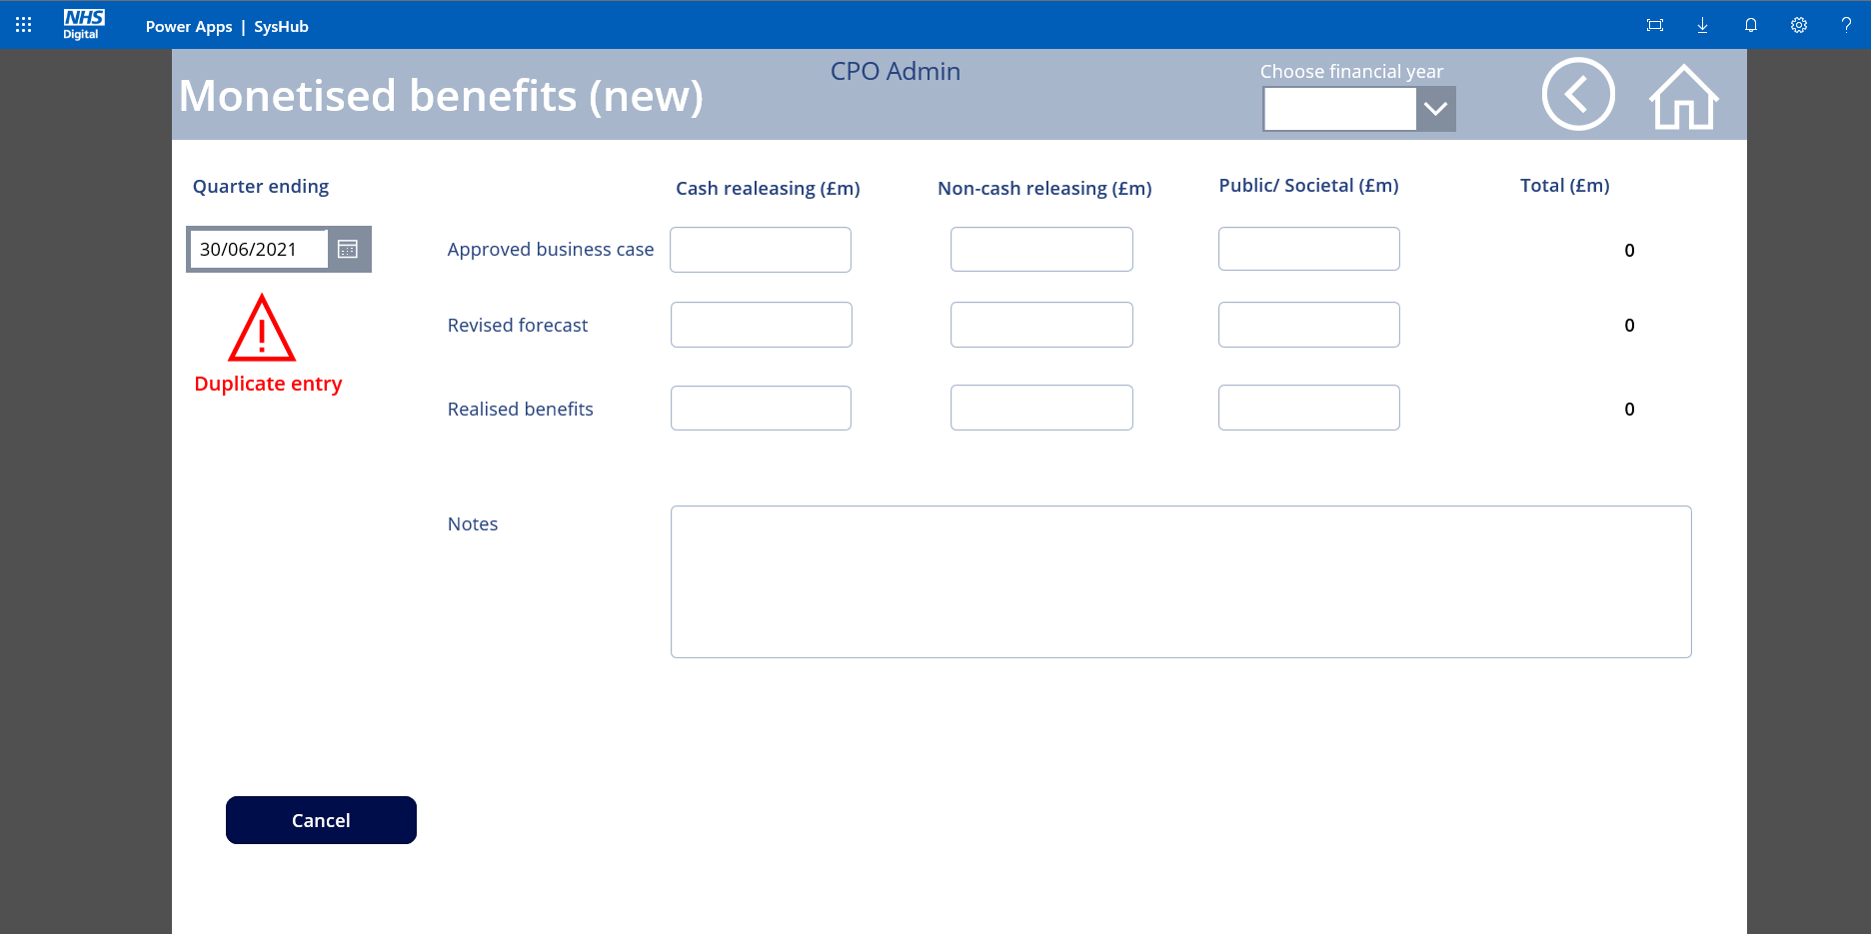

After selecting a quarter end date that has no data recorded against it you will be able to enter the data and save it.

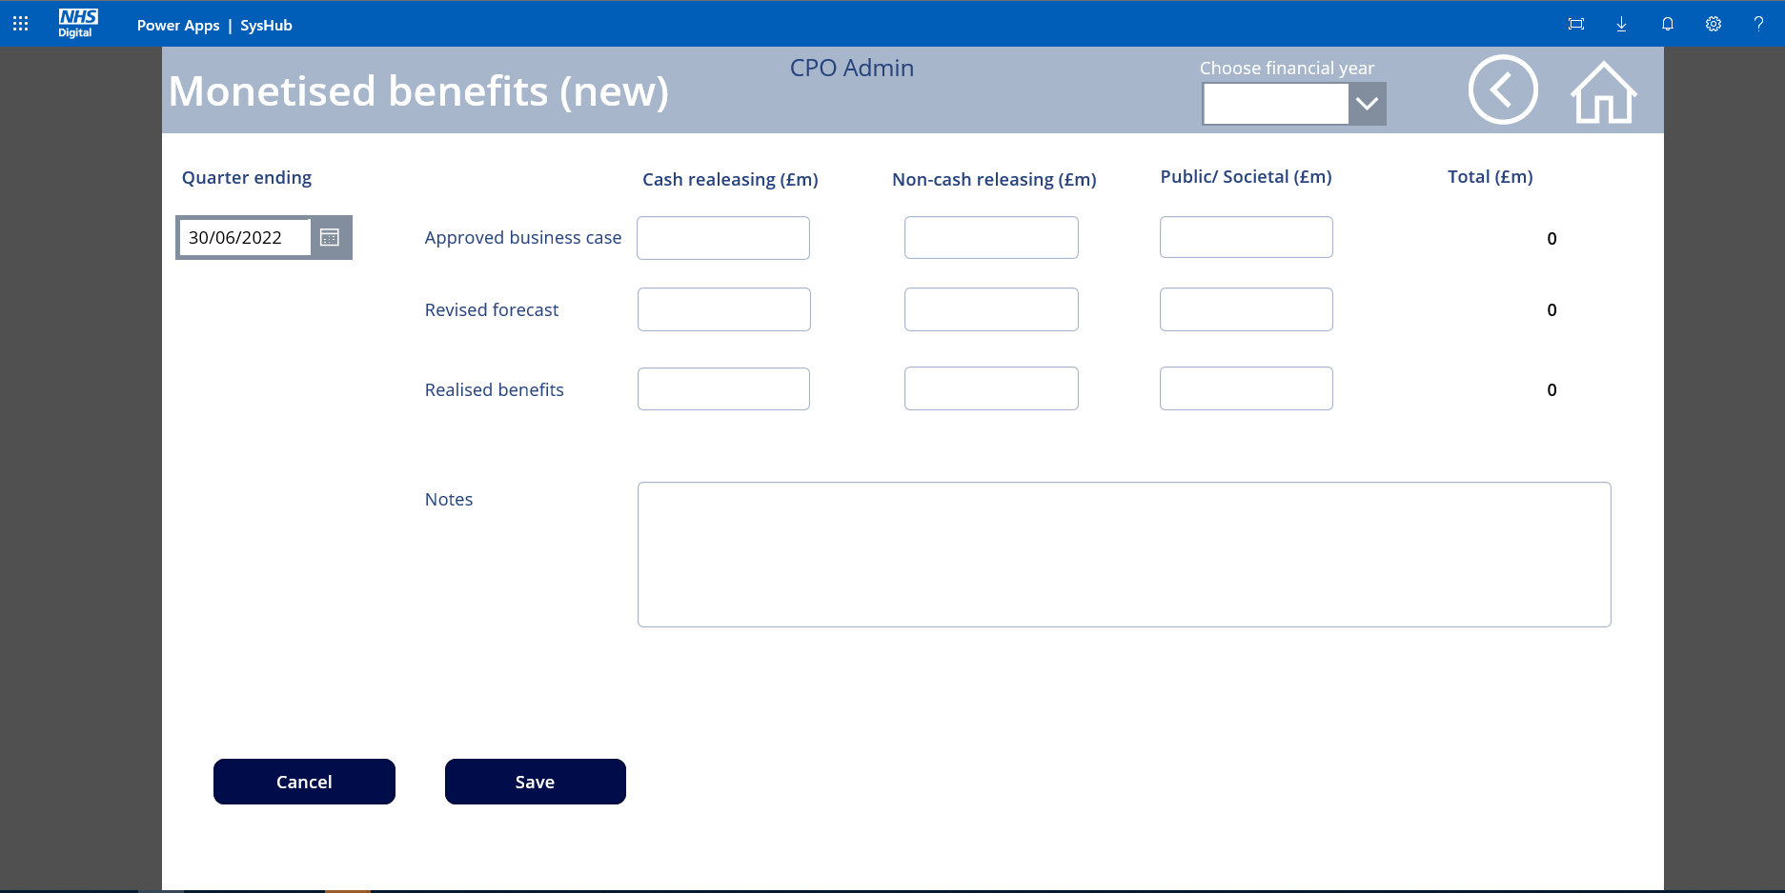

After saving, you can return to the summary page using the back arrow in the top right corner. When back on the update screen if you select the relevant year, you will see your new entry. Repeat the steps on the entry screen to complete the financial year.

Note: If you have a significant amount of data to enter then you can send a spreadsheet to the CPO Reporting team who will upload it for you to save manual entry.

Click on the back arrow in the top right corner to return to the benefits landing page.

**Quality Benefits**

Quality benefits are grouped by the beneficiary and the type of benefit. It is feasible to have more than one benefit within the same grouping. Each group is further analysed by those being realised and those yet to be realised.

Beneficiary can be selected from the following list:

Care Home

Carer

Citizen

Clinical Commissioning Groups (CCGs)

Community Dental

Community Pharmacy

Community Hospital

Domiciliary Care Provider

General Practice

Local Authority

MH Trust

NHS Digital

NHS England

NHS Trust (Acute Hospital)

Opticians

Other

Patients/Service Users

Researchers

Social Care Commissioners

Social Care Providers

Staff

Benefit Type can be selected from the following list:

Compliance

Effectiveness

Efficiency

Healthcare

Other

Safety

Satisfaction

Where “other” is selected from either list a text field is available to enter the detail.

When entering the quality benefits area you will be presented with a scrollable list of all the existing quality benefit groups for the programme. If there are no quality benefit groups recorded then the screen will be blank.

Quarterly updates are most likely to involve changing the number of ‘to be realised’ and ‘actively being realised’.

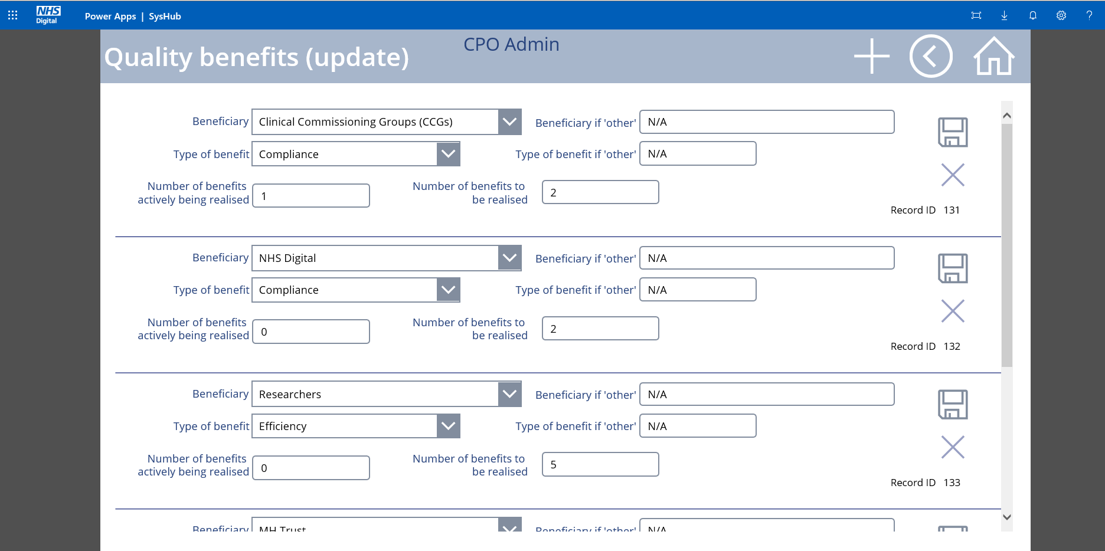

After amending the realisation numbers for any of the benefit groupings, click the disc icon to save. If you have made changes but want to cancel them then click the X.

**Note: Only one grouping can be amended at a time.**

If you need to add a new grouping then click on the +. This will bring up a new record screen.

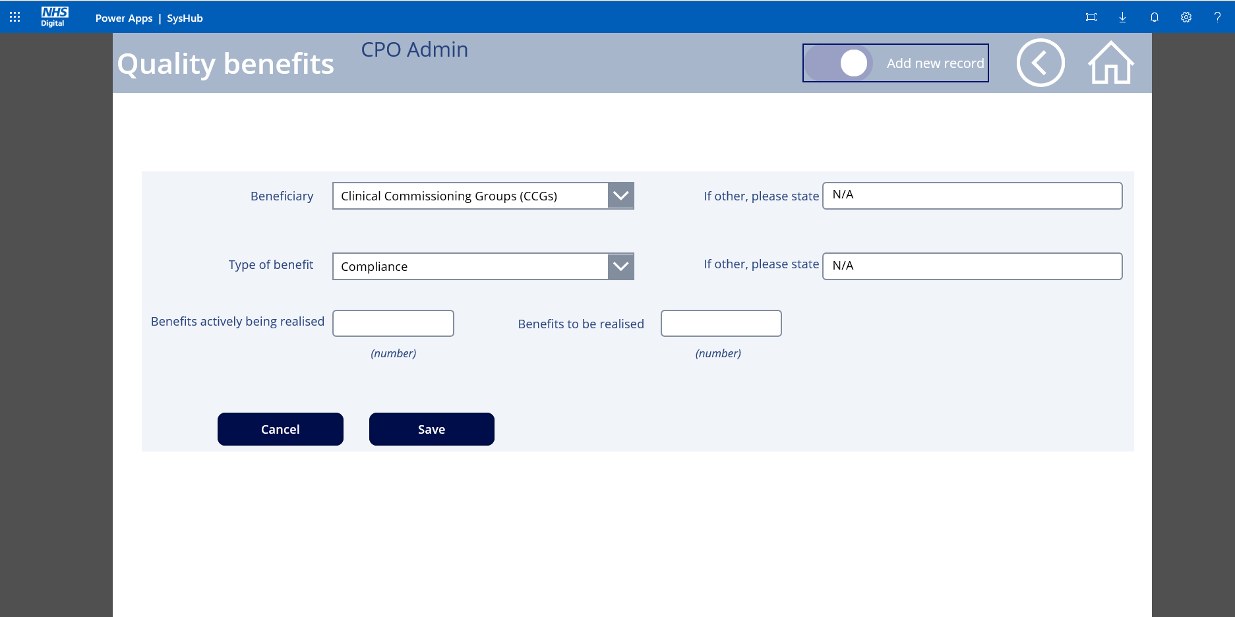

Change the beneficiary and type of benefit as required then enter the number to be realised and number being realised before clicking save.

If you enter a combination of beneficiary and benefit type that already exists, you will be presented with a ‘duplicate entry’ warning and you will not be able to save it.

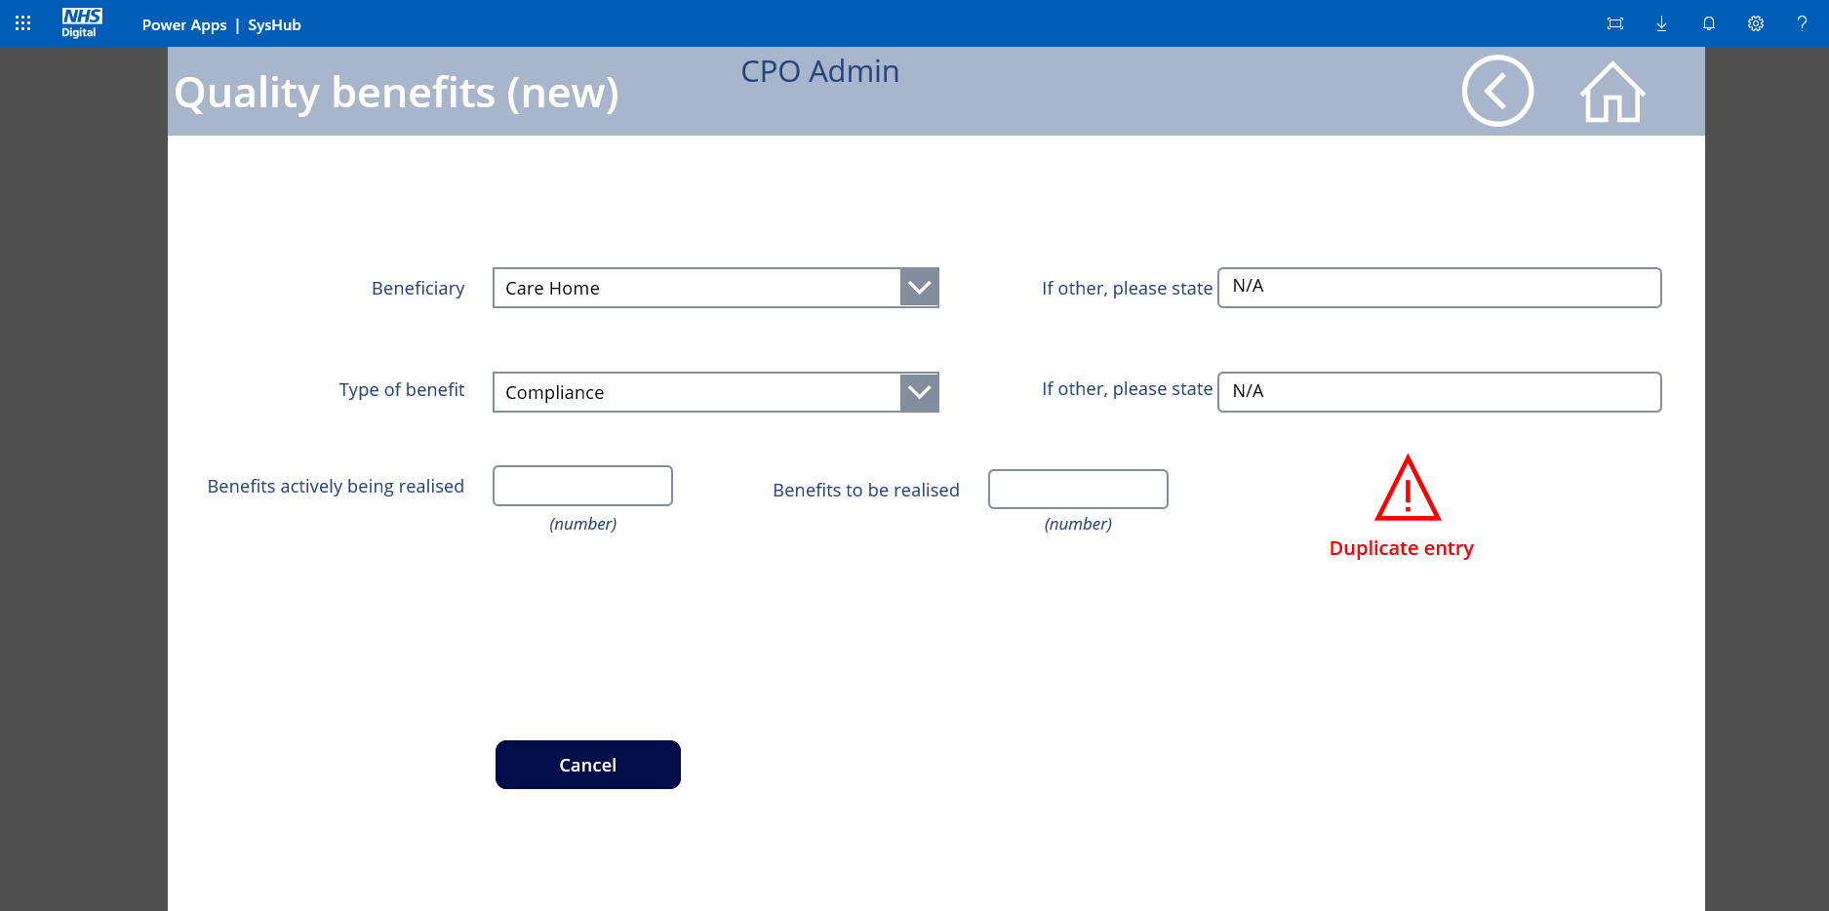

If you have identified new quality benefits for an existing grouping of beneficiary/category then click the back arrow to return to the update screen, scroll down to find the relevant combination and amend the numbers as required.

To return to the benefits landing page, click on the circled back arrow in the top right corner.

**Dependencies and benefit challenges**

This area captures details concerning benefit realisation so that without trawling through individual benefit profiles, a high level indication of how benefits are realised can be capture.

The Dependencies section asks three questions requiring a simple yes/no answer selected from drop down boxes. If the answer to any of the questions is “yes” then a further question needs to be answered. A free text box is provided to give further details if required.

An additional free text box provides the opportunity to declare any other challenges that the programme faces in delivering effective benefits management.

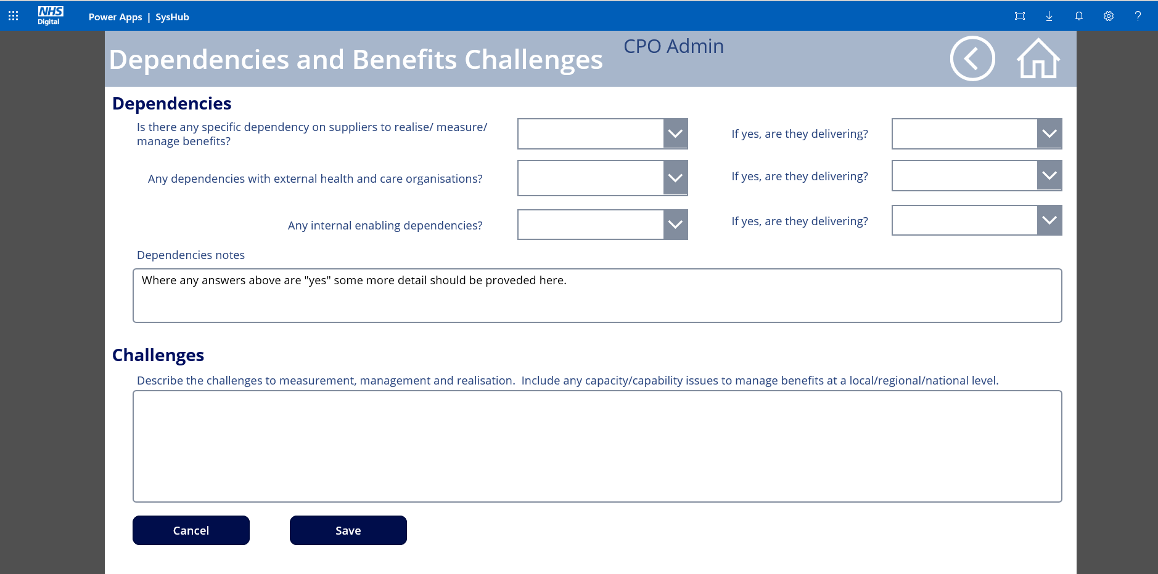

Once completed click save. The same record will be available for update whenever you revisit this screen.

To return to the benefits landing page, click on the circled back arrow in the top right corner.

**Benefits Realisation Details**

When first entering this screen you will be presented with a series of questions, each with an empty drop down box.

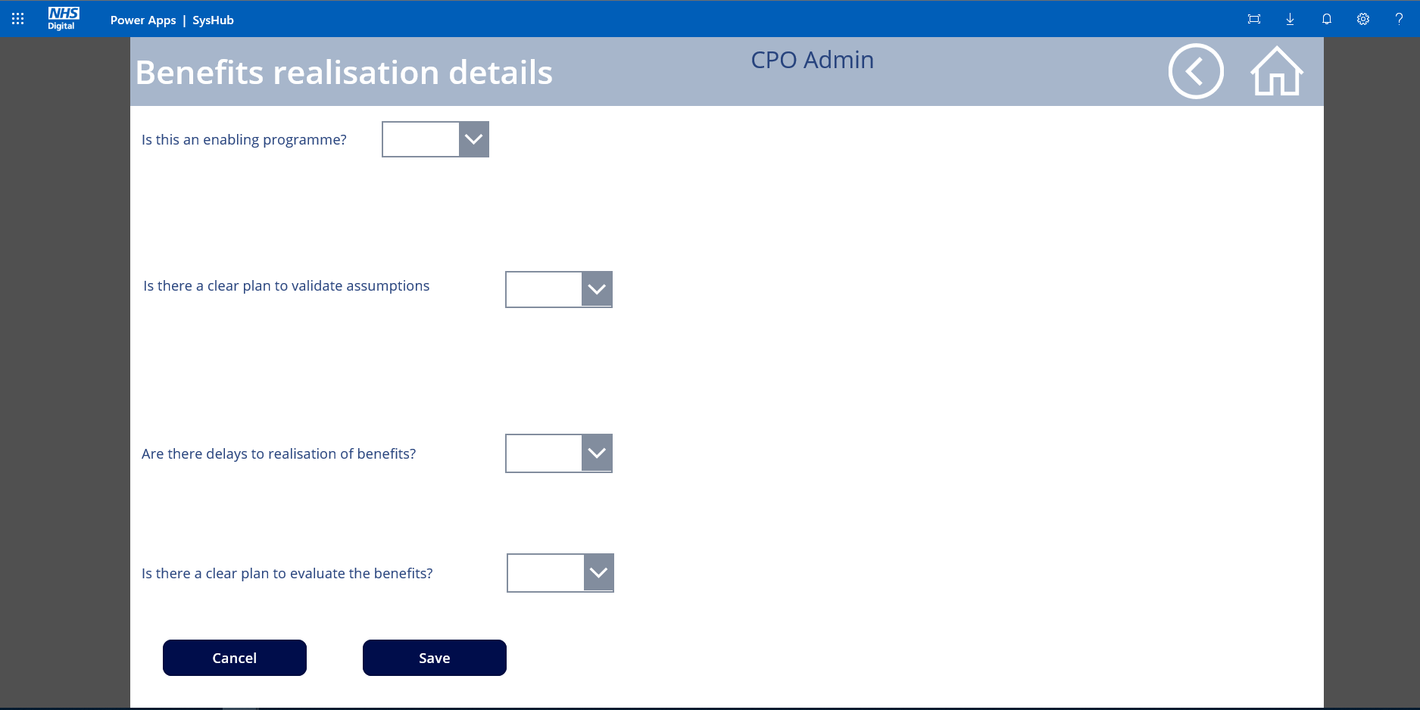

Each box contains a yes/no option. Depending upon your selection you may be asked for additional information except for the last question for which there is no additional information required.

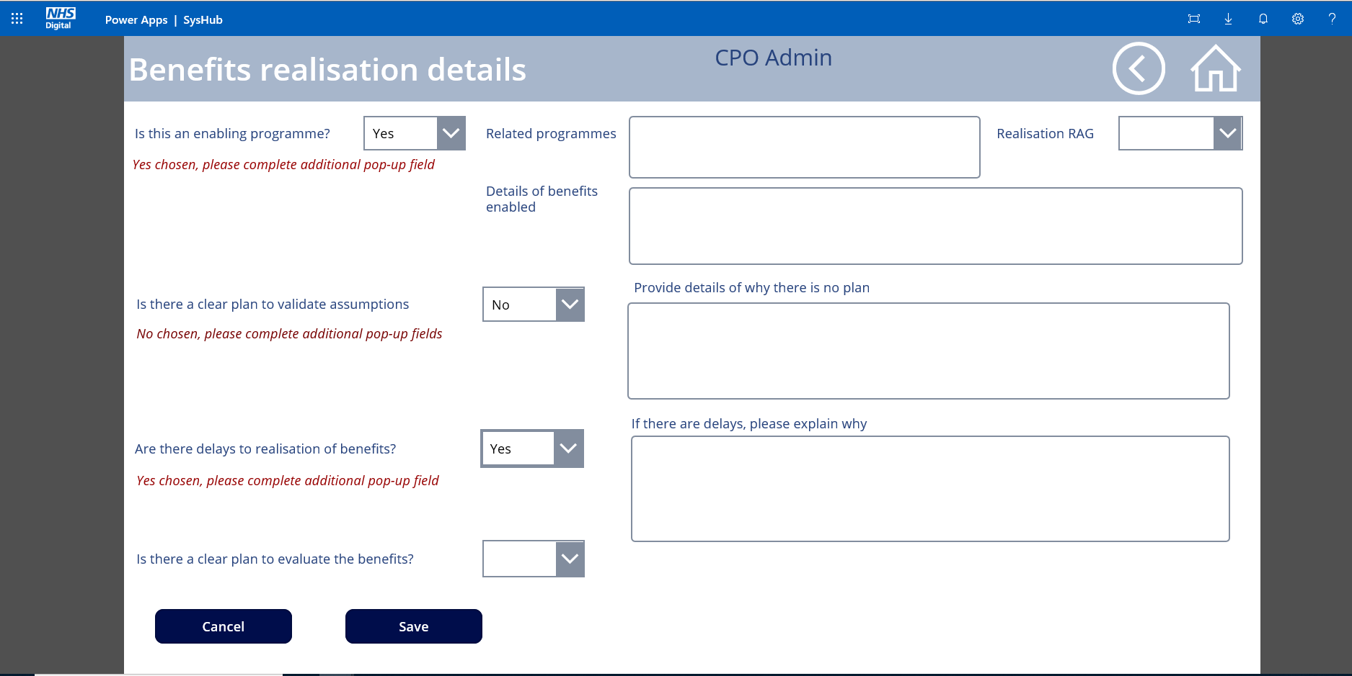

Once completed click save. The same record will be available for update whenever you revisit this screen.

To return to the benefits landing page, click on the circled back arrow in the top right corner.