01 – NETWORK BASICS

*In this chapter you will see:*

What is a network;

Why do we need a network;

How it works;

How business uses networks;

What is vital to a business.

What should be protected in this environment;

*Key Information*

There is no 100% security in the cyberspace;

There are more than one ‘internet’;

There is no guarantee that a company will never be hacked;

We can only use best practices to avoid attacks as much as we can.

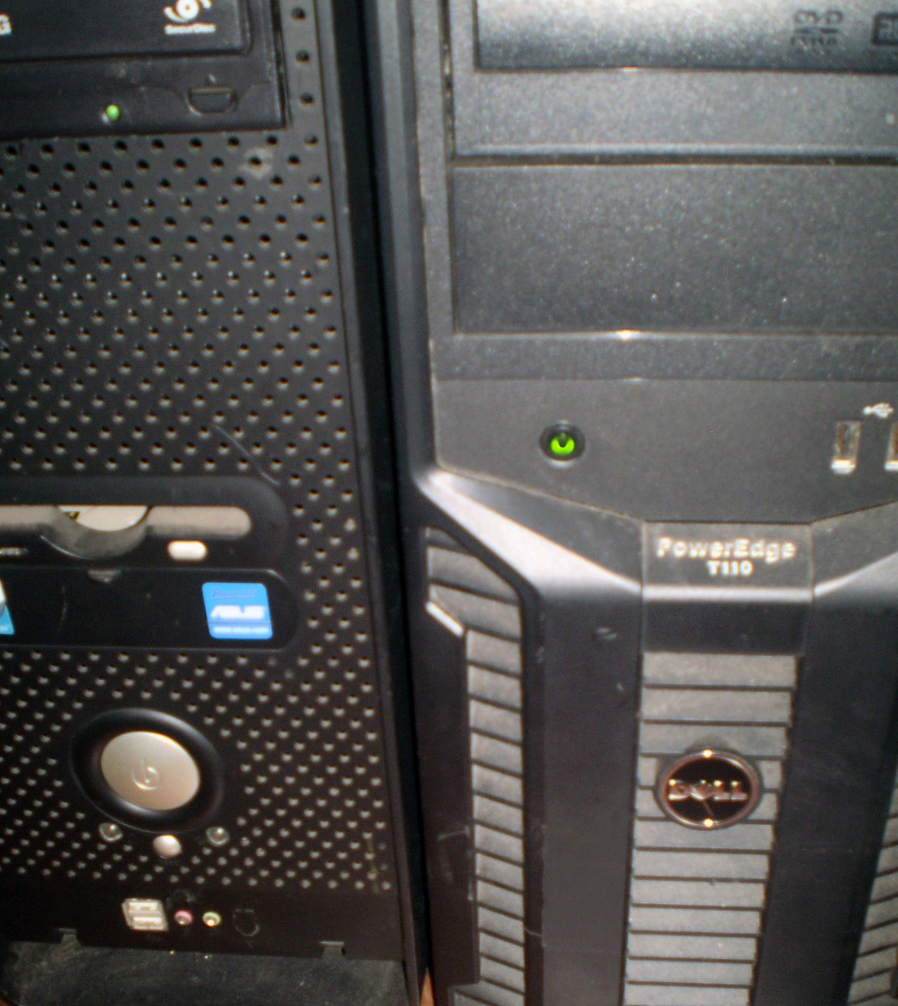

*Remember our Network Roadmap:*

*The path to Master in Network Security*

*01 – Network Basics We are here*

*02 – Network Intermediate*

*03 – Network Advanced*

*04 –Information Security Concepts*

*05 – Hacking (level 01, 02 and 03)*

*06 – Ethical Hacking*

*07 – Information Security Audits*

*08 – Related Law (information technology)*