
Getting Started Guide 7.6

Preface

Copyright
This document is Copyright © 2024 by the LibreOffice Documentation Team. Contributors are listed below. This document maybe distributed and/or modified under the terms of either the GNU General Public License (https://www.gnu.org/licenses/gpl.html), version 3 or later, or the Creative Commons Attribution License (https://creativecommons.org/licenses/by/4.0/), version 4.0 or later. All trademarks within this guide belong to their legitimate owners.

Contributors
Contributors for this edition:
Peter Schofield
Rob Thornton
Vlada Savitskaya
Olivier Hallot
Contributors for previous editions:
Amanda Labby
Andrew Jensen
Cathy Crumbley
Dan Lewis
Dave Barton
Jean Hollis Weber
Jorge Rodriguez
Kees Kriek
Leo Moons
Lera Goncaruk
Olivier Hallot
Paul Figueiredo
Peter Schofield
Simon Quigley
Steve Fanning
Valerii Goncharuk

Feedback
Please direct any comments, or suggestions, about this document to the Documentation Team Forum at https://community.documentfoundation.org/c/documentation/loguides/ (registration is required), or send an email to: loguides@community.documentfoundation.org.
- Note
Everything sent to a forum, including email addresses and any other personal information that is written in the message, is publicly archived and cannot be deleted. Emails sent to the Forum are moderated.

Publication date and software version
Published January 2024. Based on LibreOffice 7.6 Community.
Other versions of LibreOffice may differ in appearance and functionality.
Contents
Copyright 2
Contributors 2
Feedback 2
Publication date and software version 2
Who is this user guide for? 4
What is in this user guide? 4
What is LibreOffice? 4
Writer (word processor) 4
Calc (spreadsheet) 4
Impress (presentations) 5
Draw (vector graphics) 5
Base (database) 5
Math (formula editor) 5
Advantages of LibreOffice 5
Minimum requirements for using LibreOffice 6
Java software 6
How to get LibreOffice 7
Installing LibreOffice 7
Setting up and customizing LibreOffice 7
Extensions and add-ons 7
Where to get more help 8
Help system 8
Other free online support 9
Paid support and training 10
What you see may be different 10
Illustrations 10
Icons 11
Using LibreOffice on macOS 12
What are all these things called? 12
Who wrote this user guide? 13
Frequently asked questions 13
What is new in LibreOffice ? 14

Who is this user guide for?
Anyone who wants to quickly acquire knowledge on LibreOffice and is new to office software, or may be familiar with another office suite, will find this Getting Started Guide very useful.
LibreOffice is an open-source office productivity software suite containing capabilities for word processing, spreadsheets, presentations, graphics, databases, and formula editing.

What is in this user guide?
This user guide introduces the main modules of LibreOffice.
Writer (word processing)
Calc (spreadsheets)
Impress (presentations)
Draw (vector graphics)
Base (database)
Math (equation editor)
It also covers some of the features common to all modules, including setup and customization, styles and templates, macro recording, and printing. For more detail, see the user guides for the individual modules.

What is LibreOffice?
LibreOffice is a freely available, fully-featured, open source office productivity suite that is compatible with other major office suites and is available on a variety of platforms. The native file format used is Open Document Format (ODF). However, LibreOffice can also open and save documents in many other formats, including those used by several versions of Microsoft Office. For more information, see Appendix B, Open Source, Open Standards, OpenDocument.

Writer (word processor)
Writer is a feature-rich tool for creating letters, books, reports, newsletters, brochures, and other documents. Graphics and objects from other LibreOffice modules can be inserted into Writer documents. Writer can export files to HTML, XHTML, XML, Portable Document Format (PDF), and EPUB. Also, Writer can save files in many formats, including several versions of Microsoft Word files and connect to the email application being used.

Calc (spreadsheet)
Calc has all of the advanced analysis, charting, and decision making features expected from a high-end spreadsheet. It includes over 500 functions for financial, statistical, and mathematical operations, among others. The Scenario Manager provides “what if” analysis. Calc generates 2D and 3D charts, which can be integrated into other LibreOffice documents. Also, Microsoft Excel workbooks can be opened and worked on, then saved in Excel format. Calc can also export spreadsheets in several formats, including, for example, Comma Separated Value (CSV), Adobe PDF and HTML formats.

Impress (presentations)
Impress provides all the common multimedia presentation tools, such as special effects, animation, and drawing tools. It is integrated with the advanced graphics capabilities of LibreOffice Draw and Math modules. Slideshows can be further enhanced using Fontwork special effects text, as well as sound and video clips. Impress can open, edit, and save Microsoft PowerPoint presentations and save presentations in numerous graphics formats.

Draw (vector graphics)
Draw is a vector drawing tool that can produce everything from simple diagrams, flowcharts, or 3D artwork. Its Smart Connectors feature allows definition connection points. Draw creates drawings for use in any of the LibreOffice modules, and clip art can be created and added to the Gallery. Draw can import graphics from many common formats and save them in many formats, including PNG, GIF, JPEG, BMP, TIFF, SVG, HTML and PDF.

Base (database)
Base provides tools for day-to-day database work within a simple interface. Base can create and edit forms, reports, queries, tables, views, and relations, so that managing a relational database is much the same as in other popular database applications. Base provides many new features, such as the ability to analyze and edit relationships from a diagram view. Base incorporates two relational database engines, HSQLDB and Firebird. It can also use PostgreSQL, dBASE, Microsoft Access, MySQL, Oracle, or any ODBC compliant or JDBC compliant database. Base also provides support for a subset of ANSI-92 SQL.

Math (formula editor)
Math is a formula, or equation editor. Math can create complex equations that include symbols or characters not available in standard font sets. While Math is most commonly used to create formulas in other documents, such as Writer and Impress files, Math can also work as a standalone tool. Formulas can be saved in the standard Mathematical Markup Language (MathML) format for inclusion in web pages and other documents not created with LibreOffice.

Advantages of LibreOffice
The following explains some of the advantages of LibreOffice has over other office suites:
No licensing fees
LibreOffice is free for anyone to use and distribute at no cost. Many features that are available as extra cost add-ins in other office suites (like PDF export) are free with LibreOffice. There are no hidden charges now or in the future.
Open source
Distribute, copy, and modify the software as required, in accordance with the LibreOffice Open Source licenses.
Cross-platform
LibreOffice runs on several hardware architectures and under multiple operating systems, such as Microsoft Windows, macOS, and Linux.
Extensive language support
The LibreOffice user interface, including spelling, hyphenation, and thesaurus dictionaries, is available in over 100 languages and dialects. LibreOffice also provides support for both Complex Text Layout (CTL) and Right to Left (RTL) layout languages (such as Urdu, Hebrew, and Arabic).
Consistent user interface
All the modules have a similar “look and feel”, making them easy to use and master.
Integration
The individual modules of LibreOffice are well integrated with the other LibreOffice modules.
All modules share a common spelling checker and other tools, which are used consistently across the suite. For example, the drawing tools available in Writer are also found in Calc with similar, but enhanced versions in Impress and Draw.
There is no need to know which application was used to create a particular file. For example, open a Draw file from Writer and this will open Draw automatically.
Granularity
Usually, if you change an option, it affects all modules. However, LibreOffice options can be set at a module level or even at document level.
File compatibility
In addition to its native Open Document Formats, LibreOffice includes support for opening and saving files in many common formats including Microsoft Office, HTML, XML, WordPerfect, Lotus 1-2-3, and PDF. See Appendix B for a list.
No vendor lock-in
LibreOffice uses OpenDocument, an XML (eXtensible Markup Language) file format developed as an industry standard by OASIS (Organization for the Advancement of Structured Information Standards). These files can easily be unzipped and read by any text editor, and their framework is open and published.
All LO users have a voice
Enhancements, software fixes, and release dates are community-driven. Join the community and affect the course of LibreOffice.
Read more about LibreOffice and The Document Foundation on their websites at https://www.libreoffice.org/ and https://www.documentfoundation.org/.

Minimum requirements for using LibreOffice
LibreOffice 7.5 requires one of the following operating systems:
- Linux x64 (deb) and Linux x64 (rpm)
- Mac OS X (Aarch64/Apple Silicon)
- macOS x86_64 (10.14 (Mojave or higher)
- Windows x86_64 (Windows 7 SP1 or newer required)
For a detailed list of requirements and operating systems supported, see the LibreOffice website, https://www.libreoffice.org/get-help/system-requirements/.

Java software
Some LibreOffice features (wizards and the HSQLDB database engine) require that the Java Runtime Environment (JRE) or, for macOS, the Java Development Kit (JDK) is installed on a computer. If Java is not going to be used, nearly all of the LibreOffice features can still be used.
Java is available at no cost. More information and download links to the appropriate edition for your operating system can be found at: https://java.com/en/download/manual.jsp.
For macOS, the Oracle Java Development Kit (JDK) has to be installed, not just the Java Runtime Environment (JRE). Download links can be found at: https://www.oracle.com/java/technologies/downloads/.
If LibreOffice features that require Java are to be used, it is important that the correct 32-bit or 64-bit edition matches the installed version of LibreOffice. See the Advanced Options in Chapter 12, Configuring LibreOffice.

How to get LibreOffice
Versions of LibreOffice for Windows, Linux, and macOS are freely available and can be downloaded from https://www.libreoffice.org/download. Linux users will also find LibreOffice included free in many of the latest distributions.
Linux, Vanilla, and other versions may differ in a few features from the descriptions in this user guide. Also, LibreOffice is included in many of the latest Linux distributions, for example Ubuntu. Portable and other versions of LibreOffice are listed on the download page. LibreOffice is also available in the Microsoft Store and Apple Mac App Store at a low and attractive price. The profits from the sale of LibreOffice are invested to support the development of the LibreOffice project.

Installing LibreOffice
Information on installing LibreOffice on the various supported operating systems can be found at this web page: https://www.libreoffice.org/get-help/install-howto/. When LibreOffice is acquired through official app stores, follow the installation instructions provided by the store.

Setting up and customizing LibreOffice
After installation, to change the default settings (options) in LibreOffice to suit working requirements and preferences, go to Tools > Options on the Menu bar (LibreOffice > Preferences in macOS).. For more information, see Chapter 12, Configuring LibreOffice.
- Tip
Some settings are intended for power users and programmers. If it is difficult to understand what an option does, LibreOffice recommends leaving the option on its default setting unless instructions in this user guide recommend changing the setting.

Extensions
Functionality can be added to LibreOffice with extensions. Several extensions are installed with the program and other extensions from the official extensions repository, https://extensions.libreoffice.org/ or from other sources. See Chapter 13, Customizing LibreOffice, for more information on installing extensions.

Where to get more help
This user guide, the LibreOffice module user guides, Help system, and user support systems assume that users are familiar with computers and basic functions such as starting a program, opening and saving files.

Help system
LibreOffice comes with an extensive Help system and this can be used as the first line of support. Windows and Linux users can choose to download and install the offline Help for use when not connected to the Internet. Offline Help is installed with the MacOS version of LibreOffice.
To display the LibreOffice Help, press F1 or go to Help > LibreOffice Help on the Menu bar. If the offline help is not installed on a computer, but connected to the Internet, a dialog opens giving the option to Read Help Online. Select this option and the default web browser opens at the LibreOffice online help pages in the LibreOffice website.
The Help menu also includes links to other LibreOffice information and support resources. The options marked by a ‡ sign in the list below are only accessible if the computer is connected to the Internet.
What's This?
For quick tips when a toolbar is visible, place the cursor over any of the tool icons to see a small tooltip box with a brief explanation of the tool function. For a more detailed explanation, select Help > What's This? Also Extended Tips can be activated by going to Tools > Options > LibreOffice > General (macOS LibreOffice > Preferences > LibreOffice > General) on the Menu bar. Extended Tips provide a brief description about tools and commands.
User Guides
Opens the default browser at the Documentation page of the LibreOffice website https://documentation.libreoffice.org/en/english-documentation/. This page gives access to the LibreOffice User Guides and other useful information that can be opened in the default browser. Also, the User Guides are available in PDF format as a free download or to buy as printed copies.
Show Tip of the Day
Opens a small window with a random tip on how to use LibreOffice.
Search Commands
Opens a window where typing a few letters, or the name of a Menu bar command, for example, quickly finds where the command is located. Clicking on a command in the resulting list may open a relevant dialog or have other effects.
Get Help Online
Opens the default browser at the Ask LibreOffice forum of questions and answers from the LibreOffice community, https://ask.libreoffice.org/en/questions/.
Send Feedback
Opens the default browser at the Feedback page of the LibreOffice website https://www.libreoffice.org/get-help/feedback/. From this page, bugs can be reported, new features suggested and communicated with other users in the LibreOffice community.
Restart in Safe Mode
Opens a dialog window giving options to restart LibreOffice and reset the software to its default settings. Restarting in safe mode also provides an opportunity to restore LibreOffice from a backup.
Get Involved
Opens the default browser at the Get Involved page of the LibreOffice website, https://www.libreoffice.org/community/get-involved/. Choose a topic of interest to help improve the program.
Donate to LibreOffice
Opens the default browser at the Donation page of the LibreOffice website, https://donate.libreoffice.org/ providing an opportunity to make a donation to support LibreOffice.
License Information
Outlines the licenses under which LibreOffice is made available.
Check for Updates
Opens a dialog and checks the LibreOffice website for updates to version of the software. The dialog provides an opportunity to download and install any updates to LibreOffice.
About LibreOffice
Opens a dialog and displays information about the version of LibreOffice and the operating system being used. This information is often requested if the community is asked for help or assistance with the software (on macOS, this option is found under LibreOffice on the Menu bar).

Other free online support
The LibreOffice community not only develops software, but provides free, volunteer-based support. See Table 1 and the web page https://www.libreoffice.org/get-help/. For comprehensive online support from the community, look at mailing lists and the Ask LibreOffice website, https://ask.libreoffice.org/en/questions/. Other user websites also offer free tips and tutorials.
Table 1: Free support for LibreOffice users
Free LibreOffice support
FAQs | Answers to frequently asked questions  https://wiki.documentfoundation.org/Faq
Mailing lists | Free community support is provided by a network of experienced users  https://www.libreoffice.org/get-help/mailing-lists/
Questions & Answers and  Knowledge Base | Free community assistance is provided in a Question & Answer formatted web service. Search similar topics or open a new one in  https://ask.libreoffice.org/en/questions  The service is available in several other languages; just replace /en/ with de, es, fr, ja, ko, nl, pt, tr, and so on in the web address above.
Native language support | The LibreOffice website in various languages  https://www.libreoffice.org/community/nlc/  Mailing lists for native languages  https://wiki.documentfoundation.org/Local_Mailing_Lists  Information about social networking  https://wiki.documentfoundation.org/Website/Web_Sites_services
Accessibility options | Information about available accessibility options. https://www.libreoffice.org/get-help/accessibility/
OpenOffice Forum | Another forum that provides support for LibreOffice, among other open source office suites. https://forum.openoffice.org/en/forum/

Paid support and training
Support and training is available through service contracts from a vendor or consulting firm specializing in LibreOffice. For information about certified professional support, see The Document Foundation website: https://www.documentfoundation.org/gethelp/support/.
For schools, educational and research institutions, and large organizations, see https://www.libreoffice.org/download/libreoffice-in-business/.
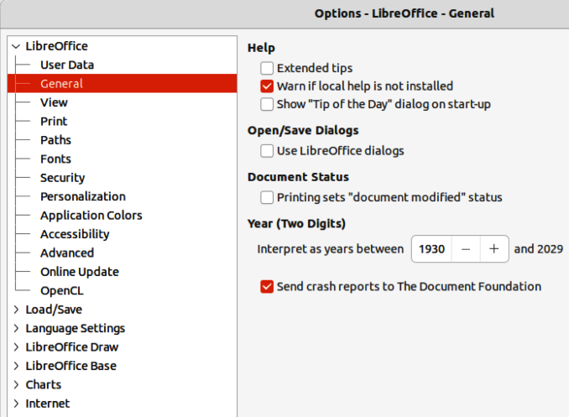
Figure 1: Options LibreOffice General dialog

What you see may be different

Illustrations
LibreOffice runs on Windows, Linux, and macOS operating systems, each of which has several versions and can be customized by users (fonts, colors, themes, window managers). The illustrations in this guide were taken from a variety of computers and operating systems. Therefore, some illustrations will not look exactly like what is seen on a computer display.
Also, some of the dialogs may differ because of the settings selected in LibreOffice. Either use dialogs from the computer system (default), or dialogs provided by LibreOffice.
To change to using LibreOffice dialogs:
- On Linux and Windows operating systems, go to Tools > Options > LibreOffice > General on the Menu bar to open the dialog for general options.
- On a Mac operating system, go to LibreOffice > Preferences > LibreOffice > General on the Menu bar to open the dialog for general options.
- Select Use LibreOffice dialogs in Open/Save dialogs to display the LibreOffice dialogs on a computer display, as shown in Figure 1.
- Click OK to save the settings and close the dialog.
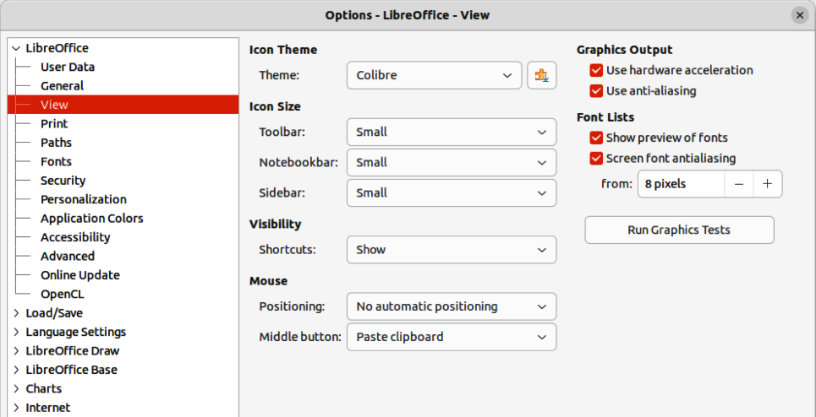
Figure 2: Options LibreOffice View dialog

Icons
The LibreOffice community has created icons for several icon sets, including Breeze, Colibre, Elementary, and Sifr. Each user can select a preferred set of fonts to use. The icons used to illustrate some of the many tools available in LibreOffice may differ from the ones used in this guide. The icons in this user guide have been taken from a LibreOffice installation that has been set to display the Colibre set of icons.
Change the icon set used in a LibreOffice installation as follows:
- On Linux and Windows operating systems, go to Tools > Options > LibreOffice > View on the Menu bar to open the dialog for view options.
- On a Mac operating system, go to LibreOffice > Preferences > LibreOffice > View on the Menu bar to open the dialog for view options.
- In Icon Style, select a font from the options available in the drop-down list as shown in Figure 2.
- In Icon Size, select the required size from the drop-down lists for Toolbar, Notebookbar and Sidebar, as shown in Figure 2.
- Click OK to save the settings and close the dialog.
- Notes
Some Linux operating systems, for example Ubuntu, include LibreOffice as part of the installation and may not include the required icon set. This icon set can be downloaded from the software repository for the Linux operating system being used.
Some of the previously included icon sets are now available only as extensions; see https://extensions.libreoffice.org/?Tags%5B%5D=49 or search for specific ones. For example, the People Gallery is available from https://extensions.libreoffice.org/en/extensions/show/people-gallery

Using LibreOffice on macOS
LibreOffice 7.6 requires macOS 10.15 or newer to run.
Some keystrokes and menu items are different on macOS from those used in Windows and Linux. Table 2 below gives some common substitutions for the instructions in this user guide. For a more detailed list, see the application help.
Table 2: Example of macOS keyboard shortcuts
Windows or Linux | macOS equivalent | Effect
Tools > Options on Menu bar | LibreOffice > Preferences on Menu bar | Access to setup options
Right-click | Ctrl+click and/or right-click depending on computer setup | Opens a context menu
Ctrl or Control | ⌘ and/or Cmd or Command, depending on keyboard | Used with other keys
Alt | ⌥ and/or Alt or Option depending on keyboard | Used with other keys

What are all these things called?
The terms used in LibreOffice for most parts of the user interface (the parts of the program seen and used, in contrast to the behind-the-scenes code that actually makes it work) are the same as for most other programs.
A dialog is a special type of window. Its purpose is to inform, or request input, or both. The technical names for common controls are shown in Figure 3. In most cases, these technical terms are not used in this user guide, but are useful to know because the Help and other sources of information often use these terms.
- Tabbed page (not strictly speaking a control).
- Radio buttons (only one can be selected at a time).
- Checkbox (more than one can be selected at a time).
- Spin box (click the up and down arrows to change the number shown in the adjacent text box, or type in the text box).
- Thumbnail or preview.
- Drop-down list from which to select an item.
- Push buttons.
In most cases, you can interact only with the dialog (not the document itself) as long as the dialog remains open. When you close the dialog after use (usually, clicking OK or another button saves your changes and closes the dialog), then you can again work with the document.
Some dialogs can be left open as you work, so you can switch back and forth between the dialog and the document. An example of this type is the Find & Replace dialog.
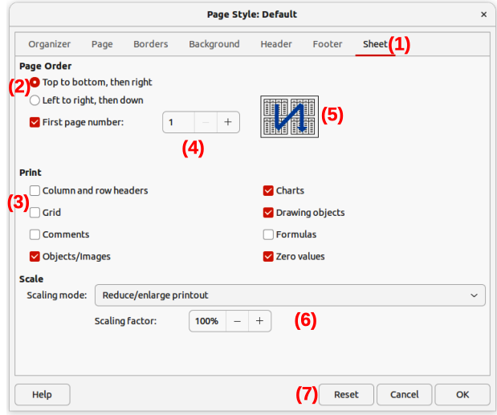
Figure 3: Dialog showing an example of common controls

Who wrote this user guide?
This user guide was written by volunteers from the LibreOffice community. Profits from sales of the printed edition will be used to benefit the community.

Frequently asked questions
How is LibreOffice licensed?
LibreOffice is distributed under the Open Source Initiative (OSI) approved Mozilla Public License (MPL). See https://www.libreoffice.org/about-us/licenses/.
It is based on code from Apache OpenOffice made available under the Apache License 2.0 but also includes software that differs from version to version under a variety of other Open Source licenses. New code is available under LGPL 3.0 and MPL 2.0.
Can LibreOffice be distributed to anyone?
Yes.
Can LibreOffice be sold?
Yes.
Can LibreOffice be used in a business?
Yes.
How many computers can LibreOffice be installed on?
As many as you like.
Is LibreOffice available in different languages?
LibreOffice has been translated (localized for more than 80%, both UI and Help) into over 46 languages, so the language required is probably supported. Localization is well under way for another 30+ languages (50-80%) and for another 50+ languages help is more than welcome. In addition, over 70 spelling, hyphenation, and thesaurus dictionaries are available for languages and dialects that do not have a localized program interface. The dictionaries are available from the LibreOffice website at: www.libreoffice.org.
How can LibreOffice be freely available?
LibreOffice is developed and maintained by volunteers and has the backing of several organizations. LibreOffice also relies upon donations from its users. To make a donation, go to the following web page: https://www.libreoffice.org/donate/.
Can the programming code from LibreOffice be used when developing a software application?
Yes, but follow the parameters set in the MPL and/or LGPL. Read the licenses: https://www.mozilla.org/MPL/2.0/.
Why is Java required to run LibreOffice? Is it written in Java?
LibreOffice is not written in Java; it is written in the C++ language. Java is one of several languages that can be used to extend the software. The Java JDK/JRE is only required for some features. The most notable one is the HSQLDB relational database engine.
Java is available at no cost. More information and download links to the appropriate edition for an operating system can be found at: https://java.com/en/download/manual.jsp
- Note
If the LibreOffice features that require Java are to be used, it is important that the correct 32-bit or 64-bit edition matches the installed version of LibreOffice. If Java is not to be used, nearly all of the LibreOffice features can still be used.
How can users contribute to LibreOffice?
Users can help with the development and user support of LibreOffice in many ways, and there is no need to be a programmer. To start, check out this webpage: https://www.libreoffice.org/community/get-involved/. An interactive web page that guides users in contributing with their best skills available at https://whatcanidoforlibreoffice.org.
Can the PDF copy of this user guide be distributed, or printed and copies sold?
Yes, as long as requirements are met for one of the licenses in the copyright statement at the beginning of this user guide. There is no need to request special permission. LibreOffice requests that users share with the LibreOffice project some of the profits made from sales of user guides, in consideration of all the work that LibreOffice volunteers have put into producing user guides.

What is new in LibreOffice 7.6?
The LibreOffice Release Notes are available at this link https://wiki.documentfoundation.org/ReleaseNotes/7.6
Also at this link, the release notes for earlier versions of LibreOffice are located giving more information on the features that are included in LibreOffice.
Noticeable improvements or enhancements to this version include the following:
- The accessibility was moved to the Sidebar to allow easier usage.
- Added Spotlighting for used Paragraph and Character styles and highlighting for used Direct Formatting in text.
- Track changes for tables.
- Page number wizard in Insert menu for easy one-step insertion of the page number in the header/footer.
- Support for drawing styles for shapes and comments in Calc spreadsheets.
- Sorting by color is now possible in spreadsheet's AutoFilter.
- Spreadsheet's Import Text dialog (as CSV file or as Unformatted Text) have a new option to not detect number in scientific notation. This option is only available if "Detect special numbers" is off.
- Import and export of theme definition for OOXML format
- Added support for multicolor gradients
- Documents in the Start Center can now be pinned to show them at the beginning of the recently opened document list

