Homework0

1. Warmup

(1) pi calculation

• create cluster

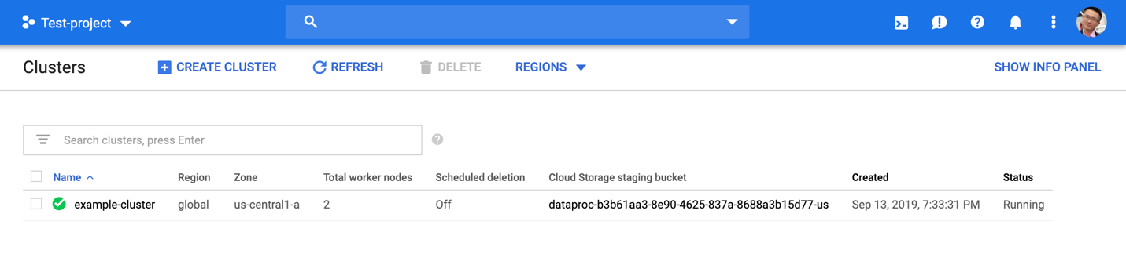

• submit job

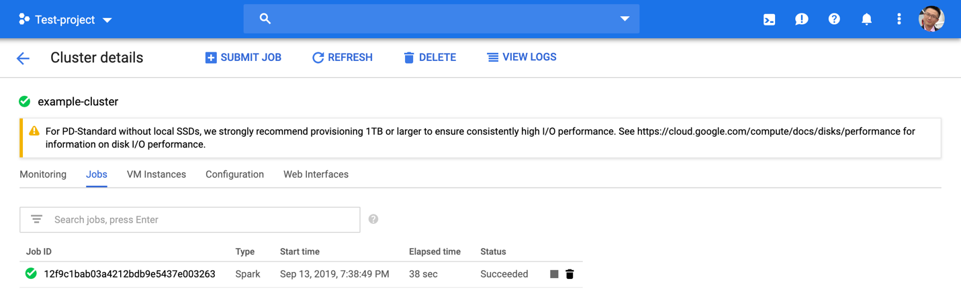

• get result

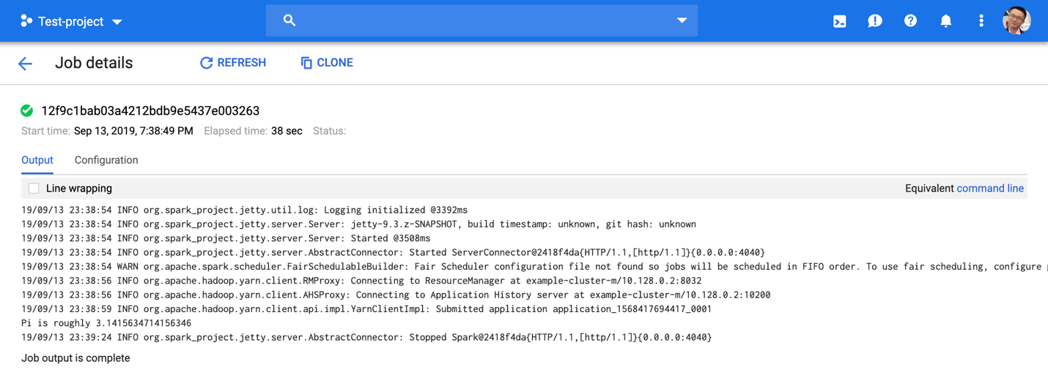

Word count

• submit job

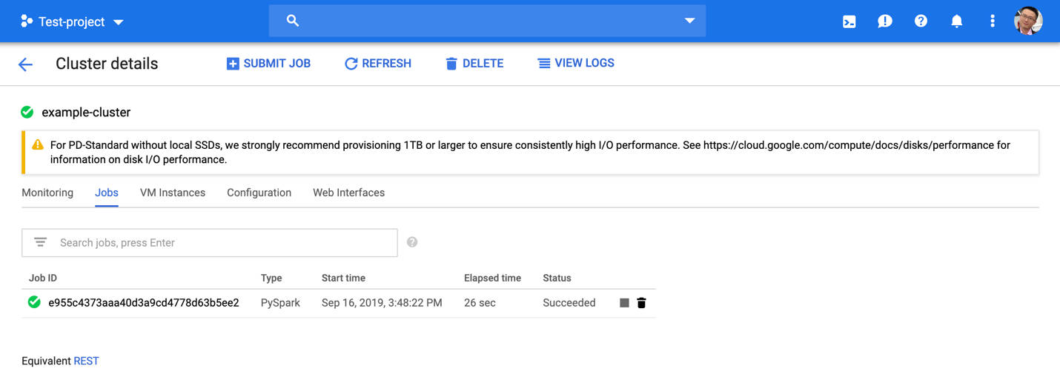

• output result

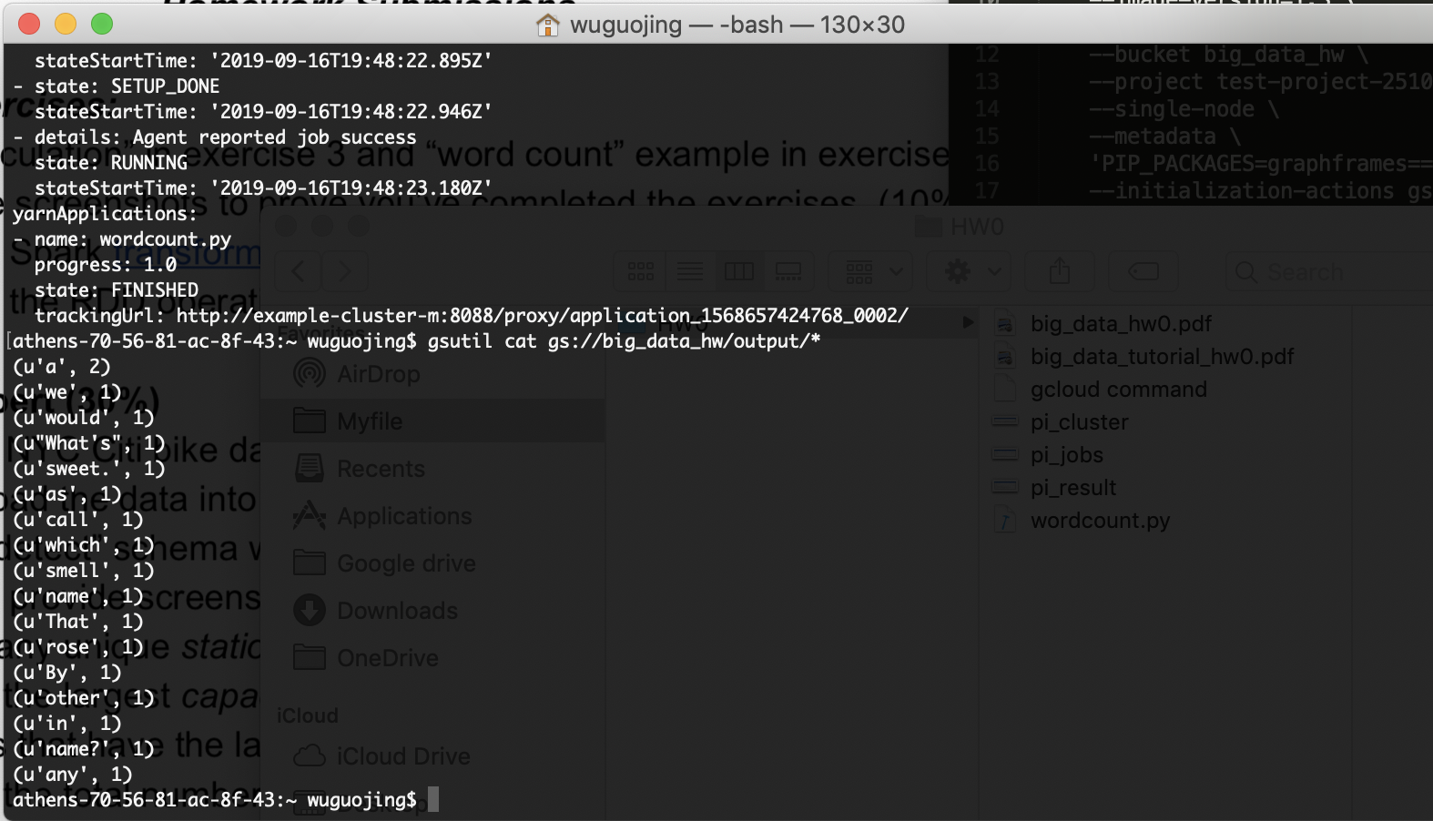

(2) pi calculation

• transformation: filter()

• action: count()

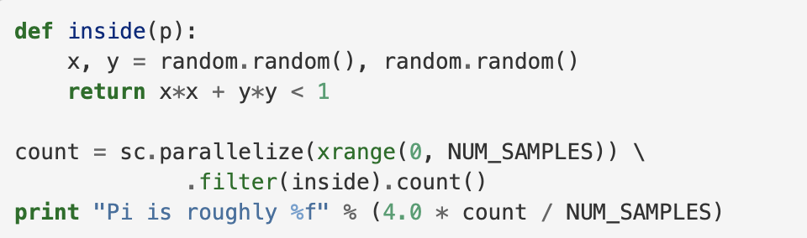

Action

transformation

Word count:

• transformation: map(), flatMap(), reduceByKey()

• action: saveAsTextFile()

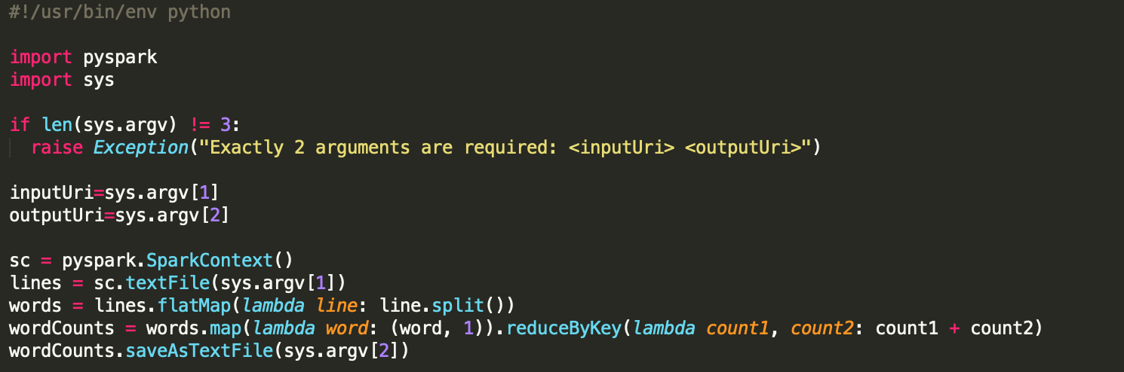

action

transformation

2. NYC Bike Expert

(1) unique station_ids

n = 843

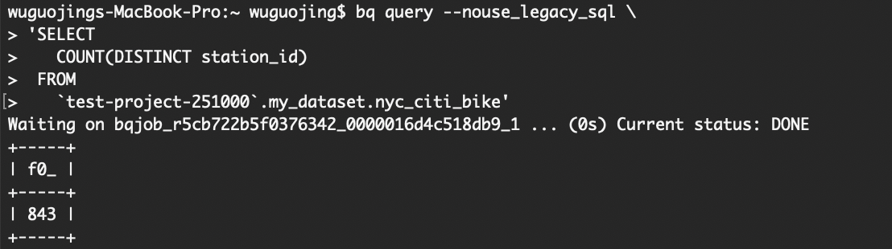

(2) largest capacity and corresponding station_id

MAX = 79

Station_id = {422, 445, 501}

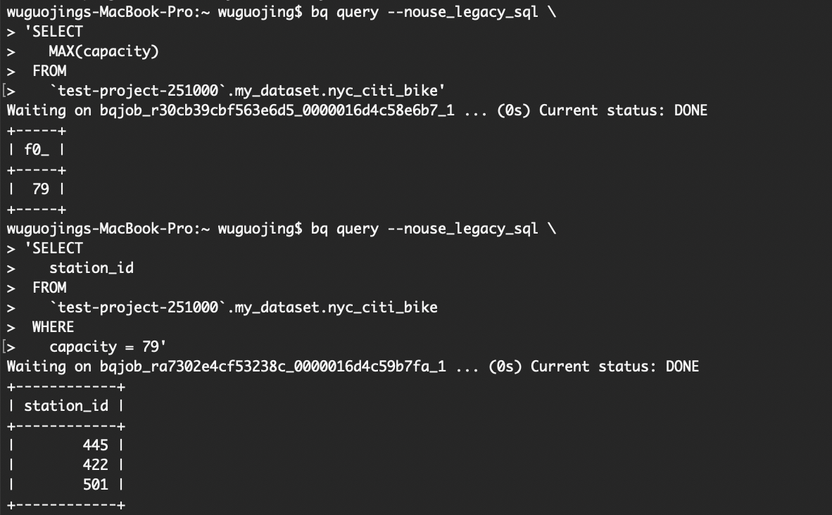

(3) total number of bikes available in region_id 70

n = 394

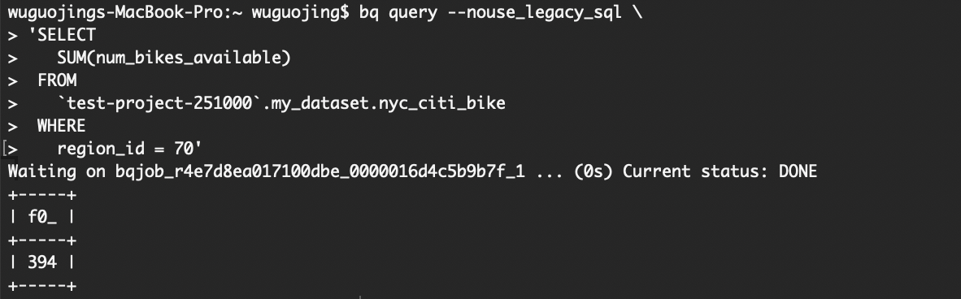

3. Understanding William Shakespeare

(1) without preprocess

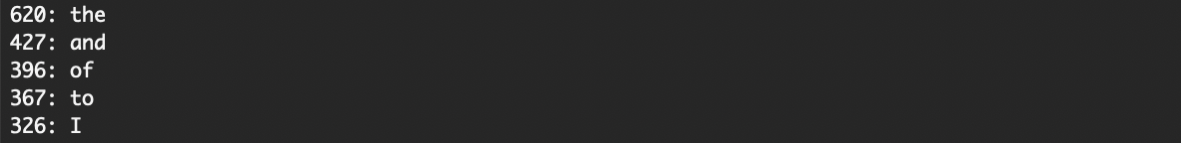

Code:

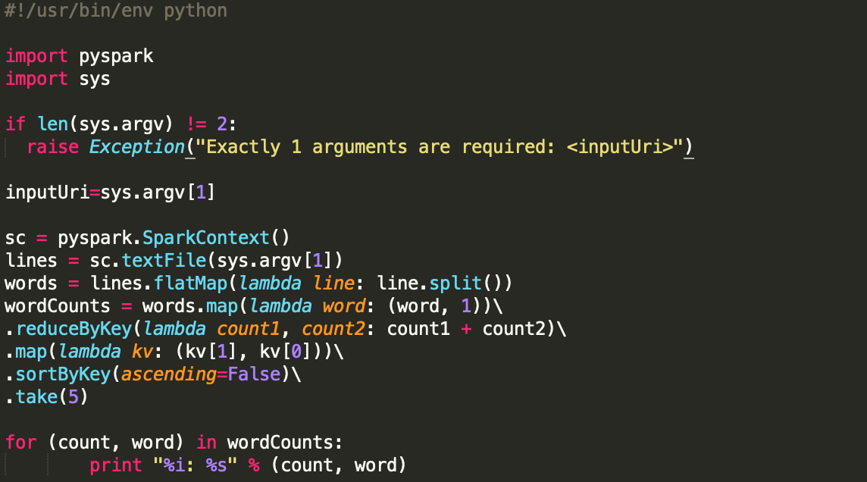

(2) NLTK preprocessed

Here we removed stop words, punctuations and words like *‘s*, *‘d, ‘m*



Code:

