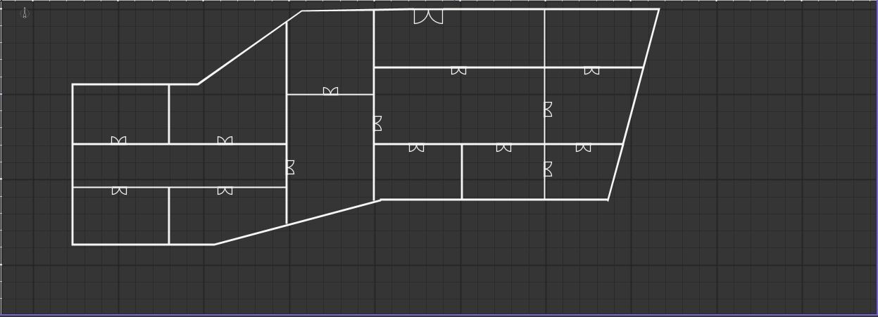
Phones
Laptops
TV’s
Gaming
PC’s
Gaming
Chairs
Gaming
monitors
Vacuum
cleaner
Dish Washer
Headsets
Corridor
Lobby
Dryers
Air Fryer
Washing
Machine

