1)**<Window x:Class="WpfApp2.MainWindow"  
xmlns="http://[schemas.microsoft.com/winfx/2006/xaml/presentation](https://vk.com/away.php?to=http%3A%2F%2Fschemas.microsoft.com%2Fwinfx%2F2006%2Fxaml%2Fpresentation&cc_key=)"  
xmlns:x="http://[schemas.microsoft.com/winfx/2006/xaml](https://vk.com/away.php?to=http%3A%2F%2Fschemas.microsoft.com%2Fwinfx%2F2006%2Fxaml&cc_key=)"  
xmlns:d="http://[schemas.microsoft.com/expression/blend/2008](https://vk.com/away.php?to=http%3A%2F%2Fschemas.microsoft.com%2Fexpression%2Fblend%2F2008&cc_key=)"  
xmlns:mc="http://[schemas.openxmlformats.org/markup-compatibility/2006](https://vk.com/away.php?to=http%3A%2F%2Fschemas.openxmlformats.org%2Fmarkup-compatibility%2F2006&cc_key=)"  
xmlns:local="clr-namespace:WpfApp2"  
mc:Ignorable="d"  
Title="MainWindow" Height="450" Width="800">  
<Grid> <Button>  
<Button.Background>  
[#f0f0f0](https://vk.com/im?sel=2000000192&st=%23f0f0f0)  
</Button.Background>  
</Button>  
<Button>  
<Button x:Name="Btn1"  
HorizontalAlignment="Left"  
VerticalAlignment="Top"  
Width="150"  
Height="30"  
FontSize="17"  
Content="Обычная кнопка"  
Foreground="White"  
BorderBrush="#303030" Click="Btn1_Click">  
<Button.Background>  
<LinearGradientBrush>  
<LinearGradientBrush.GradientStops>  
<GradientStop Color="LightBlue" Offset="0" />  
<GradientStop Color="DarkBlue" Offset="1" />  
</LinearGradientBrush.GradientStops>  
</LinearGradientBrush>  
</Button.Background>  
</Button>  
</Button>  
</Grid>  
</Window>**

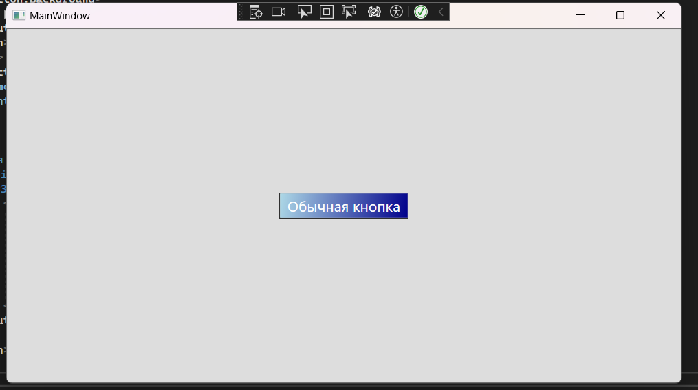

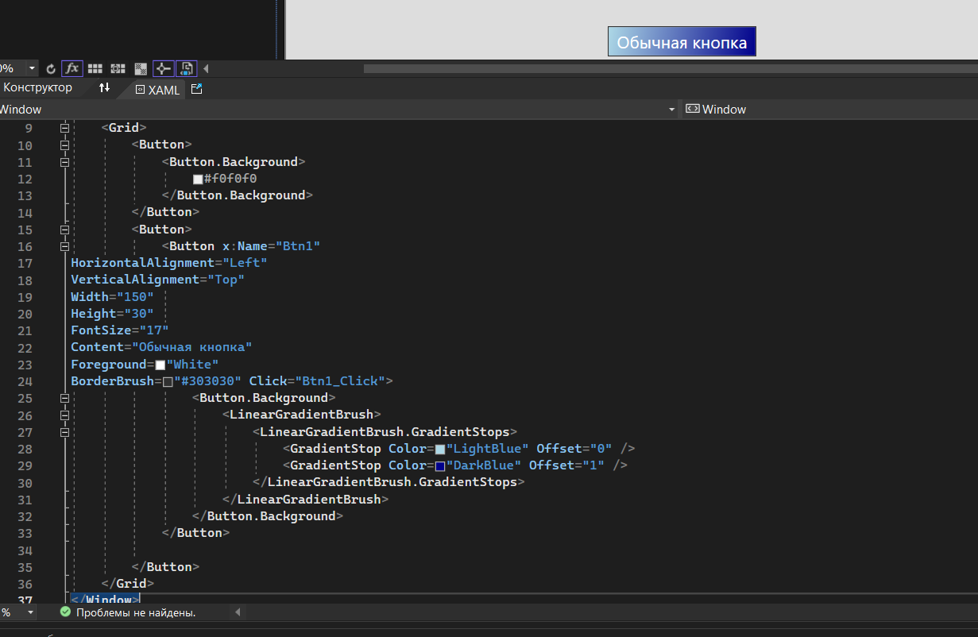

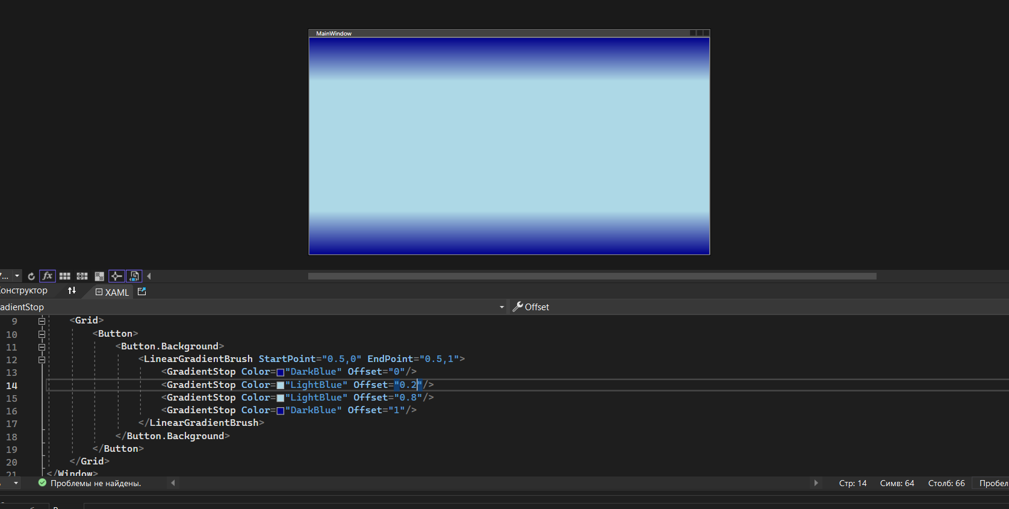2)**<Grid>  
<Button>  
<Button.Background>  
<LinearGradientBrush StartPoint="0.5,0" EndPoint="0.5,1">  
<GradientStop Color="DarkBlue" Offset="0"/>  
<GradientStop Color="LightBlue" Offset="0.2"/>  
<GradientStop Color="LightBlue" Offset="0.8"/>  
<GradientStop Color="DarkBlue" Offset="1"/>  
</LinearGradientBrush>  
</Button.Background>  
</Button>  
/Grid>**

**3)<Grid>**

**<WrapPanel>**

**<Label Content="Последние документы" />**

**<Button Content="Открыть" Margin="0,5,10,0" />**

**<Button Content="Сохранить" Margin="0,5,10,0" />**

**<Button Content="Закрыть" Margin="0,5,10,0" />**

**<Button Content="Обработать" Margin="0,5,10,0" />**

**<Button Content="О программе" Margin="0,5,10,0"/>**

**</WrapPanel>**

**<Canvas>**

**<Label Canvas.Top="29" Content="1.txt" />**

**<Label Canvas.Top="57" Content="2.txt" />**

**<Label Canvas.Top="85" Content="3.txt" />**

**<Label Canvas.Top="113" Content="4.txt" />**

**<Label Canvas.Top="141" Content="5.txt" />**

**<Label Canvas.Top="169" Content="6.txt" />**

**<Label Canvas.Top="29" Content="1.txt" Canvas.Left="122" HorizontalAlignment="Left" VerticalAlignment="Center" FontWeight="Bold" />**

**<Label Canvas.Top="29" Content="2.txt" Canvas.Left="158" HorizontalAlignment="Left" VerticalAlignment="Center" />**

**<Label Canvas.Top="29" Content="3.txt" Canvas.Left="191" HorizontalAlignment="Left" VerticalAlignment="Center" />**

**<Rectangle Fill="Yellow" Width="80" Height="100" Canvas.Left="130" Canvas.Top="60"/>**

**<Rectangle Fill="Red" Width="80" Height="100" Canvas.Left="220" Canvas.Top="60" />**

**<Rectangle Fill="Green" Width="80" Height="100" Canvas.Left="310" Canvas.Top="60" />**

**<Rectangle Fill="Blue" Width="80" Height="100" Canvas.Left="400" Canvas.Top="60" />**

**<Rectangle Fill="Gray" Width="80" Height="100" Canvas.Left="490" Canvas.Top="60" />**

**<Rectangle Fill="beige" Width="80" Height="100" Canvas.Left="580" Canvas.Top="60" />**

**<Label Content="A" HorizontalAlignment="Left" Canvas.Top="100" VerticalAlignment="Top" Canvas.Left="160" FontWeight="Bold"/>**

**<Label Content="B" HorizontalAlignment="Left" Canvas.Top="100" VerticalAlignment="Top" Canvas.Left="250" FontWeight="Bold"/>**

**<Label Content="C" HorizontalAlignment="Left" Canvas.Top="100" VerticalAlignment="Top" Canvas.Left="340" FontWeight="Bold"/>**

**<Label Content="D" HorizontalAlignment="Left" Canvas.Top="100" VerticalAlignment="Top" Canvas.Left="430" FontWeight="Bold"/>**

**<Label Content="E" HorizontalAlignment="Left" Canvas.Top="100" VerticalAlignment="Top" Canvas.Left="520" FontWeight="Bold"/>**

**<Label Content="F" HorizontalAlignment="Left" Canvas.Top="100" VerticalAlignment="Top" Canvas.Left="610" FontWeight="Bold"/>**

**<Rectangle Fill="Red" Width="80" Height="100" Canvas.Left="130" Canvas.Top="170" />**

**<Label Content="B" HorizontalAlignment="Left" Canvas.Top="200" VerticalAlignment="Top" Canvas.Left="160" FontWeight="Bold"/>**

**<Rectangle Fill="Green" Width="80" Height="100" Canvas.Left="130" Canvas.Top="280" />**

**<Label Content="C" HorizontalAlignment="Left" Canvas.Top="310" VerticalAlignment="Top" Canvas.Left="160" FontWeight="Bold"/>**

**<Rectangle Fill="Blue" Width="80" Height="100" Canvas.Left="130" Canvas.Top="390" />**

**<Label Content="D" HorizontalAlignment="Left" Canvas.Top="420" VerticalAlignment="Top" Canvas.Left="160" FontWeight="Bold"/>**

**<Rectangle Fill="Gray" Width="80" Height="100" Canvas.Left="130" Canvas.Top="500" />**

**<Label Content="E" HorizontalAlignment="Left" Canvas.Top="530" VerticalAlignment="Top" Canvas.Left="160" FontWeight="Bold"/>**

**<Rectangle Fill="beige" Width="80" Height="100" Canvas.Left="130" Canvas.Top="610" />**

**<Label Content="F" HorizontalAlignment="Left" Canvas.Top="640" VerticalAlignment="Top" Canvas.Left="160" FontWeight="Bold"/>**

**</Canvas>**

**</Grid>**



