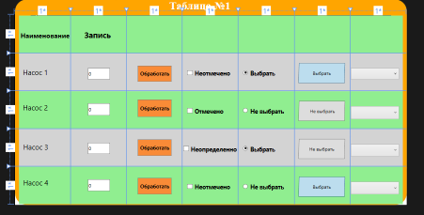

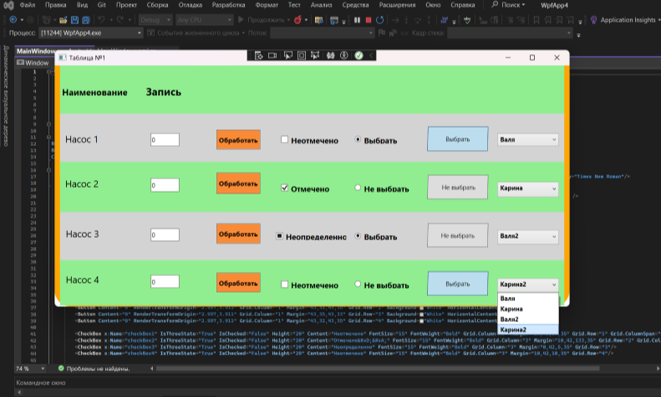

xmlns="http://schemas.microsoft.com/winfx/2006/xaml/presentation"

xmlns:x="http://schemas.microsoft.com/winfx/2006/xaml"

xmlns:d="http://schemas.microsoft.com/expression/blend/2008"

xmlns:mc="http://schemas.openxmlformats.org/markup-compatibility/2006"

xmlns:local="clr-namespace:WpfApp4"

mc:Ignorable="d"

Title="Таблица №1" Height="500" Width="1000">

<Grid RenderTransformOrigin="0.482,0.522">

<Border

BorderThickness="40"

BorderBrush="Orange"

CornerRadius="10" Margin="0,-41,0,0" Grid.ColumnSpan="7" Grid.RowSpan="6" />

<Grid Margin="0,0,0,97" Grid.RowSpan="2">

<TextBlock FontSize="28" FontWeight="Black" Foreground="#FFFCFCFC" TextWrapping="Wrap" Text="Таблица №1" VerticalAlignment="Top" Margin="394,-41,-430,0" FontFamily="Times New Roman"/>

</Grid>

<Border Background="LightGreen" Margin="10,0,10,87" Grid.RowSpan="2" Grid.ColumnSpan="7"/>

<Label Grid.Column="0" Grid.Row="0" Content="Наименование" Margin="9,34,121,22" FontWeight="Bold" FontSize="17" RenderTransformOrigin="0.465,-0.005" Grid.ColumnSpan="2" />

<Border Background="LightGray" Margin="10,0,10,70" Grid.RowSpan="2" Grid.Row="1" Grid.ColumnSpan="7"/>

<Label Grid.Column="0" Grid.Row="1" Content="Насос 1" Margin="15,31,16,24" FontSize="18"/>

<Border Background="LightGreen" Grid.Row="2" Grid.ColumnSpan="7" Margin="10,0,10,87" Grid.RowSpan="2"/>

<Label Grid.Column="0" Grid.Row="2" Content="Насос 2" Margin="15,24,16,25" FontSize="18"/>

<Border Background="LightGray" Margin="10,96,10,79" Grid.Row="2" Grid.ColumnSpan="7" Grid.RowSpan="3"/>

<Label Grid.Column="0" Grid.Row="3" Content="Насос 3" Margin="16,28,16,27" FontSize="18"/>

<Border Background="LightGreen" Grid.Row="3" Margin="10,96,10,2" Grid.RowSpan="4" Grid.ColumnSpan="7"/>

<Label Grid.Column="0" Grid.Row="4" Content="Насос 4" Margin="16,23,26,22" FontSize="18" RenderTransformOrigin="0.501,9.021"/>

<Label Grid.Column="1" Grid.Row="0" Content="Запись" Margin="29,31,30,7" FontWeight="Bold" FontSize="20"/>

<Button Grid.Column="2" Grid.Row="1" Content="Обработать" Margin="28,31,29,24" Background="#FFF98B37" FontSize="13" FontWeight="Bold"/>

<Button Grid.Column="2" Grid.Row="2" Content="Обработать" Margin="28,21,29,31" Background="#FFF98B37" FontSize="13" FontWeight="Bold"/>

<Button Grid.Column="2" Grid.Row="3" Content="Обработать" Margin="28,26,29,28" Background="#FFF98B37" FontSize="13" FontWeight="Bold"/>

<Button Grid.Column="2" Grid.Row="4" Content="Обработать" Margin="28,28,29,27" Background="#FFF98B37" FontSize="13" FontWeight="Bold"/>

<Button Content="0" RenderTransformOrigin="2.997,3.911" Grid.Column="1" Margin="43,37,43,30" Grid.Row="1" Background="White" HorizontalContentAlignment="Left" />

<Button Content="0" RenderTransformOrigin="2.997,3.911" Grid.Column="1" Margin="43,31,43,35" Grid.Row="2" Background="White" HorizontalContentAlignment="Left" />

<Button Content="0" RenderTransformOrigin="2.997,3.911" Grid.Column="1" Margin="43,35,43,33" Grid.Row="3" Background="White" HorizontalContentAlignment="Left" />

<Button Content="0" RenderTransformOrigin="2.997,3.911" Grid.Column="1" Margin="43,32,43,35" Grid.Row="4" Background="White" HorizontalContentAlignment="Left" />

<CheckBox x:Name="checkBox1" IsThreeState="True" IsChecked="False" Height="20" Content="Неотмечено" FontSize="15" FontWeight="Bold" Grid.Column="3" Margin="10,42,10,35" Grid.Row="1" Grid.ColumnSpan="1"/>

<CheckBox x:Name="checkBox2" IsThreeState="True" IsChecked="False" Height="20" Content="Отмечено&#xD;&#xA;" FontSize="15" FontWeight="Bold" Grid.Column="3" Margin="10,42,133,35" Grid.Row="2" Grid.ColumnSpan="2" Checked="checkBox2_Checked"/>

<CheckBox x:Name="checkBox3" IsThreeState="True" IsChecked="False" Height="20" Content="Неопределенно" FontSize="15" FontWeight="Bold" Grid.Column="3" Margin="0,42,5,35" Grid.Row="3"/>

<CheckBox x:Name="checkBox4" IsThreeState="True" IsChecked="False" Height="20" Content="Неотмечено" FontSize="15" FontWeight="Bold" Grid.Column="3" Margin="10,42,10,35" Grid.Row="4"/>

<RadioButton GroupName="Languages1" Content="Выбрать" IsChecked="True" Grid.Column="4" FontSize="15" FontWeight="Bold" Margin="10,42,10,35" Grid.Row="1" />

<RadioButton GroupName="Languages1" Content="Не выбрать" IsChecked="False" Grid.Column="4" FontSize="15" FontWeight="Bold" Margin="10,42,10,35" Grid.Row="2" />

<RadioButton GroupName="Languages" Content="Выбрать" IsChecked="True" Grid.Column="4" FontSize="15" FontWeight="Bold" Margin="10,42,10,35" Grid.Row="3" />

<RadioButton GroupName="Languages" Content="Не выбрать" IsChecked="False" Grid.Column="4" FontSize="15" FontWeight="Bold" Margin="10,42,10,35" Grid.Row="4" />

<ToggleButton Grid.Column="5" Margin="11,25,14,21" Grid.Row="1" IsChecked="True" Content="Выбрать" RenderTransformOrigin="0.5,0.5">

<ToggleButton.RenderTransform>

<TransformGroup>

<ScaleTransform/>

<SkewTransform AngleX="-1.394"/>

<RotateTransform/>

<TranslateTransform X="-1.176"/>

</TransformGroup>

</ToggleButton.RenderTransform>

</ToggleButton>

<ToggleButton Grid.Column="5" Margin="11,25,14,21" Grid.Row="2" IsChecked="False" Content=" Не выбрать" RenderTransformOrigin="0.5,0.5">

<ToggleButton.RenderTransform>

<TransformGroup>

<ScaleTransform/>

<SkewTransform AngleX="-1.394"/>

<RotateTransform/>

<TranslateTransform X="-1.176"/>

</TransformGroup>

</ToggleButton.RenderTransform>

</ToggleButton>

<ToggleButton Grid.Column="5" Margin="11,25,14,21" Grid.Row="3" IsChecked="False" Content="Не выбрать" RenderTransformOrigin="0.5,0.5">

<ToggleButton.RenderTransform>

<TransformGroup>

<ScaleTransform/>

<SkewTransform AngleX="-1.394"/>

<RotateTransform/>

<TranslateTransform X="-1.176"/>

</TransformGroup>

</ToggleButton.RenderTransform>

</ToggleButton>

<ToggleButton Grid.Column="5" Margin="11,25,14,21" Grid.Row="4" IsChecked="True" Content="Выбрать" RenderTransformOrigin="0.5,0.5">

<ToggleButton.RenderTransform>

<TransformGroup>

<ScaleTransform/>

<SkewTransform AngleX="-1.394"/>

<RotateTransform/>

<TranslateTransform X="-1.176"/>

</TransformGroup>

</ToggleButton.RenderTransform>

</ToggleButton>

<ComboBox Grid.Column="5" Margin="143,38,20,30" Grid.Row="1" Grid.ColumnSpan="2" FontWeight="Bold">

<TextBlock>Валя</TextBlock>

<TextBlock>Карина</TextBlock>

<TextBlock>Валя2</TextBlock>

<TextBlock>Карина2</TextBlock>

</ComboBox>

<ComboBox Grid.Column="5" Margin="143,38,20,25" Grid.Row="2" Grid.ColumnSpan="2" FontWeight="Bold">

<TextBlock>Валя</TextBlock>

<TextBlock>Карина</TextBlock>

<TextBlock>Валя2</TextBlock>

<TextBlock>Карина2</TextBlock >

</ComboBox>

<ComboBox Grid.Column="5" Margin="143,38,20,27" Grid.Row="3" Grid.ColumnSpan="2" FontWeight="Bold">

<TextBlock>Валя</TextBlock>

<TextBlock>Карина</TextBlock>

<TextBlock>Валя2</TextBlock>

<TextBlock>Карина2</TextBlock>

</ComboBox>

<ComboBox Grid.Column="5" Margin="143,38,20,27" Grid.Row="4" Grid.ColumnSpan="2" FontWeight="Bold">

<TextBlock>Валя</TextBlock>

<TextBlock>Карина</TextBlock>

<TextBlock>Валя2</TextBlock>

<TextBlock>Карина2</TextBlock>

</ComboBox>

<Grid.RowDefinitions>

<RowDefinition></RowDefinition>

<RowDefinition></RowDefinition>

<RowDefinition></RowDefinition>

<RowDefinition/>

<RowDefinition></RowDefinition>

</Grid.RowDefinitions>

<Grid.ColumnDefinitions>

<ColumnDefinition></ColumnDefinition>

<ColumnDefinition></ColumnDefinition>

<ColumnDefinition></ColumnDefinition>

<ColumnDefinition></ColumnDefinition>

<ColumnDefinition></ColumnDefinition>

<ColumnDefinition></ColumnDefinition>

<ColumnDefinition></ColumnDefinition>

</Grid.ColumnDefinitions>

</Grid>

</Window>