- 系统设计
  - 系统的类结构设计（用类图描述）
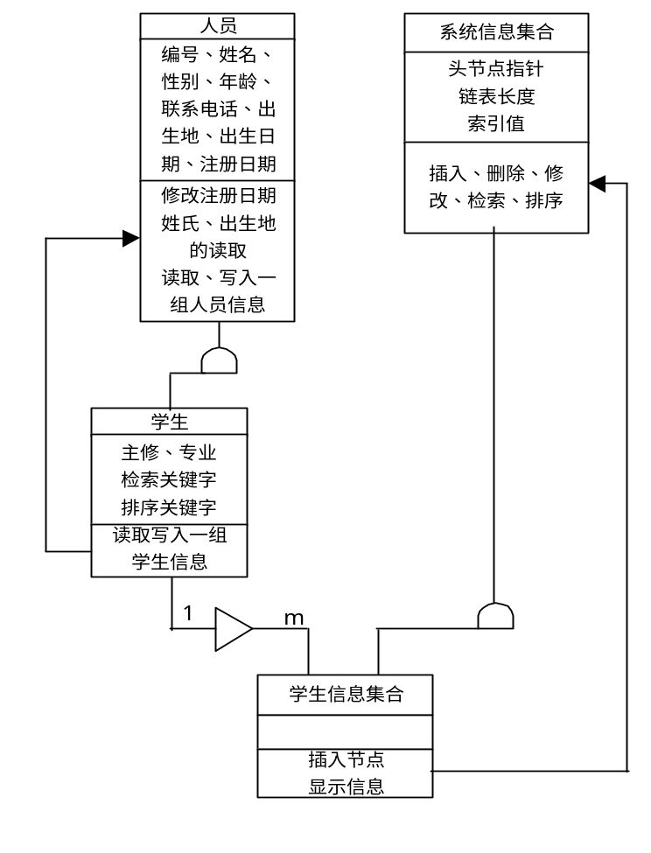
  - 各类的属性和行为设计
用类描述语言CDL对系统进行描述如下：
class CPerson
{ attribute: m_ID; attribute: m_Name; attribute: m_Sex;
attribute: m_Age; attribute: m_Phone; attribute: m_BirthPlace;
attribute: m_BirthDate; attribute: m_RegistDate;
attribute: m_UpdateDate;

method: ModifyUpdateDate; method: BirthPlace; method: Name;
method: Read; method: Write;}

class CStudent
{ attribute: m_Speciality; attribute: m_Major; attribute: m_RetrieveKey;
attribute: m_Retrieve;attribute: m_Sort;attribute: m_FieldWidth;

method: operator==; method: operator!=; method: operator<=;
method: operator>; method: Read{request CPerson.Read};
method: Write{request Cperson.Write}; method: Show; }

class CD_Link
{ attribute: *m_Head; attribute: m_Size; attribute: m_Index;

method: Head; method: First; method: Last; method: Index;
method: Size; method: Count{request: CD_Link.Get}; method: Empty;
method: FirstIndex{ request: CD_Link.Get };
method: LastIndex{ request: CD_Link.Get };
method: PrevIndex{ request: CD_Link.Get };
method: NextIndex{ request: CD_Link.Get };
method: InsertBefore; method: InsertAfter;
method: Location; method: Get; method: DeleteNode;
method: Delete{request:CD_Link.DeleteNode};
method: Contains{request: CD_Link.Location};
method: Merge;{request: CD_Link.Get}
method: MergePass{request: CD_Link.Merge};
method: MergeSort{request: CD_Link.MergePass};}
CStudentSet
{ method: InsertBefore{request: CD_Link.InsertBefore, CD_Link.Contains};
method: InsertAfter{request: CD_Link.InsertAfter};
method: ShowItem{request: CStudent.Show};
method: ShowTitle; method: DrawFrame;}
红色部分是需要你完成的重点内容，它是类方法之间的关系描述，Potter类的基本描述我已完成如下：
class CPlotter
{ attribute: pLastOut; attribute: Abspos; attribute: Phypos;
attribute: Step; attribute: PenDown; attribute: PenSpeed;
attribute: Enable; attribute: hFile;

method: OpenPort; method: ClosePort; method: PortEnable; method: OutPort;
method: XT; method: YT; method: PU; method: PD;method: PA; method: PR;
method: VS; method: InitPlotter;method: NumtoAsc; method: XYtoAsc;
method: PlotterStep; method: Phyposx; method: Phyposy; method: LastOut;
method: Absposx; method: Absposy; method: Line; method: MoveTo;
method: LineTo; method: BSP;method: Parabola; method: Shape;
}

