# Winter 2016/17

# 

# Winter 2015/16

# 

# Sommer 2015

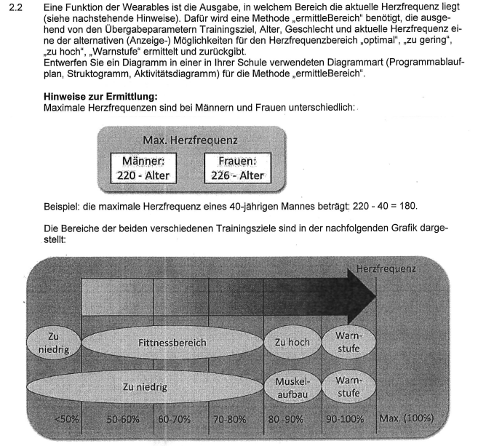

# Winter 2017/18

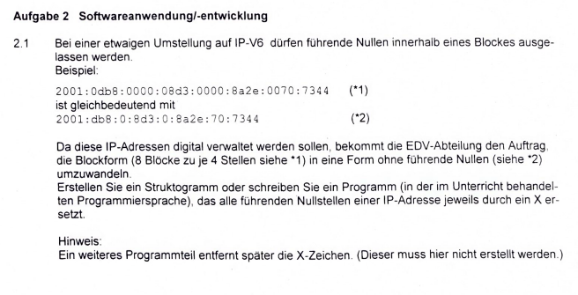

# Winter 2014/15

