e.sco Academy Statement of Achievement
Somnath Wanave
has successfully achieved student level credential for completing the Python Essentials course, provjded by Cisco Networking Academy in collaboration with OpenEDG Python Institute
The graduate has studied:
• Design devebp. debug. execute. and refaclor so-rue computer programs written 'n Python 3. Think argorirhrnicayy to anaW.'0 prob,wns ana implornon,' rhom as compoter processes.
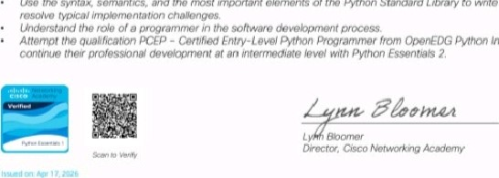
use 'he syntax. sooanrics„ and me most important ok.rnonts ot rhe Pvrhon Srandard Library to Mito Python saipts and
Python Institute and
Statement of Achievement
Somnath Wanave


has successfully achieved student level credential for completing the Python Essentials 2 course, provided by Cisco Networking Academy in collaboration with OpenEDG Python ms titute.
The graduate has studied;
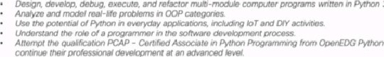Institute
3.

