**NAME:_________________________________________________________________________________ DATE:__________________**

***Note:*** This assignment builds understanding of following topics in CSS:

1. Using combinators
2. Using pseudo classes
3. Forming complex selectors
4. Basic styling using padding, border and background-color

* Build a set of panels, each having a heading and a body.
* The bodies of the panels are initially hidden (use display: none) on the body.

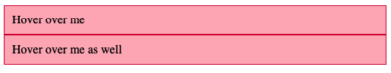

* 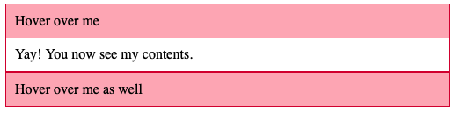When user hovers over a panel heading, the panel body is shown (use display: block on the body on hover)
* The selector to be used is quite tricky. **The + combinator selects a following sibling**. If the panel heading (with class panel-heading)and panel body (with class panel-body) are siblings (in that order in HTML), then **.panel-heading:hover + .panel-body** selects the panel body that comes after the panel heading that is being hovered upon.