2009

ONLINE TRANSLATION POST-EDITOR INTERFACE

(A sub-system in “WIKITRANS”)

Project Report

Prepared
And
Submitted By

V. ASWANI DUTT, 1207A002
G. ADITYA KUMAR, 1207A016
M. PRAVEEN, 1207A038
Master of Science in Information Technology
IIIT Hyderabad

Table of Contents

Introduction 3
Purpose 3
Intended Audience 3
Product Vision and Scope 3
Vision Statement 3
Scope and Limitations 4
References 4
Overall Description 5
Project Overview 5
Implementation 6
Snapshots 8

Introduction

Purpose

The purpose of this report is to provide complete description of our project “Online Translation Post Editor Interface”, a sub-system in Wikitrans (which is a collaborative multilingual editing framework for translation).

Intended Audience

This document provides all the necessary details related to the sub-system “Online Translation Post-editor Interface” to other developers/programmers involved in the project “Wikitrans” project or any other related projects.

Product Vision and Scope

Vision Statement

The sub-system “Online Translation Post-editor Interface” module plays an important role in “Wikitrans” project. The role of Online Translation Post Editor Interface (OTPEI) is to contribute for better translation from English to Hindi. The registered end-users can translate their own text or an entire web page from English to Hindi.

Scope and Limitations

The scope of this interface is to use this as a reference in the coming years in case if some changes have to be made to the existing post-editing services to Wikipedia and other resources available on the Internet. It also serves as a source for the future expansion of the current system in order to provide post-editing services in all types of languages.

References
Websites:
Yahoo User Interface: http://developer.yahoo.com/yui/
Moses Translation: http://www.statmt.org/moses/
Google Translate: http://translate.google.com/translate_t#
Translation Correction Tool: http://avenue.lti.cs.cmu.edu/aria/spanish/
HTML/JavaScript: http://www.w3schools.com

Overall Description

Project Overview

Online Translation Post Editor Interface (OTPEI) can be used to contribute for better translation from English to Hindi (wx format). The registered end-users on “Moses Online Translate” website can translate their own text or an entire web page from English to Hindi (wx format) online and also contribute to the translation process online. The translation is performed by Moses translation system configured on server-side. The logged in user can edit the translated sentences through an editing interface online in which he/she can:-
- Insert a single word at a time.
- Delete one or more words/phrases at a time.
- Drag and drop a single word at a time.
- Edit/Merge one or more words/phrases at a time.
- Submit his/her new translated sentence.
- Better understand and improvise translation with the help of word mappings.

Implementation

Our project mainly constitutes of the following parts:-
- Online Translation Post Editor Interface (abbreviated as OTPEI)
- “Moses Online Translate” Website development
- Translation
- Back-end Database storage
Online Translation Post Editor Interface is a tool with which different users can contribute to the translation process of his/her own text or given website/web page from English to Hindi online. Online Translation Post Editor Interface is integrated to our website named as “Moses Online Translate” with address http://202.41.92.138/login.html. The translation of the given text or webpage is performed using a stand-alone Moses translation system configured on the server-side. The user profiles and their contributions in the translation process are stored in the back-end database so that the user can use their own or other user’s contributions in the translation process.
OTPEI is developed using Yahoo User Interface (YUI) library programmed in JavaScript and HTML. “Moses Online Translate” website is developed using Perl and CGI scripting. Moses is a statistical machine translation system that allows us to automatically train translation models for any language pair. In our project it is for English to Hindi (wx format) translation. The back-end is implemented in MySQL. Also, all the required validations are handled with the help of JavaScript as well as Perl CGI scripting.

Online Translation Post Editor Interface is used in 2 modes:-
- Sentence Level Translation
In this mode, the logged-in user to the “Moses Online Translate” website enters his/her own English text which gets translated into Hindi (wx format) with the help of a stand-alone Moses translation system configured on the server-side. If the user gets the required translation from the server then that translation is finalized and stored into the database. If not, the user is provided with following features in order to get the required meaningful translation:-
- Insert a single word at a time.
- Delete one or more words/phrases at a time.
- Drag and drop a single word at a time.
- Edit/Merge one or more words/phrases at a time.
- Submit his/her new translation.
- Improvising translation with the help of word mappings
All the required input validations for the sentence level module are handled with the help of JavaScript.
- Web page Level Translation
In this mode, the logged-in user to the “Moses Online Translate” website enters a webpage link or a website (containing preferably around 400 word segments) which is translated into Hindi (wx format) in the same manner as in the sentence level mode. The translation is performed as sentence-based translation and when the translated text is mouse hovered then the corresponding original English text is displayed with the help of tooltip module. Also, since this tooltip module is integrated with the sentence-level module, the user can also make contributions to the webpage translated text.

The Moses translation system configured on the server-side (Apache on Fedora Linux) is initialized with the help of a CGI script named “daemon.pl” with proper settings. This system performs translation with the help of required phrase tables and language models.

In the back-end database design, a database named “translation” (in MySQL) is maintained on the server. Translation database consists of a table named “username” which contains the unique pairs of usernames and passwords. This table is referred when user has to login and register to the “Moses Online Translate” website. The other tables are created (when the user has to register) with names as per the usernames mentioned in “username” table. Each of these tables include the timestamp, the original English text input, the Moses Hindi (wx format) translated output and the finalized Hindi output. Each of these tables is referred during the translation process and also, when the user wants to know about his/her contributions in the translation process. But the database has to be normalized while utilizing this project on a very large scale (for as many million users as possible).

Snapshots

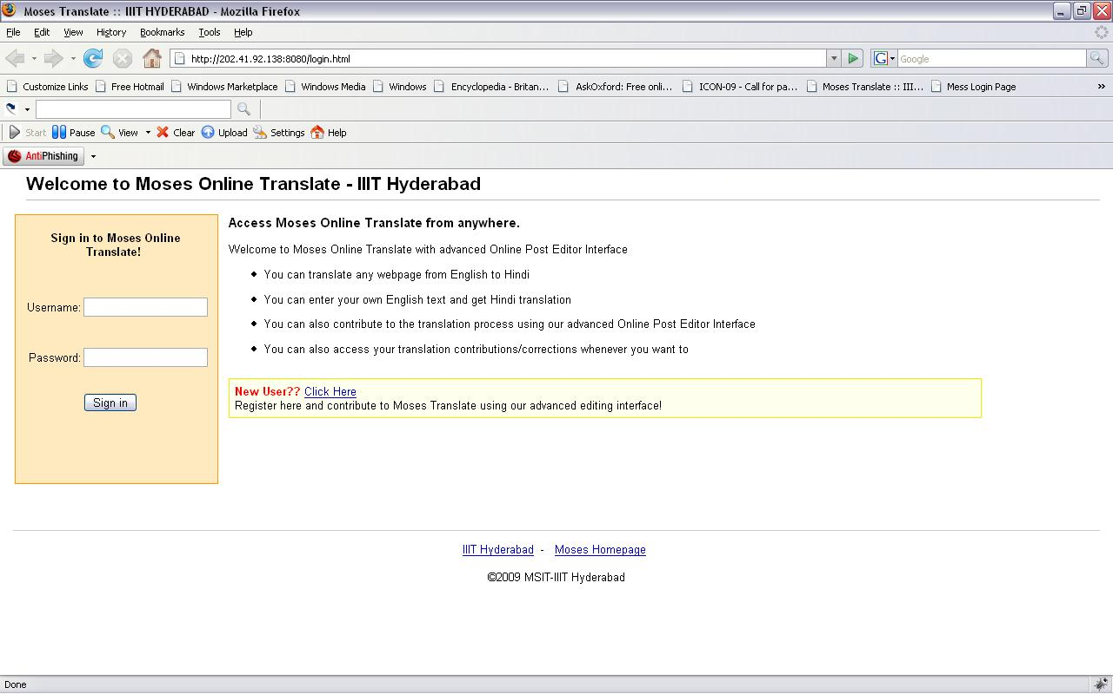

Website main page: This is the main page of the “Moses Online Translate” website where user logs in and a cookie is set on the client’s browser.
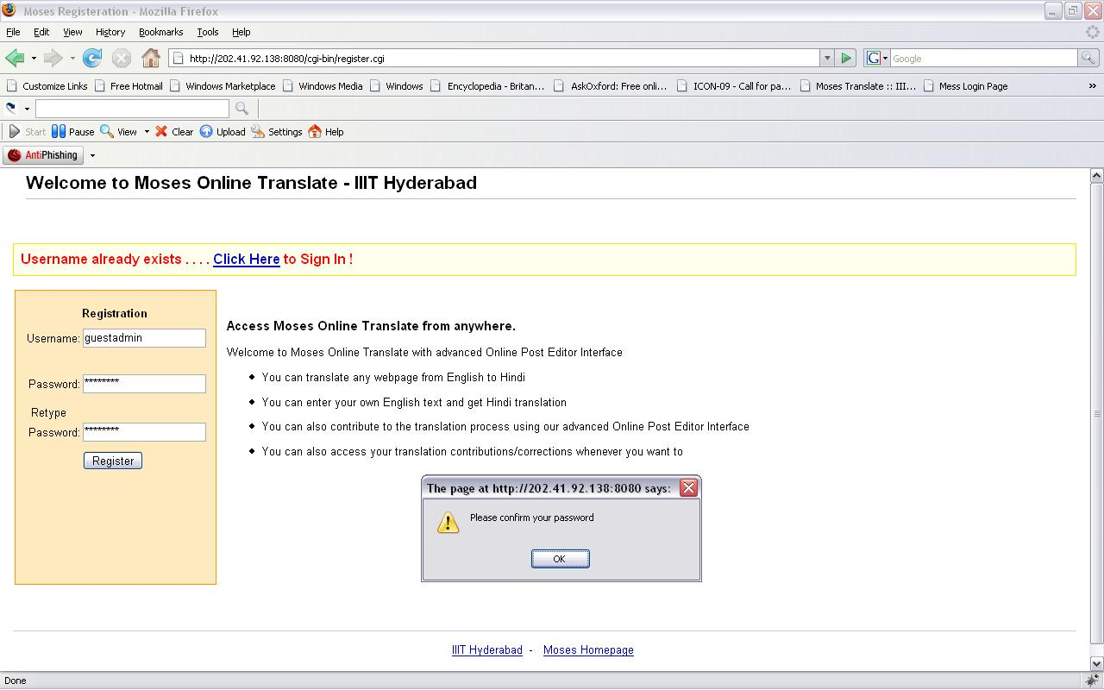

Registration Page: This is the registration page for the user to register for the “Moses Online Translate” website.
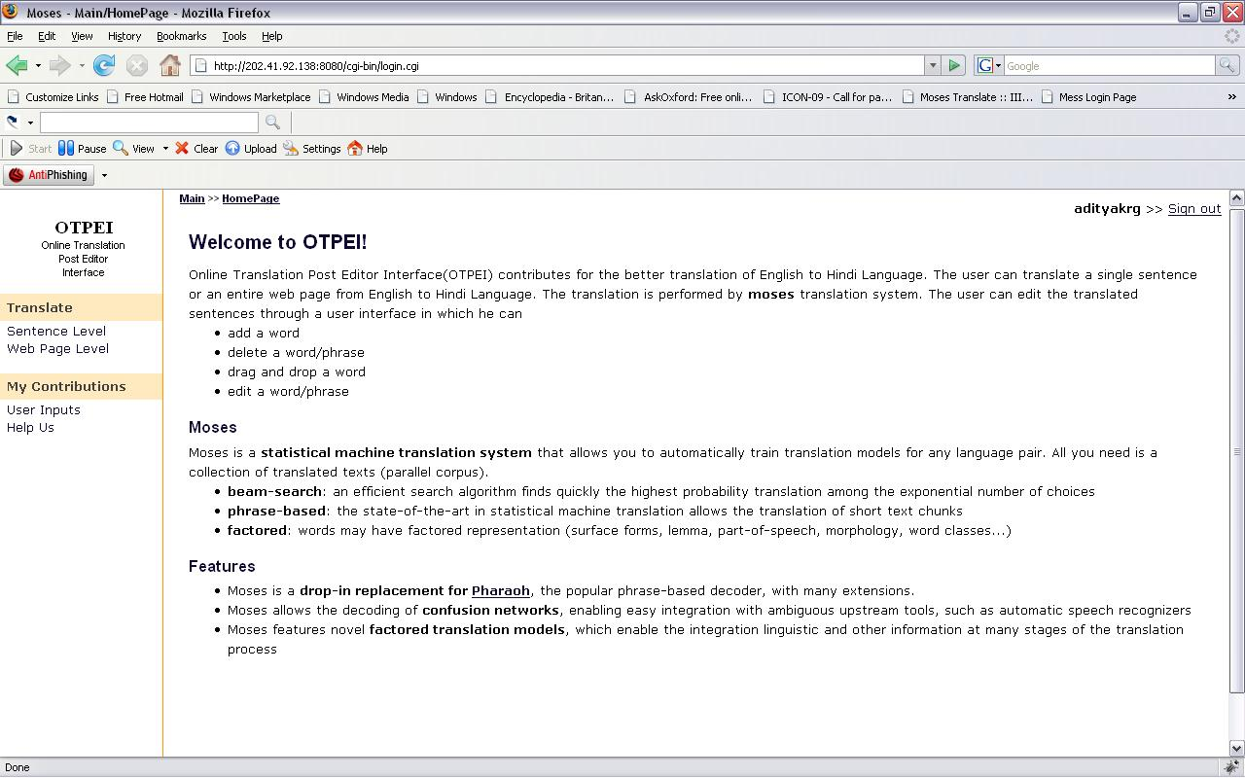

Homepage: This is the homepage viewed on the client’s browser when successfully logged-in or successfully registered.
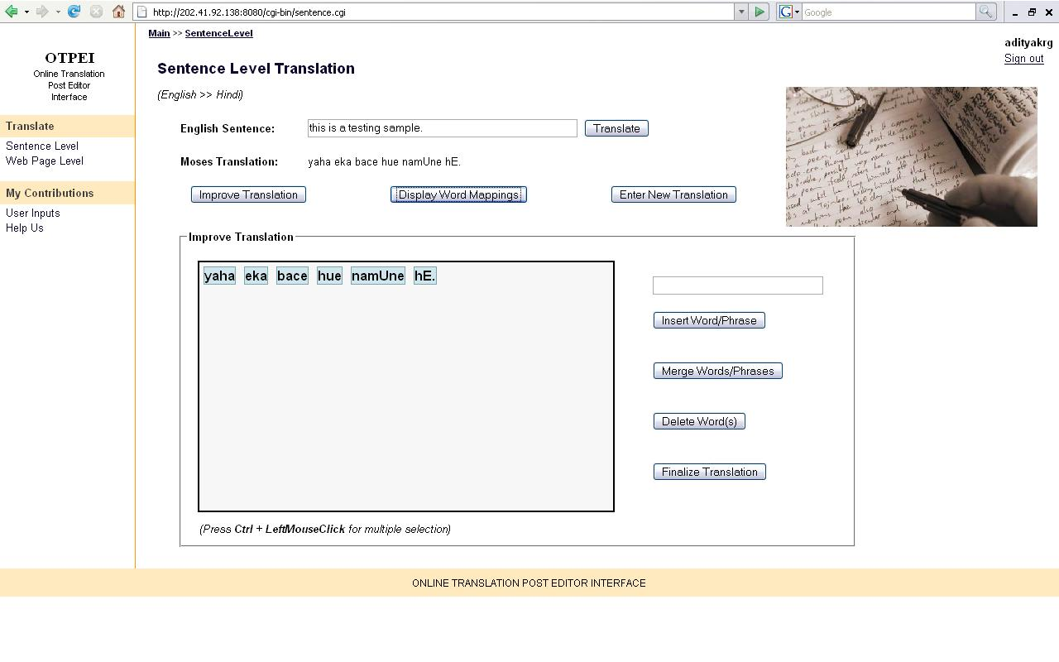
Sentence Level: It shows the editing interface for Sentence Level Translation Module where the user can translate and also contribute to the translation of his/her entered English text.
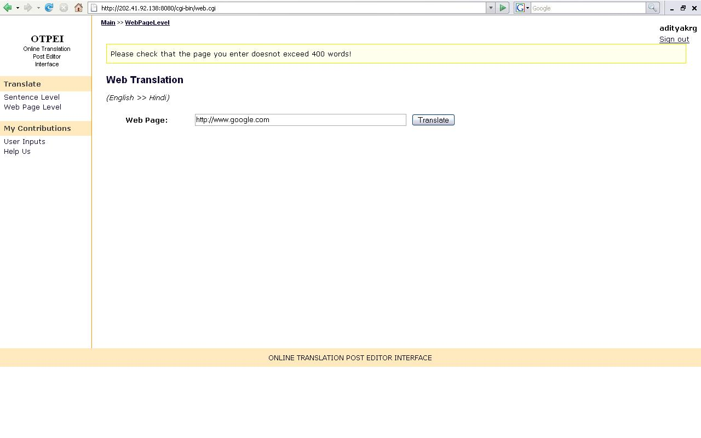
Web page Level: It shows the editing interface for the Web page Level Translation Module where the user enters a web page address and translates.
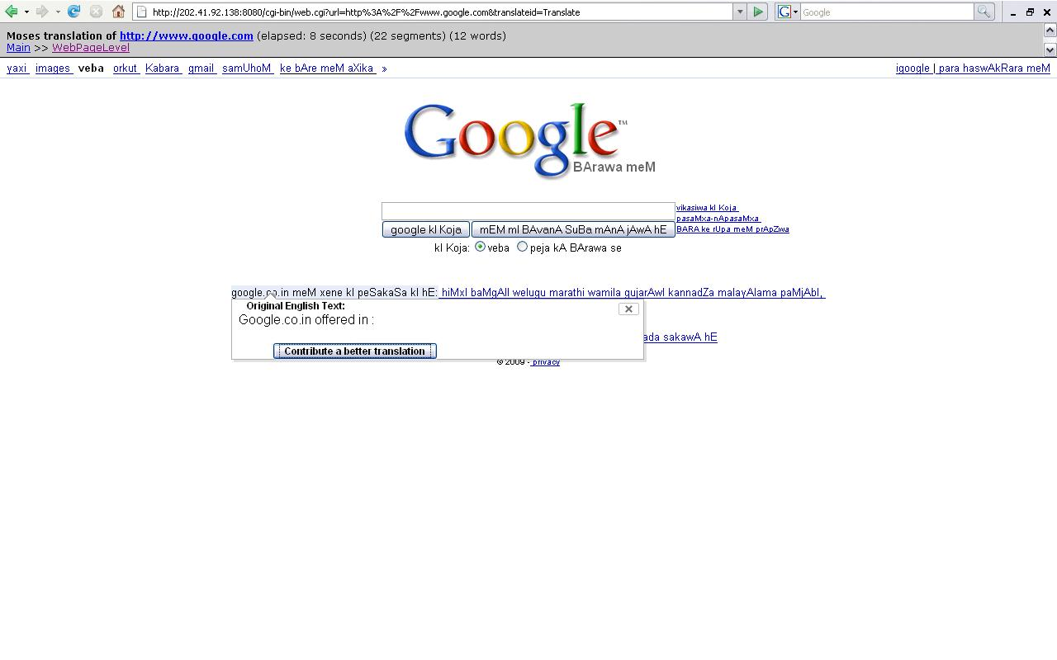
It shows the translation of the Google homepage, time taken to translate and total number of segments and words encountered in the translation process. It shows the usage of tooltip module for reflecting the original English text integrated with the Sentence Level Translation Module.
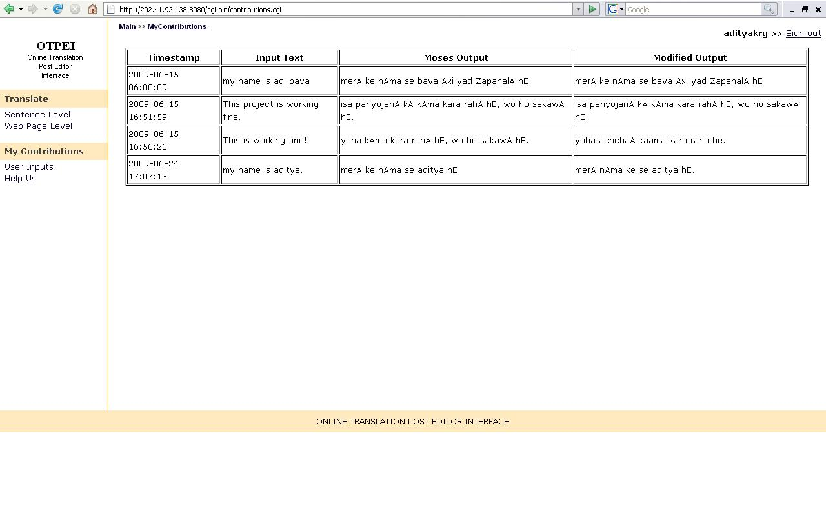
User Inputs: It shows all the contributions made by the logged-in user displayed as Timestamp, Original English Text, Moses Hindi (wx format) Output and Finalized Hindi Output by the user.
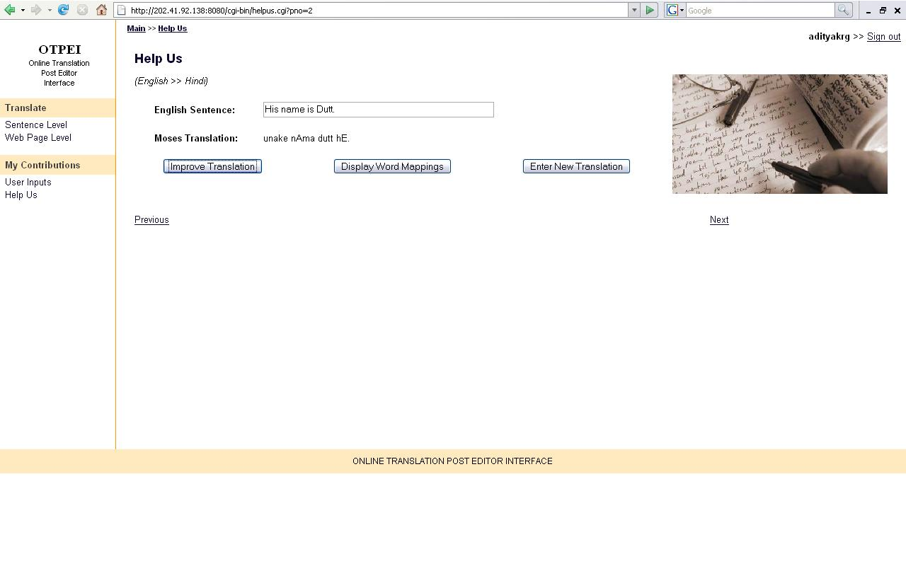
Help Us: It shows that the user can contribute again to the already Finalized Outputs and make better translations depending upon his/her requirements.

