Create Flow chart in SWDD:
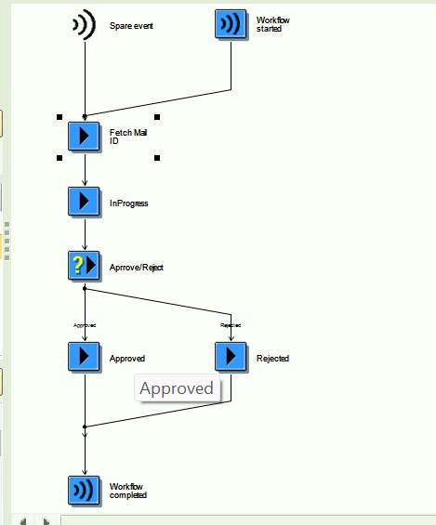

Create Workflow Containers :
agent : PA0105-USRID_LONG and properties: check import and export
user : WFSYST-AGENT and properties: check import and export.
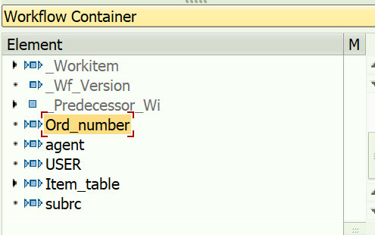

Create a BOR and methods and events and parameters against all:
T-code : swo1
Create a method using below screenshot
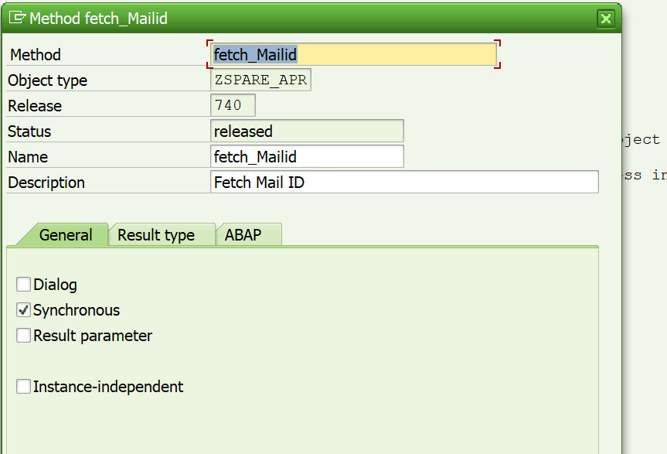
Event parameters :
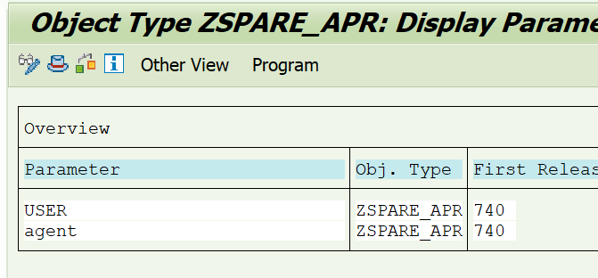
Key fields ,Implement and release tick mark in the methods and events:
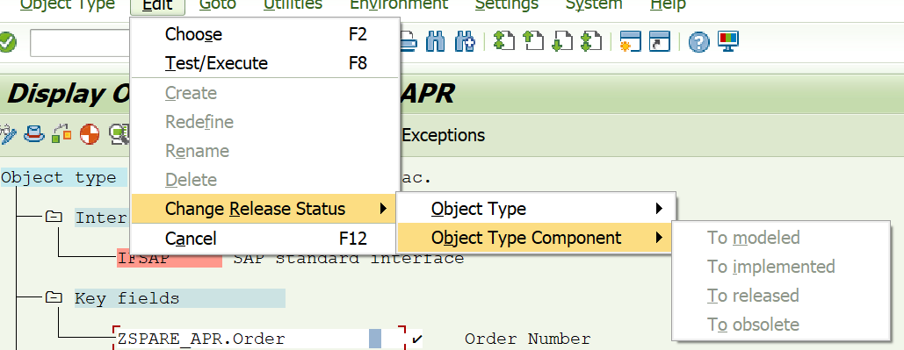
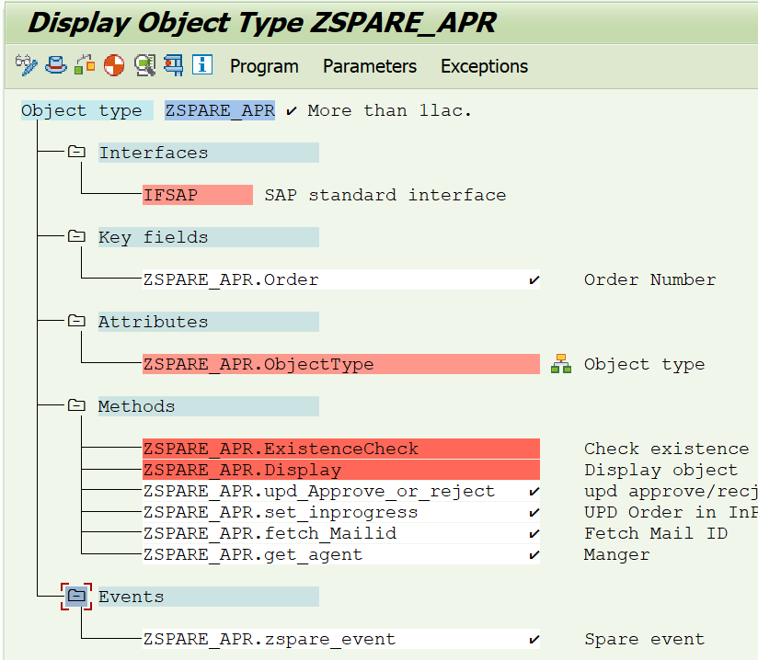

Event Type Linkage :
Create event :
T-code : SWUE
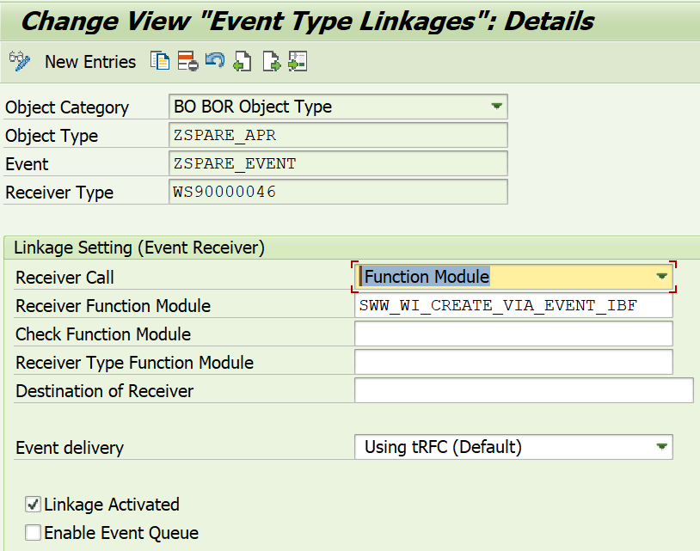
T-code : SWETYPV
It will ask customization request and moved Dev testing for test Eg : 100 t0 200
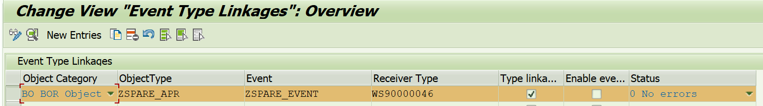
Create a Binding in the Header :
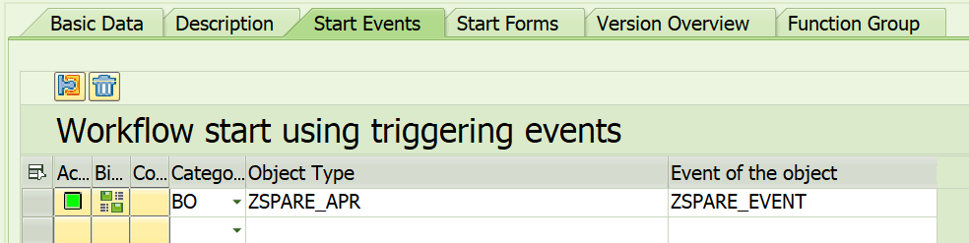
Binding : From event container to workflow container
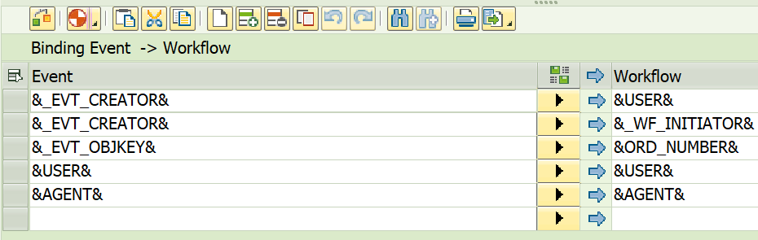
Create a Task for Activity:
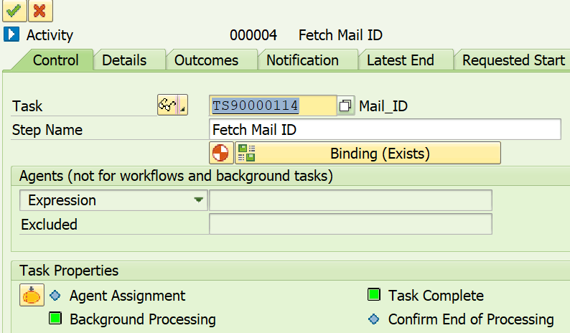
Basic data:
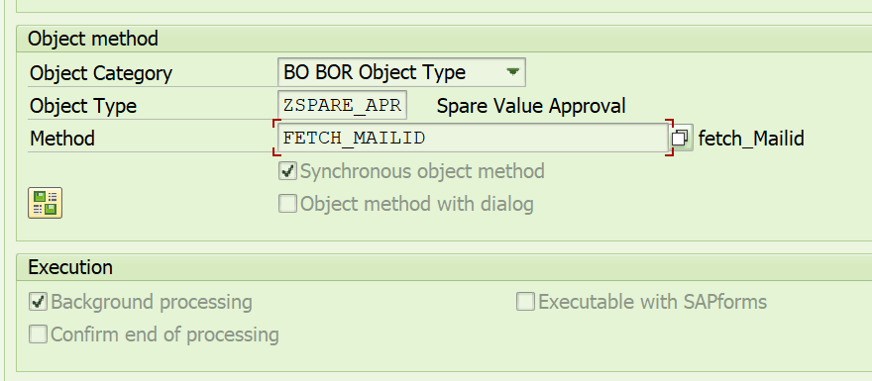
Create a Task Containers Elements :
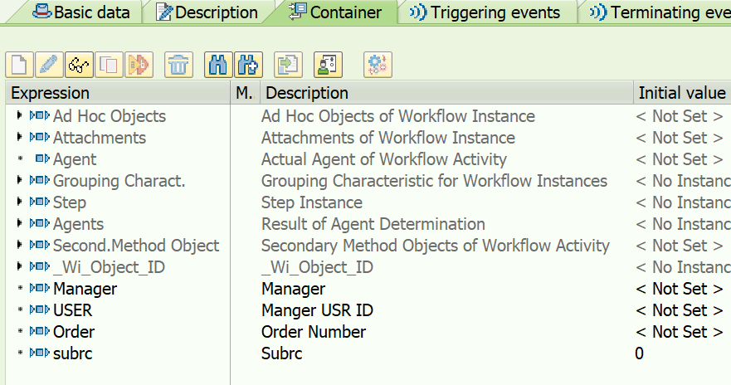
Binding :
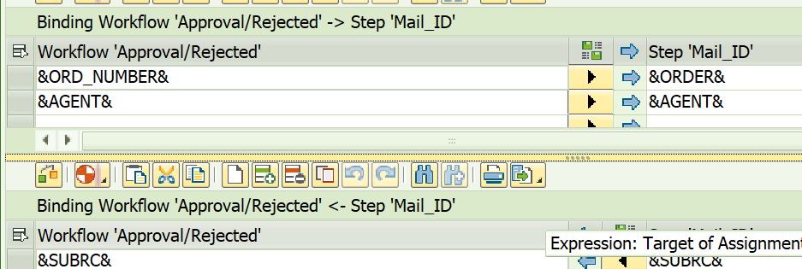

User Decision:
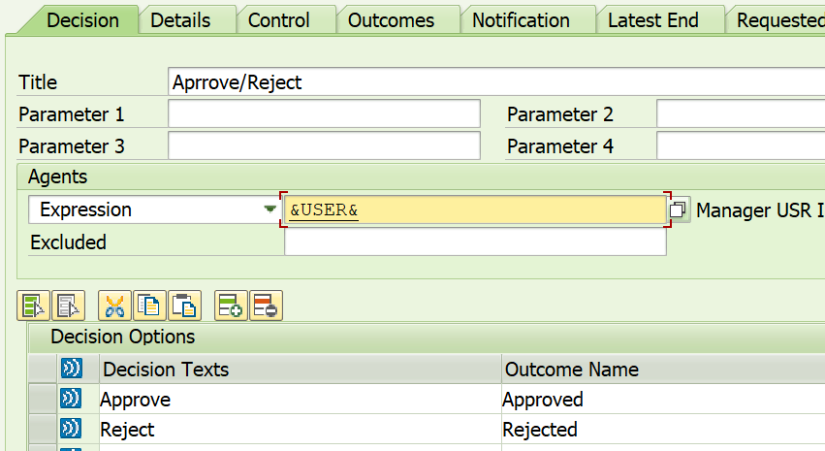
To check Trace On\Off : SWELS
To Check SAP Inbox : t-code -> sbwp
To Debugg : In method user this expression and in debug give b = X.
*DATA : a,b.
*a = 'X'.
*DO .
*if b = a.
* exit.
*ENDIF.
*ENDDO.
Method Logic :
begin_method fetch_mailid changing container.
TYPES: BEGIN OF ty_resb,
aufnr TYPE aufnr,
rsnum TYPE rsnum,
rspos TYPE rspos,
bdmng TYPE bdmng,
gpreis TYPE ppcomp,
END OF ty_resb.
DATA : user TYPE wfsyst-agent.
DATA : agent TYPE pa0105-usrid_long.
DATA : ls_mtable TYPE zspare_cons_str.
DATA : lt_mtable TYPE zspare_cons_tt.
DATA: it_resb TYPE TABLE OF ty_resb,
wa_resb TYPE ty_resb.
DATA : order TYPE aufk-aufnr.
DATA: it_final TYPE TABLE OF zspare_cons_appr,
wa_final TYPE zspare_cons_appr.
REFRESH : it_final,it_resb,lt_mtable.
CLEAR : wa_resb,wa_final,ls_mtable.
" vamsi
*DATA : a,b.
*a = 'X'.
*DO .
* IF b = a.
* EXIT.
* ENDIF.
*ENDDO.
swc_get_element container 'Order' order.
swc_get_element container 'agent' agent.
CALL FUNCTION 'CONVERSION_EXIT_ALPHA_INPUT'
EXPORTING
input = order
IMPORTING
output = order.
SELECT aufnr rsnum rspos bdmng gpreis FROM resb INTO TABLE it_resb
WHERE aufnr = order.
SELECT * FROM zspare_cons_appr INTO TABLE @DATA(it_check)
WHERE status IN ('In Progress', 'Approved').
IF it_check IS NOT INITIAL.
SORT it_check BY order_no reservation item counter DESCENDING.
DELETE ADJACENT DUPLICATES FROM it_check COMPARING order_no reservation item.
ENDIF.
REFRESH : it_final,lt_mtable.
LOOP AT it_resb INTO wa_resb.
READ TABLE it_check INTO DATA(wa_check) WITH KEY order_no = wa_resb-aufnr
reservation = wa_resb-rsnum
item = wa_resb-rspos.
IF sy-subrc = 0 AND wa_check-status = 'In Progress'.
CONTINUE.
ENDIF.
IF ( wa_resb-bdmng * wa_resb-gpreis ) LT 100000.
CONTINUE.
ENDIF.
CLEAR ls_mtable.
wa_final-mandt = sy-mandt.
ls_mtable-order_no = wa_resb-aufnr.
wa_final-order_no = wa_resb-aufnr.
ls_mtable-reservation = wa_resb-rsnum.
wa_final-reservation = wa_resb-rsnum.
ls_mtable-item = wa_resb-rspos.
wa_final-item = wa_resb-rspos.
wa_final-counter = wa_check-counter + 1.
ls_mtable-counter = wa_final-counter.
ls_mtable-cost = wa_resb-bdmng * wa_resb-gpreis.
wa_final-cost = ls_mtable-cost.
wa_final-status = 'In Progress'.
ls_mtable-status = 'In Progress'.
wa_final-created_on = sy-datum.
wa_final-created_time = sy-uzeit.
ls_mtable-created_on = sy-datum.
ls_mtable-created_time = sy-uzeit.
APPEND wa_final TO it_final.
APPEND ls_mtable TO lt_mtable.
CLEAR :wa_check,wa_resb,wa_final.
ENDLOOP.
REFRESH : it_resb,it_check.
swc_set_element container 'Item_table' lt_mtable.
*Sent Mail with table format in Body
*All the diclarations to send the email is same for this also
*except that diclare the doc type specify as HTML
DATA:
*- Structure to hold Output Details in delimited format
gf_output_soli TYPE soli,
*- Structure to hold Imported Object Components
gf_objpack TYPE sopcklsti1,
*- Structure to hold data in single line format
gf_objhead TYPE solisti1,
*- Structure to hold data in single line format
gf_objtxt TYPE solisti1,
*- Structure to hold data for API Recipient List
gf_reclist TYPE somlreci1,
*- Structure to hold email data
gf_doc_chng TYPE sodocchgi1,
*- Internal Table to hold Output Details in delimited format
gt_output_soli TYPE TABLE OF soli,
*- Internal Table to hold Imported Object Components
gt_objpack TYPE TABLE OF sopcklsti1,
*- Internal Table to hold data in single line format
gt_objhead TYPE TABLE OF solisti1,
*- Internal Table to hold data in single line format
gt_objtxt TYPE TABLE OF solisti1,
*- Internal Table to hold data for API Recipient List
gt_reclist TYPE TABLE OF somlreci1.
DATA : gv_menge1 TYPE char20.
DATA : lv_zminbe TYPE char20.
DATA : lv_menge1 TYPE char20.
DATA: g_lines TYPE sy-tabix, "To hold number of records
g_msg_lines TYPE sy-tabix, "To hold number of records
g_sent_all TYPE sonv-flag,
sender_address TYPE soextreci1-receiver.
CONSTANTS : gc_doc_type_htm(3) TYPE c VALUE 'HTM', "Code for document class
gc_rec_type TYPE c VALUE 'U', "Recipient type
gc_express TYPE c VALUE 'X'.
CLEAR : gf_objtxt ,gt_objpack,gt_objhead,gt_objtxt,gt_reclist.
*Set the Subject line
CONCATENATE sy-datum+6(2) sy-datum+4(2) sy-datum+0(4) INTO DATA(date) SEPARATED BY '.'.
CONCATENATE 'Approval for Spare Values Consumption Agaianst Order' order INTO gf_doc_chng-obj_descr.
*Set the Body background colour
gf_objtxt-line = '<body bgcolor = "#E6E6FA">'.
*- Append
APPEND gf_objtxt TO gt_objtxt.
*- Clear
CLEAR gf_objtxt.
*Set font color and its type
CONCATENATE '<FONT COLOR = "#191970" face="Garamond">' '<b>' INTO gf_objtxt-line.
*- Append
APPEND gf_objtxt TO gt_objtxt.
*- Clear
CLEAR gf_objtxt.
*Prepare mail body
CONCATENATE '<p>' 'Dear Manager,' '</p>'
INTO gf_objtxt-line.
*- Append
APPEND gf_objtxt TO gt_objtxt.
*- Clear
CLEAR gf_objtxt.
gf_objtxt-line = space.
*- Append
APPEND gf_objtxt TO gt_objtxt.
*- Clear
CLEAR gf_objtxt.
CONCATENATE '<p>'
'Please approve consumption of below component in PM order with transaction and need urgent attention.'
'</p>'
INTO gf_objtxt-line SEPARATED BY space.
APPEND gf_objtxt TO gt_objtxt.
CLEAR gf_objtxt.
gf_objtxt-line = '<left>'. "'<center>'.
APPEND gf_objtxt TO gt_objtxt.
CLEAR gf_objtxt.
* Pripare data in table format to dispay in Mail body
gf_objtxt-line = '<TABLE width= "100%" align = "LEFT" border="1">'.
APPEND gf_objtxt TO gt_objtxt.
CLEAR gf_objtxt.
CONCATENATE '<TR ><td align = "LEFT" BGCOLOR = "#708090">'
'<FONT COLOR = "BLACK"><B>Order Number</B> </FONT>'
'</td>' INTO gf_objtxt-line.
APPEND gf_objtxt TO gt_objtxt.
CLEAR gf_objtxt.
CONCATENATE '<td align = "LEFT" BGCOLOR = "#708090">' "+RA23032022
'<FONT COLOR = "BLACK"><B>Reservation No.</B> </FONT>'
'</td>' INTO gf_objtxt-line.
APPEND gf_objtxt TO gt_objtxt.
CLEAR gf_objtxt.
CONCATENATE '<td align = "LEFT" BGCOLOR = "#708090">'
'<FONT COLOR = "BLACK"><B>Item No.</B> </FONT>'
'</td>' INTO gf_objtxt-line.
APPEND gf_objtxt TO gt_objtxt.
CLEAR gf_objtxt.
CONCATENATE '<td align = "LEFT" BGCOLOR = "#708090">'
'<FONT COLOR = "BLACK"><B>Cost</B> </FONT>'
'</td>' INTO gf_objtxt-line.
APPEND gf_objtxt TO gt_objtxt.
CLEAR gf_objtxt.
*
*CONCATENATE '<td align = "LEFT" BGCOLOR = "#708090">'
* '<FONT COLOR = "BLACK"><B>Status</B> </FONT>'
* '</td>' INTO gf_objtxt-line.
*APPEND gf_objtxt TO gt_objtxt.
*CLEAR gf_objtxt.
LOOP AT lt_mtable INTO ls_mtable.
CLEAR : gv_menge1.
WRITE ls_mtable-cost TO lv_zminbe.
* write wa_final-zmenge to lv_zmenge.
* write wa_final-dfc_qty to lv_dfc_qty.
* write wa_final-ocdqty_su to lv_ocdqty_su.
*
SPLIT lv_zminbe AT '.' INTO gv_menge1 lv_menge1.
* split lv_zmenge at '.' into gv_menge2 lv_menge2.
* split lv_dfc_qty at '.' into gv_menge3 lv_menge3.
* split lv_ocdqty_su at '.' into gv_menge4 lv_menge4.
*
* concatenate wa_final-fkdat+6(2) wa_final-fkdat+4(2) wa_final-fkdat+0(4) into lv_date separated by '.'.
* if lv_date = '00.00.0000'.
* lv_date = ''.
* endif.
CONCATENATE '<TR><td align = "LEFT">'
'<FONT COLOR = "BLACK">'ls_mtable-order_no'</FONT>'
'</td>' INTO gf_objtxt-line.
APPEND gf_objtxt TO gt_objtxt.
CLEAR gf_objtxt.
CONCATENATE '<td align = "LEFT">'
'<FONT COLOR = "BLACK">'ls_mtable-reservation'</FONT>'
'</td>' INTO gf_objtxt-line.
APPEND gf_objtxt TO gt_objtxt.
CLEAR gf_objtxt.
CONCATENATE '<td align = "LEFT">'
'<FONT COLOR = "BLACK">'ls_mtable-item'</FONT>'
'</td>' INTO gf_objtxt-line.
APPEND gf_objtxt TO gt_objtxt.
CLEAR gf_objtxt.
CONCATENATE '<td align = "LEFT">'
'<FONT COLOR = "BLACK">'gv_menge1'</FONT>'
'</td>' INTO gf_objtxt-line.
APPEND gf_objtxt TO gt_objtxt.
* CONCATENATE '<td align = "LEFT">'
* '<FONT COLOR = "BLACK">'wa_final-status'</FONT>'
* '</td>' INTO gf_objtxt-line.
* APPEND gf_objtxt TO gt_objtxt.
CLEAR gf_objtxt.
CLEAR : ls_mtable.
ENDLOOP.
gf_objtxt-line = '</TABLE>'.
APPEND gf_objtxt TO gt_objtxt.
CLEAR gf_objtxt.
gf_objtxt-line = '</left>'. "'</center>'.
APPEND gf_objtxt TO gt_objtxt.
CLEAR gf_objtxt.
* CONCATENATE '<p>' ' Please confirm the appropriate actions'
* 'have taken place in regards to this change'
* '</p>'
* INTO gf_objtxt-line SEPARATED BY space.
* APPEND gf_objtxt TO gt_objtxt.
* CLEAR gf_objtxt.
*
* CONCATENATE '<p>' ' For further questions, please contact system administrator'
* '</p>'
* INTO gf_objtxt-line SEPARATED BY space.
* APPEND gf_objtxt TO gt_objtxt.
* CLEAR gf_objtxt.
gf_objtxt-line = space. "'<center>'.
APPEND gf_objtxt TO gt_objtxt.
CLEAR gf_objtxt.
gf_objtxt-line = space. "'<center>'.
APPEND gf_objtxt TO gt_objtxt.
CLEAR gf_objtxt.
gf_objtxt-line = 'Regards,<br />'.
APPEND gf_objtxt TO gt_objtxt.
CLEAR gf_objtxt.
gf_objtxt-line = 'Arjas Steel Pvt Ltd.<br />'.
APPEND gf_objtxt TO gt_objtxt.
CLEAR gf_objtxt.
gf_objtxt-line = '<br><br><b><center><i><font color = "RED">*This is an auto generated Email.'.
APPEND gf_objtxt TO gt_objtxt.
CLEAR gf_objtxt.
gf_objtxt-line = '</FONT></body>'.
*- Append
APPEND gf_objtxt TO gt_objtxt.
*- Clear
CLEAR gf_objtxt.
DESCRIBE TABLE gt_objtxt LINES g_msg_lines.
READ TABLE gt_objtxt INTO gf_objtxt INDEX g_msg_lines.
gf_doc_chng-doc_size = ( g_msg_lines - 1 ) * 255 + strlen( gf_objtxt ).
*- Creation of the entry for the compressed document
gf_objpack-transf_bin = ' '.
gf_objpack-head_start = 1.
gf_objpack-head_num = 0.
gf_objpack-body_start = 1.
gf_objpack-body_num = g_msg_lines.
gf_objpack-doc_type = gc_doc_type_htm.
*- Append
APPEND gf_objpack TO gt_objpack.
*- Clear
CLEAR gf_objpack.
*- Creation of the document attachment
*- Describe
DESCRIBE TABLE gt_output_soli LINES g_lines.
*- Don't create attachment if no data is present
IF g_lines <> 0.
LOOP AT gt_output_soli INTO gf_output_soli.
gf_objtxt = gf_output_soli.
*- Append
APPEND gf_objtxt TO gt_objtxt.
*- Clear
CLEAR gf_objtxt.
ENDLOOP.
ENDIF.
**- Completing the recipient list
* LOOP AT s_mailid.
*gf_reclist-receiver = 'mudunuri.vamsikrishnaraju@arjas.com'.
gf_reclist-receiver = agent.
gf_reclist-rec_type = gc_rec_type.
gf_reclist-express = gc_express.
**- Append
APPEND gf_reclist TO gt_reclist.
**- Clear
* CLEAR gf_reclist.
* ENDLOOP.
sender_address = sy-uname.
CALL FUNCTION 'SO_DOCUMENT_SEND_API1'
EXPORTING
document_data = gf_doc_chng
put_in_outbox = g_sent_all
sender_address = sender_address
commit_work = 'X'
IMPORTING
sent_to_all = g_sent_all
TABLES
packing_list = gt_objpack
object_header = gt_objhead
contents_txt = gt_objtxt
receivers = gt_reclist
EXCEPTIONS
too_many_receivers = 1
document_not_sent = 2
document_type_not_exist = 3
operation_no_authorization = 4
parameter_error = 5
x_error = 6
enqueue_error = 7
OTHERS = 8.
IF sy-subrc = 0.
cl_os_transaction_end_notifier=>raise_commit_requested( ).
CALL FUNCTION 'DB_COMMIT'.
cl_os_transaction_end_notifier=>raise_commit_finished( ).
* MESSAGE s022(so).
ENDIF.
MODIFY zspare_cons_appr FROM TABLE it_final.
IF sy-subrc = 0.
COMMIT WORK AND WAIT.
ENDIF.
end_method.
begin_method set_inprogress changing container.
end_method.
begin_method get_agent changing container.
end_method.
begin_method approved changing container .
DATA : ls_mtable TYPE zspare_cons_str.
DATA : lt_mtable TYPE zspare_cons_tt.
DATA : order TYPE resb-aufnr.
DATA: it_final TYPE TABLE OF zspare_cons_appr,
wa_final TYPE zspare_cons_appr.
" vamsi
DATA : a,b.
a = 'X'.
DO .
IF b = a.
EXIT.
ENDIF.
ENDDO.
swc_get_element container 'Item_table' lt_mtable.
swc_get_element container 'Ord_number' order.
*
*CALL FUNCTION 'CONVERSION_EXIT_ALPHA_INPUT'
* EXPORTING
* input = order
* IMPORTING
* output = order.
*
*SELECT aufnr rsnum rspos bdmng gpreis FROM resb INTO TABLE it_resb
* WHERE aufnr = order.
*
*SELECT * FROM zspare_cons_appr INTO TABLE @DATA(it_check)
* WHERE status IN ('In Progress', 'Approved').
*
*IF it_check IS NOT INITIAL.
* SORT it_check BY order_no reservation item counter DESCENDING.
* DELETE ADJACENT DUPLICATES FROM it_check COMPARING order_no reservation item.
*ENDIF.
*
*REFRESH : it_final,lt_mtable.
*LOOP AT it_resb INTO wa_resb.
*
* READ TABLE it_check INTO DATA(wa_check) WITH KEY order_no = wa_resb-aufnr
* reservation = wa_resb-rsnum
* item = wa_resb-rspos.
* IF sy-subrc = 0 AND wa_check-status NE 'In Progress'.
* CONTINUE.
* ENDIF.
* IF sy-subrc = 0 AND wa_check-status = 'Approved' AND wa_check-cost = ( wa_resb-bdmng * wa_resb-gpreis ).
* CONTINUE.
* ENDIF.
* IF ( wa_resb-bdmng * wa_resb-gpreis ) LT 100000.
* CONTINUE.
* ENDIF.
*
* wa_final-mandt = sy-mandt.
* wa_final-order_no = wa_resb-aufnr.
* wa_final-reservation = wa_resb-rsnum.
* wa_final-item = wa_resb-rspos.
* wa_final-counter = wa_check-counter + 1.
* wa_final-cost = wa_resb-bdmng * wa_resb-gpreis.
* wa_final-status = 'Approved'.
* wa_final-created_on = sy-datum.
* wa_final-created_time = sy-uzeit.
*
* MODIFY zspare_cons_appr FROM wa_final.
* IF sy-subrc = 0.
* COMMIT WORK AND WAIT.
* ENDIF.
* APPEND wa_final TO it_final.
* CLEAR :wa_check,wa_resb,wa_final.
*ENDLOOP.\
REFRESH : it_final.
IF lt_mtable IS NOT INITIAL.
LOOP AT lt_mtable INTO ls_mtable.
wa_final-mandt = sy-mandt.
wa_final-order_no = ls_mtable-order_no.
wa_final-reservation = ls_mtable-reservation.
wa_final-item = ls_mtable-item.
wa_final-counter = ls_mtable-counter.
wa_final-cost = ls_mtable-cost.
wa_final-status = 'Approved'.
wa_final-created_on = sy-datum.
wa_final-created_time = sy-uzeit.
APPEND wa_final TO it_final.
CLEAR :ls_mtable,wa_final.
ENDLOOP.
MODIFY zspare_cons_appr FROM TABLE it_final.
IF sy-subrc = 0.
COMMIT WORK AND WAIT.
ENDIF.
ENDIF.
end_method.
begin_method rejected changing container.
" vamsi
DATA : a,b.
a = 'X'.
DO .
IF b = a.
EXIT.
ENDIF.
ENDDO.
DATA : ls_mtable TYPE zspare_cons_str.
DATA : lt_mtable TYPE zspare_cons_tt.
DATA : order TYPE resb-aufnr.
DATA: it_final TYPE TABLE OF zspare_cons_appr,
wa_final TYPE zspare_cons_appr.
REFRESH : it_final.
swc_get_element container 'Ord_number' order.
swc_get_element container 'Item_table' lt_mtable.
IF lt_mtable IS NOT INITIAL.
LOOP AT lt_mtable INTO ls_mtable.
wa_final-mandt = sy-mandt.
wa_final-order_no = ls_mtable-order_no.
wa_final-reservation = ls_mtable-reservation.
wa_final-item = ls_mtable-item.
wa_final-counter = ls_mtable-counter.
wa_final-cost = ls_mtable-cost.
wa_final-status = 'Rejected'.
wa_final-created_on = sy-datum.
wa_final-created_time = sy-uzeit.
APPEND wa_final TO it_final.
CLEAR :ls_mtable,wa_final.
ENDLOOP.
MODIFY zspare_cons_appr FROM TABLE it_final.
IF sy-subrc = 0.
COMMIT WORK AND WAIT.
ENDIF.
ENDIF.
end_method.

