The Vamp Audio Analysis Plugin API: A Programmer's Guide
written and deftly illustrated by Chris Cannam

Overview
A Vamp plugin is a chunk of compiled program code that carries out analysis of a digital audio signal, returning results in some form other than an audio signal. These results are often called audio features.
Vamp plugins are distributed in shared library files with extension .dll, .so, or .dylib depending on the platform, with one or more plugins in each library. A plugin is usually identified to the computer using the shared library name plus a short text identifier naming the plugin within the library. The plugin cannot be used on its own, but only with a conforming “host” application which loads the plugin from its shared library and calls functions within the plugin code to configure it, supply it with data and run it.
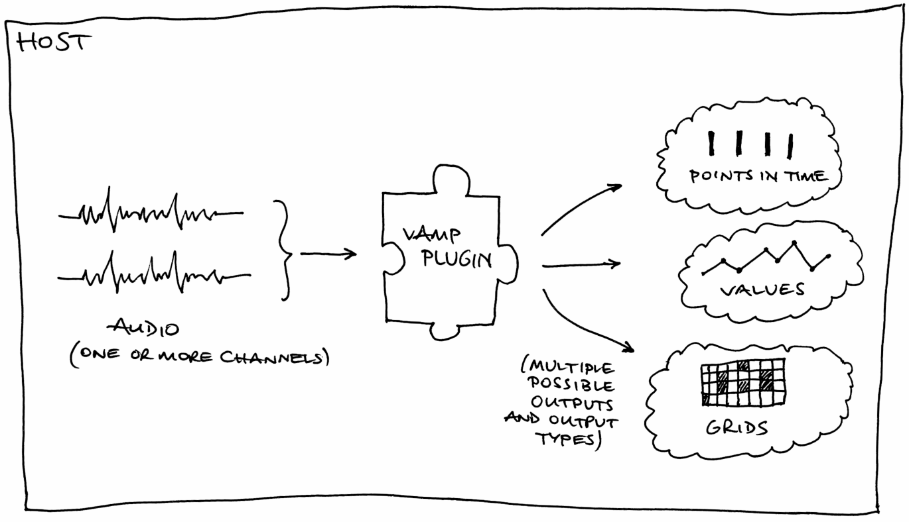
Plugins are not supplied with the whole of their audio input at once, but instead are fed it as a series of short blocks: in this respect they resemble real-time audio processing plugins, but in all other respects they are executed “off-line”, meaning that they are not expected to run in real-time and are not obliged to return features as they occur.
The Vamp plugin binary interface is defined in C, and the plugin SDK (software development kit) which will be described here is written in C++. Plugin authors are recommended to use the C++ interfaces in preference to plain C. This document explains the concepts and structures necessary to write Vamp plugins; it is not an API reference, which can be found at http://www.vamp-plugins.org/code-doc/.
Vamp is not an acronym. It contains letters suggestive of audio, plugins, visualisation and so on, but not in the right order.

Examples
Throughout this document we will use as examples three types of feature extractor that already exist as Vamp plugins. We will not consider the serious audio processing necessary to implement these techniques; we only describe how they communicate with the host as plugins. They are:
- Note onset detector. This estimates the times at which new note events begin in the signal, and returns those times as results. There are no particular values associated with the times. For the purposes of this example, our onset detector will actually have two outputs – the first will report the times as described above, and the second will report a measure of the likelihood that there is an onset within the current input block.
- Chromagram. This example of a visualisation data extractor analyses audio and produces from it a grid of values, with a time step as the X coordinate and a pitch bin within the octave as the Y coordinate. Each value in the grid describes the “strength” of the corresponding pitch in the music within the given time range.
- Amplitude tracker. This calculates structurally simple two-dimensional data (time and value) from the audio, to be displayed by the host as a data plot or used for some other purpose.
As these examples show, Vamp plugins do not actually do any display or user interaction: they just return data. In most cases, these data are not the final result of the work the host is doing, but are useful for something else – either for a host to display and the user to interact with in some way, or as intermediate calculations for a particular purpose such as semantically meaningful audio editing. Vamp plugins do not do swirly visualisation and are not very useful in real-time contexts such as interacting with musical performers.

What does a Plugin Contain?
A Vamp plugin needs to make a certain amount of information available to the host.
Every plugin, no matter how simple, should provide the following:
- The identifier, name, and description of the plugin itself.
See “Identifiers, Names and Descriptions” below.
- The name of the maker of the plugin, and the plugin's copyright status and version number.
- The input domain which the plugin would like its audio provided in.
See “Inputs” below.
- The plugin's preferred step size and block size for audio input.
See “Step and Block Size” below.
- The minimum and maximum number of input audio channels the plugin is capable of handling.
See “Inputs” below for discussion of these.
- A list of output descriptors that contain information about the structure of the results that the plugin may produce.
See “Outputs” below.
- Implementations of standard functions that set up, reset, and run the plugin.
See “Inputs” below for discussion of these.
Some plugins have parameters that can be set to adjust the way they do their processing. These plugins will also need to provide:
- A list of parameter descriptors that contain information about the editable parameters of the plugin. The host may use these descriptors to show the user a control window for the plugin, for example.
See “Parameters” below.
- Implementations of standard functions that retrieve and set the values of parameters.
A plugin may also have a set of pre-defined configurations that can be offered to the user by name. These are known as programs and a plugin that supports them will also need to provide:
- A list of program names.
See “Programs” below.
- Implementations of standard functions that retrieve the current program name and select a new program. The C++ base class provides virtual methods to override for these.

Base classes
The Vamp SDK contains one class from which plugin implementation classes should be derived. This class, Plugin, exposes pure virtual methods for most of the accessor and action functions that a plugin class needs to implement. Those that are not directly defined in Plugin are themselves inherited from a further class called PluginBase, which contains virtual methods for things that are not specific to the output structures used in Vamp – plugin name, maker, parameters, program names, etc. These classes, like everything in the SDK, are found in the Vamp namespace.
The Plugin and PluginBase classes also contain a number of data classes that are used when returning bundles of information about features (Feature, FeatureList, FeatureSet), outputs (OutputDescriptor), parameters (ParameterDescriptor) and so on. These will be referred to in the appropriate sections of this document.

Identifiers, Names and Descriptions
Vamp uses a combination of “identifier”, “name” and “description” strings to describe several sorts of object. Most obviously, the plugin itself must implement getIdentifier, getName and getDescription methods (inheriting from pure virtual methods in PluginBase) that return textual information about the plugin. Similar data are included as public data members in the ParameterDescriptor and OutputDescriptor classes.
In all of these cases, the purposes of the three strings are:
- identifier – This should contain a short string that the host can use to refer to the object, within the immediate surrounding scope. That is, the plugin identifier needs to be unique within the plugin's library; an output descriptor's identifier needs to be unique among output descriptors for the plugin; similarly for parameter descriptors. Identifiers are very limited in the characters they may include – upper and lower case ASCII alphabetical characters, digits 0 to 9, and the underscore character only.
- name – This is a text that may be shown to the user by the host as the normal label for the object.
- description – This is optional, and may contain extra text to describe the purpose of the object in a way that adds to the information in the name. Hosts that show the description to the user will normally do so in addition to the name, so it should not duplicate information already in the name.

Categories
The Vamp API itself does not provide any way for the host to categorise plugins by type or purpose. However, the host extension classes in the SDK do include a method to load plugin categories from category files (with .cat extension) that may be found in the Vamp plugin load path alongside the plugin libraries. These are text files which contain lines of the form
vamp:libraryname:pluginidentifier::category
The category string is a series of category names separated by “ > ”, which describe a possibly multi-level path into a category tree. For example,
vamp:vamp-example-plugins:percussiononsets::Time > Onsets

Inputs
The input to a Vamp plugin is audio data, with one or more channels. The audio is non-interleaved, so the plugin receives a set of pointers to data, one per channel. The plugin can specify how many channels it will accept using its getMinChannelCount and getMaxChannelCount methods.
The number of channels, as well as the block size and step size that will be used when running the plugin, are fixed when the plugin's initalise method is called.
bool initialise(size_t inputChannels, size_t stepSize, size_t blockSize);
If the plugin finds the values supplied to initialise unacceptable, it should return false to indicate that initialisation has failed.
After initialisation, to supply audio data and run the plugin, the host calls the plugin's process method repeatedly. The process method receives a set of input pointers, and a timestamp.
FeatureSet process(const float *const *inputBuffers, RealTime timestamp);
Each time process is called, it is passed a single block of audio of size in samples equal to the block size that was passed to initialise. The difference in sample count between the input to one process call and that to the next is equal to the step size.
As with channel count, the plugin can influence the step and block size by returning its desired values through its getPreferredStepSize and getPreferredBlockSize methods; unlike channel count, the preferred step and block size are only hints, so you should always check the actual values used in initialise if they are important to your code.
The audio may be provided in either time domain or frequency domain form. Time domain audio input is conventional PCM sampled digital audio with a floating-point sample type; frequency domain input is the result of applying a windowed short-time Fourier transform to each input block. The input domain is specified by the plugin using its getInputDomain method.

Time Domain Input
When a plugin requests time domain input, the host divides the audio input stream up into a series of blocks of equal size, and feeds one to each successive call to process. The process call may then return features derived from that audio input block, according to its whim. The inputBuffers argument to process will point to one array of floats for each input channel. For example, inputBuffers[0][blockSize-1] will be the last audio sample in the current block for the first input channel.
When all of the audio data has been supplied, the host calls getRemainingFeatures, and the plugin returns any features that are now known and not yet been returned from earlier process calls.
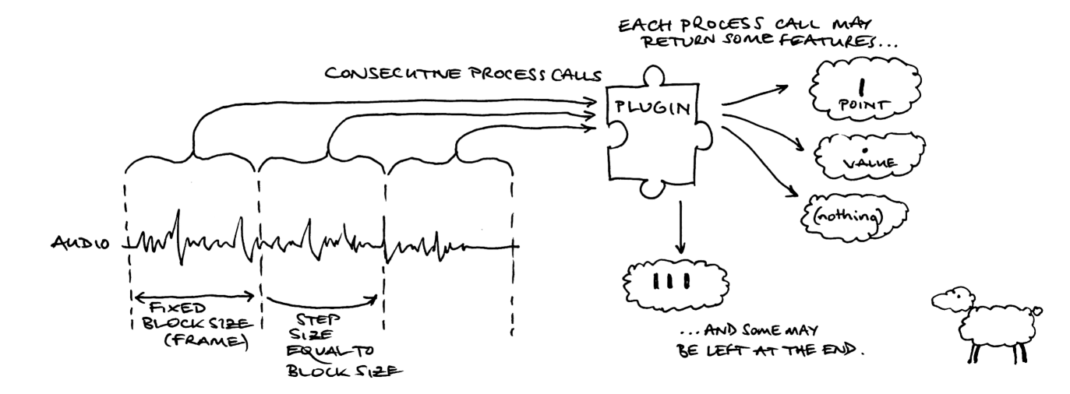
When supplying time domain input, it is most usual for the step size to be equal to the block size as shown above. This means that the plugin is receiving every sample in the audio input exactly once, in a series of contiguous blocks of data.
This does not have to be the case – the plugin can return a different value for getPreferredStepSize to that returned from getPreferredBlockSize if for any reason it would prefer to receive overlapping or non-contiguous blocks.
Vamp currently makes no provision for partial input blocks. If the audio input ends in the middle of a block, the host will fill the block with zero values up to the block size.

Frequency Domain Input
If the plugin requests frequency domain input, each block of audio input is processed by the host using a windowed short time Fourier transform before being supplied to the process function.
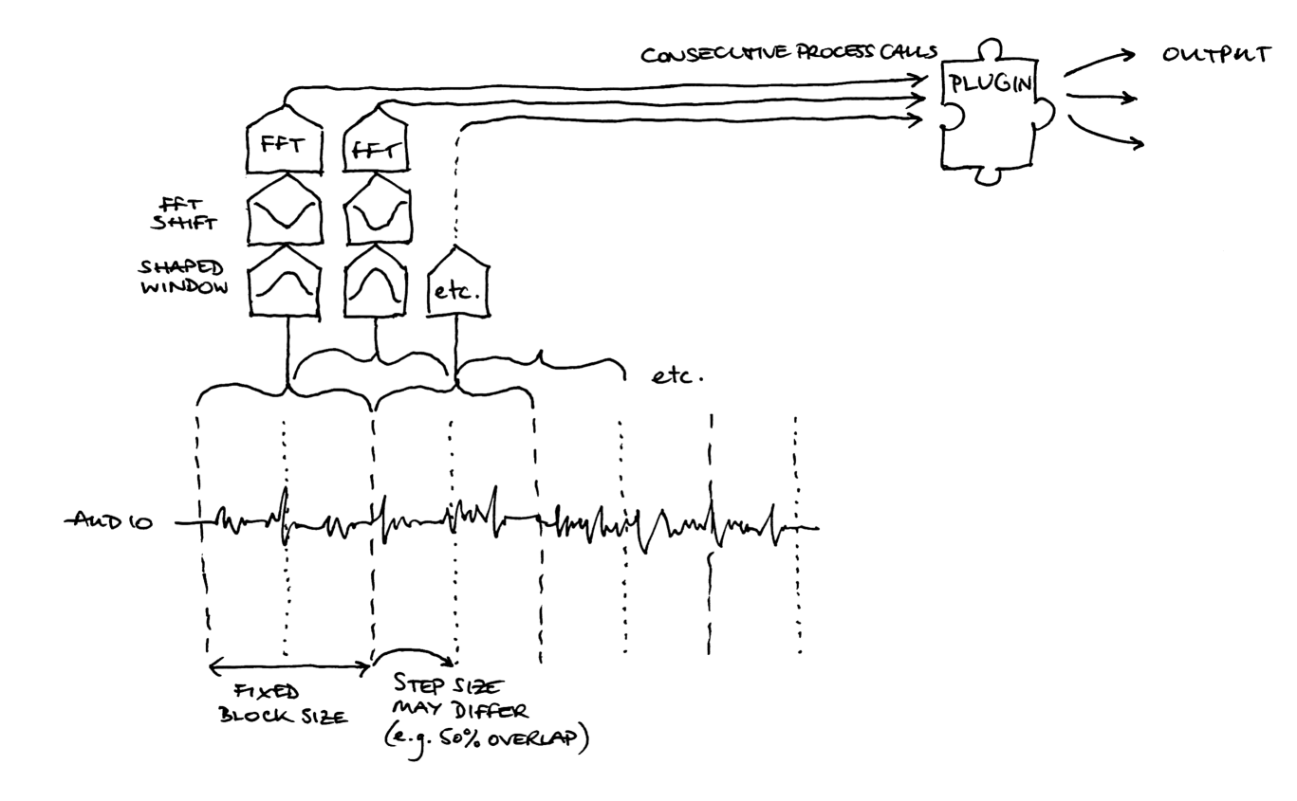
In this situation, it is most usual for the input blocks to overlap – that is, for the step size to be half of the block size, or less. This is because the original time-domain data needs to be shaped using a cosine or similar window before the Fourier transform is applied, in order to avoid generating spectral noise because of the discontinuities at the edges of the input blocks. This windowing is the host's responsibility, but the plugin needs to be aware that it will happen so that it can choose sensible preferred step and block sizes.
The plugin does not get any control over what shape of window is used, or any other details of the time- to frequency-domain processing apart from the step and block size. If more control is needed, you will need to ask for time domain input and carry out the processing in the plugin instead.
When receiving frequency domain input, the inputBuffers argument to process will point to one array of floats for each input channel as for time domain input, but the arrays of float have a particular layout. Each channel contains blockSize+2 floats, which are alternately real and imaginary components of the Fourier transform's complex output bins.
For example:
- inputBuffers[0][0] and inputBuffers[0][1] contain the real and imaginary components of the DC bin for this block in the first input channel. The imaginary component for this bin should be zero.
- inputBuffers[0][2] and inputBuffers[0][3] contain the real and imaginary components of the bin with frequency sampleRate / blockSize for the first input channel.
- inputBuffers[0][blockSize] and inputBuffers[0][blockSize+1] contain the real and imaginary components of the bin with “Nyquist” frequency sampleRate / 2. Again, this imaginary component should be zero.

Outputs

Feature Structure
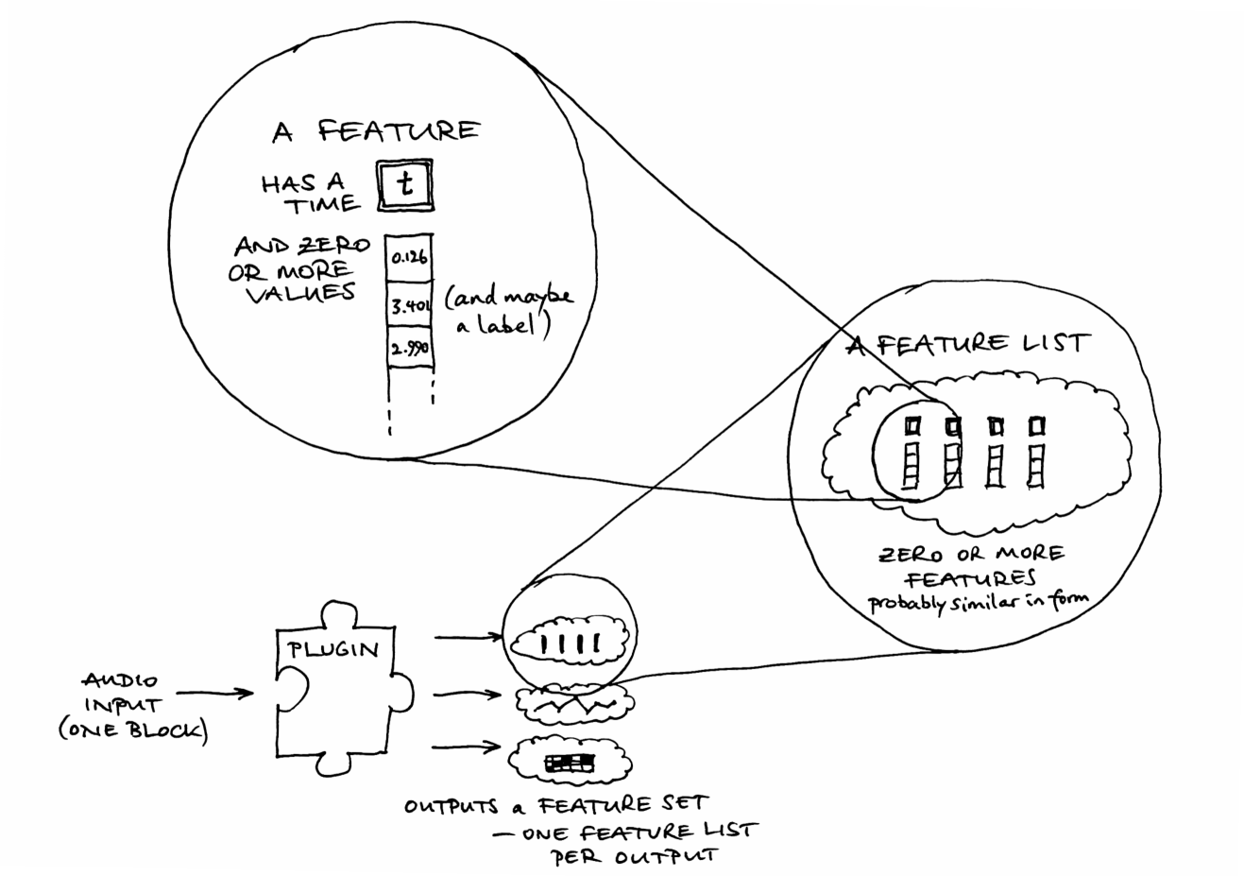
A plugin may return features in two places: from the process call, and from getRemainingFeatures. The process call is made repeatedly to provide the plugin with input data; see “Input” above. When all of the input has been consumed, getRemainingFeatures is called once, and the plugin should return any other features that it has computed or can now compute but has not yet returned.
The return type from process and getRemainingFeatures is called FeatureSet. This is an STL map whose key is an output number and whose value is a FeatureList, which is an STL vector of Feature objects. The use of a FeatureList allows the plugin to return features with more than one timestamp from a single process call, or to return all features for the entire audio input in a single FeatureSet from getRemainingFeatures.
A Feature has an optional timestamp (see “Sample Types and Timestamps”, below), a vector of zero or more values, and an optional label. Note that even a Feature with zero values, no timestamp, and no label could still be a valid feature; it may indicate that “something happened in the block of audio passed to this process call”, with the interpretation of “something” depending on which output of the plugin was returning the feature.
A lot about the interpretation of returned features depends on which output the feature is associated with. A plugin has a fixed number of outputs, and it must provide a getOutputDescriptors method that returns data about all of them, as a vector of OutputDescriptor objects. The descriptor with index zero in this vector contains information about the output whose values are found with a key of zero in the feature sets returned by the plugin, and so on.

Output Descriptors

Default Step and Block Sizes

Sample Types and Timestamps
Every feature that is returned from a Vamp plugin has a time associated with it. This is the time at which the feature is considered to “start”, as a fractional number of seconds since the start of the audio input.
The time may be explicit – stored in the timestamp of the feature structure itself – or implicit – omitted from the feature itself and instead deduced by the host on the basis of the sample type and rate defined for the output in which the feature is returned. Whether the time is implicit or explicit depends on the sampleType field of the output and the hasTimestamp field of the feature.
The permitted sampleType values for an output are:
- OneSamplePerStep – Implicit time: the effective time of any feature returned by process for that output is the same as the time that was passed in to the process function by the host. The host should not read the timestamp from the output feature, even if the feature's hasTimestamp field is true.
- FixedSampleRate – Implicit time: the effective time of the first feature returned by the first call to process for that output is the same as the time that was passed in to the process function, and the effective times of any subsequent features from this or all remaining process calls increment according to the sampleRate specified in the output descriptor. Again, the host should not read the timestamp even if it is present.
- VariableSampleRate – Explicit time: the time of each feature is returned in the timestamp of the feature, and the feature's hasTimestamp field must be set to true. The feature may have a “resolution” given by the sampleRate value for that output, but the host may ignore it.
You may notice that the hasTimestamp field in the feature structure is actually redundant. There is no situation in which the host will use hasTimestamp to decide whether to read the timestamp or not. If the sample type is VariableSampleRate, the host must always read and use the timestamp; if the sample type is anything else, the host will never read the timestamp.

Configuration

Parameters
The principal method for users and hosts to adjust the working of a Vamp plugins is via parameters. A parameter is a named value that may be set (and retrieved) by the host at any point between instantiation and initialisation of the plugin.
The plugin must provide a getParameterDescriptors method, which returns a list of ParameterDescriptor objects describing the available parameters of the plugin. The host refers to a parameter using the identifier given in its descriptor, and the plugin must provide getParameter and setParameter methods to retrieve and set the current value of the parameter.
Parameter values for Vamp plugins are always floating-point numbers. The parameter descriptor must provide limits for the permissible values through its minValue and maxValue fields. It may also provide a quantization for values, through its isQuantized and quantizeStep fields; if, for example, a parameter has isQuantized set to true and quantizeStep is set to 1.0f, then the host will only provide integer values for this parameter (or, strictly, floating point values that are the closest to integers). The descriptor may also include names to be associated with the quantize steps for a quantized parameter through its valueNames field: a graphical host may use these names to offer the user a list of named options instead of a numeric entry field or controller for the parameter.

Programs

What Can Depend on a Parameter?
One difference between Vamp plugins and most real-time audio processing plugin APIs is that the Vamp plugin may need to make significant aspects of its operation – such as the preferred input step and block size – dependent on the parameters used to configure it.
For this reason, a Vamp plugin must be completely configured by the host, with its parameters and programs set, before it is initialised; the parameters cannot be changed afterwards. Furthermore, some properties of the plugin can depend on the values passed in to the initialise function, so the host must query these again after initialisation but before calling process.
The properties that a plugin may decide to change on the basis of its parameter and program settings are:
- Its preferred input step size and block size.
- Everything within the Output Descriptor for any output – the number of values per output (binCount), sample type and rate, extents and so on – except for the identifier, name, and description fields of the output. Also, the plugin may not change its total number of outputs.
Everything listed in (2.) above may also change depending on the number of channels, step size, and block size passed in to the initialise function.

Host Extension

Loader

Adapters

Appendix I: Contents of a Plugin Library

Appendix II: An Annotated Example Plugin

#ifndef _PERCUSSION_ONSET_DETECTOR_PLUGIN_H_
#define _PERCUSSION_ONSET_DETECTOR_PLUGIN_H_

#include "vamp-sdk/Plugin.h"

/**
* Example plugin that detects percussive events.
*/

class PercussionOnsetDetector : public Vamp::Plugin
{
public:
PercussionOnsetDetector(float inputSampleRate);
virtual ~PercussionOnsetDetector();

bool initialise(size_t channels, size_t stepSize, size_t blockSize);
void reset();

InputDomain getInputDomain() const { return FrequencyDomain; }

std::string getIdentifier() const;
std::string getName() const;
std::string getDescription() const;
std::string getMaker() const;
int getPluginVersion() const;
std::string getCopyright() const;

size_t getPreferredStepSize() const;
size_t getPreferredBlockSize() const;

ParameterList getParameterDescriptors() const;
float getParameter(std::string id) const;
void setParameter(std::string id, float value);

OutputList getOutputDescriptors() const;

FeatureSet process(const float *const *inputBuffers,
Vamp::RealTime timestamp);

FeatureSet getRemainingFeatures();

protected:
size_t m_stepSize;
size_t m_blockSize;

float m_threshold;
float m_sensitivity;
float *m_priorMagnitudes;
float m_dfMinus1;
float m_dfMinus2;
};

#endif

#include "PercussionOnsetDetector.h"

using std::string;
using std::vector;
using std::cerr;
using std::endl;

#include <cmath>

PercussionOnsetDetector::PercussionOnsetDetector The sample rate at which a plugin runs is fixed at instantiation;
(float inputSampleRate) : the plugin has no control over this, and must accept any rate
Plugin(inputSampleRate),
m_stepSize(0), We are using 0 for step and block size to indicate “not yet set”
m_blockSize(0),
m_threshold(3), Default values for our public parameters
m_sensitivity(40),
m_priorMagnitudes(0), Basic initialisation of internal processing data
m_dfMinus1(0),
m_dfMinus2(0)
{ A host needs to instantiate (construct) a plugin just to find out
} what outputs it provides, and other basic information. The plugin
therefore needs to make its constructor as cheap to run as
possible and defer any expensive setup work to initialise.

PercussionOnsetDetector::~PercussionOnsetDetector()
{
delete[] m_priorMagnitudes; Clean up processing data. delete[] is safe even if the data
} were never initialised and the pointer is still NULL.

string
PercussionOnsetDetector::getIdentifier() const
{
return "percussiononsets"; Identifier for this plugin within its shared library.
}

string
PercussionOnsetDetector::getName() const
{
return "Simple Percussion Onset Detector"; Name of this plugin, as far as the user is concerned.
}

string
PercussionOnsetDetector::getDescription() const
{ Description of what the plugin does, to accompany its name.
return "Detect percussive note onsets by identifying broadband energy rises";
}

string
PercussionOnsetDetector::getMaker() const
{
return "Vamp SDK Example Plugins"; Normally, the company, institution, or developer of the plugin.
}

int
PercussionOnsetDetector::getPluginVersion() const
{ Newer versions of the plugin must have larger version numbers.
return 2; The host may use this to warn the user the the plugin has been
} updated since they last used it, or that it may be out of date.

string
PercussionOnsetDetector::getCopyright() const
{ Concise summary of copyright and distribution license.
return "Code copyright 2006 Queen Mary, University of London, after Dan Barry et al 2005. Freely redistributable (BSD license)";
}

size_t
PercussionOnsetDetector::getPreferredStepSize() const
{ This plugin works with any step size. Since the plugin demands
return 0; frequency domain input, most hosts will use a step size equal to
} half the block size.

size_t
PercussionOnsetDetector::getPreferredBlockSize() const
{
return 1024; Preferred block size (i.e. FFT size, for frequency domain input).
}

bool
PercussionOnsetDetector::initialise(size_t channels, size_t stepSize, size_t blockSize)
{ This function does the real work of setting up the plugin's
if (channels < getMinChannelCount() || internal processing. If any of the values provided are
channels > getMaxChannelCount()) return false; unacceptable, it should return false to indicate failure.

m_stepSize = stepSize;
m_blockSize = blockSize;

m_priorMagnitudes = new float[m_blockSize/2]; Properly initialise our processing data.

for (size_t i = 0; i < m_blockSize/2; ++i) {
m_priorMagnitudes[i] = 0.f;
}

m_dfMinus1 = 0.f;
m_dfMinus2 = 0.f;

return true; True indicates success.
}

void
PercussionOnsetDetector::reset()
{ After reset is called, the plugin should behave as if it has
for (size_t i = 0; i < m_blockSize/2; ++i) { just been initialised.
m_priorMagnitudes[i] = 0.f;
}

m_dfMinus1 = 0.f;
m_dfMinus2 = 0.f;
}

PercussionOnsetDetector::ParameterList
PercussionOnsetDetector::getParameterDescriptors() const
{ Host calls this to find out what adjustable parameters the plugin
ParameterList list; has. These are returned as a ParameterList, which is an STL
vector of ParameterDescriptors.
ParameterDescriptor d;
d.identifier = "threshold";
d.name = "Energy rise threshold";
d.description = "Energy rise within a frequency bin necessary to count toward broadband total";
d.unit = "dB";
d.minValue = 0;
d.maxValue = 20;
d.defaultValue = 3;
d.isQuantized = false;
list.push_back(d);

d.identifier = "sensitivity";
d.name = "Sensitivity";
d.description = "Sensitivity of peak detector applied to broadband detection function";
d.unit = "%";
d.minValue = 0;
d.maxValue = 100;
d.defaultValue = 40;
d.isQuantized = false;
list.push_back(d);

return list;
}

float
PercussionOnsetDetector::getParameter(std::string id) const
{ Return the current value of the parameter whose identifier
if (id == "threshold") return m_threshold; is given in the id argument.
if (id == "sensitivity") return m_sensitivity;
return 0.f;
}

void
PercussionOnsetDetector::setParameter(std::string id, float value)
{ Set the value of the parameter whose identifier is given.
if (id == "threshold") {
if (value < 0) value = 0;
if (value > 20) value = 20;
m_threshold = value;
} else if (id == "sensitivity") {
if (value < 0) value = 0;
if (value > 100) value = 100;
m_sensitivity = value;
}
}

PercussionOnsetDetector::OutputList
PercussionOnsetDetector::getOutputDescriptors() const
{ Host calls this to find out what outputs a plugin has. A single
OutputList list; plugin may have any number of outputs. The host does not
specify which outputs it is going to use; the plugin always
OutputDescriptor d; computes and returns value from all of them.
d.identifier = "onsets";
d.name = "Onsets";
d.description = "Percussive note onset locations";
d.unit = "";
d.hasFixedBinCount = true; This output has a fixed number of values per feature ...
d.binCount = 0; ... and that is zero: only the time of the feature is relevant
d.hasKnownExtents = false;
d.isQuantized = false;
d.sampleType = OutputDescriptor::VariableSampleRate; Each feature will have its own timestamp ...
d.sampleRate = m_inputSampleRate; ... which is accurate to 1/ the input sample rate, in seconds
list.push_back(d);

d.identifier = "detectionfunction";
d.name = "Detection Function";
d.description = "Broadband energy rise detection function";
d.binCount = 1; This output has one value per feature ...
d.isQuantized = true; ... that value is quantized ...
d.quantizeStep = 1.0; ... to 1, that is, the output values are originally integers
d.sampleType = OutputDescriptor::OneSamplePerStep; Each process call returns a single implicitly-timed feature.
list.push_back(d);

return list;
}

PercussionOnsetDetector::FeatureSet
PercussionOnsetDetector::process(const float *const *inputBuffers,
Vamp::RealTime ts)
{
if (m_stepSize == 0) {
cerr << "ERROR: PercussionOnsetDetector::process: "
<< "PercussionOnsetDetector has not been initialised"
<< endl;
return FeatureSet();
}

int count = 0;

for (size_t i = 1; i < m_blockSize/2; ++i) {

float real = inputBuffers[0][i*2];
float imag = inputBuffers[0][i*2 + 1];

float sqrmag = real * real + imag * imag;

if (m_priorMagnitudes[i] > 0.f) {
float diff = 10.f * log10f(sqrmag / m_priorMagnitudes[i]);

// std::cout << "i=" << i << ", mag=" << mag << ", prior=" << m_priorMagnitudes[i] << ", diff=" << diff << ", threshold=" << m_threshold << std::endl;

if (diff >= m_threshold) ++count;
}

m_priorMagnitudes[i] = sqrmag;
}

FeatureSet returnFeatures;

Feature detectionFunction;
detectionFunction.hasTimestamp = false;
detectionFunction.values.push_back(count);
returnFeatures[1].push_back(detectionFunction);

if (m_dfMinus2 < m_dfMinus1 &&
m_dfMinus1 >= count &&
m_dfMinus1 > ((100 - m_sensitivity) * m_blockSize) / 200) {

Feature onset;
onset.hasTimestamp = true;
onset.timestamp = ts - Vamp::RealTime::frame2RealTime
(m_stepSize, lrintf(m_inputSampleRate));
returnFeatures[0].push_back(onset);
}

m_dfMinus2 = m_dfMinus1;
m_dfMinus1 = count;

return returnFeatures;
}

PercussionOnsetDetector::FeatureSet
PercussionOnsetDetector::getRemainingFeatures()
{
return FeatureSet();
}

[Fri Jan 25 2008] [15:08:30] <las> cannam: where i am right now is that a "Feature" is a particular point in time (possibly); it may or may not have a set of values associated with it
[Fri Jan 25 2008] [15:08:40] <cannam> basically you get a set of feature outputs, and each of those consists of a sequence of feature vectors, either regularly spaced or at variable intervals... you're right, it's not obvious is it?
[Fri Jan 25 2008] [15:08:52] <cannam> las: that's about right
[Fri Jan 25 2008] [15:09:05] <cannam> las: a Feature always has a time, and may have zero or more values
[Fri Jan 25 2008] [15:09:33] <las> cannam: the mental problem for me was that i was imagining that the plugin might return multiple different kinds of info, and that "Feature" referred to a specific kind of info
[Fri Jan 25 2008] [15:09:40] <cannam> las: you can get more of an idea for a specific plugin by running it in vamp-simple-host and looking at how it prints the results
[Fri Jan 25 2008] [15:09:43] <las> cannam: i.e. "Feature 3 occurs at a, b, c and d"
[Fri Jan 25 2008] [15:10:02] <las> cannam: as opposed to "there is a feature at a, b, c and d"
[Fri Jan 25 2008] [15:10:07] <cannam> las: that would usually be an "output", i.e. "output 3 has features at a, b, c and d"
[Fri Jan 25 2008] [15:10:24] <las> cannam: is they all have times, what is hasTimestamp for?
[Fri Jan 25 2008] [15:10:40] <cannam> or, "this output has features at a, b, c and d with value X and features at e and f with value Y"
[Fri Jan 25 2008] [15:11:40] <cannam> las: the "sample type" of the output specifies whether the features are equally spaced (in which case the timestamps are implicit), or will have individual timestamps
[Fri Jan 25 2008] [15:12:12] <cannam> las: so you only set, and read, the timestamps if the sample type is something other than "one sample per step"
[Fri Jan 25 2008] [15:12:37] <cannam> las: however, this aspect of vamp "isn't well thought out"
[Fri Jan 25 2008] [15:13:18] <cannam> las: in that the timestamp is either mandatory (if the sample type is not one sample per step), or else it should be totally ignored (if the sample type is one sample per step)
[Fri Jan 25 2008] [15:13:52] <cannam> las: there is no situation in which the host ever actually needs to take notice of hasTimestamp, although I suppose it can check it and warn if it's false for a sample type in which the timestamp is needed
[Fri Jan 25 2008] [15:14:26] <cannam> las: that may be revised in a future vamp release, but not until we have other things worth breaking the api for as well -- no hurry there
[Fri Jan 25 2008] [15:15:05] <las> cannam: this is where your "functional package" idea comes in
[Fri Jan 25 2008] [15:15:36] <las> cannam: since i am not writing a generic "load this VAMP plugin and run it" host, but rather using VAMP to do specific work, i wasn't inspecting the OutputList of PercussionOnset
[Fri Jan 25 2008] [15:16:55] <las> cannam: ergo, something that just took audio and gave me back results would be handy (but not essential). i don't know how many other uses of VAMP might be similar.
[Fri Jan 25 2008] [15:17:09] <cannam> las: probably quite a few
[Fri Jan 25 2008] [15:17:26] <cannam> las: that's definitely the way I was thinking
[Fri Jan 25 2008] [15:22:28] <las> cannam: now i am totally confused. looking at the code for the perc onset process() call, it appears that it generates either zero or 1 onset per process call
[Fri Jan 25 2008] [15:23:10] <cannam> las: never attempt to read the top sekrit code
[Fri Jan 25 2008] [15:23:28] <cannam> las: but yes, that's exactly what it does
[Fri Jan 25 2008] [15:23:59] <cannam> las: its "resolution" therefore is limited to the step size, which is 512 samples
[Fri Jan 25 2008] [15:36:05] <las> cannam: ok, thats actually entirely reasonable :)
[Fri Jan 25 2008] [15:36:36] <cannam> las: the resolution could be much better; making a higher resolution version particularly for tracks that are expected to contain nothing much besides percussion is on my todo list
[Fri Jan 25 2008] [15:38:01] <las> cannam: isn't that a 15 min task?
[Fri Jan 25 2008] [15:38:34] <cannam> las: well, tuning these things is actually rather fiddly
[Fri Jan 25 2008] [15:38:53] <cannam> las: you can make an instant "higher resolution version" by using a much smaller step size, but you won't necessarily get better results out of it
[Fri Jan 25 2008] [15:39:13] <las> cannam: oh my, that explains why this is kind of slow too. stepsize = 512, blocksize = 1024; its reading all the data twice :(
[Fri Jan 25 2008] [15:39:37] <las> cannam: maybe i should update the vendor branch with that buffering adapater stuff
[Fri Jan 25 2008] [15:39:48] <cannam> las: that would certainly avoid that problem
[Fri Jan 25 2008] [15:39:57] <cannam> las: though it would still be fft'ing all the data twice
[Fri Jan 25 2008] [15:40:46] <las> cannam: hmm
[Fri Jan 25 2008] [15:41:05] <las> cannam: so this where i should do my own FFT and pass it spectral data?
[Fri Jan 25 2008] [15:41:08] <cannam> las: with this sort of stuff, 10% of the work is deciding on a method, 90% is tuning it -- that's why it's worth making plugins of these things & reusing the code even though the real work may be only a few lines
[Fri Jan 25 2008] [15:41:34] <cannam> las: unfortunately, with this method you do actually want it to do the fft twice
[Fri Jan 25 2008] [15:41:44] <las> cannam: really?
[Fri Jan 25 2008] [15:41:47] <cannam> las: it's an overlapped shaped window
[Fri Jan 25 2008] [15:41:51] <las> cannam: ok
[Fri Jan 25 2008] [15:41:58] <las> cannam: yes, i remember reading that
[Fri Jan 25 2008] [15:42:33] <cannam> las: if you don't use a shaped window, you get a lot of noise in the fft resulting from the "edges" of your window being treated as part of the (theoretically infinite) signal
[Fri Jan 25 2008] [15:42:52] <cannam> las: and if you do use a shaped window, you have to have an overlap or you miss some material
[Fri Jan 25 2008] [15:43:03] <las> cannam: ok, i'll update the vendor branch from svn now
[Fri Jan 25 2008] [15:44:12] <cannam> las: let me know if it works!

Because there is no mapping between input channels and output data sets
in a Vamp plugin, SV can't make any useful decisions about how it
should handle data from a plugin that did in fact want to produce
one "channel" of output per input channel. So there is no way in which
SV can run a single Vamp plugin on a multi-channel audio input and
produce meaningful "multi-channel" output displays (and in fact there
are no existing Vamp plugins in which this would be possible anyway, as
I mentioned in an earlier email -- all the existing plugins either
accept one channel only, or produce output that depends on the
relationship between channels rather than independent output per
channel).

What SV could do -- but does not do currently -- is make an instance of
the Vamp plugin for each input channel, and produce either a
single "multi-channel" output layer (as you suggest) or a set of output
panes or layers, one per channel. SV is unlikely ever to support the
concept of "multi-channel" layers of anything other than audio data,
but it could very reasonably be made capable of automatically
instantiating a plugin once per input channel and running all plugins
at once into several separate output panes. The plugin would then need
to support only a single channel of input, and the host could worry
about applying it to multiple channels.

That feature is not there in SV at the moment, though.

