PORTFOLIO SAMPLE — This document was independently authored for demonstration purposes only. It is not official MadCap Software documentation and is not affiliated with, endorsed by, or sourced from MadCap Software, Inc. For authoritative guidance, refer to MadCap's official Flare documentation and Getting Started Guide.
USER MANUAL (PORTFOLIO SAMPLE)
MadCap Flare
A User Manual for Technical Writers
UM-FLR-2026 | Revision 01 | Effective Date: 2026-07-29

Document Control
Document No. | UM-FLR-2026
Title | MadCap Flare User Manual for Technical Writers
Applies To | MadCap Flare (current desktop release), single-sourcing help authoring workflows
Revision | 01
Effective Date | 2026-07-29
Audience | Technical writers new to MadCap Flare, or transitioning from another authoring tool

1. About This Manual
This manual introduces MadCap Flare to technical writers who are new to the tool or transitioning from another authoring platform (such as Word-based documentation, a wiki, or a different help authoring tool). It covers the core workflow — creating a project, authoring topics, structuring navigation, single-sourcing content, applying styles, and publishing — at the level needed to become productive on a first real project.
This manual does not replace MadCap's own product documentation. Advanced topics such as DITA import, localization/translation workflows, scripting, and MadCap Central publishing pipelines are outside its scope.

2. Introduction to MadCap Flare
MadCap Flare is a professional help authoring tool (HAT) used to create and publish technical documentation, online help systems, and knowledge bases from a single set of source content. Its defining characteristic is single-sourcing: rather than maintaining separate documents for a PDF manual, an online help site, and a Word export, a Flare author maintains one set of topics and publishes multiple outputs from it.
Unlike a word processor, a Flare project is not one file. Content, navigation, styling, and glossary/index information all live in separate, linked files within the project. The table below summarizes the concepts every new Flare author needs before opening the application.
Term | What It Means in Flare
Project | The container for everything: topics, images, stylesheets, TOCs, targets, and settings for a single documentation deliverable or family of outputs.
Topic | A single, modular unit of content (an XHTML file). Most Flare documentation is built from many small topics rather than one long document.
Table of Contents (TOC) | A separate file that defines the navigation structure and reading order of topics. A project can contain more than one TOC for different outputs or audiences.
Target | A defined output configuration (e.g., HTML5, PDF, Word, Microsoft Help). Building a target compiles the selected topics and settings into the final deliverable.
Stylesheet | A CSS file controlling the visual appearance of topics. Styles are typically managed centrally rather than formatted manually inside each topic.
Snippet | A reusable chunk of content (text, tables, images) stored once and referenced across multiple topics. Editing the snippet updates every topic that uses it.
Variable | A reusable single value (a product name, version number, phone number) inserted by reference so it can be updated once and applied everywhere.
Condition Tag | A label applied to content or files that determines whether that content is included in a given output target — the core mechanism behind single-sourcing.

3. System Requirements and Installation
Confirm the current system requirements on MadCap Software's website before installing, since minimum specifications change between releases. In general, plan for:
- A supported Windows version (Flare is a Windows desktop application; Mac users typically run it through virtualization)
- Sufficient disk space for the application plus project source files, generated output, and any linked media
- A valid Flare license (trial, single-user, or organization-managed license)
- Download the installer. Download the current Flare installer from MadCap's official site or your organization's licensed distribution source.
- Run the installer. Run the installer with administrative privileges and follow the setup wizard's prompts.
- Activate your license. Launch Flare and activate it using your license key or organization's license server, per your license type.
- Confirm the installation. Open Flare and confirm it launches to the Start Page without errors before beginning project work.

4. Getting Started: Creating Your First Project
Flare projects can be created from a blank template, an existing sample template, or by importing content from Word, HTML, or other supported sources.
- Start the New Project wizard. From the Start Page, select New Project and choose a starting template (Empty, Default, or a sample) appropriate for your output type.
- Name and locate the project. Give the project a clear name and choose a local or source-controlled folder location per your team's conventions.
- Select initial target types. Choose which output types (HTML5, PDF, Word, etc.) to scaffold; additional targets can be added later.
- Review the generated structure. Flare creates a starter project structure, including default folders in the Content Explorer and Project Organizer, a default stylesheet, and a default target.
- Save and explore. Save the project and spend a few minutes browsing the generated folders before authoring any content, so the structure is familiar.
TIP: Start every new project from a consistent template if your team maintains one — it keeps styles, folder structure, and naming conventions aligned across projects from day one.

5. The Flare Interface
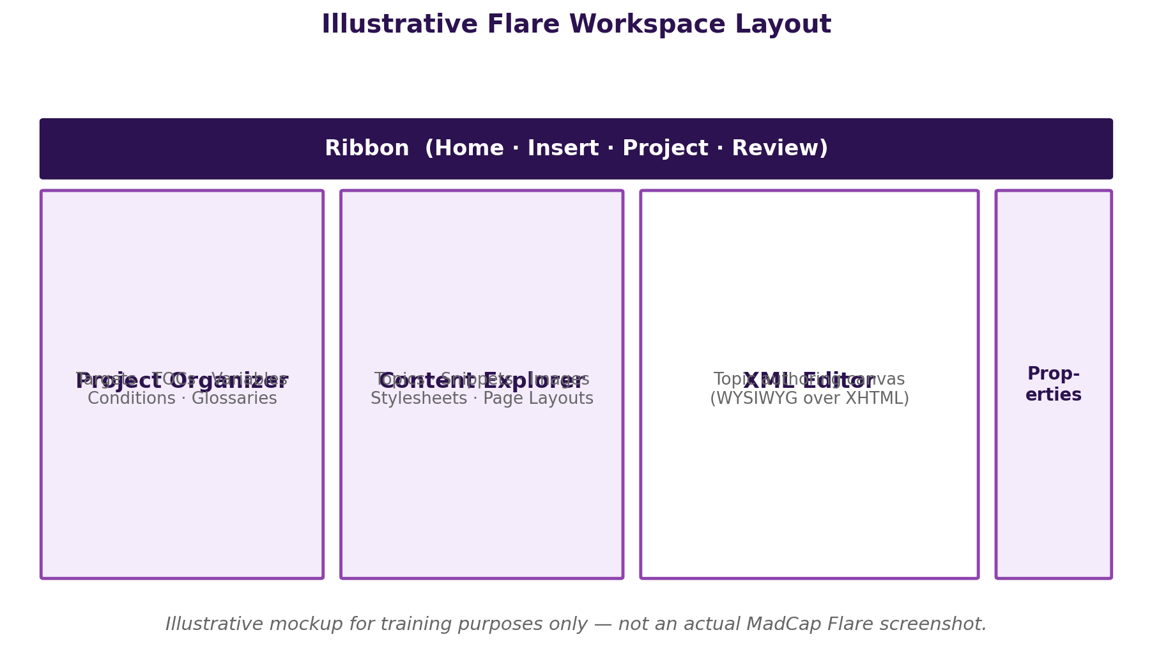
Figure 1. Illustrative Flare workspace layout — mockup for training purposes, not an actual product screenshot.

Project Organizer
Located on the left side of the workspace by default, the Project Organizer lists project-level files: Targets, TOCs, Variables, Conditional Text, Glossaries, and Import/Export settings.

Content Explorer
Also on the left, the Content Explorer lists your actual content files: Topics, Snippets, Images, Stylesheets, and Page Layouts, typically organized into folders you define.

XML Editor
The main authoring pane in the center of the workspace. Despite the name, most day-to-day work here looks like formatting a document — Flare topics are XHTML under the hood, and the editor exposes that structure without requiring you to hand-write markup.

Ribbon and Local Toolbars
The ribbon (Home, Insert, Project, and other tabs) provides most authoring commands. Individual panes such as the TOC editor or Stylesheet editor also expose their own local toolbars for pane-specific actions.

6. Authoring Topics
- Create a new topic. Right-click the appropriate folder in the Content Explorer, choose Add Topic, and select a topic template (or start blank).
- Name the topic clearly. Use a descriptive, consistent file name — topic titles and file names are searched and referenced constantly as a project grows.
- Write and format using styles. Apply paragraph and character styles from the Styles window rather than manually formatting text, so appearance stays controlled by the stylesheet.
- Insert reusable content. Insert variables and snippets where appropriate instead of typing repeated values or boilerplate directly into the topic.
- Add cross-references and links. Use Flare's cross-reference and hyperlink tools to link between topics, so links update automatically if a target topic is renamed or moved.
- Save frequently. Save topics regularly, especially before switching panes or running a build.

7. Building the Table of Contents
The TOC defines the reading order and navigation hierarchy of your output — it is a separate file from the topics themselves, which is why the same topics can appear in different structures across different TOCs.
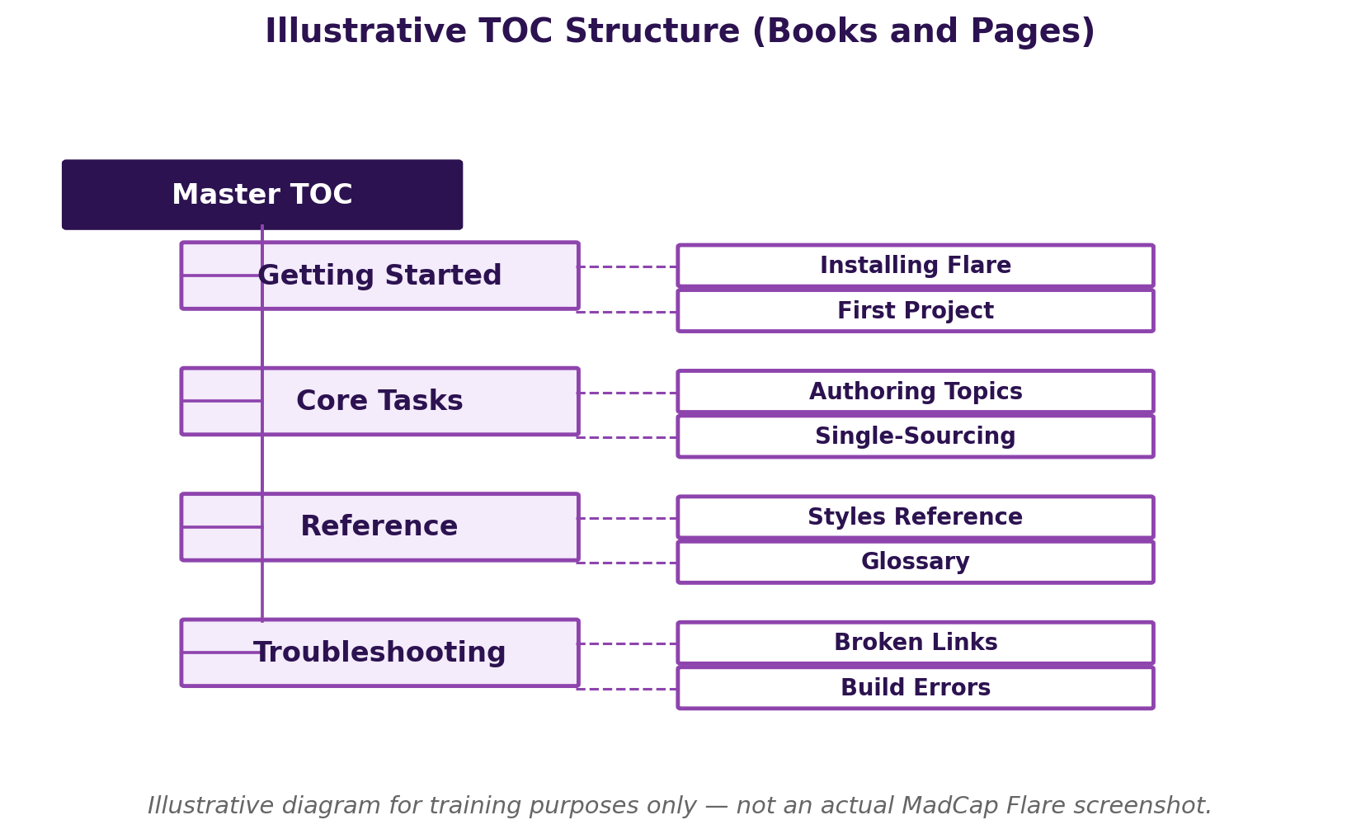
Figure 2. Illustrative TOC structure showing books and pages — mockup for training purposes, not an actual product screenshot.
- Open or create a TOC. In the Project Organizer, open the default TOC or create a new one for a distinct output structure.
- Add topics as TOC entries. Drag topics from the Content Explorer into the TOC editor, or use Add TOC Book/Add TOC Entry to build the structure manually.
- Organize into books and pages. Group related entries into TOC "books" (folders) and order entries to reflect the intended reading sequence.
- Assign the TOC to a target. In the target's settings, confirm which TOC that target should use when it builds.

8. Single-Sourcing: Conditions, Snippets, and Variables
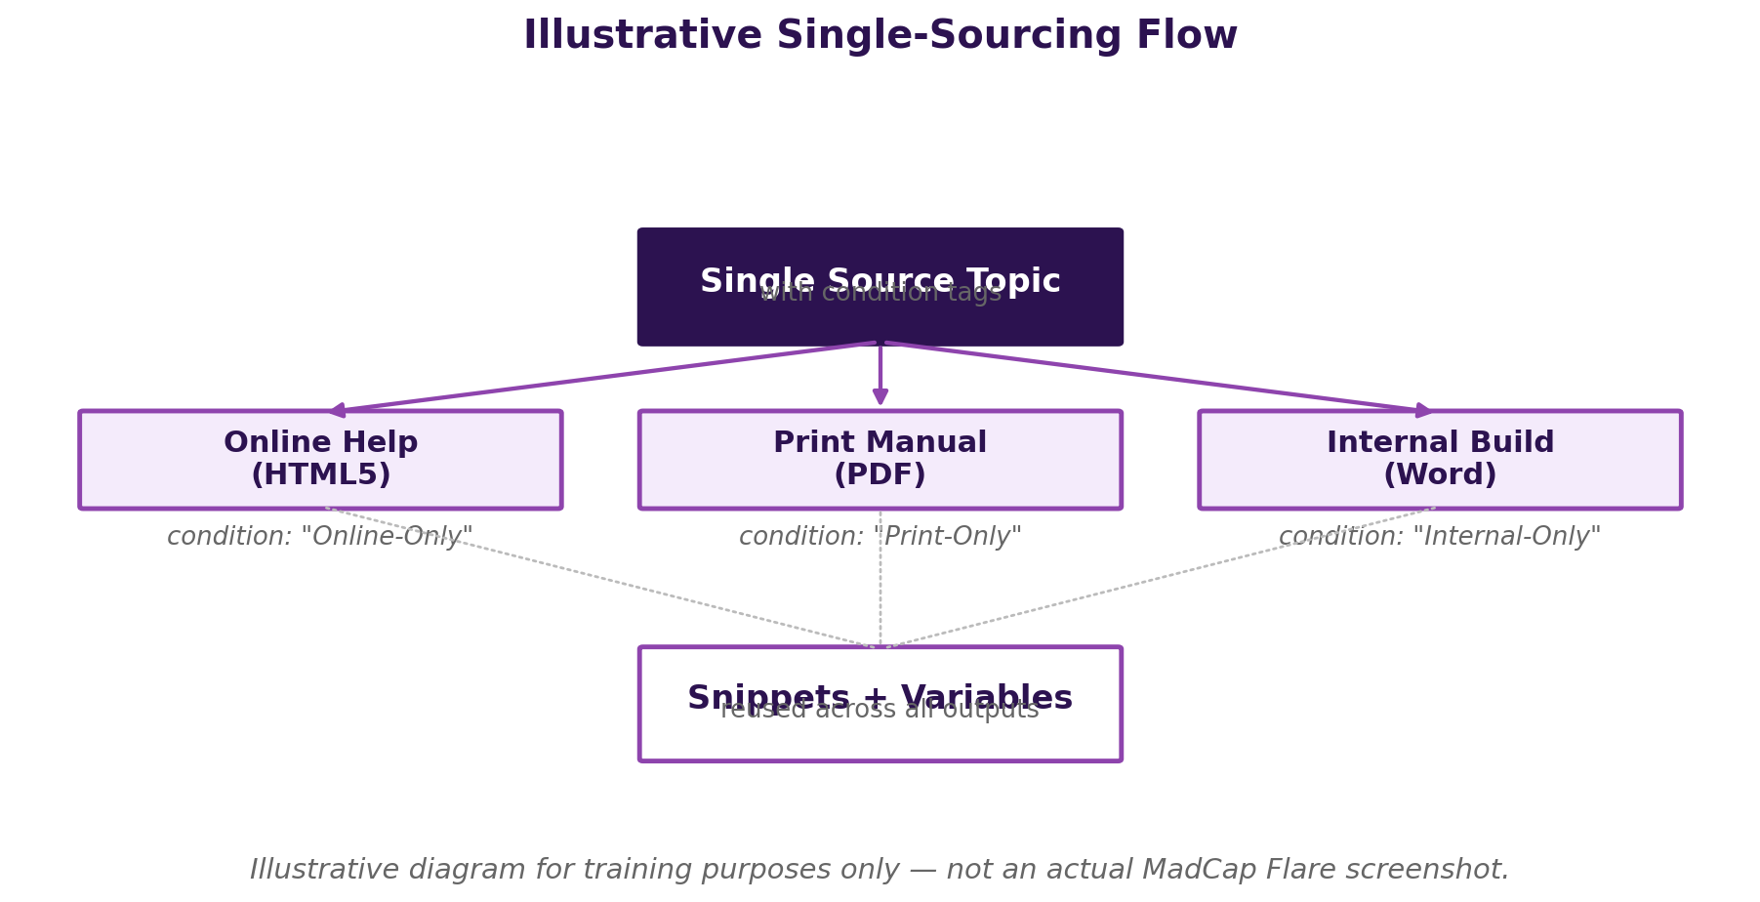
Figure 3. Illustrative single-sourcing flow — one source topic filtered by condition tags into multiple outputs.

Condition Tags
Condition tags let you mark content — whole topics or portions of a topic — for inclusion or exclusion in specific outputs. This is the core mechanism behind publishing an internal version and a customer-facing version, or an online version and a print version, from the same source.
- Create a condition tag set. In the Project Organizer, right-click Conditional Text and choose Add Condition Tag Set, then add the specific tags you need (e.g., Online-Only, Print-Only, Internal-Only).
- Apply conditions to content. Select a topic, file, or a portion of text, then apply the relevant condition tag from the Home ribbon's Conditions command.
- Configure conditions per target. In each target's settings, specify which condition tags are included or excluded, so the same source produces different filtered output per target.

Snippets
Snippets store reusable content — boilerplate paragraphs, standard warnings, repeated tables — once, and insert it by reference into any topic that needs it. Editing the snippet file updates every topic referencing it.
- Create a snippet. Right-click the appropriate folder in the Content Explorer and choose Add Snippet, then author the reusable content.
- Insert the snippet. Place your cursor in a topic, then use the Insert Snippet command from the local toolbar to insert it by reference.
TIP: Use View Links (right-click a snippet) to see every topic that references it before making a significant edit — especially in larger projects.

Variables
Variables store a single reusable value — a product name, version number, or support phone number — so it can be updated once and propagate everywhere it's used.
- Open or create a variable set. In the Project Organizer, open the Variables folder and its default variable set, or create a new set for a distinct group of values.
- Define variables. Add variables with clear names and current values (Flare includes starter examples such as CompanyName by default).
- Insert variables into topics. Place your cursor in a topic and insert the variable by reference rather than typing the literal value.
Both variables and snippets can be overridden at the target level (and, for snippets, at the individual instance level), which is useful for producing multiple branded or versioned outputs from the same source content.

9. Styles and Stylesheets
Flare topics are formatted using CSS-based stylesheets rather than manual, topic-by-topic formatting. This keeps visual consistency centrally controlled and makes rebranding or restyling a matter of editing one file instead of every topic.
- Define paragraph, character, and table styles once in the project's stylesheet
- Apply styles to content from the Styles window rather than using manual bold/font/size overrides
- Maintain separate stylesheets per output type if online and print outputs need meaningfully different visual treatment
- Use Page Layouts to control recurring print/PDF elements such as headers, footers, and page numbering
TIP: Avoid local formatting overrides wherever possible. They're the most common cause of "why does this one topic look different" issues later in a project.

10. Building and Publishing Targets
A target defines a specific output configuration: format, included TOC, condition settings, and output-specific options. The same project can contain multiple targets producing different deliverables from the same source content.
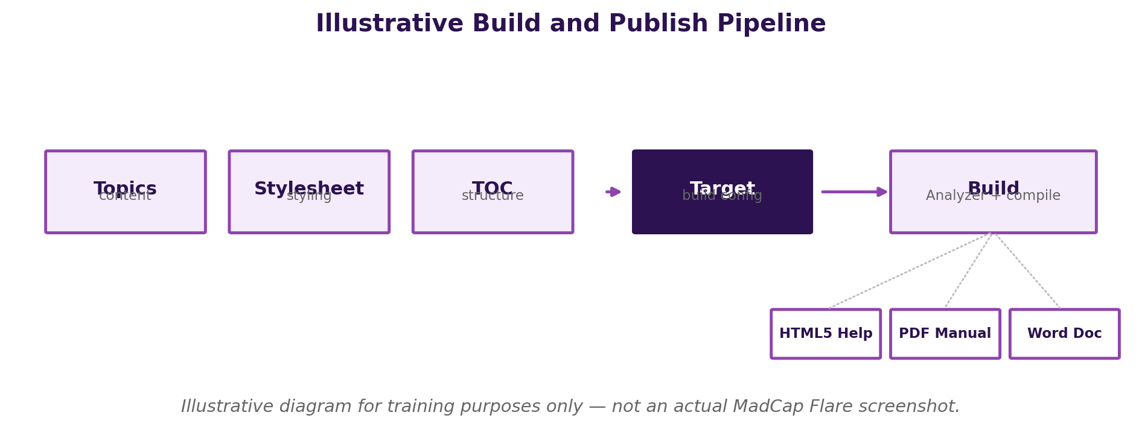
Figure 4. Illustrative build and publish pipeline — mockup for training purposes, not an actual product screenshot.
- Open the target's settings. In the Project Organizer, open the target you want to configure (e.g., an HTML5 or PDF target).
- Configure format-specific options. Set the TOC, stylesheet, skin (for HTML5) or page layout (for PDF/print), and any condition tag inclusion/exclusion rules.
- Run the Analyzer before building. Use Flare's built-in Analyzer report to catch broken links, unused files, and other issues before generating output.
- Build the target. Build the target to generate the final output (a web help site, a PDF file, a Word document, etc.).
- Review the generated output. Open the generated output and spot-check navigation, formatting, and any conditionally included/excluded content before publishing.
- Publish. Publish the built output to its destination — a web server, a knowledge base platform, or a shared file location — per your team's publishing process.

11. Best Practices for Technical Writers
- Plan your topic structure and naming conventions before authoring at scale — restructuring a large project later is expensive.
- Write topics to stand reasonably on their own; readers may land on any topic directly from search, not just from the TOC.
- Use snippets for anything repeated more than once or twice, not just large boilerplate blocks.
- Keep condition tag sets small and well-named — sprawling, overlapping condition schemes become difficult to reason about.
- Run the Analyzer regularly, not just before a release build.
- Use source control (Git or another Flare-supported system) for team projects to avoid overwritten work and to track history.
- Document your own project's conventions (naming, condition usage, snippet library) so new team members ramp up quickly.

12. Troubleshooting
Common issues encountered by new Flare authors, and where to start diagnosing them.
Symptom | Probable Cause | Corrective Action
A topic doesn't appear in the built output | Topic isn't added to the TOC used by the target, or a condition tag is excluding it | Confirm the topic is placed in the correct TOC; open the target's Conditional Text settings and verify the topic's condition tags are not excluded.
Formatting looks different than expected in one topic | Local (inline) formatting overriding the stylesheet, or the wrong style applied | Use the Styles window to check which style is applied; remove local formatting overrides and rely on stylesheet styles instead.
Edited a snippet but content didn't update everywhere | The instance was converted to text and decoupled from the snippet, or the build wasn't regenerated | Check whether Convert to Text was used on that instance; rebuild the target to regenerate the output from current source files.
Variable shows the wrong value in one output but not another | Variable value was overridden at the target or topic level | Check for a variable definition override in the target's settings or in the specific topic before assuming the variable set itself is wrong.
Build fails or produces broken links | Broken cross-reference, moved/renamed file not updated project-wide, or missing target dependency | Run the project Analyzer to detect broken links and unused files; use View Links before renaming or moving any file that may be referenced elsewhere.

13. Glossary of Key Terms
Term | Definition
Content Explorer | The Flare pane listing topics, snippets, images, stylesheets, and page layouts within a project.
Project Organizer | The Flare pane listing project-level files: targets, TOCs, variables, conditions, and glossaries.
XML Editor | Flare's main authoring window, where topic content is written and formatted (Flare topics are XHTML under the hood).
Single-sourcing | Authoring content once and reusing or repurposing it across multiple outputs, audiences, or formats.
Skin | The set of navigation, branding, and layout elements wrapped around an HTML5 output (toolbar, search, menu structure).
Analyzer | A built-in Flare report that flags unused files, broken links, and other project issues before a build.
Page Layout | A template file controlling recurring page elements such as headers, footers, and print page numbering for PDF/print targets.

14. Revision History
Rev. | Date | Author | Description of Change
00 | 2026-05-11 | M. Langley, Tech. Writer | Initial release covering project setup through basic publishing.
01 | 2026-07-29 | M. Langley, Tech. Writer | Added single-sourcing deep dive (conditions, snippets, variables), troubleshooting section, and glossary.

