SALESFORCE ADMINISTRATOR
TRAINING MANUAL
Setup, User Management, Security, and Workflow Automation

Table of Contents

1. Introduction
This manual trains new Salesforce Administrators on the core responsibilities of the role: configuring the org, managing users and data access, building automation, and maintaining reporting infrastructure. It assumes no prior Salesforce experience but expects familiarity with general business software concepts.

1.1 The Administrator's Role
A Salesforce Admin is responsible for the day-to-day configuration and health of the org — not for writing code (that's a developer's job), but for everything achievable through declarative (point-and-click) tools.
- Managing users, roles, profiles, and permissions
- Customizing objects, fields, page layouts, and record types
- Building automation with Flow
- Maintaining data quality and security
- Creating reports and dashboards for business visibility
TIP: Trailhead (trailhead.salesforce.com) is Salesforce's free official training platform — use it alongside this manual for hands-on practice.

1.2 Key Terminology
Term | Definition
Org | A single Salesforce instance/environment (e.g. your company's production database)
Object | A table that stores a type of data (Account, Contact, Opportunity, or custom objects)
Field | A column on an object
Record | A single row of data on an object
App | A collection of tabs/objects grouped for a business function
Sandbox | A copy of your org used for testing changes safely

2. Navigating Setup
Setup is the control panel for the entire org. Access it via the gear icon in the top-right corner → Setup.
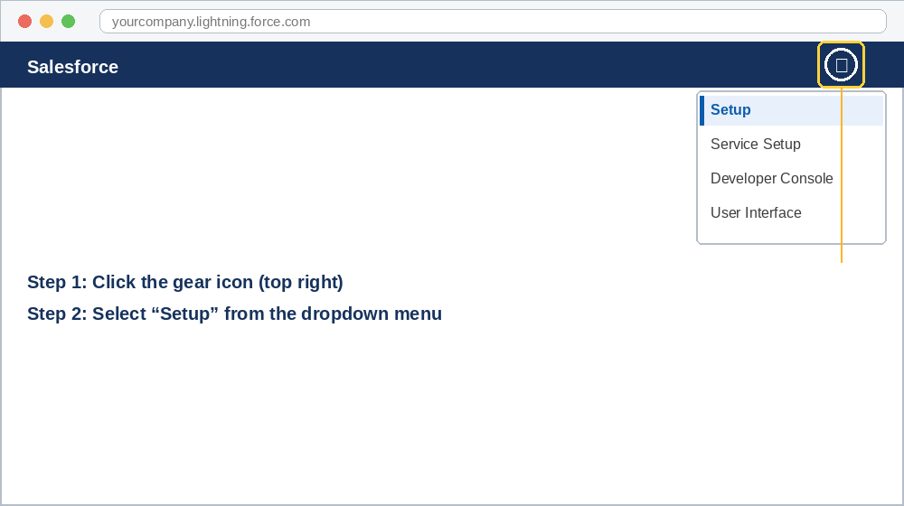
Figure 2.1 — Accessing Setup from the gear icon menu

2.1 Setup Layout
- Object Manager — create/edit objects, fields, page layouts, and record types
- Users — create and manage user accounts
- Company Settings — business hours, holidays, fiscal year
- Security — profiles, permission sets, sharing rules, login policies
- Process Automation — Flow Builder, approval processes

2.2 Quick Find
Use the Quick Find search box at the top of Setup to jump directly to any settings page instead of navigating menus manually — this is the fastest way to work once you know what you're looking for.
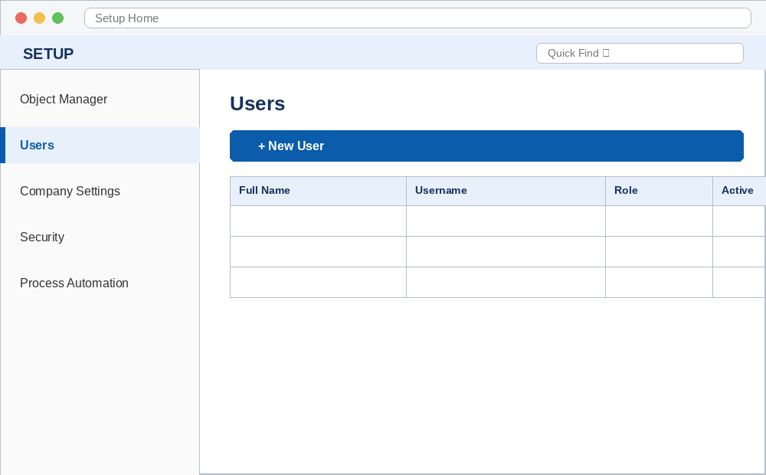
Figure 2.2 — Setup's left sidebar and the Users list view

3. User Management

3.1 Creating a User
- Go to Setup → Users → New User
- Enter the user's name, email, and username (must be unique across all of Salesforce, formatted like an email)
- Assign a Profile (determines baseline object/field access) and a Role (determines data visibility in the hierarchy)
- Assign licenses as needed (e.g. Salesforce, Chatter Free)
- Save — the user receives a welcome email with login instructions
TIP: Usernames are global across all Salesforce orgs, so 'jsmith@company.com' may need to become 'jsmith@company.com.sandbox' in a test environment.
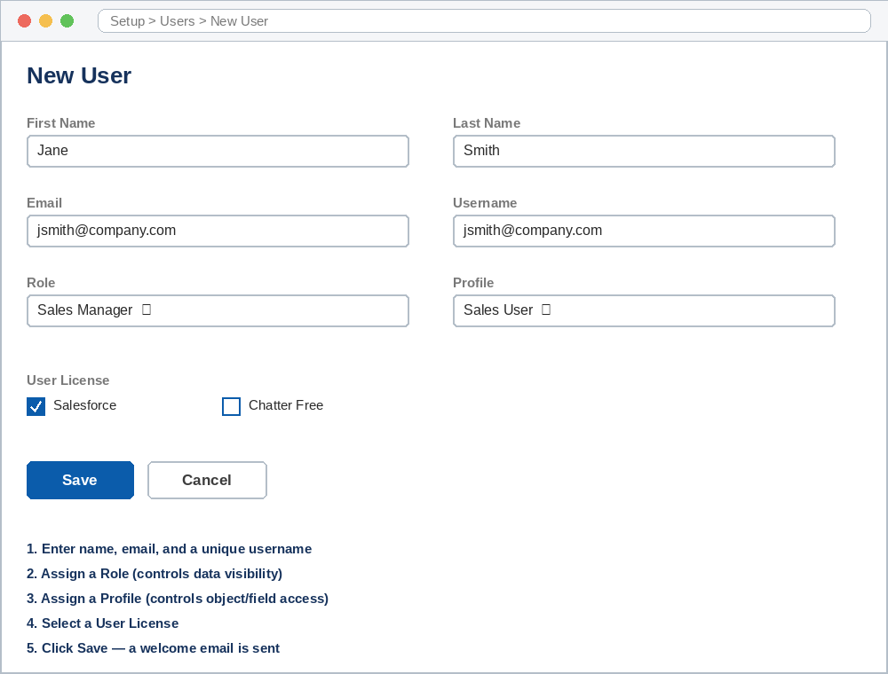
Figure 3.1 — The New User form

3.2 Profiles vs. Permission Sets
 | Profile | Permission Set
Assignment | Exactly one per user | Zero or more per user
Purpose | Baseline access level | Grants additional access on top of profile
Best Practice | Keep broad and minimal (e.g. 'Sales User') | Use for granular, role-specific add-ons
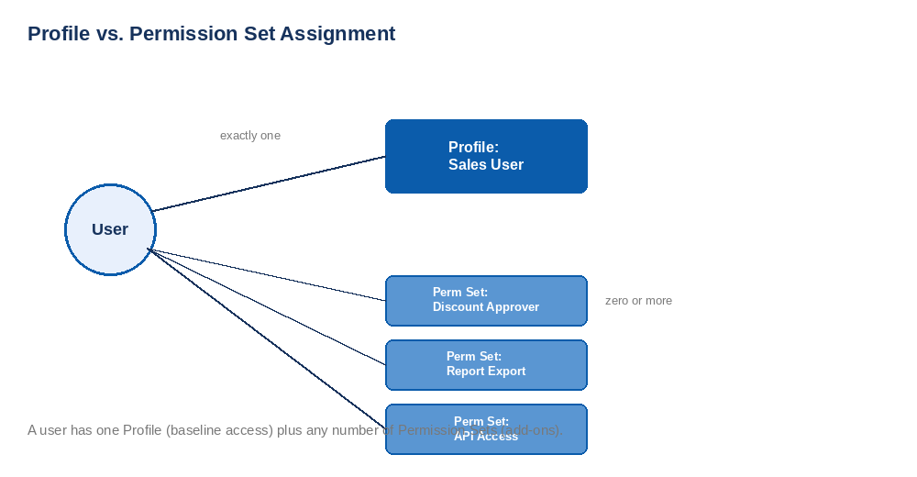
Figure 3.2 — One Profile, many Permission Sets

3.3 Roles & the Role Hierarchy
Roles control record visibility, not object permissions. A user can see records owned by users below them in the role hierarchy (in addition to their own), which is essential for manager reporting visibility.
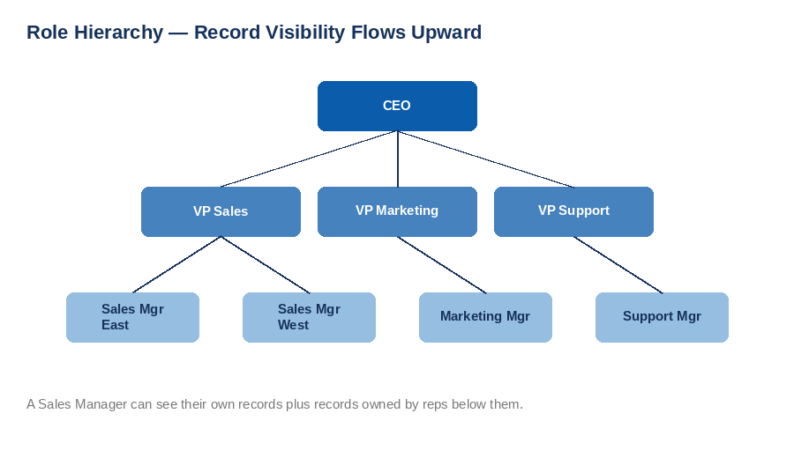
Figure 3.3 — Record visibility flows up the role hierarchy

4. Security & Data Access

4.1 The Access Control Layers
Layer | Controls
Organization-Wide Defaults (OWD) | Baseline record visibility per object (Private, Public Read Only, Public Read/Write)
Role Hierarchy | Grants visibility upward through management chains
Sharing Rules | Extends access beyond OWD/hierarchy for specific criteria or groups
Profiles / Permission Sets | Object- and field-level permissions (create, read, edit, delete)
TIP: Set OWD to the most restrictive setting your business allows, then open up access with sharing rules — it's easier to grant access than to take it away later.
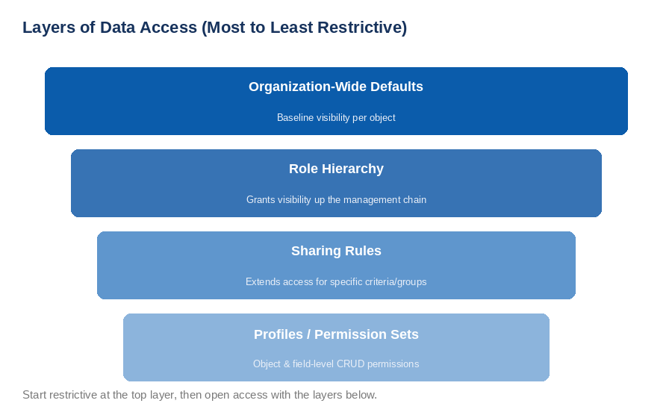
Figure 4.1 — The four layers of data access, most to least restrictive

4.2 Field-Level Security
Even if a user's profile allows access to an object, individual fields can be hidden or made read-only. This is commonly used to hide sensitive fields (e.g. Social Security Number, salary data) from users who don't need them.

5. Automation with Flow
Flow Builder is the modern, primary tool for declarative automation in Salesforce (Workflow Rules and Process Builder are legacy and being retired — always build new automation in Flow).

5.1 Flow Types
Flow Type | Trigger | Use Case
Screen Flow | User launches it manually | Guided data entry, wizards
Record-Triggered Flow | Record created/updated/deleted | Auto-update fields, send notifications
Scheduled Flow | Runs on a schedule | Batch cleanup, reminder emails
Autolaunched Flow | Called by another process (Apex, another Flow) | Reusable sub-processes

5.2 Building a Basic Record-Triggered Flow
- Setup → Flows → New Flow → Record-Triggered Flow
- Select the object and trigger condition (e.g. 'when a record is created')
- Add entry conditions to filter which records trigger the flow
- Add elements: Get Records, Decision, Update Records, Send Email
- Save, activate, and test in a sandbox before deploying to production
TIP: Always test automation in a sandbox first — a faulty Flow can silently corrupt or overwrite production data at scale.
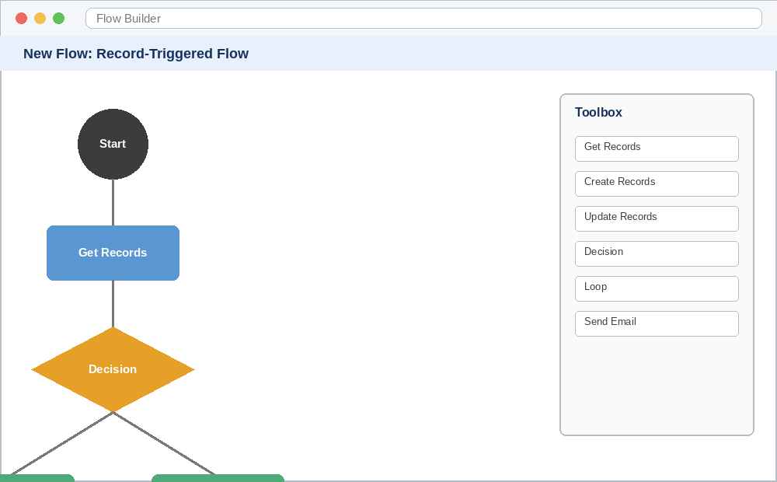
Figure 5.2 — A record-triggered Flow with a decision and two outcomes

6. Reports & Dashboards

6.1 Report Types
- Tabular — simple list of records, like a spreadsheet
- Summary — grouped rows with subtotals (most common for sales reporting)
- Matrix — grouped by both rows and columns, good for cross-tab analysis
- Joined — combines multiple report types into one view
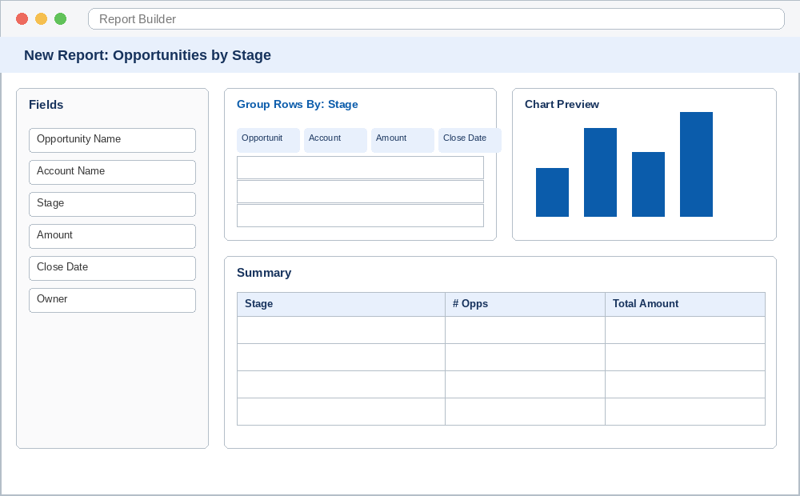
Figure 6.1 — Report Builder: fields, grouping, chart preview, and summary

6.2 Dashboards
Dashboards visualize one or more reports as charts, gauges, or tables. Each dashboard component is a filtered view of an underlying report, and dashboards can be set to refresh on a schedule and emailed to stakeholders automatically.

7. Change Management Best Practices
- Always build and test in a Sandbox before deploying to Production
- Use Change Sets or a version-controlled deployment tool (e.g. Salesforce CLI, Gearset) to move changes between environments
- Document every configuration change — object modifications, new automation, permission changes
- Communicate changes to end users ahead of deployment, especially UI or process changes
- Review the Setup Audit Trail regularly to track who changed what

8. Quick Reference Checklist
Task | Where
Create a new user | Setup → Users → New User
Adjust object permissions | Setup → Profiles or Permission Sets
Build automation | Setup → Flows
Set org-wide sharing defaults | Setup → Sharing Settings
Create a report | Reports tab → New Report
View recent changes | Setup → Audit Trail
End of Manual — for hands-on practice, use a free Developer Edition org at developer.salesforce.com.

