Standard Incident Report Template

1. Identifiers
Site:
Incident Date:
Severity:

2. Description
Duration:
Sample Tray Layout
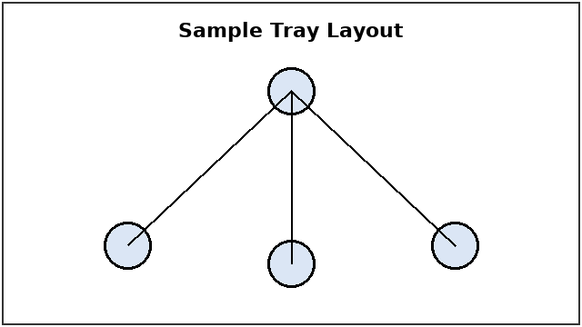

3. Timeline
Containment Zone
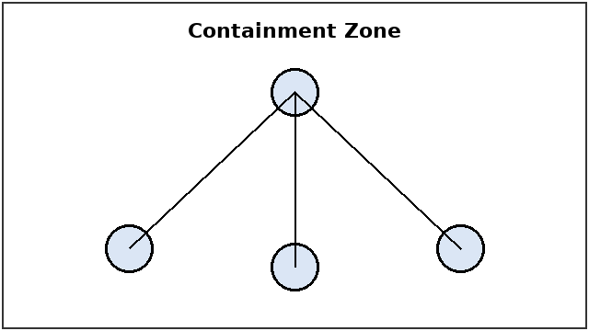

4. Contributing Factors
Software Version:
Cross-section of the Worn Reagent Seal
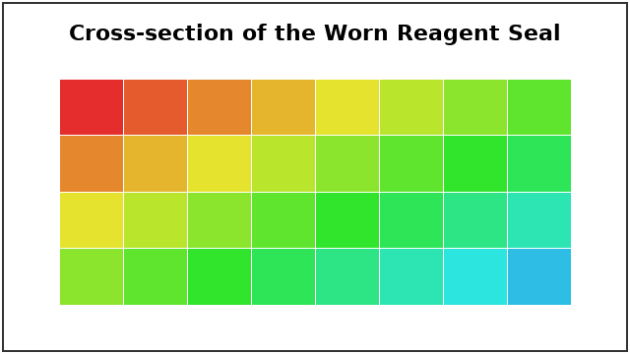

5. Corrective Actions
Table 1: Corrective Actions
Action | Owner | Due Date | Verification

6. Approvals

