Nav Bus Interface Control Document

1. Scope
System: Navigation Data Bus (Nav Bus)
Spec Date: 2026-04-10
Approval Status: Draft
This document defines the interface between the Navigation Computer and the Flight Management Unit over the Nav Bus. See Figure 2 for the physical topology.

2. Interface Overview
Signaling Rate: 50 kbps
Bus Voltage: 5 volts
The Nav Bus carries periodic messages from the Navigation Computer to the Flight Management Unit on a fixed schedule.
Message Timing
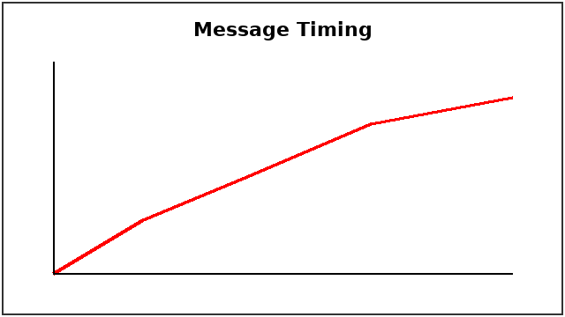

3. Signal Definitions
Message | Update Rate | Word Length

4. Data Formats
Numeric fields use two's complement signed integers, most significant bit first.
[FIGURE: figure1.png]

5. Revision Notes
Initial draft for review.

