TGX-9 North Ridge Incident Report

1. Identifiers
Site: North Ridge Relay Station
Incident Date: 2026-03-02
Severity: Low

2. Description
The TGX-9 gateway at North Ridge dropped 34 percent of inbound sensor packets over a two hour window. See Figure 2 for the network topology.
Cabinet Thermal Layout
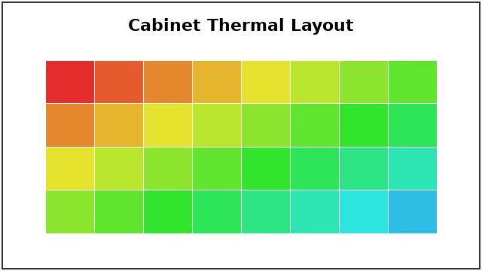

3. Timeline
Buffer occupancy alarm at 02:11; packet loss 02:14; recovery after manual power cycle at 06:31.
[FIGURE: figure1.png]

4. Contributing Factors
Firmware 4.2.0 was running on the affected unit. Cabinet temperature was elevated during the event.

5. Corrective Actions
Owner | Action | Due Date

6. Approvals
Reviewer:
Signoff Date:

