Standard Incident Report Template

1. Identifiers
Site:
Incident Date:
Severity:

2. Description
Duration:
Relay Station Network Topology
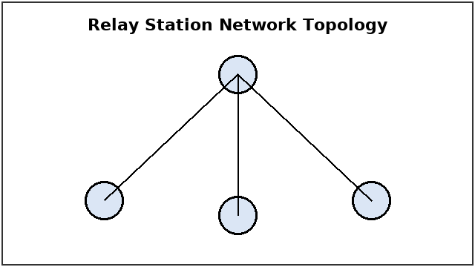

3. Timeline
Packet Loss vs Cabinet Temperature
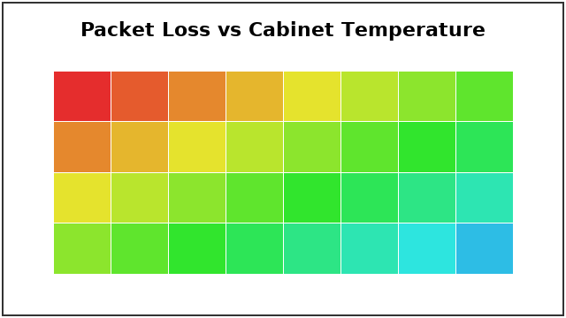

4. Contributing Factors
Firmware:
Cabinet Thermal Layout
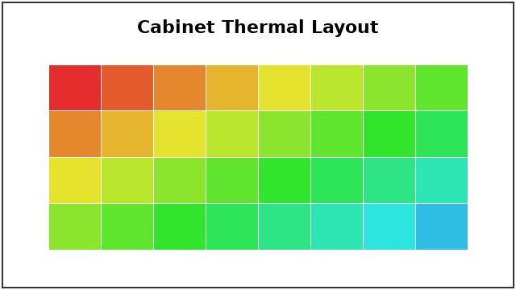

5. Corrective Actions
Table 1: Corrective Actions
Action | Owner | Due Date | Verification

6. Approvals

