Customer Portal Breach Attempt Report

1. Identifiers
Site: Customer Portal
Incident Date: 2026-05-11
Severity: Informational

2. Description
The customer portal saw credential-stuffing traffic over a two hour window. See Figure 2 for the botnet distribution.
Authentication Flow
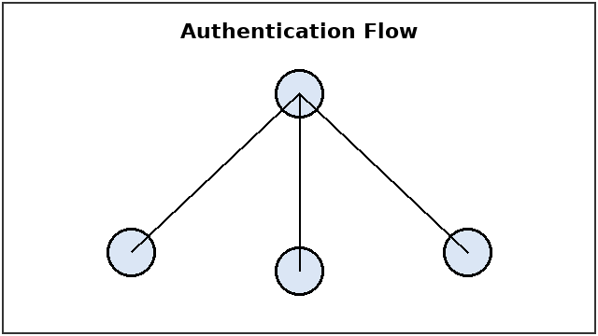

3. Timeline
Anomalous login alarm at 22:58 UTC; surge 23:05 UTC; contained after WAF rate-limiting at 05:10 UTC.
[FIGURE: chart.png]

4. Contributing Factors
Auth-gateway 3.5.2 was running on the affected service. Rate limiting was absent.

5. Corrective Actions
Owner | Action

6. Approvals
Reviewer:
Signoff Date:

