Bay 2 Reagent Spill Report

1. Identifiers
Site: Chemistry Analyzer Bay 2
Incident Date: 2026-07-03
Severity: Minor

2. Description
A reagent spill on the Bay 2 analyzer halted processing over a one hour window. See Figure 2 for the tray layout.
Cross-section of the Worn Reagent Seal
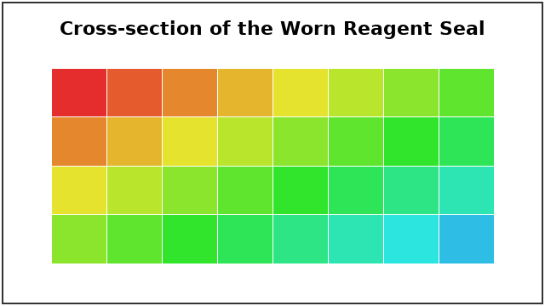

3. Timeline
Reagent-level warning at 08:12; spill detected 08:20; resumed after decontamination at 11:20.
[FIGURE: figureA.png]

4. Contributing Factors
Control-software 7.2.0 was running on the affected analyzer. A secondary catch tray was absent.

5. Corrective Actions
Due Date | Action

6. Approvals
Reviewer:
Signoff Date:

