Line 3 Housing Defect Report

1. Identifiers
Site: Injection Molding Line 3
Incident Date: 2026-08-09
Severity: Cosmetic

2. Description
Line 3 produced housings with a hairline crack over a two hour window. See Figure 2 for the crack micrograph.
Firmware Pressure-compensation Response Curve
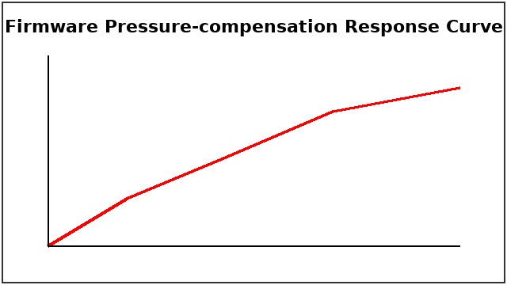

3. Timeline
Cavity pressure deviation alarm at 06:31; first flagged part 06:40; production paused after hold at 11:40.
[FIGURE: trace.png]

4. Contributing Factors
Mold-controller firmware 2.1.1 was running on the affected line. Melt temperature drifted high.

5. Corrective Actions
Owner | Due Date | Action

6. Approvals
Reviewer:
Signoff Date:

