Standard Incident Report Template

1. Identifiers
Site:
Incident Date:
Severity:

2. Description
Duration:
Micrograph of the Hairline Crack Defect
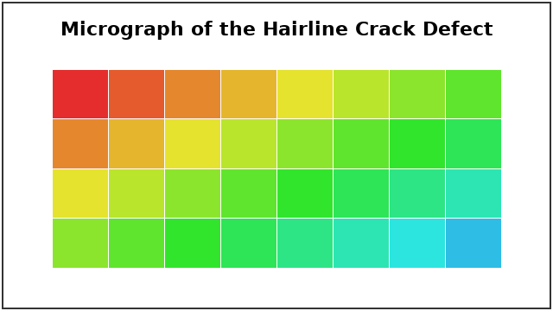

3. Timeline
Cavity Pressure Trace
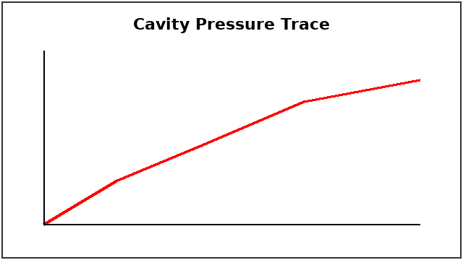

4. Contributing Factors
Firmware:
Firmware Pressure-compensation Response Curve
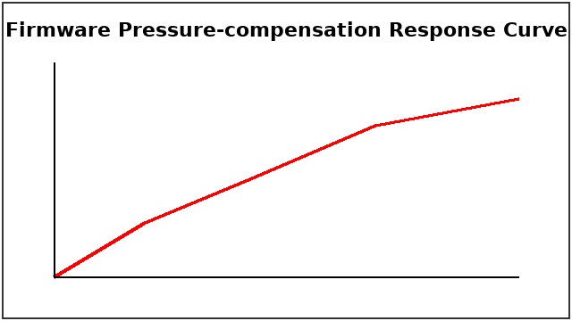

5. Corrective Actions
Table 1: Corrective Actions
Action | Owner | Due Date | Verification

6. Approvals

