Standard Incident Report Template

1. Identifiers
Site:
Incident Date:
Severity:

2. Description
Duration:
Schematic of Hydraulic System B
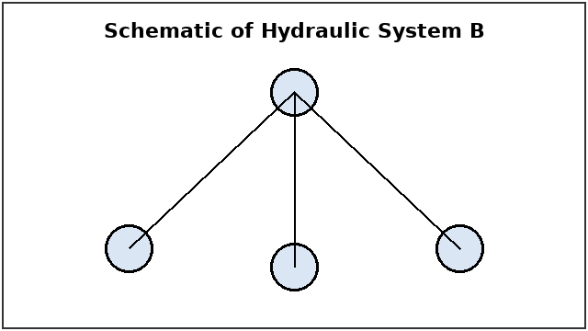

3. Timeline
Pressure Decay Plot
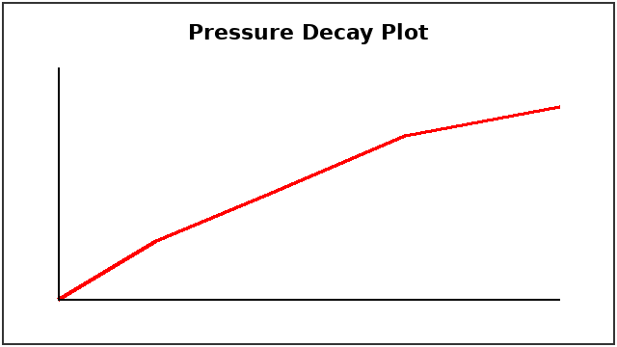

4. Contributing Factors
Software Version:
Comparison of Worn Versus New Actuator Seal
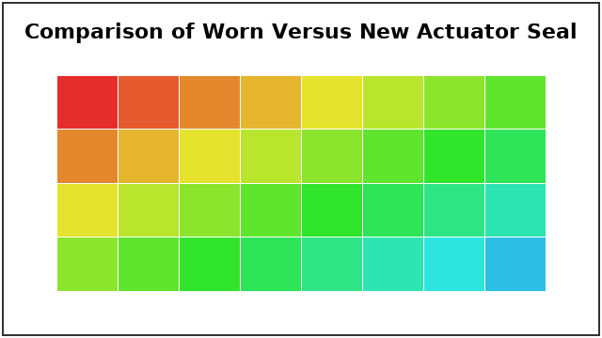

5. Corrective Actions
Table 1: Corrective Actions
Action | Owner | Due Date | Verification

6. Approvals

