Standard Incident Report Template

1. Identifiers
Site:
Incident Date:
Severity:

2. Description
Duration:
Geographic Distribution of Source Traffic
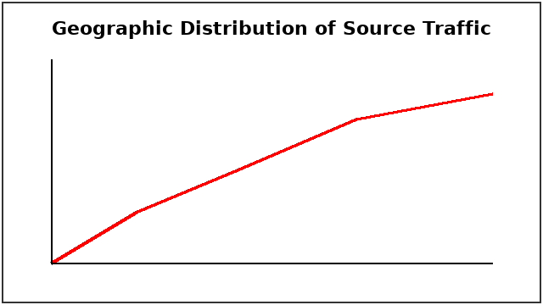

3. Timeline
Login Attempt Volume
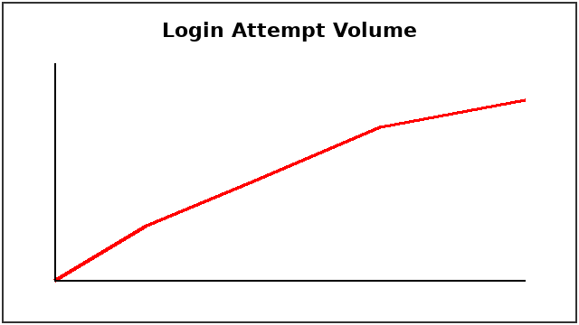

4. Contributing Factors
Auth Version:
Authentication Flow
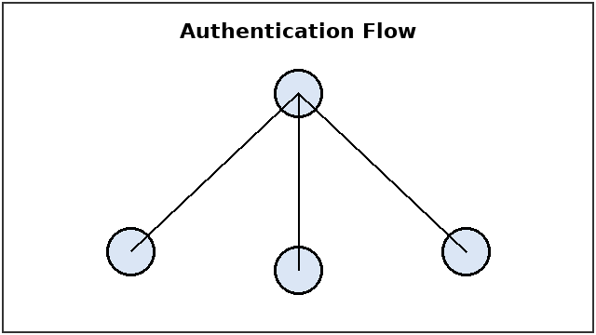

5. Corrective Actions
Table 1: Remediation Actions
Action | Owner | Due Date | Verification

6. Approvals

