Tail 512 Hydraulic Discrepancy Report

1. Identifiers
Site: Tail 512 Hydraulic System B
Incident Date: 2026-09-06
Severity: Routine

2. Description
Hydraulic System B on tail 512 showed slow pressure decay grounding the aircraft over a three hour window. See Figure 2 for the schematic.
Comparison of Worn Versus New Actuator Seal
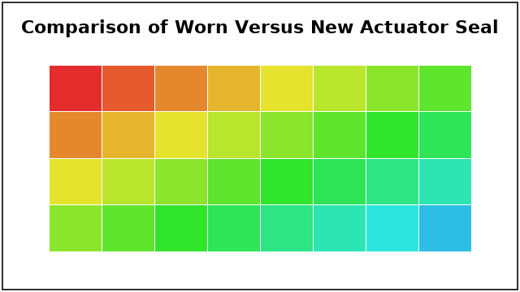

3. Timeline
Hydraulic low advisory at 05:41; discrepancy logged 05:50; returned to service after seal replacement at 12:50.
[FIGURE: plot.png]

4. Contributing Factors
Actuator-controller software B2.5 was running on the affected unit. The actuator seal was degraded.

5. Corrective Actions
Action | Owner

6. Approvals
Reviewer:
Signoff Date:

