Interface Control Document Template

1. Scope
System:
Spec Date:
Approval Status:

2. Interface Overview
Signaling Rate:
Bus Voltage:
Nav Bus Physical Topology
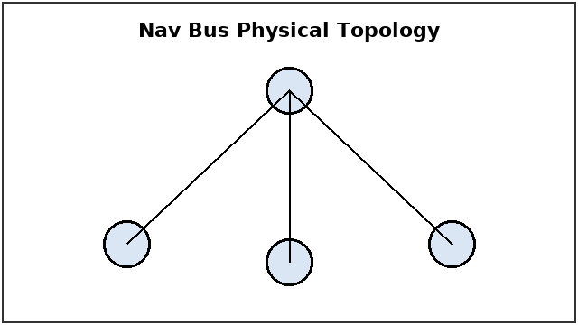

3. Signal Definitions
Table 1: Signal Definitions
Message | Word Length | Update Rate | Units

4. Data Formats
Message Timing
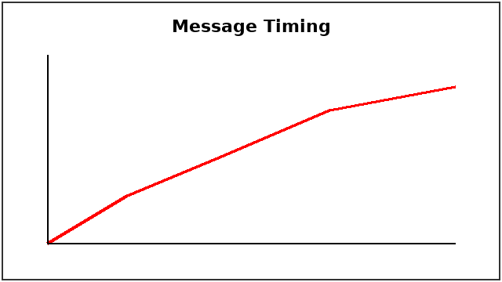

5. Revision Notes
Detailed Timing of the Position Message Word


