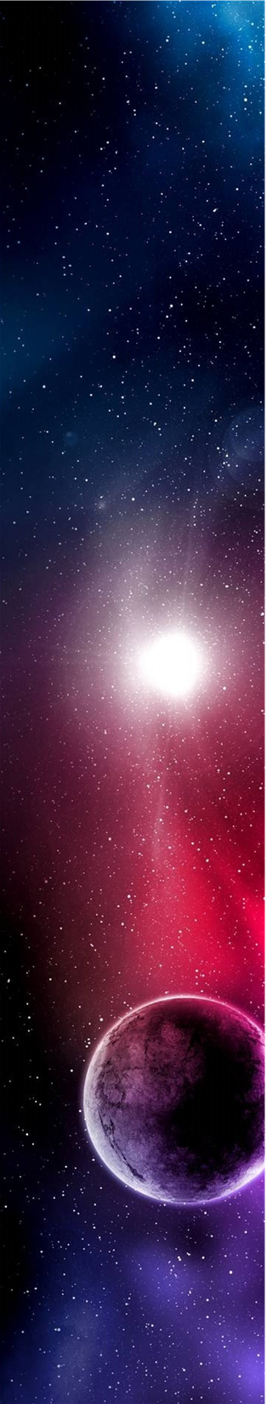

The
Universe
by

Diert Maage
A thesis submitted in partial fulfillment of the requirements for the degree of
Doctoral Degree in Astrophysics
 | Glenwood University
 | 20XX
 | Approved by
 |  |  | Chairperson of Supervisory Committee
 | Program to Offer Degree |  | Authorized
 | Date

Glenwood University

Abstract

The Universe

By Diert Maage

Chairperson of the Supervisory Committee:

Professor Janessa Bughatti
Department of Science

A thesis presented on the history of astronomy and the solar system, beginning with the birth of the solar system, and covering the geology, atmosphere, and moons of Mercury, Venus, Earth, Mars, Jupiter, Saturn, and Uranus.

Table of Contents
Acknowledgments 5
Glossary 6
Chapter 1 The Solar System 7
To Customize This Thesis: 7
To Create a Document from the Template 7
How to Insert a Picture or Caption 7
Bibliography 8
Index 9

List of figures
Number Page

- Mercury 12
- Venus 13
- Earth 14
- Mars 16
- The Asteroid Belt 17
- Landforms 18
- Site Topography 21
- Views 24
- Functional Relationships 28
- Spatial Magnitudes 36

Acknowledgments
The author wishes to express sincere appreciation to Professors Smith and Jones for their assistance in the preparation of this manuscript. In addition, special thanks to Dr. Elsa Leavitt whose familiarity with the needs and ideas of the class was helpful during the early programming phase of this undertaking. Thanks also to the members of the school council for their valuable input.

Glossary
Asteroid. A very small planet ranging from 1,000 km to less than one km in diameter. Asteroids are found commonly around other larger planets.

Atmosphere. The gaseous mass that surrounds any planet, including Earth.

Density. The number (as of particles) per unit of measure.

Galaxy. A system of stars independent from all other systems.

Moon. The natural satellite of any planet.

Orbit. The path taken by a satellite around a celestial body.

Planet. A large, nonluminous mass, usually with its own moons, which revolves around a star. Planets are found everywhere in the galaxy.

Solar. Having to do with the sun.

The Solar System

To Customize This Thesis:
Insert your information in place of the sample text, and then click Save As on the File menu. In the Save as type list, click Document Template.

To Create a Document from the Template
To open the thesis template as a document, on the File menu, click New. The customizations you made will appear in the document.

To change the spacing between, for example, body text paragraphs, click in a paragraph, and then click Paragraph Settings on the Home ribbon. On the Indents and Spacing tab, under Spacing, adjust the number in the Before or After list, and make additional adjustments as needed.

To save your style changes, with the cursor blinking in the changed paragraph, click Styles and Formatting on the Formatting menu. In the Styles and Formatting pane, right-click the selected style and choose Update to Match Selection.

How to Insert a Picture or Caption
On the Insert menu, point to Picture, and then click the command that corresponds to the type of element you want to insert. To insert a caption, in a new paragraph, on the Format menu, click Styles and Formatting. In the Styles and Formatting task pane, click All styles in the Show list, and then make the selection you want in the list.

Bibliography
. . , . |  | . . , .
. . , . |  | . . , .
. . , . |  | . . , .
. . , . |  | . . , .
. . , . |  | . . , .
. . , . |  | . . , .
. . , . |  | . . , .
. . , . |  | . . , .
. . , . |  | . . , .
. . , . |  | . . , .
. . , . |  | . . , .
. . , . |  | . . , .
. . , . |  | . . , .
. . , . |  | . . , .
. . , . |  | . . , .
. . , . |  | . . , .
. . , . |  | . . , .

Index
A |  | M |  | S
Aristotle, 3 |  | Mariner space mission, 2 |  | Solar system, 2
F |  | Mercury, 3 |  | creation, 2
From a Galaxy, 2 |  | Milky Way, 2 |  | geocentric theory, 2
G |  | O |  | heliocentric theory, 3
Geocentric theory, 2 |  | Orbit, 3 |  | Mariner mission, 2
H |  | Mercury, 3 |  | Voyager mission, 2
Heliocentric theory, 3 |  | P |  | T
 |  | Planets and Moons, 2 |  | The Solar System, 2
 |  | R |  | V
 |  | Rotation, 2 |  | Voyager space mission, 2
 |  | Mercury, 3

Endnotes are notes that you can use to explain text in a document. To insert an endnote, click where you want to insert the note reference mark. On the Insert menu, point to Reference, and then click Footnote. Click Endnote, make any other selections you want, and then click Insert.

