Space Explorer Navia
Game Design Document
OpenWorld 2d puzzle platformer



Table Of Contents
Table Of Contents 2
1. Game Overview 3
1.1 Game Title 3
1.2 Genre 3
1.3 Platform 3
1.4 Summary 3
2. Game Mechanics 4
2.1 Core Gameplay 4
2.2 Controls 4
3. Story and Characters 5
3.1 Story 5
3.2 Characters 5
4. Game World 6
4.1 Environment 6
5. Art and Style 7
5.1 Visual Style 7
5.2 Characters Design 7
5.3 UI/UX Design 7
6. Sound and Music 8
6.1 Sound Effects 8
6.2 Music 8

1. Game Overview

1.1 Game Title
Space Explorer Navia

1.2 Genre
OpenWorld 2d puzzle platformer

1.3 Platform
Pc

1.4 Summary
A open world platformer where you need to explore your way getting trough puzzling minigames to unlock certain abilities. These abilities will help you progress further in the game and allows you to reach new area’s.

2. Game Mechanics

2.1 Core Gameplay
You will start of with almost nothing only having the ability to walk and jump. You will quickly encounter a problem where you need to find your first ability. The option to double jump will be the very first ability you find. But to unlock this ability you first need to solve the puzzle. By solving puzzles you gain more abilities. You will need them to reach new places and explore the world.

2.2 Controls
Default Binding | Input type | Action | Description
A | Press & Hold | Walk to the right
D | Press & Hold | Walk to the left
S | Press & Hold | Crouch
Space | Press | Jump
S+Space | Press | Jump off a platform | Key combination that allows you to go down from a platform.

3. Story and Characters

3.1 Story
While exploring the universe you got stranded on a unknown planet. You have no clue where you are or how to get back up. But luckily there is plenty of oxygen meaning that survival is easy. You will need to find a way to restore the ship. But be careful it may not always be as safe it seems. The planet holds many different secrets that are yet to be found out. Like the fairy that suddenly appeared out of nowhere.

3.2 Characters
Astronaut [Player]
The character you will play as you will go trough a adventure with him. Exploring the planet while you have to platform your way trough. Together with him you will discover more things. Along the way gaining new ways to navigate trough it.
Fairy Navia
Your guide fairy who will always follow on your grand journey. You will bump into her at the very start of the game. It will give you some hints of how to play at start. As well give a option to save the game at certain locations.

4. Game World

4.1 Environment
There will be a variety of different environments throughout the game. You will start of in a rocky area where there isn’t much detail or things to see. But later on you will encounter a lab like environment, grasslands and a city.

5. Art and Style

5.1 Visual Style
The characters will be pixel art. While the environment will be smooth with lot’s of details.

5.2 Characters Design
Astronaut sprite base art.
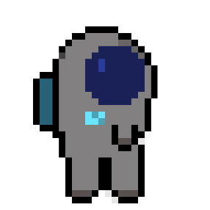
Navia sprite art base art.
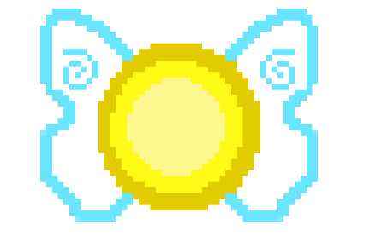

5.3 UI/UX Design
The overall ui will be rather simple and easy to use using mainly dark colors.

6. Sound and Music

6.1 Sound Effects
The player will have a sound effect for walking. The actually sounds depends on the environment. Navia will sometimes randomly make noise in the form of a high pitched hey.

6.2 Music
Classic violin music with drums support.

